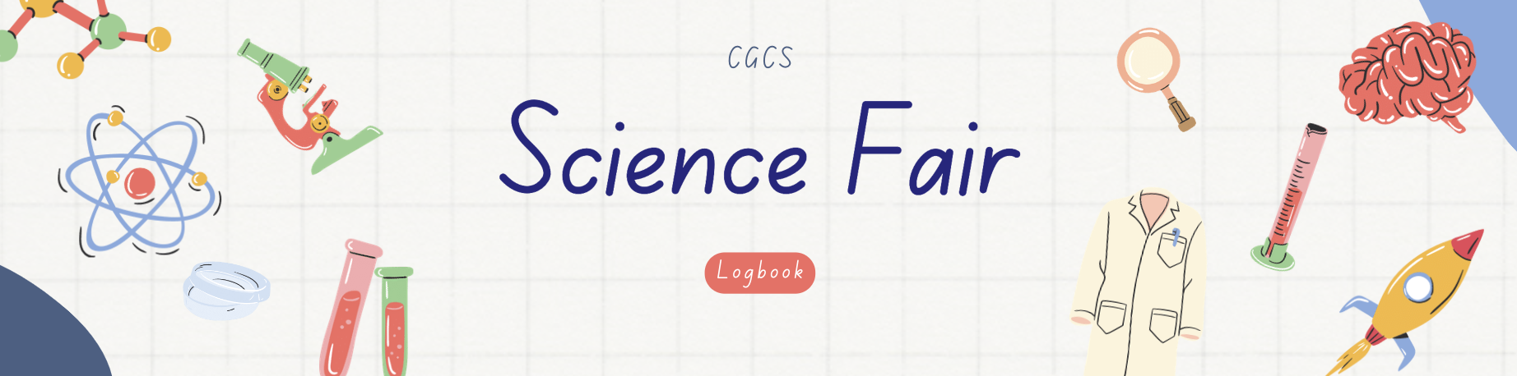

Does age matter?
When your muscles, joints, and bones change it can affect your posture and walk, that could lead to weakness and slow movement. When people age they lose bone mass or density, especially women after their menstrual cycle. They lose bone calcium and other minerals. The spine is made up of a bone called the vertebrae It’s located in the spine.
between the age of 30 and 25 that’s when your bones are the strongest because they can rebuild backup instead of down . When you hit the age of 40 you slowly began to lose bone mass. If you have a well balanced diet and exercise regularly it will be a slow process
Answer/Conclusion:
In females, age 25. This is why it's important to participate in weight bearing exercises early in life to help build your maximum amount of bone strength early.

Are Non-lactose bones or Lactose bones fragile?
According to our research lactose intolerance may have less bone density and fragility fractures. Lactose intolerance also has a higher chance of getting osteoporosis if they are not getting enough dietary calcium that is why they need to pay extra attention to their health/bone health.
Answer:
Dietary calcium (from food) is the best place to get calcium to help strengthen bones. Calcium isn't just from lactose containing food products, or just from milk. Some dairy products will add in lactase (the enzyme to break down lactose), or filter out the lactose to make dairy foods tolerable for lactose intolerant people. People who are lactose intolerant can definitely have bones that are as strong as non lactose intolerant people. I suggest looking at the website https://osteoporosis.ca/calcium-calculator/, which is a helpful tool that can help with seeing if you are getting enough dietary calcium for your age and shows your recommended amount of calcium and different dietary sources/ amount of calcium each of these have. Some people do need to supplement with calcium tablets though, but should be done with a family doctor.

-Does diet matter for bone density?
According to our research, it is important to consume a well-balanced diet containing a variety of food though you can make your bones stronger by eating a lot of vitamin D. If you have good nutrition your body will have the nutrition it would need for maximum bone strength such as: calories, protein, calcium, and vitamin d. If a child doesn’t get enough of the vitamin d they need, it can cause them to get rickets.

Answer/conclusion:
It is important to get dietary calcium and a source of vitamin D for our bones. Every single adult Canadian should be taking at least 1000-2000 IU of vitamin D every single day. Vitamin D is an interesting vitamin because it is fat soluble. Due to the way it's stored, you can take your entire daily dose of vitamin D one day a week and it's safe! A well balanced diet is very important to give you the energy to be able to participate in weight bearing exercises to help strengthen bones.

Would bones be easier to break if I didn't drink milk -
According to our research professionals have not been seeing a difference in fracture rates. Even if you’ve been drinking milk for your whole life or everyday there not seeing a difference in fracture rates. Men are more likely to experience fractures than women. When women hit the age of 45 fracture rates become higher among women. Among everyone over the age of 65 and over, fracture rates become three times higher among women and men.
Answer/conclusion:
There are many factors that go into overall bone health and not just milk - milk, vitamin D and exercise are just 3 things that we can try to control. Family history of osteoporosis, 4 genetics, medications, smoking, age of menopause, certain medical conditions, and smoking status all play a role in overall bone health.

What milk is the healthiest and why?
For this research question we got four different answers. First answer was that skim, cows, nonfat, and hemp milk were the healthiest for bones. Skim and nonfat have all the milk fat removed. It has more calories and a higher percentage of calcium by weight. A cup of skim milk contains 325 mg of calcium. That third of daily calcium an adult needs. Cow milk is high in protein and nutrients that support a healthy bone and healthy body. Hemp milk helps strengthen bone, muscles, and teeth . Hemp milk has more protein and is healthier than other plant based milk but it depends what brand it's from. Hemp milk also can boost your immune system and brain, it can help your body fight off diseases. That's how healthy it is.

How does calcium work to strengthen your bones
Calcium is a way you can strengthen your bones and harden them . Humans can not make calcium in their bodies. You can get calcium from foods and drinks to strengthen your bones. Those elements make your bones and teeth stronger( teeth are stronger than bone because of the outer covering of the tooth which is enamel). Those elements could also make your bones less likely to break.

Problem
We wanted to do this project because people don't really pay attention to their bones and there are a lot of bone diseases people are getting nowadays, especially older people because they probably didn't have a well balanced diet when they were younger or didn't participate in weight bearing exercises early in life or they would lose bone minerals. If we didn't take care of our bones we'd be like jelly and have no structure we wouldn't be able to do anything physical. Also are blood flow, lungs, nerves, (and are bones protected are vital organs) organs , and all of that would be blocked and squeezed. So basically what we're trying to do is spread awareness that humans could be healthy and active throughout life.

Method
How we got all these answers:
When we did the research we found totally different answers than the conclusion. We were not sure how to tell the truth until we checked multiple sites to see if the information was true. Lots of websites say different things, so to get the proper information we decided to get it from professionals who do this daily, we decided to interview doctors that study about health and bone density. We got some different answers than what we got while using google. The questions we asked were: does age matter for bone density, does diet matter for bone density, if we didn’t drink milk would it be easier to break bones, how does calcium work, what milk is the healthiest for bones, and are lactose or non intolerance bones more fragile .

Research / Data

Does age matter for bone density?
According to our research when you're between the age 25 and 30 is when your bones are the strongest. When you hit the age of 40 you lose bone mass especially women after they are done with their menstrual cycle because their bone loses calcium and other minerals . If you participate in weight bearing exercises regularly such as: walking, dancing, elliptical training machines, climbing stairs, gardening and you have a well balanced diet the process will be slower. When your muscles, bone, and joints change it affects your posture and walk that leads to weakness and slow movement.

Are lactose or non lactose bone more fragile
According to our research lactose intolerants may have less bone strength and mass because they can’t produce milk like non lactose intolerants can.Lactose intolerant people also have a higher chance of getting osteoporosis which happens when mineral density and bone mass shrinks, or when the structure and strength of your bone change. Half of the women population have a fracture located in their hip,wrist, vertebra, a bone located in your spine .They also need to pay extra attention so that they are getting enough dietary calcium they need you can get that from tofu, sardines, almonds, figs, canned salmon, kale, lentils and beans,and soya beans.
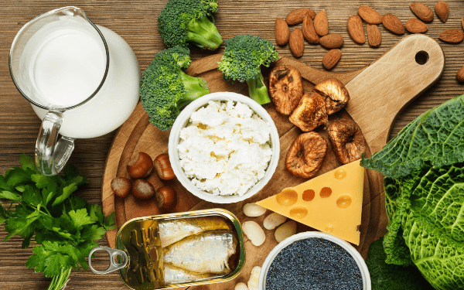

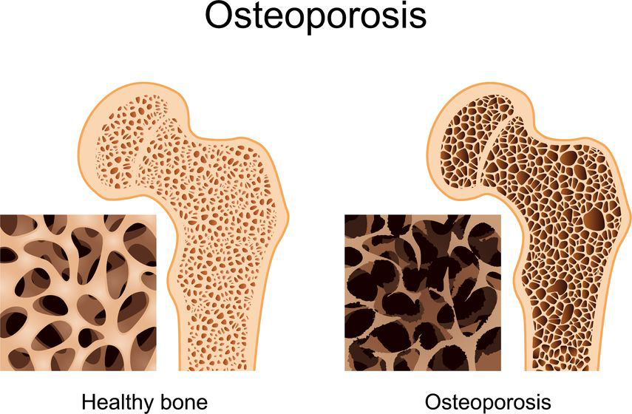

Does diet matter?
It’s important to have a well balanced diet, it helps keep you in sports and doing daily things easier. You can also have strong bones by eating a lot of vitamin d which is in oily fish, fatty fish and cheese.
If you don’t have a well balanced diet you can lose bone and all the minerals you need for your bones that could give you a risk of getting osteoporosis. If you get all the nutrients you need you can have health benefits and have all the nutrients you need for maximum bone strength (such as calories, protein, calcium, and vitamin D). If a child doesn’t get enough of the vitamin d they need, it can cause them to get rickets.

Would it be easier to break bones if we didn’t drink milk?
According to are research
Fracture rates have been high, fractures have usually been happening on your arm or hip. People who’ve been drinking milk every single day professionals are not seeing a difference in fracture rates. The men population are most likely to get fractures because they take bigger risks and play different sports than women . After the age of 45 a woman especially has it after they have done their menstrual cycle because they lose calcium from their bones.

How does calcium help our bones?
Calcium hardens and strengthens bones. Humans can not make calcium. If you want strong bones you can get your calcium from drinks and foods. Those elements make your bones and teeth( teeth are stronger than bone because of the enamel the outer covering of your tooth) stronger. Also those elements can make your bones less likely to break.

Milk is the best for bones.
For this research question we got four different answers. First answer was that skim, cows, nonfat, and hemp milk were the healthiest for bones. Skim and nonfat have all the milk fat removed. It has more calories and a higher percentage of calcium by weight. A cup of skim milk contains 325 mg of calcium. That third of daily calcium an adult needs. Cow milk is high in protein and nutrients that support a healthy bone and healthy body. Hemp milk helps strengthen bone, muscles, and teeth . Hemp milk has more protein and is healthier than other plant based milk but it depends what brand it's from. Hemp milk also can boost your immune system and brain, it can help your body fight off diseases. That's how healthy it is.

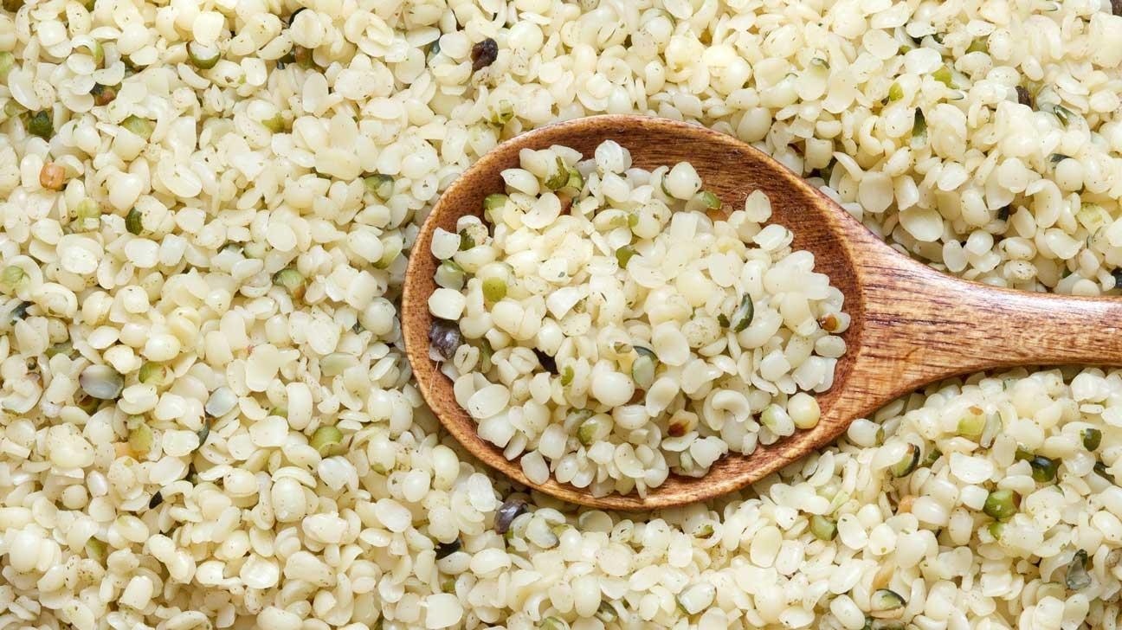

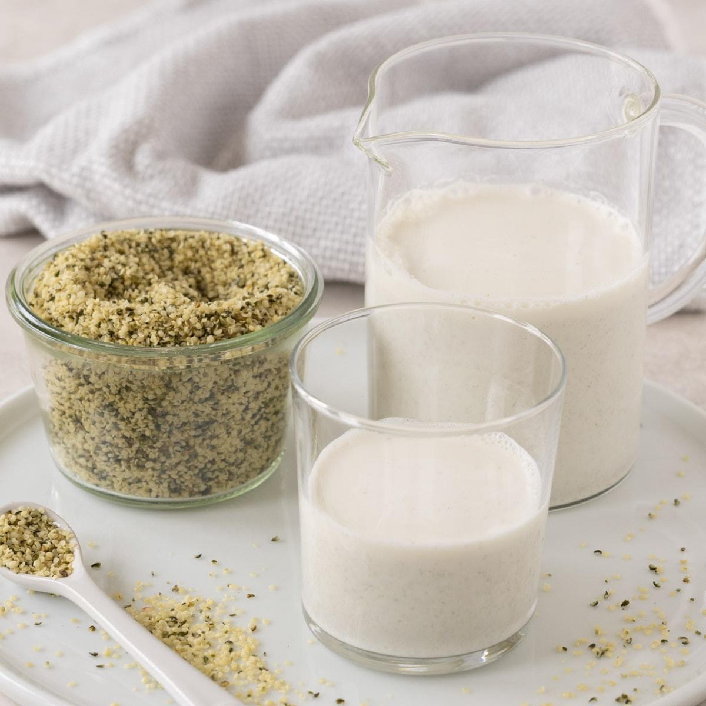
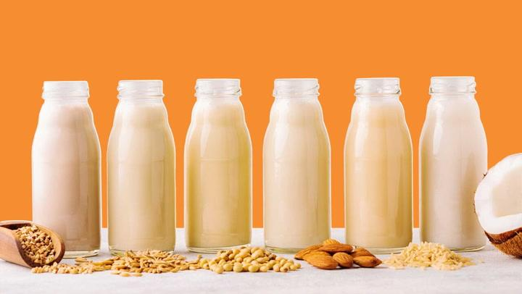

Conclusion
Does age matter conclusion
According to doctors we interviewed when you hit the age 20. It’s very important for humans to practicapite weight bearing exercises for that you could build bone back up but if you don’t you could lose bone mineral and bone. It’s important to do weight bearing exercise 30 minutes everyday so that you can have maximum bone strength earlier in life .

Are non lactose or lactose bones more fragile
According to the doctors we interviewed
Calcium is an element that can help strengthen bones. Calcium isn’t just for lactose containing foods or milk. You can get calcium from foods that don’t contain dairy but contain calcium. Lactose intolerants can have as strong bones as non lactose by eating other food elements. The doctors we interviewed recommended a cite where you can see if your getting the dietary calcium you need and for your age: https://osteoporosis.ca/calcium-calculator/

Does diet matter for bone density
According to the doctors we interviewed.
Having a well balanced diet is good for bone strength and for that you can participate in weight bearing exercises . Vitamin d is a fat soluble so that means it can dissolve in fats and oils. Every adult should be taking a source of vitamin d every single day. You can take your entire daily dose of vitamin d one day of the week and it's safe

If we didn’t drink milk would it be easier to break your bones
According to the doctors we interviewed
Milk is a part of bone health but it is not overall bone health. There are other elements such as: milk, vitamin d, and exercise are things we can control. Some things that can make you have a high risk of getting a bone fractures/diseases such as: smoking can make you have a high chance of getting osteoporosis, when your done your menstrual cycle bone density decreases, when your on medication it can cause bone loss, and some medical conditions it can affect the structure of your bones and they can become weak which means they will be more likely to break, all those elements play a part in overall bone health.

How does calcium help our bones?
According to the Harvard cite we looked into
Calcium helps strengthen and harden bones and we can’t make calcium in our body’s ourselves. We need to get them from foods and drinks. If you have broken bones or fractures and you get the calcium you need and nutrients it can repair it. It’s better to eat low fat dairy food items with calcium and vitamin d. If you get about 800 mg of calcium a day it can increase bone density. Apparently a lot of people think that osteoporosis only affects women but men too.

What milk is the healthiest for your bones and why?
According to the site we’ve looked into it depends on your diet for what milk could be the best for you. People stick with cow, skim, and low fat milk. It also gives a higher amount of calcium than other milks. It also depends if you’re allergic or not. Plant based and organic milks are probably the best options because they give a high amount of vitamin d and calcium. Milk isn’t the only thing that makes your bones healthier or stronger. There are many other elements such as your leafy green or fortified drinks and weight bearing exercises.

Citations / Sources
- https://osteoporosis.ca/calcium-calculator/
- Milk and Osteoporosis — Is Dairy Really Good for Your Bones?
- https://www.google.com/url?sa=t&rct=j&q=&esrc=s&source=web&cd=&ved=2ahUKEwjz8-6v-7aEAxWLHjQIHZb4BtkQFnoECA4QAw&url=https%3A%2F%2Fwww.niams.nih.gov%2Fhealth-topics%2Fcalcium-and-vitamin-d-important-bone-health%23%3A~%3Atext%3DCalcium%2520phosphate%2520hardens%2520and%2520strengthens%2Cto%2520break%2520if%2520we%2520fall.&usg=AOvVaw1CEKzxtZFl-7NtSzP080DQ&opi=89978449
- https://www.google.com/url?sa=t&rct=j&q=&esrc=s&source=web&cd=&ved=2ahUKEwja1tOR_LaEAxVICTQIHVDyCPIQFnoECA8QAw&url=https%3A%2F%2Fwww.ncbi.nlm.nih.gov%2Fpmc%2Farticles%2FPMC6521087%2F%23%3A~%3Atext%3DBased%2520on%2520the%2520available%2520evidence%2Cintake%2520or%2520avoidance%2520of%2520dairy.&usg=AOvVaw0R-zlbl-yH6LVw51eFVa08&opi=89978449
- https://www.google.com/url?sa=t&rct=j&q=&esrc=s&source=web&cd=&ved=2ahUKEwjDr9j_hbmEAxWUGDQIHd1nCQwQFnoECCsQAQ&url=https%3A%2F%2Fhealth.clevelandclinic.org%2Fcan-drinking-too-much-milk-make-your-bones-more-brittle&usg=AOvVaw1RCm_8kpOqnZ1lCk5JM7jj&opi=89978449
- https://www.google.com/url?sa=t&rct=j&q=&esrc=s&source=web&cd=&ved=2ahUKEwjes8vUhrmEAxVINzQIHWa9CkIQFnoECCkQAQ&url=https%3A%2F%2Fhealth.clevelandclinic.org%2Fhow-do-your-bones-change-over-time&usg=AOvVaw3w4M3wYY9vPVzNjVDG1TnO&opi=89978449
- https://www.google.com/url?sa=t&rct=j&q=&esrc=s&source=web&cd=&ved=2ahUKEwjIpte4nbmEAxUxHDQIHRfUAmIQFnoECCQQAQ&url=https%3A%2F%2Fwww.health.harvard.edu%2Fblog%2Fhow-well-does-calcium-intake-really-protect-your-bones-201509308384&usg=AOvVaw0XH_lacl3Ekt-ZxGXN6JyB&opi=89978449
- https://www.google.com/url?sa=t&rct=j&q=&esrc=s&source=web&cd=&ved=2ahUKEwjn85bjnrmEAxUHODQIHX4JDWQQFnoECA4QAw&url=https%3A%2F%2Fwww.medicinenet.com%2Fwhich_milk_is_best_for_bones%2Farticle.htm%23%3A~%3Atext%3DLow%252Dfat%2520milk%2520has%2520a%2Cyour%2520daily%2520value%2520of%2520calcium.%26text%3DSkim%2520or%2520no%252Dfat%2520milk%2Cpercentage%2520of%2520calcium%2520by%2520weight.&usg=AOvVaw3jGxePofyOba3AzFlPdH2w&opi=89978449

Why is this information important - where do we go from here

-We think that it is very important to learn about bones. If your bones are not cared for correctly you can get lots of bone problems and diseases such as osteoporosis, the most common bone disease . Osteoporosis is a bone disease that develops when mineral density and bone mass decreases, or when the structure and strength of your bones change. Your bones also protect your vital organs. We wanted to do this research project to prove that our bones have a purpose. If the world didn’t care about bones we would be like jelly and have no structure and we wouldn’t be able to do anything physical. Also our lungs, nerves, blood flow, and organs would be blocked and squeezed . Most important thing: We wanted to let people know that bones do have a big impact and that your bones are so important to keep humans healthy and active throughout life.

We are also thinking that we could make a part 2 for city fairs. Maybe some of the questions that the judges ask that we don’t know we could use those questions for are next project.

