Which Method Of Fruit Cleaning Works Best?
Science Fair Logbook

By: Sage Guan & Audrilyn Gunaratnam 6-2

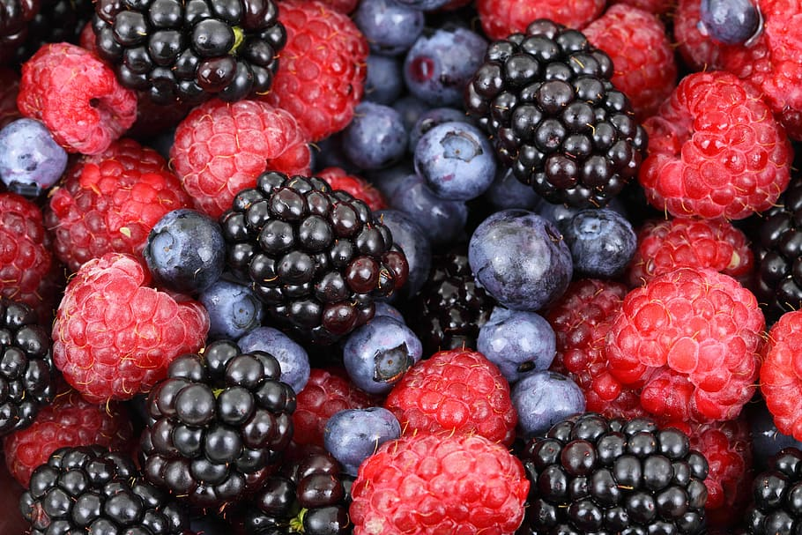

Scientific Question:.................................................................................................................. 4
Hypothesis:.............................................................................................................................. 4
Prediction:.......................................................................................................................... 4
Research:..................................................................................................................................... 4
No wash has no cleaning properties, it does nothing, we are using it as our control group……………………………………………………………………………………………………… 4
Total Materials………………………………………………………………………………………... 6
Necessary Materials…………………………………………………………………………….. 7
Supporting Materials…………………………………………………………………………….. 7
Procedure………………………………………………………………………………………… 8
Prep Procedure………………………………………………………………………………….. 8
Observations (Blueberries Round 1)....................................................................................... 9
24 hours (Black petri dish):................................................................................................ 9
24 hours (Blue petri dish):................................................................................................ 10
24 Hours (Green petri dish):............................................................................................. 11
24 hours (petri dish) :....................................................................................................... 12
24 hours (Yellow petri dish):............................................................................................. 13
48 hours (Black petri dish):.............................................................................................. 14
48 hours (Blue petri dish):................................................................................................ 16
48 hours (Green petri dish):............................................................................................. 17
48 hours (Red petri dish):................................................................................................ 18
48 hours (Yellow petri dish):............................................................................................ 20
72 Hours ( Black petri dish)............................................................................................. 21
72 Hours (Blue petri dish)................................................................................................ 22
72 Hours (Green petri dish)............................................................................................. 24
72 Hours (Red petri dish)................................................................................................. 25
72 Hours (Yellow petri dish)............................................................................................. 26
120 Hours (Black petri dish)............................................................................................. 27
120 Hours (Blue petri dish).............................................................................................. 28
120 Hours (Green petri dish)........................................................................................... 30
120 Hours (Yellow petri dish)........................................................................................... 31
120 Hours (Red petri dish)............................................................................................... 32
Observations (Strawberries Round 2)..................................................................................... 33
24 Hours (Black petri dish)............................................................................................... 33
24 Hours (Blue petri dish)................................................................................................ 34
24 Hours (Green petri dish)............................................................................................. 35
24 Hours (Red petri dish)................................................................................................. 36
24 Hours (Yellow petri dish)............................................................................................. 37
48 hours ( Green petri dish):............................................................................................ 38
48 hours (Yellow petri dish):............................................................................................. 38
48 hours (Blue petri dish):................................................................................................ 38
48 hours (Black petri dish):.............................................................................................. 38
48 hours (Red petri dish):................................................................................................ 38
48 hours (Yellow petri dish):............................................................................................. 38
72 hours (Green petri dish):............................................................................................. 38
Sources of Error:.............................................................................................................. 39
Variables:......................................................................................................................... 40
Data:............................................................................................................................................ 41
24 hours:.......................................................................................................................... 41
48 hours:.......................................................................................................................... 42
72 hours:.......................................................................................................................... 43
120 hours:........................................................................................................................ 44
24 hours (strawberries):................................................................................................... 45
48 hours (Strawberries):.................................................................................................. 46
72 hours:.......................................................................................................................... 47
120 hours (strawberries):................................................................................................. 48
Analysis:..................................................................................................................................... 49
24 hours:.......................................................................................................................... 49
48 hours:.......................................................................................................................... 49
72 hours:.......................................................................................................................... 50
120 hours:........................................................................................................................ 50
Conclusion:................................................................................................................................ 51
Acknowledgments…………………………………………………………………………………….. 51
Application……………………………………………………………………………………………… 52
Citations………………………………………………………………………………………………… 52
Experiment Photos……………………………………………………………………………………. 54

Scientific Question:
Does the solution used for cleaning fruit impact the amount of bacteria that will grow on the fruit under controlled conditions?

Hypothesis:
If you use the veggie wash , then it will remove the most bacteria from the fruit because it contains more fruit-cleaning properties than other solutions.

Prediction:
The veggie wash will be the best solution for cleaning fruit because it has the most bacteria-killing ingredients

Research:

No wash has no cleaning properties, it does nothing, we are using it as our control group.

Next type of cleaner is water. Water has some basic cleaning properties such as it is an excellent solvent which means that hydrophilic dirt will dissolve off of it.
The next type of the cleaner that we are testing is vinegar. The cleaning properties of vinegar are much better than just using water. Vinegar is 5% acetic acid which helps it break down dirt, bacteria, oils, and films.

Veggie Wash is a fruit and vegetable cleaner. This has the most benefits that we could find. There are many things that this “veggie wash” does. It breaks down the wax layer on your fruits and vegetables, dirt, pesticides, bacteria, and people handling residue.

Ingredients in Veggie Wash: Water, Organic Ethanol, Organic Sunflower Oil, Organic Glycerin, Organic Lemon Oil, Organic Coconut Oil, Potassium Hydroxide, Citric Acid

What ingredients help clean fruits that are found in fruit washing methods? Some of the most effective and beneficial contents that help clean fruits include; acetic acid, chlorine (sodium hypochlorite), organic acids, electrolyzed water, hydrogen peroxide, citrus organic oils, potassium hydroxide and water.

What are the effects of good fruit cleaner ingredients? Acetic Acid - Destroys the bacteria’s cell structure. Chlorine (Sodium hypochlorite) - Breaks the chemical bonds in the bacteria’s molecules. Organic Acids - Alters the bacteria’s membrane. Electrolyzed Water - Produces hypochlorous acid, which kills bacteria. Hydrogen Peroxide - Produces destructive hydroxyl free radicals that attack bacteria membranes. Citrus Organic Oils - Binds the bacteria wall and disrupts its growth. Potassium Hydroxide - Kills microorganisms such as bacteria.
Total Materials
-1 liter vinegar
-1 bottle of veggie wash
-30 petri dishes
-60 cotton swabs
-50 grams nutrient agar
-1 basket strawberries
-1 basket blueberries
-incubator
-light dish
- 12 petri dish grids
-hydrometer
-thermometer
-electrical tape
-petri dish holders
- 1 liter distilled water
Necessary Materials

-1 liter vinegar
-1 bottle veggie wash
-1 liter distilled water
-30 petri dishes
-100 grams nutrient agar
-1 basket strawberries
-1 basket blueberries
-60 cotton swabs

Supporting Materials

-incubator
-light dish
-12 petri dish grids
-hydrometer
-thermometer
-electrical tape
-petri dish holders
- petri dish racks

Procedure
- Put masks on
- Wash fruit for 30 seconds.
- Swab the fruit for 30 seconds
- Roll the swab evenly over the petri dish for 30 seconds.
- Wash fruit with either water, vinegar, or veggie wash.
- Dip cotton swab into distilled water.
- Swab the fruit, make sure to be even when swabbing the fruit for 30 seconds.
- Roll swab on the other side of the split petri dish for 30 seconds make sure to roll the swab evenly each time.
- Place the petri dishes in an incubator.
- Watch and wait for the bacteria colonies to grow.

Prep Procedure

- Mix 50 grams of nutrient agar with water.
- Stir until combined.
- Carefully fill petri dishes evenly with the nutrient agar solution.
- Let petri dishes set for 20 minutes
- Sort fruit into 6 groups.
- Put petri dishes into their assigned petri dish rack.

Observations (Blueberries Round 1)

24 hours (Black petri dish):
On the control side there are small colonies of bacteria. There are three bacteria colonies that have a stringy appearance. The average size of one of these bacteria colonies is about 0.25 square centimeters in size; the three colonies are quite thin. All of the stringy colonies are close together. There is one quite thin spread out colony need to zoom in to see it. There is 0.5 square centimeters it is roundish. There are around 1050 small colonies.

On the water side of the petri dish there is a small film on the top half of the petri dish. The film is quite thin and is in a sweeping pattern. There is one very small stringy colony that is close to the film. There are other small bacteria colonies that are scattered around the petri dish half. There are around 840 tiny bacteria colonies that cover the petri dish.

On the vinegar side of the second petri dish there is one big bacteria colony in the center of the petri dish. It has a large blooming pattern that looks like roots or a brain pattern. It is about eight square centimeters. There is a smaller bacteria colony in the upper left corner of the petri dish. It has more of a brain-like appearance. There are around 1,140 bacteria colonies.
On the veggie wash side of the second black petri dish there is a 0.1 centimeter square stringy colony that is on the upper left hand area. Two blocks away there are two one centimeter colonies that are close together that look kinda like a ying and yang shape. There are around 750 bacteria colonies. There is a film on the bottom half of the petri dish. There is a very thin film.

24 hours (Blue petri dish):
On the control side of the blue petri dish there are large amounts of bacteria, mostly there are two films one is eight square cementires and the other one is also eight square cemeteries. Both are quite thick. One of them is on the top on the half of the petri dish and the other one is on the bottom half on the half of the petri dish. There is a thin film in the middle of the petri dish, this film is quite thin. It is just four square centimeters . There is one bacteria colony that is located near the upper filmy bacteria colony. The bacteria colony has a wet appearance like a coloured drop of water. There are around 330 bacteria colonies.

On the water side of the blue petri dish there are many bacteria colonies, most of them are around the edges of the petri dish. There is a thin rim around the outside of the petri dish. The bacteria colonies that are closer to each other are quite thin and have more of a Blooming pattern formation. One of the bacteria colonies is 1 square centimeter in size. There are three others that are around 0.5 square centimeters in size. One of them is 6 square centimeters; it is also the thickest out of the colonies. There are around 430 bacteria colonies in this half of the petri dish.

On the vinegar side of the second petri dish, there are very few bacteria colonies, only around 6. They are quite thin and mostly circular in shape. With one of them being in a o shape and a hole in the middle, it is just a line of bacteria. There are around 1200 bacteria colonies in the vinegar side of the petri dish.

On the Veggie Wash side of the second blue petri dish, we could find only two small, wispy, circular looking bacteria colonies. One was quite thin, and the other one was thicker and had a more wet looking consistency. Both were around 0.25 square centimeters in size. There are around 900 bacteria colonies in this half of the petri dish.

24 Hours (Green petri dish):
IMG_1065.HEIC On the control side of the green petri dish, there is a zigzag film which is quite thin. You need to zoom in to see it. The middle area is the thickest. The film is 6 square centimeters. There is a thin film around the rim and appears to have a wet consistency. There is one stringy ball of bacteria, that is about 1 square centimeter. There are around 759 bacteria colonies.

On the water side of the green petri dish, there is blooming film on the outer rim of the petri dish. It is quite thick in some areas, and in others it appears to be thinner. It has almost flower-like sections. Closer to the edge of the petri dish it becomes thicker and as it stretches out it becomes thinner. It is 8 square centimeters. There are two very wet looking bacteria colonies that have a more stringy consistency. They are both around 1 square centimeter. There are around 500 bacteria colonies.

On the vinegar side of the green petri dish, there is an oddly shaped colony that at the top is thicker and the bottom is thinner. Overall the shape appears like a zigzag triangle. There appears to be a very thin film over the entire petri dish. The film is 4 square centimeters. There are around 520 bacteria colonies.

On the veggie wash side of the green petri dish, there is a thin film of the upper half of the petri dish. This film then goes into a much thicker film that covers the bottom quarter it leads into a much thinner film. Then there is a small bacterial dot that is 0.5 square centimeters. The film is about 12 square centimeters if not more. There is a little red streak of bacteria that covers almost one square centimeter. There are around 325 bacteria colonies.

24 hours (petri dish) :
On the control side of the red petri dish, there is a small S shaped bacteria colony that takes up 0.25 square centimeters. There is a 0.5 square centimeter bacteria colony. This colony is very thick. There is a hook shaped bacteria colony That is ranging in thickest. There are around 263 bacteria colonies.

On the water side of the red petri dish, there are hundreds of small colonies that are scattered on the entire petri dish; there is a larger colony around the middle of the petri dish. All of the small dots are the same in shape and color. All of them have a white, and yellow color. There are about 560 bacteria colonies.

On the vinegar side there are lots of small bacteria patches that are all around the petri dish. All of the colonies are around 0.01 square centimeters in size and are all off white in color; most of them are just little dots of very small circles. There are 2 line shaped bacteria colonies that are only 0.2 square centimeters in size, both are quite thin. There is a large thin bacteria colony on the bottom half of the petri dish. It is 5 square centimeters in size. There are around 936 bacteria colonies.

On the Veggie Wash side of the petri dish, there are very few easy to see bacteria colonies. From what we could see there were only 3 bacteria colonies that you could easily see and not have to zoom in to see. 2 of the colonies werė just little lines that were close to each other. The other one is a stringy looking ball. That is 0.25 square centimeters in size. There are around 580 bacteria colonies.

24 hours (Yellow petri dish):
On the control side of the petri dish, there is barely any bacteria and you need to zoom in to view it. The total amount of bacteria takes up about 3.4 square centimeters. The average size of the larger colonies is around 0.15 square centimeters. There are also some small dotted bacteria colonies spread out on the petri dish. There are about 880 small dotted colonies. Each one measures about 0.01 square centimeters.

On the water side of the petri dish, there are also very little bacteria amounts. There is an extremely thin film that takes up about 5 square centimeters. The thin film is located in the bottom right corner of the petri dish. We have also noticed that there are lots of small dotted bacteria colonies. They are located everywhere and are also visible through the film due to the thinness of the film. There are about 1,363 small dotted bacteria colonies. Each one measures around 0.01 square centimeters.

On the vinegar side of the second yellow petri dish, there is an extremely thin film. It is barely visible even when zoomed in. All of the film combined takes up about half of the petri dish. We have also noticed the same small dotted bacteria colonies located all over the petri dish. There are about 1,276 small dotted colonies. Each one measures about 0.017 square centimeters.

On the Veggie Wash side of the second yellow petri dish, the pattern of the bacteria growth resembles the same as a dill plant. The bacteria mostly blooms from the curved film-like border of the petri dish. All of the bacteria combined takes up approximately 10 square centimeters in total. There are also some small dotted bacteria colonies. These small dotted colonies are located all across the petri dish. The average size of each small colony is around 0.01 square centimeters.

48 hours (Black petri dish):
Copy of IMG_1068.HEIC On the control side there is 1 thin zigzagged film that spreads across the petri dish. There are also some very small bacteria colonies that are spread around the zigzagged film, there are around 150 small dotted colonies that can be found around the film. These colonies range from 0.01-0.1 square centimeters. On the button edge of the zigzag there are two blooming colonies of bacteria, with one being 0.5 square centimeter and the other being 1/3 of a square centimeter. There are around 150 small dotted colonies that can be found around the film. On the edge of the petri dish there is a thin, film-like border. We have also noticed the film takes up approximately 2/3 of the petri dish.

On the water side there are some different shaped and sized films that are spread out all over the petri dish. Some of the shapes include diagonal and straight watery lines, ovals, circles, and waves. All of the film takes up about half of the petri dish. Like the control side there are also small dotted bacteria colonies that are spread out on the entire petri dish. We have recorded around 320 dotted colonies. The average size of each dotted colony is 0.01 square centimeters. Compared to the control side of the petri dish the film on the water side is slightly thicker. Most of the rim of the petri dish has a film border with some blank spots and gaps.

On the vinegar side of the second petri dish there is some film, which takes up around half of the petri dish. The film is relatively thin for the most part, with some areas slightly thicker but smaller. The bacteria blooming pattern is very similar to that of frost on a window. There are some spread out circular colonies of bacteria located all over the petri dish. These colonies are about 0.15 square cm each. There are around 510 small dotted colonies spread out all over the petri dish except for the areas covered with film.

On the Veggie Wash side of the second petri dish there is some thin, slightly foggy film growing in some large lined groups and others curved and straight lines. There is also some thinner film surrounding the inside edge of the petri dish. There are also some small dotted bacteria colonies forming around the foggy-like film. The total amount of dotted bacteria colonies is around 1,100. The total amount of film covers around 2/5 of the petri dish.

48 hours (Blue petri dish):
IMG_1069.HEIC On the control side of the petri dish, there is a thin, foggy film that covers most of the petri dish, around 4/5 of the petri dish. The film pattern is somewhat similar to a frost pattern but is mostly a more liquid pattern. There are some smaller wavey bacteria colonies blooming from parts of the rim of the petri dish. There are a couple circular small colonies spread out toward the mid section to the bottom half. These colonies are around 0.1 square centimeter each. There is one large circular colony that is 0.30 square centimeters by itself. There are about 10 medium to small dotted bacteria colonies across the petri dish. The average size per medium dot is 0.12 square centimeters.

On the water side of the petri dish, there are multiple frost-like bacteria colonies in line formations emerging from the edge of the petri dish. There is a film bordering the edge of the petri dish. The total amount of bacteria takes up around a little over 1/3 of the petri dish. There appears to be some small dotted colonies located across the petri dish, with each one measuring about 0.01 square centimeters and one larger one measuring 0.1 square centimeters. The total number of small dotted bacteria colonies is around 414.

On the vinegar side of the second petri dish, there is some film closer to the bottom area of the petri dish. The total amount of film takes up around 1/4 of the petri dish. There are four small bacteria colonies spread out from the lower middle to the top half of the petri dish. There is also one larger bacteria colony with some small islands. The size of the colony is around 3 square centimeters. There are around 1,950 small dotted colonies. Their location ranges from the top of the petri dish to the bottom.

On the Veggie Wash side of the second petri dish, there is some thin film which covers approximately 6/8 of the petri dish. There are 8 larger dotted colonies that take up around 0.1 square centimeters. Out of the 8 colonies 6 are covered by a thin layer of film, however they are still visible but appear blurry. There are around 143 small dotted colonies that are spread out around the areas with film. On the inside rim of the petri dish there is a thin film border outlining the petri dish.

48 hours (Green petri dish):
IMG_1070.HEIC On the control side of the petri dish, there are five foggy, thick bacteria films with each being quite spread out from the others. We have also noticed some bacteria colonies forming a frame or border to the petri dish. Emerging from parts of the border there are some blooming frost-like bacteria patterns growing inwards of the petri dish. There around 560 small dotted bacteria colonies spread out all over the petri dish. Each dotted colony is about 0.05 square centimeters.

On the water side of the petri dish, there are some bacteria colonies blooming inwards from the right edge of the petri dish. There are about 252 small dotted colonies, with each being around 0.05 square centimeters. Close to the bottom, there are two bacteria colonies resembling the shape of mold on bread. Both of them combined would take up around 0.25 square centimeters. There appears to be the similar frost patterns of bacteria blooming from the edges of the petri dish. However, these small frost patterns seem to be slightly rounder, and more consistent compared to the previous control side of the petri dish.

On the vinegar side of the second petri dish, there is a thin film border that is thicker in width compared to the previous borders. The thick width border only appears on the left edge. On the right side border it has the opposite appearance, it is thick but extremely thin in width. There is a large bacteria colony emerging from the left border. The colony takes up about 6 square centimeters. On the lower bottom half of the petri dish there is a more visible and defined bacteria colony. In total it takes up around 2 square centimeters. There are around 700 dotted bacteria colonies. Each dotted colony takes up about 0.03 square centimeters.

On the Veggie Wash side of the second petri dish, there is a bubbly like frame on the right edge of the petri dish. There is a large thin film that takes up 2/3 of the petri dish. This large film can be found from the lower middle all the way to the top of the petri dish. On the film there is a large bacteria colony forming in the shape of a perfect circle. The colony takes up around 0.3 square centimeters. There are about 180 small dotted bacteria colonies. These colonies can be found in the areas around the film. Each dotted colony is around 0.02 square centimeters.

48 hours (Red petri dish):
IMG_1071.HEIC On the control side of the petri dish, there is a very thin and cloudy bacterial film blooming from the middle of the left edge. From the middle to the bottom section there is a thicker film colony forming in the the shape of an s with multiple imperfections on the side. In the middle and upper section of the petri dish there are some bacteria colonies in the shape of a circle. Each circular bacteria colony is about 0.15 square centimeters. There are also some small dotted colonies appearing all over the petri dish except for the areas covered with film. There are around 570 small dotted bacteria colonies. Each dotted colony takes up around 0.01 square centimeters.

On the water side of the petri dish, almost all of the bacteria colonies are emerging from the left edge of the petri dish. The colonies are blooming in a horizontal line from the edge. Each horizontal colony takes up about 2 square centimeters. There are also multiple small dotted bacteria colonies. They can be found everywhere around the larger bacteria colonies. There are around 1,080 small dotted colonies. Each colony is around 0.01 square centimeters. A border has been formed by the bacteria outlining the entire edge of the petri dish.

On the vinegar side of the second petri dish, the top half of the petri dish for the most part has little to no bacteria. However, almost all of the bacteria has gathered on the entire bottom half of the petri dish. There are around five lines going from edge to edge on the bottom half. All of the bacteria takes up about 15 square centimeters. We have also noticed some small dotted colonies appearing all over the petri dish. There are around 752 dotted colonies. Each colony is about 0.01 square centimeters. There is also a frame made of bacteria outlining the petri dish.

On the Veggie Wash side of the second petri dish, there isn’t as much bacteria compared to the previous petri dishes. There is a very thin border around the petri dish made of bacteria. The border is barely visible due to its thinness. There are two large bacteria colonies. They are both located close to the bottom of the petri dish. Each one is about 1 square centimeter. There appears to be some small dotted bacteria colonies spread out on the petri dish. There are around 1,170 small dotted colonies.

48 hours (Yellow petri dish):
IMG_1072.HEIC On the control side of the petri dish, there is some very thin film blooming from the left edge of the petri dish. On the right side there is some thicker film growing out of the edge in a consistent line, which continues from the bottom to the top of the petri dish. There is a singular large circular bacteria colony located close to the upper edge of the petri dish. The colony is around 1/3 of a square centimeter. There are some small dotted bacteria colonies. There are about 640 dotted colonies, with each one measuring around 0.02 square centimeters.

On the water side of the petri dish, there are larger amounts of bacteria com[pared to the control side of the petri dish. The bacteria is in a film-like state, the film is rather thin and is semi-transparent. There seems to be a very thin border made of bacteria outlining the petri dish. The total amount of the film-like bacteria would take up around 3/4 of the petri dish. There are also numerous small dotted bacteria colonies. There are around 420 colonies. Each colony takes up about 0.01 square centimeters.

On the vinegar side of the second petri dish, almost the entire petri dish is covered from top to bottom in bacteria and film-like bacteria. The bacteria colonies and film takes up around 5/6 of the petri dish. The film has a foggy, thin appearance. There seems to be some thicker spots in the film. This is caused by the film growing over previously existing bacteria colonies.

On the Veggie Wash side of the second petri dish, we have noticed it has significantly less bacteria compared to the previous vinegar. We have noticed a film-like border outlining the entire petri dish. There is a thick frost-like pattern of bacteria blooming from the right edge reaching the left edge and some parts redirecting its growth downward when it reaches the left edge. There are some small dotted bacteria colonies. There are about 448 small dotted colonies. Each one measures around 0.01 square centimeters.

72 Hours ( Black petri dish)
IMG_1077.HEIC On the control side of the petri dish, there is a film-like bacteria frame outlining the petri dish. Most of the petri dish is covered in the same film-like bacteria. The total amount of the film takes up around 3/5 of the petri dish. There are numerous small dotted bacteria colonies. These are located all over the petri dish excluding the areas covered with the bacterial film. There are around 169 small dotted colonies. Each one takes up about 0.01 square centimeters.

On the water side of the petri dish, their bacterial film appears to have a water-like pattern. Like the control side of the petri dish the water side also has the border made up of bacteria. There seems to be some small dotted bacteria colonies. There are around 551 small dotted bacteria colonies. These colonies are located around the bacterial film.

On the vinegar side of the second petri dish, there is a thin film-like border that runs around the petri dish outlining it in a film-like bacteria. On the upper border there is a flower, frost-like blooming pattern of a small bacteria colony. There are some small dotted bacteria colonies spread out. There are about 187 dotted bacteria colonies. In the upper left corner there are two bacterial colonies in the shape of circles. One is 0.15 square centimeters and the other is 0.25 square centimeters.

On the Veggie Wash side of the second petri dish, there are large amounts of bacterial film. The film is quite thin, making it semi transparent. All of the film takes up around half of the petri dish. There are also some small dotted bacteria colonies. These small dotted colonies can be found everywhere excluding the areas covered with the bacterial film. There are about 380 dotted colonies in total. Each small dotted bacteria colony measures around 0.01 square centimeters.

72 Hours (Blue petri dish)
IMG_1076.HEIC On the control side of the petri dish, the petri dish is nearly completely covered in bacterial film. There seems to be a bacterial border formed around the petri, however the border has some parts where it is broken or isn’t directly connected. There also seems to be some minor cracking in the bacterial film covering most of the petri dish. There are six medium sized bacteria colonies in the shape of circles. These colonies are covered by a thin layer of film but are still visible. Each one measures around 0.2 square centimeters. There is also one larger circular bacteria colony which measures about 0.3 square centimeters.

On the water side of the petri dish, there is significantly less bacteria compared to the control side. The total amount of bacteria covers around 40% of the petri dish. There seems to be bacteria blooming from both the right and left edge of the petri dish in a frost-like pattern. However, it is mostly blooming from the left edge. There are some small dotted bacteria colonies. There are about 480 small dotted colonies. Each one takes up around 0.01 square centimeters.

On the vinegar side of the second petri dish, the middle to upper middle has little to no bacteria. Close to the upper edge of the petri dish, there is one medium sized bacteria colony with 3 small circular island-like colonies located quite close to the main medium sized colony. The medium sized bacteria colony takes up about 2 ⅓ square centimeters. Each small island is around 0.1 square centimeters. By the middle of the petri dish there is a small bacteria colony, which takes up about 0.25 square centimeters. Near the colony there are two circular colonies. Each one takes up around 0.17 square centimeters. By the bottom of the petri dish, there is a large bacteria colony that has a film-like appearance. The colony takes up around 6 square centimeters. We have noticed some small dotted colonies that can be found all over the petri dish, including the areas with the film-like bacteria colonies. There are about 1,792 dotted colonies.

On the Veggie Wash side of the second petri dish, there is a film-like border outlining the petri dish with bacteria. All of the bacteria colonies are connected including the border, but excluding the few small dotted colonies and circular colonies. Most of the bacteria is connected to the border and shares the same appearance as a thin foggy film. There are about five circular bacterial colonies. Each one is about 0.1 square centimeters. There are also some small dotted colonies spread out on the petri dish. There are around 308 small dotted colonies. Each small dotted colony measures about 0.02 square centimeters.

72 Hours (Green petri dish)
IMG_1075.HEIC On the control side of the petri dish, there is a frost-like patterned border made of bacteria. The border runs around the petri dish outlining it. We have noticed every bacteria colony (excluding the small dotted colonies) is connected to the border. The recurring patterns of bacteria colony formations include; smooth film-like lines, oval blooming flowers, and finally a frost-like blooming pattern. The average size of each colony is around 3 square centimeters. Each small dotted colony takes up about 0.02 square centimeters. There are around 527 of these small dotted bacteria colonies.

On the water side of the petri dish, there are multiple consistent oval flower-like blooming patterns of bacteria colonies by the edge and on edge. There are also some bacteria colonies that showcase some frost blooming patterns. The average size of these colonies is about 2 ½ square centimeters. There are some small dotted bacteria colonies. There are around 126 of these small dotted colonies. This amount is significantly less compared to the control petri dish. Each small dotted colony is about 0.02 square centimeters.

On the vinegar side of the second petri dish, there is a film-like border. The border appears thicker on the curved part of the edge and quite thin on the straight part. There are five bacteria colonies. The largest one is close to the middle of the petri dish and takes up around 6 square centimeters, it is also connected to the curved part of the border. The second largest colony is close to the bottom of the petri dish. It measures around 2 square centimeters. The third largest is at the top of the petri dish and is connected to the curved part of the border. It takes up about 4/5 of a square centimeter. The final one is between the largest and third largest and takes up about half of a square centimeter. There are some small dotted colonies. There are around 322 of these small dotted colonies. Each one is about 0.01 square centimeters.

On the Veggie Wash side of the second petri dish, there is a large bacteria colony made up of a thick film. The colony takes up about 3/5 of the petri dish. There is a medium sized circular colony inside of the large colony made of thick film. It measures around 0.22 square centimeters. There is one more colony, it is located close to the bottom of the petri dish. It measures around 2 ½ square centimeters. There are about 21 small dotted colonies. Each small dotted colony takes up about 0.02 square centimeters. There appears to be a thin bubbly border made of bacteria.

72 Hours (Red petri dish)
IMG_1074.HEIC On the control side of the petri dish, numerous bacteria dots have gathered on the rim of the petri dish and formed a border that covers most of the rim. All of the bacteria on the petri dish takes up about half of the petri dish. On the top half there are two yellow bacterial colonies. One takes up about 0.44 square centimeters, while the other measures around 0.26 square centimeters. There are also some small dotted bacteria colonies. There are about 517 small dotted colonies. Each one is about 0.01 square centimeters.

On the water side of the petri dish, the total amount of bacteria takes up about 1/3 of the petri dish. There is also a thin border made of thick film. There are lots of small dotted bacteria colonies. They are located all over the petri dish excluding the areas covered with larger bacteria colonies and film. There are around 405 of these small dotted bacteria colonies. Each one takes up about 0.02 square centimeters.

On the vinegar side of the second red petri dish, there are larger bacteria amounts compared to the water petri dish. The total amount of bacteria takes up around a little under 3/4 of the petri dish. Most of the bacteria colonies are located on the bottom half of the petri dish. We have noticed some small dotted colonies. There are about 207 of these small dotted bacteria colonies. These colonies are located all over the petri dish excluding the areas with the larger colonies and film. Each one takes up around 0.02 square centimeters.

On the Veggie Wash side of the second red petri dish, the petri dish is almost completely covered in bacteria colonies. There is a large bacteria colony that has a film-like appearance. The colony alone takes up about 23 square centimeters. There are about 39 small dotted bacteria colonies. Each one takes up about 0.01 square centimeters.

72 Hours (Yellow petri dish)
IMG_1073.HEIC On the control side of the petri dish, we have noticed that the majority of the petri dish is covered in bacteria. There is a large colony that takes up around 3/4 of the petri dish by itself. Majority of the bacteria is located on the bottom half of the petri dish. There is a circular bacteria colony located close to the top of the petri dish. The circular colony takes up about 0.5 square centimeters.

On the water side of the petri dish, the total amount of bacteria takes up approximately 3/5 of the petri dish. Most of the bacteria is semi-transparent. There seems to be some small dotted bacteria colonies. Each colony takes up about 0.02 square centimeters. There are around 205 of these small dotted bacteria colonies. There are also some of these dotted colonies gathering on the edge, possibly forming the base of a border.

On the vinegar side of the second yellow petri dish, nearly the entire petri dish is covered in bacteria. All of the bacteria takes up about 9/10 of the petri dish. All of the bacteria is connected creating one massive bacteria colony.

On the Veggie Wash side of the second yellow petri dish, there is significantly less bacteria compared to the vinegar side of the petri dish. All of the bacteria combined takes up around 3/5 of the petri dish. The blooming pattern of the bacteria resembles a window frost pattern. All of the bacteria is blooming out in line formations horizontally out of the curved part of the border of bacteria on the rim of the petri dish.

120 Hours (Black petri dish)
IMG_1078.HEIC On the control side of the petri dish, there is a thin foggy film covering most of the petri dish. It covers about 3/4 of the petri dish. There are some small dotted bacteria colonies spread all over the petri dish. There are about 40 dotted colonies. Each colony is around 0.02 square centimeters. Connected to the large film-like colony there is a thin film border that outlines the entire half of the petri dish.

On the water side of the petri dish, there is a zigzag pattern of a large bacteria colony. The large colony appears to have a stringy and watery consistency. There is also a border that has a wavy or bubbly appearance. The border continues on most of the rim leaving some spots blank. There are about 323 small dotted colonies. Each colony measures about 0.01 square centimeters.

On the vinegar side of the second petri dish, there is a frost-like pattern of bacteria located in the middle area of the petri dish. There are thin film lines coming out horizontally out of the are numerous different circular shaped colonies by the top of the petri dish. The average size of each colony is about 0.27 square centimeters. There are around 30 small dotted colonies. To view these colonies you must zoom into the photo.

On the Veggie Wash side of the second petri dish, there are multiple bacteria colonies that have a thin film appearance. All of the films combined take up approximately 65% of the entire petri dish. There are also some small dotted colonies present throughout the petri dish. Each small dotted colony measures about 0.02 square centimeters. There are about 234 small dotted colonies.

120 Hours (Blue petri dish)
IMG_1079.HEIC On the control side of the petri dish, there are multiple bacteria colonies that have a film-like appearance. Some areas of the film are thinner than others, but for the most part is a mostly thick, foggy film. All of the film takes up approximately 5/6 of the petri dish. There are six small dots that have a bright yellow color. Each one is about 0.1 square centimeters. There is one foggy circular bacterial colony overlapping with film. It measures about 0.28 square centimeters.

On the water side of the petri dish, the bacteria color appears to be a more cream or beige color compared to the control side of the petri dish. The pattern of the bacteria growth seems to have a flower-blooming pattern mixed with a frosty pattern. All of the bacteria colonies are blooming from the edge of the petri dish, with the exception of a couple small dots and dotted colonies. There is a blurry looking dot close to the edge that takes up about 0.2 square centimeters. There are some small dotted bacteria colonies. There are around 340 small dotted colonies, each one is about 0.017 square centimeters.

On the vinegar side of the second blue petri dish, there is a very thin film by the bottom of the petri dish. It takes up about 5 square centimeters. There is a thicker bacteria colony on the top of the petri dish. It measures about 3.5 square centimeters. There are multiple circular colonies located by the middle section of the petri dish. There are also some small dotted bacteria colonies present throughout the entire petri dish. There are about 510 of these small dotted colonies. Each one is about 0.018 square centimeters.

On the Veggie Wash side of the second blue petri dish, there is a large thin film covering nearly all of the petri dish. The film takes up approximately 7/8 of the petri dish. There are two dots, each one measures about 0.3 square centimeters. The film has a watery looking pattern and consistency.

120 Hours (Green petri dish)
IMG_1080.HEIC On the control side of the petri dish, there are horizontal and diagonal colonies emerging from the edges of the petri dish. The pattern is similar to a flower blooming in certain areas while others have a small frost pattern. There are some small dotted colonies present throughout the petri dish. There are around 209 small dotted colonies of bacteria. Each one measures about 0.02 square centimeters.

On the water side of the petri dish, the patterns from the last 24 hours have grown about 0.2 square centimeters. There seems to be some extremely thin new film blooming in a flower pattern by the top of the petri dish. There are also some new small circular bacteria colonies. They appear very close to the rim and some appear on the rim. Each one measures about 0.15 square centimeters.

On the vinegar side of the second green petri dish, there is a border made of bacterial film on the curved part of the rim. For the most part the bacteria colony hasn’t seen much growth for the most part. There is an average growth of about 0.03 square centimeters. There is a somewhat small dot in the shape of mold on bread. The dot is about 0.014 square centimeters. The small dotted bacteria colonies have grown about 0.006 square centimeters each.

On the Veggie Wash side of the second green petri dish, the large film that appeared in the previous 24 hours has grown much thicker. You are still able to see through the film except it appears very foggy and cloudy. The color of the film is a light, dirty beige and the more it grows the more defined it becomes. The dot in the film has grown about 0.05 square centimeters. The film-like border has grown so thick you are no longer able to see through it.

120 Hours (Yellow petri dish)
IMG_1083.HEIC On the control side of the petri dish, the film has grown slightly thicker and the growth pattern has become more defined as there are some areas with overlapping bacteria and they highlight lines of the pattern. The actual pattern is like a half-moon. It goes in some parts straight and leads into angled lines consistently.

On the water side of the petri dish, the previous film has slightly thickened and some areas are now covered with a new thin film. Small white dots are appearing on the very thin border that hasn't seen much growth. The dotted colonies are now clumping with each other in groups of about five or six. It has a similar resemblance to a flower shape and they are slowly starting to grow into each other and combine into a larger colony.

On the vinegar side of the second yellow petri dish, nearly the entire petri dish is completely covered in a white somewhat thick film. It covers about 11/12 square centimeters.

On the Veggie Wash side of the second yellow petri dish, the frost pattern is becoming more and more defined the more the bacteria grows. The pattern is a mix of wispy looking frost. All of the bacteria take up about 3/4 of the petri dish. There are about 114 small dotted bacteria colonies. They can be found in all of the areas on the petri dish excluding the areas covered with the wispy frost patterned bacteria colonies and the border.

120 Hours (Red petri dish)
IMG_1084.HEIC On the control side of the petri dish, there is a medium sized film located between the middle and the bottom of the petri dish. The film is about 11 square centimeters. The film is quite thin. There appears to be two smaller bacteria colonies. Each colony is around 0.5 square centimeters. One of them has a more yellow appearance while the other has a more white appearance. There is a thin film border outlining the petri dish. Close to the top right corner there is a yellow bacteria colony, which is about 0.13 square centimeters. There are around 440 small dotted colonies. Each colony is around 0.01 square centimeters.

On the water side of the petri dish, there isn’t a lot of bacteria. The total amount of bacteria takes up about 1/5 of the petri dish. The bacteria colonies haven’t changed or grown much since the last 24 hours. However, there is a new furry or fluffiness on a dot that is located by the rim or border of the petri dish.

On the vinegar side of the second red petri dish, the total amount of bacteria takes up around 2/3 of the petri dish. Half of the bacteria is quite thin, while the other half is thicker. The bacteria maintains the same color of a dusty white. The dots seem to have combined in some areas. This caused smaller numbers but slightly larger and thicker colonies of bacteria to form.

Observations (Strawberries Round 2)

24 Hours (Black petri dish)
IMG_1094.HEIC On the control side of the petri dish, we have noticed quite a bit of bacteria growth within the first 24 hours of incubation. The total amount of bacteria takes up about 55% of the entire petri dish. We have recorded eight total small circular bacteria colonies. Some of them overlap with the film while others don’t. However, they all can be quite easily spotted. There is also a small yellow streak at the bottom of the petri dish and some small dotted bacteria colonies. There is a thin border made up of bacteria.

On the water side of the petri dish, there isn’t a large amount of bacteria. The total amount of bacteria takes up about 1/3 of the petri dish. There appears to be a thin border of bacteria outlining the entire rim of the dish. There are some small dotted bacteria colonies. These small dotted colonies are located all over the petri dish including the areas covered with bacteria. There are around 320 of these small dotted bacteria colonies. The average size of each of these colonies is around 0.01 square centimeters.

On the vinegar side of the second blue petri dish, there is a large bacteria colony resembling a sharper version of the number three. There are also some small circular colonies. These circular colonies are located all over the petri dish. The average size of each circular colony is around 0.17 square centimeters.

On the Veggie Wash side of the second blue petri dish, the majority of the petri dish is covered in bacteria colonies. Most of the bacteria is an extremely thin film. The film itself takes up about 6/10 of the petri dish. There are also some round bacteria colonies. They are all different shapes from each other. Each one measures around 0.2 square centimeters.

24 Hours (Blue petri dish)
IMG_1095.HEIC On the control side there are not that many bacteria patches but there are 2 films that are on the middle right and the bottom left of the petri dish. Both of them are a white-color and they are misshapen and not close to a circle-like shape. They are both very different. There are a total of 18 grid squares covered with bacteria.

On the water side of the petri dish, all of the bacteria combined takes up approximately 28% of the petri dish. There seems to be some small dotted bacteria colonies spread on the petri dish. There are about 564 of these small dotted colonies. Each one measures about 0.02 square centimeters. The blooming pattern of the bacteria resembles a frost pattern and in certain areas there is still a frost pattern but it is rounder than the other parts.

On the vinegar side of the second black petri dish, there is a zigzag shaped bacteria colony located a little bit above the middle line. The colony itself takes up about 7 square centimeters. There are some areas with an extremely thin film. It is so thin it is barely visible. There seem to be lots of larger dotted colonies. They gather in clusters but each one is still separate from the others. Each one measures about 0.1. Compared to the blueberries these dotted colonies are quite large since the previous dotted colonies on the blueberry petri dishes measured about 0.01-0.02 square centimeters.

On the Veggie Wash side of the second black petri dish, there is a thin film covering the majority of the petri dish. It covers around 3/4 of the petri dish. For the most part the bacteria colonies have quite a clean cut making the pattern or shape more defined. There are about 36 large dotted bacteria colonies. They are located in all areas including the areas covered with the clean film. The average size of each circular dot is around 0.2 square centimeters.

24 Hours (Green petri dish)
On the control side of the petri dish, most of the petri dish is covered in bacteria colonies. We have noticed that the bacteria's growth on the strawberries is faster compared to the blueberries from last week. All of the bacteria takes up approximately 10/11 of the petri dish. There is one large round bacteria colony located at the bottom of the petri dish, it has an oval shape. About 95% of the bacteria is semi-transparent

On the water side of the petri dish, the bacteria appears to have a more wet, 3-D appearance. On the bottom and top of the petri dish there are two large bacteria colonies. The average size of these colonies is around 2 square centimeters. In between these two colonies there are small dots that look wet and 3-D. We do not have a number of the small wet dots since they are extremely hard to count. Each small wet bacterial dot measures around 0.09 square centimeters.

On the vinegar side of the second blue petri dish, there appears to be the same wet, 3-D looking dots appearing all over the petri dish. There are some small dotted bacteria colonies forming a border around the petri dish. They are most present in the curved area of the petri dish’s rim. There are about 3-4 small circular bacterial colonies. The average size of each circular bacteria colony is approximately 0.28 square centimeters. There are a lot of circular colonies spread out on the petri dish. The average size of each circular colony is around 0.17 square centimeters. There are also some other colonies connected to the border and rim of the petri dish. These colonies have a fungi-like blooming pattern; there are approximately 3 of these colonies.

On the Veggie Wash side of the second blue petri dish, there are some small dotted bacteria colonies that have a wet looking texture and about half of them have a bright grime green color. There are three medium sized circular bacteria colonies. These three colonies are located close to the middle line and two of them are in the upper half of the petri dish.

24 Hours (Red petri dish)
IMG_1093.HEIC On the control side of the petri dish, the total amount of bacteria takes up around 1/3 of the petri dish. Almost all of the bacteria colonies are emerging out of the edge of the petri dish. These bacteria colonies have a round frost-like appearance. The average size of each colony is around 3 square centimeters. There are also some small dotted bacteria colonies. Each small dotted bacteria colony has an average measurement of around 0.02 square centimeters.

On the water side of the petri dish, there is a lot of bacteria almost completely covering the petri dish. There is a colony that looks like a brain and is huge in size it looks like it takes up about ⅕ of the petri dish. The total amount of grid squares covered in bacteria is 12 grid squares covered with bacteria.

On the vinegar side in the second yellow petri dish there is a large amount of bacteria. It has a fern-like appearance and covers the right hand side of the petri dish. It is more of a yellow-like color instead of a more white color.

24 Hours (Yellow petri dish)
IMG_1091.HEIC
On the control side of the petri dish there is a large amount of bacteria. The bacteria is ranging in color from off white to more yellow in color. There is one large bacteria colony that starts on the upper right hand side of the petri dish and goes down to the lower right section of the petri dish. The top of the petri dish the bacteria is more dense than the bottom of the petri dish. The colony that is at the top of the petri dish has a very thin line that connects the upper section of the colony to the bottom of the petri dish. The total amount of grid squares covered for the control side is 18 grid squares covered with bacteria.
On the water side of the yellow petri dish there is a thin layer of bacteria covering the middle section of the petri dish. This colony is not very dense. There are some very small colonies that are all around the petri dish. Most of these colonies are 0.25 cm in size. There is one colony that has a brain-like pattern to it and it has a very low pigmentation. This colony is about 1 cm in size. On top of that there is a circle-like colony that is yellow in color. It is about 1 cm in size and very dense. The location of this colony is around the middle and about 2 grid squares to the left of the film. The total number if grid squares covered with bacteria is 20 grid
On the vinegar side of the yellow petri dish there is a film that has a mass of 8 grid squares with different thicknesses and the color is off white. There are quite a few smaller bacteria colonies ranging in size but all having a circle-like shape and are off white in color but are closer to a yellow like color. The total number of grid squares covered is 12 grid squares covered with bacteria.
On the veggie wash side on the second yellow petri dish there are very few bacteria colonies and all of them are very small and the same off-white color. The total number of grid squares overed is 4 bacteria colonies.

48 hours ( Green petri dish):
On the control side of the petri dish there are a lot of bacteria colonies. The bacteria colonies are overlapping. This is causing many different thicknesses of the bacteria colonies. The total number of grid squares covered with bacteria is 14 grid squares covered.

On the water side of the green petri dish there is a very large amount of bacteria. There is a film on the bottom of the petri dish that is a yellow color. It is a side to side stroking motion that we used to stroke with the swab. There are many other small colonies that are above the main film/colony. The total amount of grid squares covered is 15 grid squares covered.

On the vinegar side of the second green petri there is only one large colony that covers almost every grid square. This colony is off white with no change in color or in how dense it is. The total number of grid squares covered is 19 grid squares covered with bacteria.

On the Veggie wash side of the second green petri dish there is a thin layer of bacteria that covers the entire petri dish half. There are some spots where it is thicker but they are only spots of bacteria, probably sites where there would have been just spots of bacteria. There were 20 grid squares covered with bacteria.

48 hours (Blue petri dish):
On the control side of the blue petri dish there are no spots where you can see the agar solution. Overall there is no breakage in the thickness except for one spot where there is a small rim and then a thick spot on the right middle side of the petri dish. The total number of grid squares covered was 30 grid squares covered with bacteria.

On the water side of the petri dish there are two main bacteria colonies that are located at the upper right hand side of the petri dish and the lower right hand side of the petri dish. With there being other small bacteria colonies around the petri dish. The total number of grid squares covered is 19 grid squares covered with bacteria.

On the Vinegar side of the second blue petri dish there are mostly just small colonies that are everywhere and covering everything. They are all off white color. The total number of grid squares covered with bacteria is 16 grid squares covered with bacteria.

On the veggie wash side of the second blue petri dish there is only a very large film that is going in a blooming pattern. It is very thin and does not have a color yet. The total number of grid squares covered is 19 grid squares covered.

48 hours (Black petri dish):
On the control side of the first black petri dish there is a large amount of bacteria. It onlys looks like there is one bactericidal colony. There could be other bacteria colonies that are much smaller but from a first glance there is only one bacteria colony. This colony is white-ish in color and is in a stroking manner for shape (going from side to side). The total number of grid squares covered is 18 grid squares covered with bacteria.

On the water side of the first black petri dish there is some space where there is no bacteria but there is a large colony in the lower section of the petri dish. It is overall more of a white color with some parts being more of a yellow color. The total amount of grid squares covered is 19 grid squares covered.

On the vinegar side of the second petri dish there is a lot less bacteria than the other types of fruit cleaner even though there is a lot of bacteria. The bacteria is less dense and more of a white color than a yellow color. The total number of grid squares covered is 16 grid squares covered with bacteria.

On the veggie wash side of the second petri dish there is the most bacteria out of all of the cleaning solutions. It is more of a yellow color than a white color. In the middle the colony becomes less dense than the other parts of the bacteria colony. The total number of grid squares covered with bacteria is 15 grid squares covered with bacteria.

48 hours (Red petri dish):
On the control side of the first red petri dish there is a large amount of bacteria and it appears to have a brain-like appearance and is covering a large section of the half of the petri dish but it does not cover everything there is a lot of space where there is space and you can see the natural agar solution. The total number of grid squares covered is 19 grid squares covered with bacteria.

On the water side of the first petri dish there is a film that covers the whole half of the petri dish except for the right middle part where there is a thin rim and then there is a large brain-like colony. That covers around 4 grid squares. The density of the film stays pretty constit with some spots being thicker. The total number of grid squares covered with bacteria is 21 grid squares covered with bacteria.

On the vinegar side of the second red petri dish there are a few large colonies that look like brains and look like very thin roots. The color of the bacteria colonies is more of a white color then a white yellow. The density is the same overall the entire colony. The total number of grid squares covered is 10 grid squares covered with bacteria.

On the veggie wash side of the second red petri dish there is a film that covers most of the petri dish. The density of the film changes quite a bit based on the location of the bacteria. The color is white. The total number of grid squares covered is 2 gris squares covered.

48 hours (Yellow petri dish):
On the control side of the first yellow petri dish there is A large amount of bacteria that is forming around well around the entire petri dish it is relatively consistent in color and is very has more of a brain like appearance then I more standard circular appearance with there being lots of bacteria surrounding it going from the left the rim of the petri dish and then branching Out close to the middle divider of the petri dish. The total number of grid squares covered with bacteria is 19 grid squares covered with bacteria.

On the water side of the petri dish there is A large amount of bacteria. It appears to be a film and it starts at the top and branches down to the bottom. the color of it is more of a white color than a yellow color. This Colony stops at near the bottom of the petri dish and starts to thin out and the line is not super even and the bottom starts to look way thinner with a more brain-like consistency. The total number of grid squares covered is 21 grid squares covered.

On the vinegar side there is not that much bacteria but one of the more noticeable things is there is a thin film. around the middle of the petri dish although it is quite thin. and lacks not much pigmentation. Other than that there are small colonies all white in color not too much of a concern. The total number of grid squares covered is 12 grid squares covered with bacteria.

On the veggie wash side of the second petri dish there is little to no bacteria. I can visibly easily see three spots of bacteria that are quite small. probably they are around only 0.25 cm and do not contribute a whole bunch they are visibly white in color. The total number of good squares covered is two.

72 hours (Green petri dish):
On the Control side of the green petri dish, there is one main colony taking up almost all of the bottom half of the petri dish. This colony is made up of a thin layer of bacterial film. Some areas inside of the film are thicker and have a strong white appearance. The thicker areas have a circular shape. The color of the bacteria ranges from a white to a light beige. We have also noticed some small amounts of bacteria lining onto the rim of the petri dish. The average number of grid squares covered is 20 grid squares covered with bacteria.

On the water side of the green petri dish, the main bacteria colony is located near the bottom of the petri dish. This colony is in the shape of a Z or zigzag. There are also some small dotted bacteria colonies located all over the petri dish. However, compared to the previous small dotted bacteria colonies we have seen these have a larger and fuzzier appearance. There are smaller numbers of these small dotted colonies because groups of them have combined into one. This resulted in larger bacteria colonies. There are also small amounts of bacteria gathered on the rim of the petri dish. The total number of grid squares covered was 22.

On the vinegar side of the second green petri dish, there is one large main colony. This main colony takes up almost all of the petri dish. The bacteria has a dirty white appearance. The edges of the colony have a frost-like blooming pattern. The rim of the petri dish is covered in a thin border of bacteria which is thick in width. The bacteria on the main bacteria colony is quite thick. Vinegar performed the worst at 72 hours on the green petri dish. The total number of grid squares covered with bacteria is 8.

On the Veggie Wash side of the second green petri dish, the petri dish is almost completely covered in bacteria. Excluding the numerous small dotted bacteria colonies there is one main colony. This colony is very large and almost covers the entire petri dish. The colony is quite thin. The color of the bacteria is a dirty white. Some spots are thicker than others so the patches are circular and have a more visible white color than the thinner areas. The total number of grid squares covered with bacteria is 3.

72 hours (Blue petri dish):
On the Control side of the blue petri dish, there is a lot of bacteria. The bacteria covers the entire petri dish. In some areas the bacteria is thin, however in other areas there are patches of thicker more visible bacteria. The bacteria is quite patchy. The total number

On the water side of the blue petri dish, there are lots of small dotted bacteria colonies. These small dotted bacteria colonies and present all over the petri dish. The larger colonies of bacteria are either attached to the rim or stay within a close range of the edge of the petri dish.

On the vinegar side of the second blue petri dish, there isn’t a whole lot of bacteria. The bacteria colonies are small but look like small dust groups. They have a crummy appearance. There is also a bacteria colony at the bottom of the petri dish. The colony has a shape of a zigzag or Z.

On the Veggie Wash side of the second blue petri dish, there isn’t a lot of bacteria. The bacteria on the petri dish is thin and cloudy. Most of the bacteria is located around the middle of the petri dish. The rim of the petri dish also has a bit of bacteria.

72 hours (Black petri dish):
On the Control side of the black petri dish, there is quite a lot of bacteria. The bacteria is relatively thick on the colonies close to the top of the petri dish. As for the clones closer to the bottom of the petri dish they were mildly thinner. The bacteria colonies resemble horizontal and diagonal lines.

On the water side of the black petri dish, there is less bacteria than there was on the Control side of the petri dish. Most of the bacteria is located on the bottom half of the petri dish. The bacteria colonies are quite thin for the most part.

On the vinegar side of the second black petri dish, the bacteria colonies are spread out over the petri dish. The bacteria colonies were shaped into zigzags, diagonal lines, and horizontal lines. The edges of the colonies were quite neat. There were also some small circular bacteria colonies scattered across the petri dish.

On the Veggie Wash side of the second black petri dish, The bacteria colonies have different appearances in thickness. Half of the bacteria colonies are a very thin but mildly cloudy film. The other half is thin to medium. The bacteria has some thicker patches in certain areas.

72 hours (Red petri dish):
On the Control side of the red petri dish, there is quite a bit of bacteria. The bacteria growth pattern resembles frost on a window. There appears to be more bacteria only because the colonies are spread out and crowded in other areas. The bacteria color ranges from a white to a dirty white. There is also some frost looking bacteria rowing on the rim of the petri dish.

On the water side of the red petri dish, the bacteria covers almost the entire petri dish, except the bacteria is very thin. The bacteria color is a mix of a beige white and dirty dark yellow. There is also a blossoming bacteria colony kind of like a flower on the bottom right.

On the vinegar side of the second red petri dish, the bacteria blooming pattern is a mix of frost and clean lines. Most of the petri dish is covered in bacteria. The bacteria color is a white. The bacteria is mildly thick. The bacteria colonies are spread out. The edges of the petri dish are lined with bacteria in certain areas.

On the Veggie Wash side of the second red petri dish, most of the petri dish is covered in bacteria. The bacteria maintains a thin to medium thickness, with some areas or patches being thicker than others. However the patches are a minority of the bacteria colonies.

72 hours (Yellow petri dish):
On the Control side of the yellow petri dish, most of the petri dish is covered in bacteria. The bacteria color is a dirty white with hints of yellow. The bacteria is quite patchy. The bacteria is thick by the top of the petri dish and closer to the bottom of the petri dish the bacteria is thinner.

On the water side of the yellow petri dish, most of the petri dish is covered in bacteria. However the bacteria remains a thin, cloudy film. The bacteria has a small amount of a frosty blooming pattern but is mostly thick lines and patches. The rim of the petri dish has a little bit of bacteria lining up on it.

On the vinegar side of the second yellow petri dish, the bacteria covers approximately 25% of the petri dish. There is one large colony close to the top of the petri dish. The colonies toward the bottom are circular and grouped up dots.

On the Veggie Wash side of the second yellow petri dish, there is barely any bacteria. The bacteria colonies are circular. There are numerous small dotted bacteria colonies. They are located all over petri dishes. The bacteria color is a mix of white and dirty white.

120 hours (Red petri dish):
On the Control side of the red petri dish, the petri dish is mostly covered in bacteria. The bacteria shapes and patterns are a stringy, patchy, and liny pattern. The color of the bacteria is a yellowy white. At the top of the petri dish there are multiple bacteria colonies clumped up into the top.

On the water side of the red petri dish, the bacteria remains quite thin all throughout the petri dish. The petri dish is mostly covered in thin filmy bacteria. There are 1 or 2 small, circular bacteria colonies with a bright yellow color. Most of the bacteria has a white-ish yellow color.

On the vinegar side of the second red petri dish, there is barely any bacteria on the petri dish. Most of the bacteria is located on the top half of the petri dish. There is mainly one large bacteria colony at the top of the petri dish. There are multiple small circular bacteria colonies spread out all over the petri dish.

On the Veggie Wash side of the second red petri dish, there is hardly any bacteria present. All of the bacteria colonies have a circular shape. There are also numerous small dotted bacteria colonies located all over the petri dish.

120 hours (Yellow petri dish):
On the Control side of the yellow petri dish, the bacteria blooming pattern is a mix of a frosty blooming pattern and a circular pattern. The color of the bacteria is a dirty white with hints of yellow. The rim of the petri dish is lined with thin frosty bacteria.

On the water side of the yellow petri dish, most of the petri dish is covered in bacteria. The color of the bacteria is a gray-ish yellow with a mix of dirty white. The bacteria blooming pattern is similar to one of a flower. There is one large bacteria colony on the bottom right corner.

On the vinegar side of the second yellow petri dish, most of the petri dish is covered in bacteria. The bacteria color is a dirty white with small hints of a light beige. Most of the bacteria is located in the bottom half of the petri dish. Most of the rim of the petri dish has a small amounts of bacteria lining up onto it.

On the Veggie Wash side of the second yellow petri dish, the bacteria is relatively thin. The bacteria is patchy and has a liquidy spread pattern. The bacteria color is a dirty white. Some part have a very thin bacteria film mostly toward the top of the petri dish.

120 hours (Black petri dish):
On the Control side of the black petri dish, aproximatly 70% of the petri dish is covered in bacteria. There 2 main bacteria colonies that are quite large in size. The first colony is at the top of the petri dish and the second colony is located on the bottom of the petri dish. The edges of the petri dish have a thin border of bacteria.

On the water side of the black petri dish, there is siginficantly less bacteria than Control. The bacteria colonies towards the bottom of the petri dish have a crummier appearance. To see this you must zoom into the photo of the petri dish. Towards the top of the petri dish the bacteria colonies originate from the rim of the eptri dish and bloom inwards of the petri dish. These colonies are quite small in size.

On the vinegar side of the second black petri dish, the bacteria blooming pattern or shape is similar to zigzag lines and small speckled dotts. Towards the top of the petri disht there is a clump of small speckled bacteria colonies. There 18 small speckled dotts in the clump.

On the Veggie Wash side of the second black petri dish, most of the petri dish is covered in bacteria. Close to the middle of the petri dish there is a section of thin filmy bacteria. The rest of the bacteria is anywhere from thin to medium thickness. The color is a dirty yellow mixed with a dity white.

120 hours (Blue petri dish):
On the Control side of the blue petri dish, almost all of the petri dish is covered in bacteria. The bacteria thickness is mostly on the mildly medium side. The bacteria is quite patchy in certain areas. The color of the bacteria is a yellow ish white.

On the water side of the blue petri dish, there is a thin film that spans all over the petri dish. The film is very thin it is only visible because it makes the petri dish slightly cloudy and the color. Most of the bacteria colonies are located close to the rim of the petri dish.

On the vinegar side of the second blue petri dish, the bacteria remains quite thin all throughout the petri dish. The bacteria mostly on the top half has a crummy appearance. The bacteria color is a dirty yellow for the crummy looking as for the rest of the bacteria it is a dirty white mixed with a bit of beige.

On the Veggie Wash side of the second blue petri dish, most of th petri dish is covered in bacteria. The bacteria is quite thin for the most part. There are lots of small, speckled, white bacteria colonies. The rims are covered in a thin borderof bacteria.

120 hours (Green petri dish):
On the Control side of the green petri dish, the bacteria is very patchy and any where from thin to medium in thickness. The color ranges from a white beige to a dirty white. There are also some small dotted bacteria colonies.

On the water side of the green petri dish, there isn’t a lot of bacteria. The bacteria colour is a light beige. The small bacteria colonies have a circular shape. On most of the rim there is a thin border of bacteria. By the bottom of the petri dish there is a bacteria colony that is shaped like a Z or zigzag.

On the vinegar side of the second green petri dish, most of the petri dish is covered in bacteria. The bacteria is medium to thick in thickness. The bacteria colour is a dirty white. The blooming pattern of the bacteria is similar to frost and is slightly stringy.

On the Veggie Wash side of the second green petri dish,most of the petri dish is covered in a thin bacteria. The color of the bacteria is a dirty white with hints of yellow. There are also some circular bacteria colonies and some small dotted bacteria colonies.

Sources of Error:
- Wearing gloves and masks can prevent bacterial cross-contamination
- The original amount of bacteria on the fruit.
- Observation time or time of the photos.

Variables:
Manipulated variable: Type of fruit cleaner/solution
Controlled variables: The type of fruit, the swabbing time, the washing time, amount of time in the incubator, heat in the incubator, double masking, boiled materials, wearing a mask.
Responding variable: Amount of bacteria colonies or grids filled with bacteria .

Data: 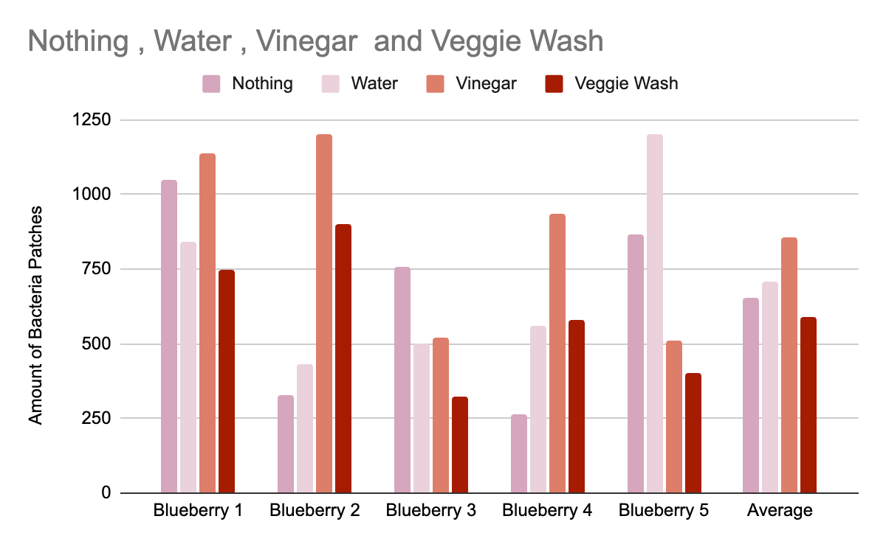

24 hours:
We had 5 petri dishes per type of cleaner. This shows that so far veggie wash is the cleanest. With an average of 591 bacteria colonies. In second place is nothing with an average of 653. In third place is water with an average of 706 bacteria colonies. Lastly is vinegar with a whooping average of 857 bacteria colonies.

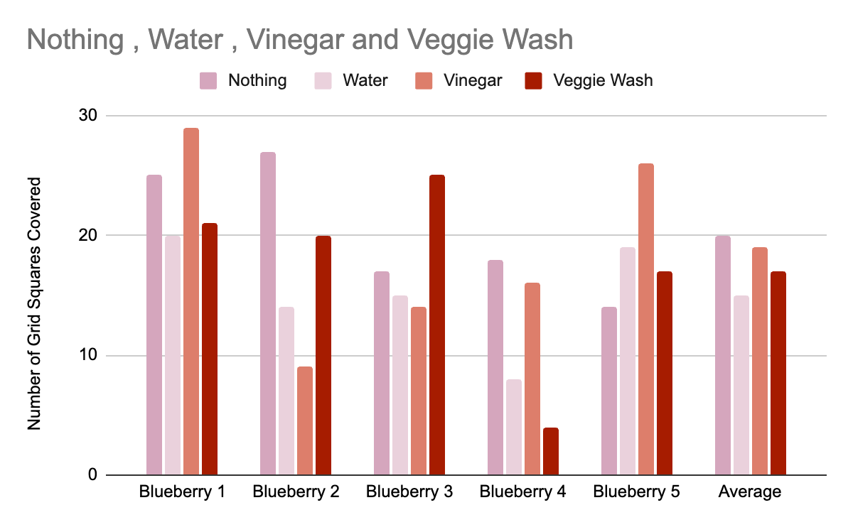

48 hours:
We still have 5 petri dishes for this cleaner. The best cleaning one is water with an average of 15 squares covered in bacteria per petri dish. In second place Veggie wash with and had an average of 17 squares covered per petri dish. In third place there was vinegar which had an average of 19 squares covered in bacteria. Lastly there is nothing with an average amount of squares covered in bacteria being 20.

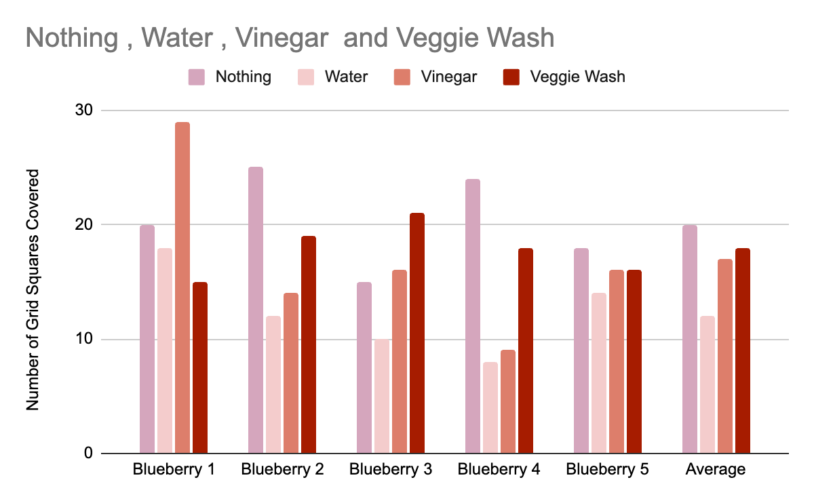

72 hours:
We had five petri dishes per type of cleaner. The best fruit cleaner was water with an average of an average of 12 grid squares covered. The next best cleaner is vinegar with an average of 17 grid squares filled with bacteria. Veggie Wash was the next best with an average of 18 grid squares covered with bacteria. Lastly control was the worst at fruit cleaning with an average of 20 squares covered with bacteria.

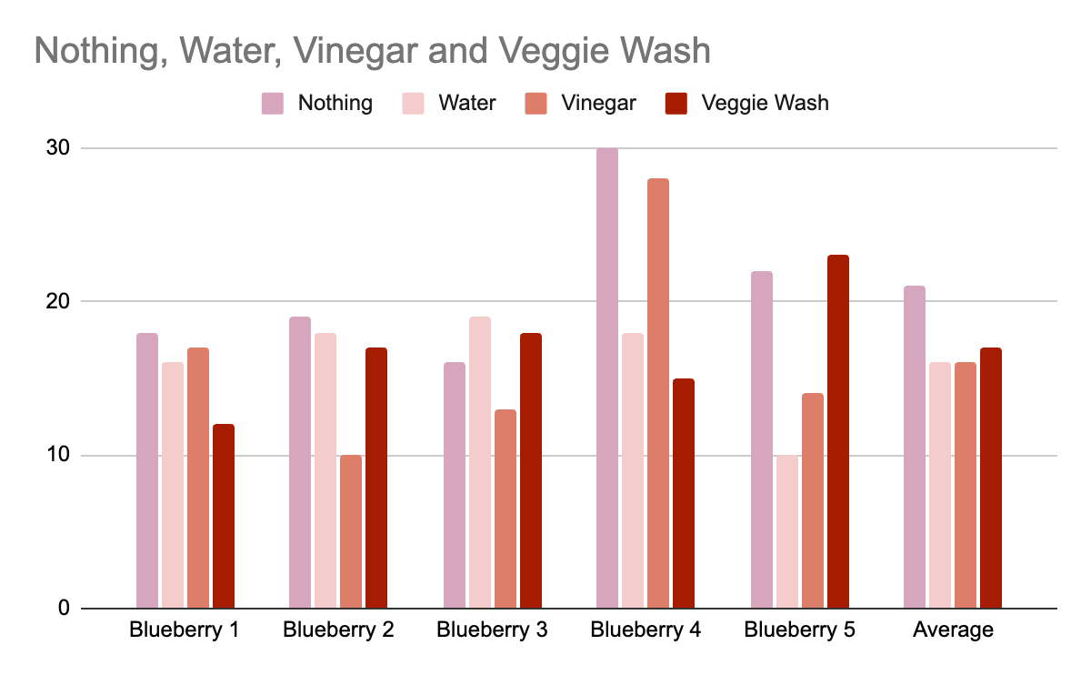

120 hours:
We had five petri dishes per type of cleaner. The best type of cleaner was water with an average of 16 bacteria colonies. The second best type of cleaner was vinegar with an average of 16. Now both had 16 but water had lower numbers then vinegar. In third was Veggie Wash with an average of 17 bacteria grid squares covered. In last place is control with an average of 21 bacteria grid squares covered.

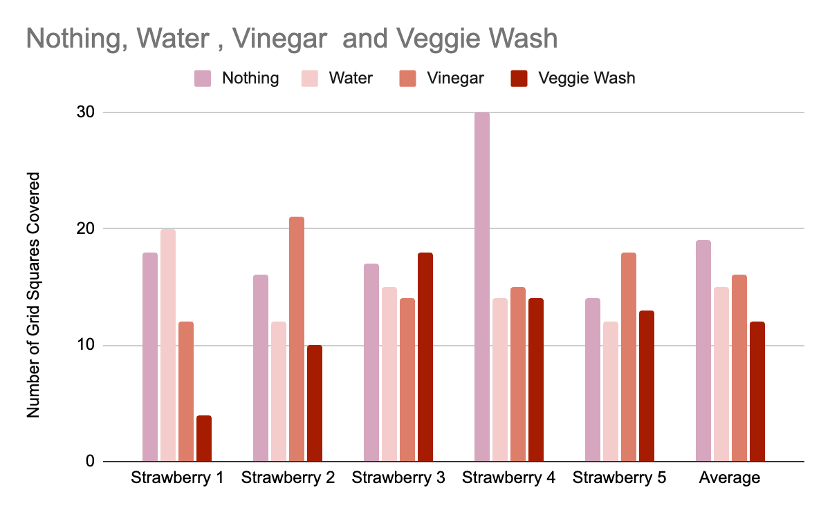

24 hours (strawberries):
We used five petri dishes per type of cleaner. The cleanest was Veggie Wash with an average of 12 grid squares covered. The second cleanest is water with an average of 15 grid squares covered with bacteria. The next one is vinegar with an average of 16 grid squares filled with bacteria. Lastly there is control or nothing with an average of 19 grid squares covered with bacteria.

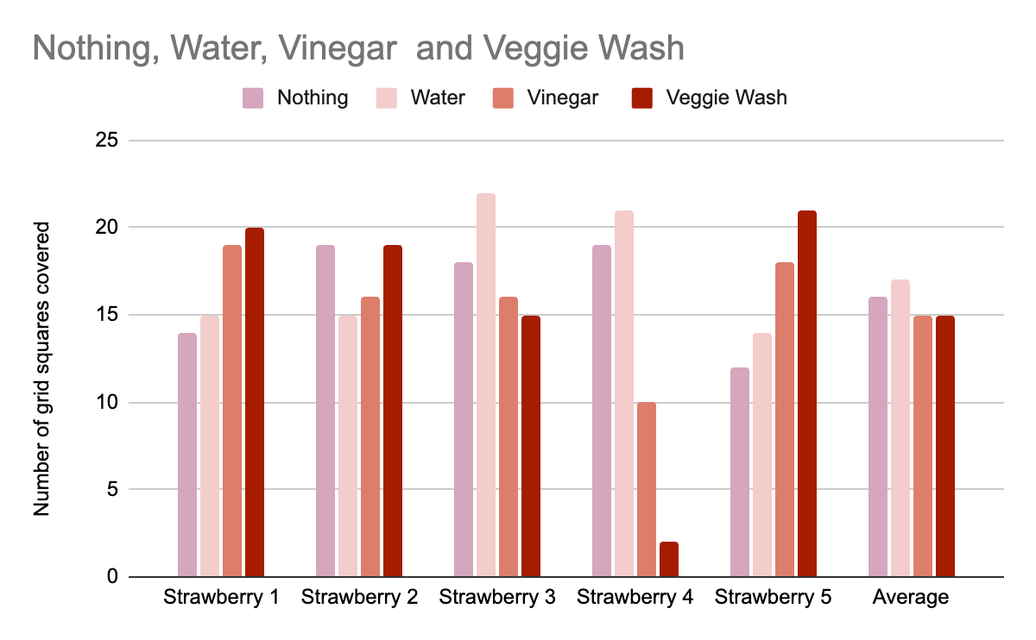

48 hours (Strawberries):
We had five petri dishes per type of cleaner. The best one was Veggie wash with an average of 15 bacteria colonies now this does tie with Vinegar it overall had lower numbers. Next is Vinegar with an average of 16 grid squares being covered with bacteria. In third is control with an average of 16 grid squares being filled with bacteria. Lastly is water with an average of 17 grid squares covered with bacteria.

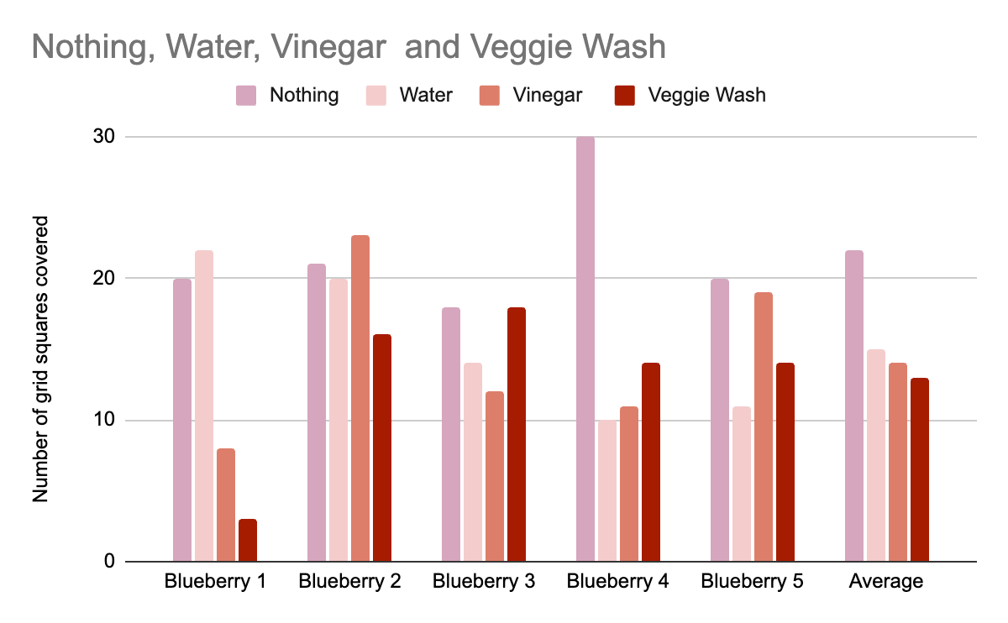72 hours:
We had five petri dishes per type of cleaner. The results were… The best cleaning solution was Veggie Wash with an average of 13 grid squares covered with bacteria. Next is Vinegar with an average of 14 grid squares filled with bacteria. In third is water with an average of 15 grid squares covered in bacteria. Lastly is Control with an average of 22 grid squares covered with bacteria.

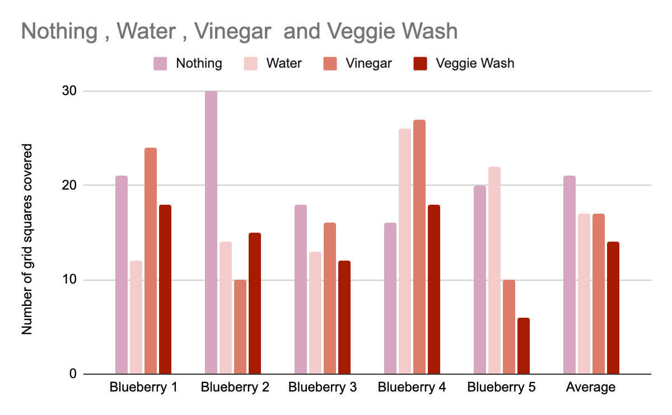

120 hours (strawberries):
We had five petri dishes per type of cleaner. The best cleaner was Veggie Wash with an average of 14 grid squares per petri dish that are covered with bacteria. Next was Vinegar now it is tied with water but because the numbers are overall lower the average for this type of cleaner has an average of 17 grid squares filled with bacteria. Next is Water with an average of also 17 grid squares covered with bacteria. Lastly is control with an average of 21 grid squares covered with bacteria.

Analysis:

24 hours:
Veggie Wash grew the least bacteria in both rounds of the experiment. In both sets the amount of bacteria sayed consistent and overall was the best at 24 hours. The next best one at cleaning fruit is Water, water was the best in the blueberries experiment but in the strawberries one it was close to control so it was the next best. In the strawberries experiment they were very consistent but in the blueberries one there is one large spike on blueberry 5. The next best type of cleaner is Control now in the strawberries experiment Control was not the greatest but in the strawberries experiment while in the blueberries experiment there is a large margin. The worst type was Vinegar. Now in the strawberries experiment it was better than the Control but in the blueberries experiment it was better By a small margin.

48 hours:
At 48 hours Veggie Wash grew the least bacteria in the strawberry round of the experiment, while water performed the best in the blueberry round. Both of their final averages were 16. They worked equally as well. The Veggie Wash’s average in the blueberries was 17 and in the strawberries it was 15. The water’s results were viceversa it had an average of 15 in the blueberries and an average of 15 in the strawberries. The next best one at cleaning fruit is vinegar, vinegar’s bacteria growth pattern was quite unpredictable. However it came close to nothing, since its total average was 17 and nothing was 18. The worst type was nothing. In both rounds of blueberry and strawberry the bacteria amounts weren’t very consistent. Since it would spike in bacteria and suddenly drop then maintain the amount.

72 hours:
At 72 hours the best type of cleaner was Water with an average 14 grid squares covered with bacteria. In the blueberries round water was very consistent with the amount of bacteria results. While in the strawberries round there were some spikes that caused the data to be higher or lower. The next best was Veggie Wash with an average of 15 grid squares covered with bacteria. Overall Veggie Wash was very consistent with the amount of bacteria, until there is one very low amount of bacteria. The third best type of cleaner was Vinegar with an average of 16 grid squares covered with bacteria. It was quite consistent with the amounts of bacteria. Lastly is control with on average 21 grid squares covered with bacteria. Overall it was consistent.

120 hours:
At 120 hours Veggie Wash performed the best. The bacteria levels had no spikes and were consistent. The bacteria levels weren’t too high. The water did the second best, and had a relatively stable and consistent amount of bacteria. The amounts of bacteria for the most part had little to no spikes . The vinegar did the third best. The bacteria had some spikes but also remained consistent in some parts. The worst fruit cleaning solution is nothing/no wash. It was consistent with the bacteria amounts and had quite high bacteria levels. There are rarely any spikes.

Conclusion:
In this experiment we wanted to know what was the best type of fruit/vegetable cleaner. We tested to see if the more cleaning properties that are in Veggie Wash and Vinegar will do better. We predicted that the fruit cleaner with the most cleaning properties would be the best because it had the most properties that would kill bacteria. Overall the experiment showed that Veggie Wash is the best type of fruit cleaner and it reduced the amount of bacteria with a large margin. Our hypothesis was therefore correct since Veggie Wash performed the best. This is because it has the largest amount of cleaning properties.

Acknowledgments
We would like to thank multiple people for the success of this project and making this possible. Starting with the Guan and Gunaratnam families, thank you for providing us with the resources for this project and thank you for your support. Next we would like to thank Cinthia Doe who majors in science at the University of Calgary. Thank you for your recommendations and constructive criticism. Moving on to Mrs Lai, Ms Mah, and Ms.Willemsen. We would like to thank you for making this possible and providing support and time for us to work on this experiment. Last but not least we give our thanks to Westmount and our friends for showing us continuous support. Thank you.

Application
Our project will affect Earth by hopefully limiting the consumption of bacteria. Surprisingly only 73% of the world population regularly washes their fruits and vegetables. In this experiment we are trying to find out how much bacteria is actually on your fruits before and after you wash it. As well as what solution or method of fruit cleaning works best. To us this has truly come as a shock for the amount of bacteria each piece of fruit holds even after washing. We hope this will teach others how to properly prepare and wash fruits so we can consume as little bacteria as possible.

Citations
-Veggie Wash Veggie Wash® ORGANIC Fruit and Vegetable Wash - Veggie Wash (veggie-wash.com)
-Healthline White Vinegar: Ingredients, Uses and Benefits (healthline.com)
-Food.com
https://www.toppr.com/ask/question/which-property-of-water-is-used-while-washing-clothes-3/
https://www.nsf.org/blog/consumer/reliable-scientific-tips-cleaning-with-vinegar
https://www.veggie-wash.com/#:~:text=Veggie%20Wash%20is%20specially%20formulated,handling%20residue%20quickly%20and%20easily.
-Food Network
-NSF.org
-Health.com

Experiment Photos
