February 11th, 2021

Science Fair Ideas:

Ideas: | Research: | Result:
Eye Scanner |  | I don’t have the right resources
Comparing solar cars vs. electrical cars and which battery is more sustainable for the environment | https://educbeca-my.sharepoint.com/:p:/r/personal/mahrosha1_educbe_ca/_layouts/15/Doc.aspx?sourcedoc=%7B975DDC8E-D905-4149-9CBB-A727630475DD%7D&file=CYSF%20Research.pptx&action=edit&mobileredirect=true | Kits are very expensive to get ($60-$80)
Measuring UV radiation in the city where I live and what are the peak times of UV radiation | https://educbeca-my.sharepoint.com/:p:/r/personal/mahrosha1_educbe_ca/_layouts/15/Doc.aspx?sourcedoc=%7B9B1ACBBB-951F-4E17-8A23-6F70BADB473C%7D&file=Raspberry%20Pi.pptx&wdOrigin=OFFICECOM-WEB.MAIN.MRU&ct=1615313708799&action=edit&mobileredirect=true  https://educbeca-my.sharepoint.com/:w:/r/personal/mahrosha1_educbe_ca/_layouts/15/Doc.aspx?sourcedoc=%7BF0AF8A5E-405B-4C28-AB1C-F4CC1ED3BF24%7D&file=Science%20Fair.docx&wdOrigin=OFFICECOM-WEB.MAIN.MRU&ct=1615313794737&action=default&mobileredirect=true | Its winter so I won’t be able to get good UV readings
Seeing which commercial humidifiers are the best |  | Don’t have enough humidifiers
Growing plants indoors using sensors |  | It will take too long to grow plants and I don’t have enough plants

Plant Idea:

At this point in time, the plant idea seems the best.

What can be done: | Issues:
- Instead of buying plants/seeds from the store, I can use materials found at home (spring onions, beans, chillies, etc.)  - If it takes too long to grow, I can use plants which grow within a week (do research to see which plant seeds grow rapidly)  - With using beans, chillies, etc. - I can have as many samples as needed | - I need 5 to 7 of the same plants (too expensive)  - It will take too long to grow the plants further or start from a seed and grow the plant  - If one of the samples becomes ruined, I will not be able to get another one

After doing some research, I realized that mung beans are the fastest to grow (3-5 days)

Basic Project Information:

Testable Question: What is the effect of temperature and humidity on plant growth?

Idea: My idea is to take several bags of various fast-growing plant seeds and place them in areas with several different humidity and temperature levels. I will then be analyzing the plant seeds every 24 hours in each location to see whether or not which plant seeds grow faster/slower. Then I will conclude whether or not the temperature and humidity has affected the growth of the plant seeds.
I will also be using the raspberry pi as well as a DHT22 sensor to be able to determine the different temperature and humidity levels for ach location.

Application: I bought a money plant a few weeks ago. I put it in a moderate amount of sunlight. The next day I noticed its leaves began to yellow slightly. I then changed its location – but even then, it yellowed even more. I concluded that it is a very sensitive plant.

Hypothesis: My hypothesis is that the lack of optimal temperature and humidity will make the plants grow very slow and will disrupt its growing pattern. - Expand more on hypothesis

Material List:
✔ Raspberry Pi
✔ Power Sources
✔ Bean plants
✔ 3 Ziplock Bags
✔ 3 paper towels
✔ Water

Procedure:
1. Get 3 mung beans and place it in a dry container
2. Next, get a paper towel and hold it under the tap until it is damp.
3. The place paper towel on a hard surface
4. Then take your 3 beans from the container, and place them on the damp paper towel – make sure they are evenly spaced
5. Next, fold the paper towel in half – left to right
6. Then fold the half – top to bottom
7. Then place your perfect damp, square paper towel inside a dry Ziplock bag
8. Seal the Ziplock tightly shut.
9. Measure humidity and temperature of area where you want to place Ziplock bag(s) in
10. Put data in a chart.
11. Put Ziplock bag in area for 24 hours
12. The next day, observe
13. Repeat this 9 times.

How to record data:
1. Place Ziplock bag in area with low temperature and low humidity
2. Place it in area with optimal temperature but low humidity
3. Place it in area with optimal humidity but low temperature
4. Place it in area with optimal temperature and optimal humidity
5. Place it in area with extreme temperature and low humidity
6. Place it in area with extreme humidity and low temperature
7. Place it in area with extreme temperature and optimal humidity
8. Place it in area with extreme humidity and optimal temperature
9. Place it in area with extreme humidity and extreme temperature

Variables:
Independent Variable: Environments – I can manipulate my environments.
Dependent Variable: Growth of beans
Controlled Variable: Amount of beans, amount of water, amount of sunlight

In labs, from what I have seen, scientists/researchers usually do a very rough preliminary experiment before an actual experiment to make sure it works. I should do the exact same.

Preliminary Background Testing:

- I took a damp paper towel and wrapped the paper towel around the beans. Then I placed it in a Ziploc bag. I did this 3 times.
o First sample was placed in extreme humidity and temperature (kitchen)
o Second sample was placed in optimal humidity and optimal temperature (our room)
o Third sample was placed in low humidity and low temperature (storage room)

Results:
1. First sample ~ sprouted within a day and a half
2. Second sample ~ sprouted in 3 days
3. Third sample ~ sprouted in 2 days

This means that this project is doable and that I will hopefully receive good results.

Tasks for this week: | When will I complete them:
- Create a python script to organize data from sensors automatically | Feb 15
- Create a python script so that when the raspberry pi is plugged in a power source - it will automatically take data from its surroundings and put them in a text file automatically | Feb 18
- Figure out a way to stop the new data overriding the old data | Feb 15
- Keep observing preliminary testing | Feb 22
Legend

Task is very easy
Task is somewhat difficult

Task is very hard

February 18th, 2021

Progress report for past week:

- I finished working on a python script so that the data I received from the sensors would be automatically put into a text file. (Completed task 1)
- After trial and error and reading a lot of articles, I fixed the overriding issue. Now, when I run the program, stop it, and then run it again, I still have the previous data saved. (Completed task 3)
- There was also a sensor issue. My sensor (DHT22) wasn’t working properly. It wouldn’t gather data. So, I had to switch the sensors from a DHT22 to a DHT11. This fixed my issue.
- For task 2, it is incredibly difficult. I have read several articles and tried various methods to make an automatic python script to collect data from the sensors and automatically put it in a text file but none of the methods I have tried have worked. I have made some progress though. I managed to create a python script which - whenever the script runs and the sensors turn on - it automatically creates a text file to write its data in. Now I have to just figure out how to turn on sensors automatically when the raspberry pi is powered.

2/20/2021

Source of error!

I was going to take pictures of the preliminary testing today but when I looked at the bags, I saw the paper towel was green and brown on all 3 samples. Then when I opened each sample bag, there was an unpleasant smell. I was wondering why this occurred. This could be because of the damp paper towel I had in there and the bag was also sealed, meaning the moisture was trapped! This is my guess for the bad smell. To prove this – I even saw water droplets on the inside of the bag.
I just realized a huge error in the experiment itself! If all that moisture is trapped, then the fact that I change the humidity in the room won’t affect the plants because it's constant because the bag is sealed! My experiment will be pointless if the humidity is constant.

2/21/2021

Task 2:

Goal: When the raspberry pi is plugged in, I want it to automatically turn on its sensors to collect data (temperature and humidity) from its surroundings and automatically put it in a text file.

Progress: I managed to create a script so that when I power the raspberry pi, it automatically, without me having to do anything, puts the data into a text file.

I have also found an article talking about scheduling the Raspberry Pi to turn on its sensors and run them automatically at a specific time when it's powered. I tried to create a script to do that at 7:40am but it didn’t work. After doing more research, I figured out I need to change the time zones. It worked but then it only printed one line. After reading specific articles and using and then understanding the code - I figured out how to run the script when it's plugged in to the power source. Only issue is that I would only get one line of data which wasn’t sufficient. Finally, I have gotten the script to run multiple times!
I can try improving the script though:
- My sensors turn on automatically, collect data and put it in a text file automatically
- Now when I want to see that text file to see the results, I have to plug the raspberry pi into my monitor to turn it on and view my results. This isn’t a problem, but maybe I can make the process much easier.
- I have a USB. Maybe if I plugged it in one port, the sensors would put their data in a text file on the USB instead of putting the data on a text file on the raspberry pi. Then when I plug it into the computer, I can see data without having to plug it into the monitor. I will try this. To do this is very simple. All I need to do is change the file path where the sensors input their data to inputting their data in a text file on the USB.

*20 minutes later*

I checked the text file on the USB and it was empty. I think I know why:
- The data on the text file probably didn’t save
- After thinking about this, I realized that the sensor cannot transport data over to an external source. It would need special code and software for it to do
so I believe.

I will just have to revert to the original plan with the script running automatically but I have to plug in a monitor to see the data.

February 22, 2021

I decided to change my whole procedure up based on my results for the preliminary testing.

New Procedure:
1. Take a paper towel and spray a controlled amount of water on it.
2. Then, place mung bean seed inside paper towel
3. Next, take an egg carton and take 3 cups from it.
4. Place damp paper towel with seed in each egg carton cup
5. Take the temperature and humidity of the area and match it to your needs.
6. Then place 3 egg cartons in that one area.
7. Take pictures and write data.
8. Then after 24 hours, analyze the cup and take pictures. Also take temp and hum. of area and make sure it remains consistent.
9. Also then take the same controlled amount of water and water 2 cups but leave the third cup and don’t water it.
10. Repeat 5 times.

Doing this experiment in an egg carton is better because it allows for the temperature and humidity to affect the growth of the plant unlike in the preliminary experiment.

Extension: 2 of the samples in the group will be watered the same amount of water every 24 hours. One of the samples will only be watered once and it will never be watered again. This could show (if it grows) that mung beans are very tough and can still grow without water.

Maybe replace the damp paper towel w/ soil – but then the soil will cover up the seed and it will be hard for me to check the progress of the seed.

Now let’s analyze judging – What if the judges ask me why didn’t you use other thermometers and humidifier sensors? Why did I choose raspberry pi?

Research Topic: | Research: | Resources:
Hygrometers | - -measures humidity in a given volume using indirect methods  - -different types of hygrometers  - -oldest version uses human hair or animal hair to determine relative humidity  2nd resource  - There are many health risks associated with too much or too little humidity in your home, such as bacteria and mold growing. This can be dangerous to humans. Having a hygrometer tells you humidity of your house  - prevents furniture and other expensive property damage as well as plants and animals | https://www.differencebetween.com/difference-between-hydrometer-and-vs-hygrometer/  https://buythermopro.com/knowledge/8-benefits-of-owning-hygrometers/
dht11 | - -Sensor is low cost  - -Isn’t very fast  - -ideal to use in areas where you don’t need rapid data or there aren’t any fast changes in temperature and humidity  - -Humidity is 20-80% (5% accuracy)  - -Temperature is 0-50% (+2degrees celcius accuracy)  - -Timing is an issue in this one. If you try to obtain data faster than 2 seconds – your timing will get messed up  - -specific library for this one making its setup much much easier  2nd resource  - -senses, measure, and regularly reports relative humidity and moisture in the air  - -very cheap  - -require power supply ~ 3 to 5 volts  - -Humidity is 20-80% (5% accuracy)  - -Temperature is 0-50% (+2degrees celcius accuracy)  3rd resource  - -Digital temperature and humidity sensor  - -used for lots of things ~ anything that is relevant to temperature and humidity control  - -long term stability  - -low cost  - -*long distance signal transmission*  - -responds very fast, very good quality, it prevents anyone from interfering with it  - -avoid placing sensor in area with a lot of smoke or -acidic/oxidizing gases/long term exposure to chemical pollution  - -should be placed in areas with 10-40 degrees celsius  - -humidity: 60% RH or less  - -avoid dry conditions  - -avoid really wet conditions  - -avoid long term exposure to sunlight or UV radiation | https://www.raspberrypi-spy.co.uk/2017/09/dht11-temperature-and-humidity-sensor-raspberry-pi/  https://techzeero.com/sensors-modules/dht11-temperature-humidity-sensor/  https://techzeero.com/wp-content/uploads/2018/07/dht11-datasheet.pdf

Conclusion for research:

So I came to the conclusion that the raspberry pi sensors are more accurate, they measure both temperature/humidity, and they can measure humidity/temperature for long periods of time as well as then insert it into text files so that you can read it after.
To prove the fact that raspberry pi sensors are more accurate compared to other standard devices used for temperature/humidity, I ran a quick test.

I got a hold of a honeywell mist humidifier. On that box it read ‘auto-shutoff’. I thought it meant that when the room reaches optimal humidity, the humidifier shuts off. After doing research, I figured out that auto-shutoff means that the humidifier turns off automatically when the humidifier runs out of water.

Preliminary Humidifier Testing:
I filled the honeywell humidifier with water to the top.
· I checked a standard humidifier clock that I had with me which read 42% humidity.
· After that, I ran the humidifier for 15-20 minutes. After, I checked the little clock and it still said 42%. My raspberry pi said 50%.

This proves that most standard humidifier devices don’t work/aren’t accurate. The raspberry pi sensors are better compared to them.

February 23rd, 2021

Tasks: | How to accomplish them: | Amount of time:
Run raspberry Pi + rethink each aspect for the experiment | Run the raspberry pi in:  - Optimal temperature. + optimal humidity  - Low temperature + extreme humidity | 2 hours (required for accurate data)
Have a materials list | Think about and write down what materials you will require to conduct the experiment | 10-15 minutes
Have a procedure | Based on the procedure you wrote a few days ago, form the same one, but make sure it is correct and accurate | 5-10 minutes
Conduct experiment | Based on the data I collect, the material list and the procedure I form - conducting the experiment will be easy. I only have 2 locations available right now so I can only do 2 tests today. | 30 minutes - 1 hour  (it will take time because I will have to obtain materials, conduct experiments, take pictures, set up areas, etc.)

Source of error: I realized a source of error that I have is light. In each area, the light is not controlled. I can attempt to make a shield against the light out of cardboard.

New testing method:
- Place cartons in cardboard boxes instead, and place them in deep corners of the area you intended to grow them in. This will help block out natural light, as well as artificial light since that also can affect the growth of plants.

Questions:
Some articles say to fold paper towels on seeds so that it gets enough moisture, but what if I have the paper towel moisture plus room moisture. Isn’t that a lot? Maybe a lot of moisture will make plant grow even faster

Now to the experiments: Will I turn on humidifier/heater during tests or before tests?

Place it in a humid environment and then run the humidifier/heater to maintain that environment during the test.

Equipment for experiment:

Also there are the egg cartons themselves.

3 cups = 1 group
1 cup = 1 seed

In 2 cups if I put water regularly and in one cup I put it only once – is the data I collect from this even useful? I think it is because this could show that mung beans (if they sprout) are not sensitive plants. They are able to withstand harsh environments and face drought.

Raspberry PI Data:

Materials List:

· Spray bottle
· Syringe
· 6 egg carton cups
· 6 mung bean seeds
· 2 folded up paper towels
· Scissor
· Tape

Procedure:
1. Take a paper towel and spray 1ml of water on it
2. Then, place mung bean seed inside paper towel
3. Next, take an egg carton cup and place a damp paper towel with a seed in the cup
4. Place the egg carton cup in a box.
5. Take the box to the required area and put it in a corner
6. Repeat this 5 more times
7. For each area, you will have 3 samples. Based on this - water sample number 1,2, and 3 with 1ml
8. Exactly 24 hours later, water sample #2 and #3, but don’t water sample #1

Pictures from experiment:

So my experiment has been successfully conducted.
- I placed 3 carton cups in an optimal temperature and optimal humidity environment - 8:00pm
- I also placed another 3 carton cups in an extreme humidity and low temperature environment - 5:00pm
- I made sure to give all the sample of both locations an initial watering of 1ml

Pictures from procedure:
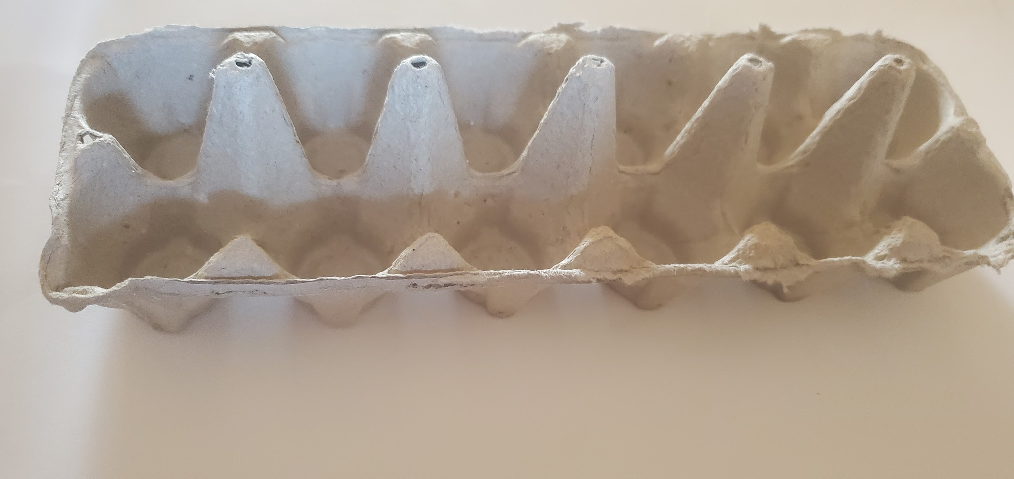
- Egg carton
- I separated 3 cups from the egg carton
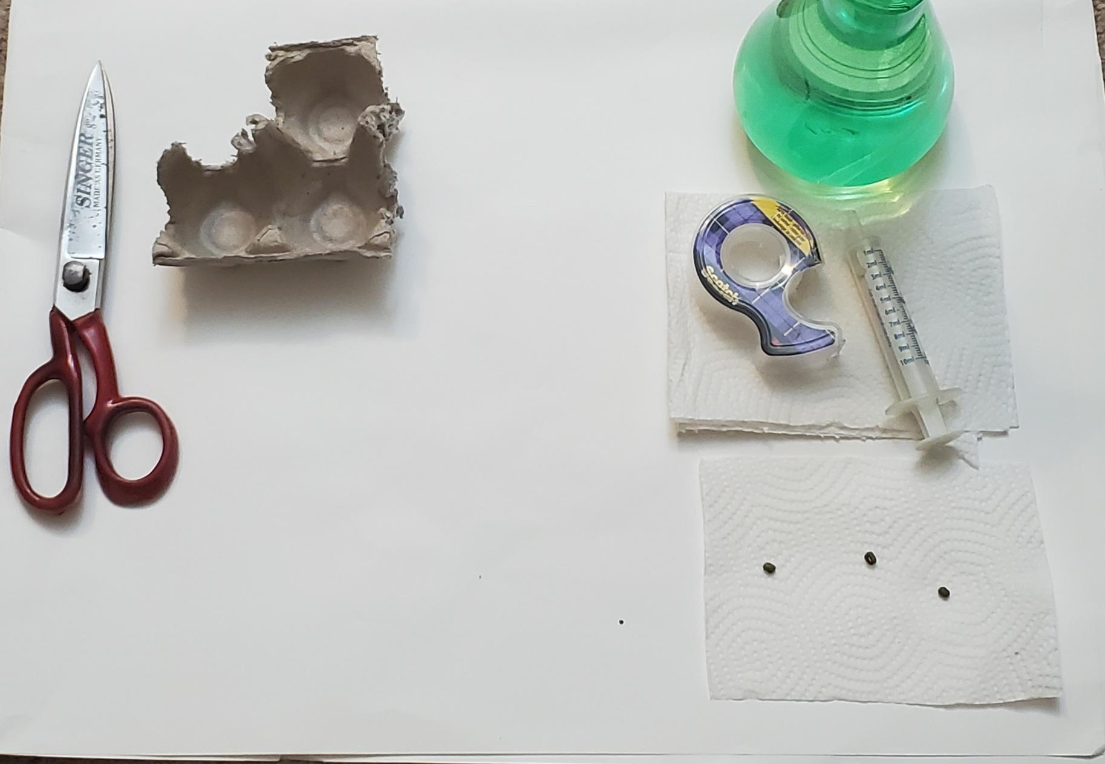
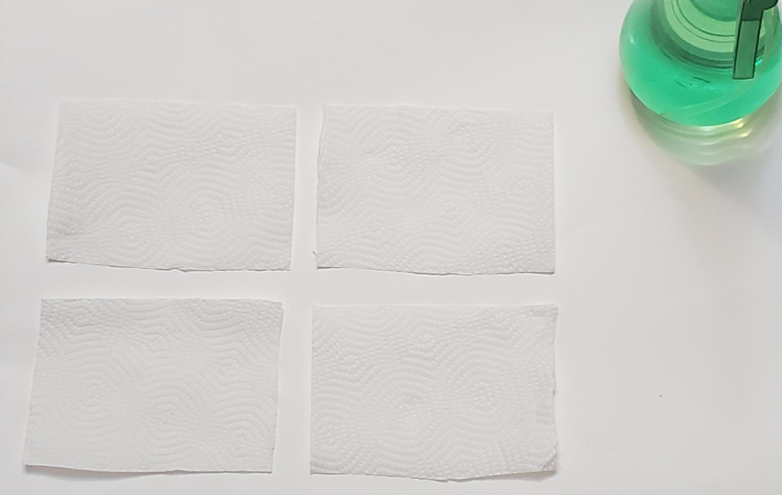
- 1ml of water
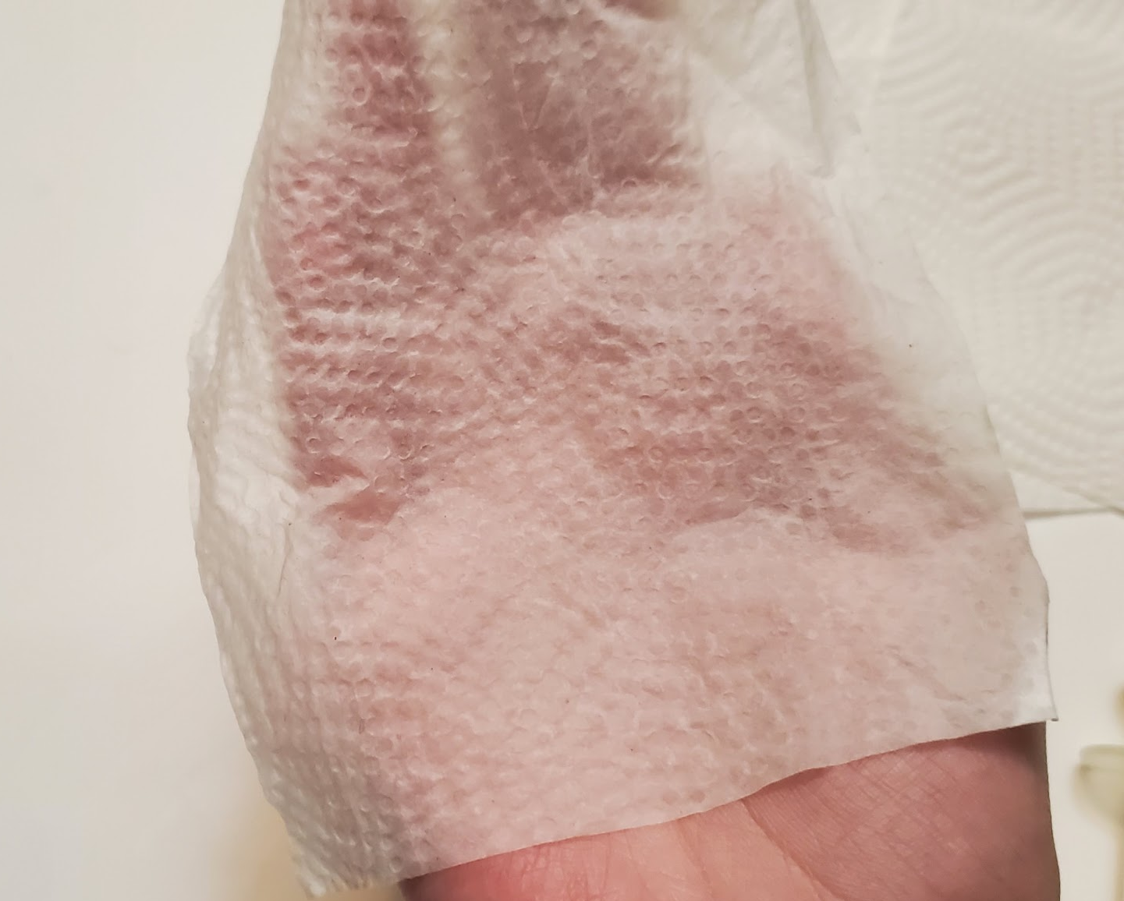
11)
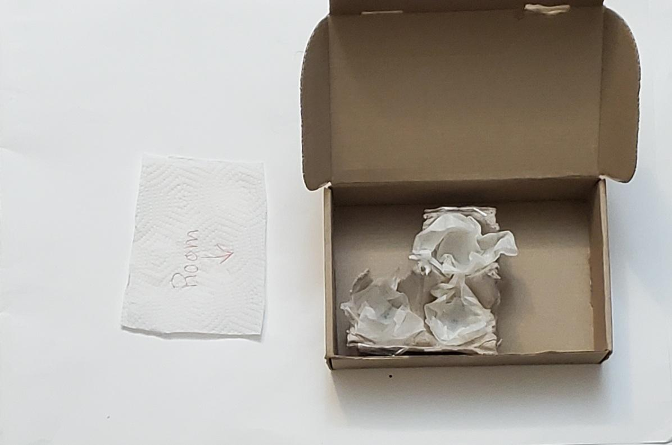
12)
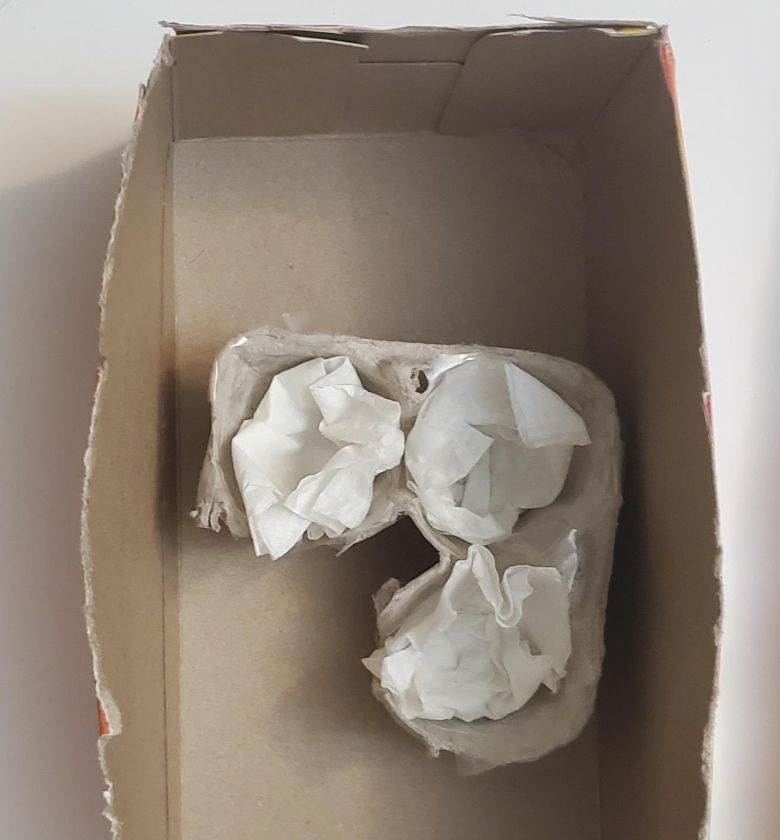
12)

​Observations:
​
Please refer to the observations section in the portal.
​

References:
https://www.ncbi.nlm.nih.gov/pmc/articles/PMC5876200/
https://www.apieceofrainbow.com/super-fast-way-start-seeds/
https://www.codementor.io/@gergelykovcs/how-to-run-and-schedule-python-scripts-on-raspberry-pi-n2clhe3kp
https://www.itechfy.com/tech/auto-run-python-program-on-raspberry-pi-startup/
https://www.realvnc.com/en/raspberrypi/
https://www.botany.one/2019/03/microplastics-could-pose-a-threat-to-plants/
https://www.youtube.com/watch?v=dirz0WIMQi0
https://www.gardenershq.com/Growing-Mung-Beans.php
https://www.siagroup.com/articles-1/lima-bean-in-a-bag#:~:text=Place%20the%20wrapped%20bean%20in,a%20spray%20bottle%20of%20water.
https://www.raspberrypi.org/forums/viewtopic.php?t=63040
https://geek-university.com/raspberry-pi/list-running-processes/
https://www.raspberrypi-spy.co.uk/2015/02/how-to-autorun-a-python-script-on-raspberry-pi-boot/
https://www.raspberrypi.org/forums/viewtopic.php?t=70809
https://www.youtube.com/watch?v=SY4QeRCICVU
https://raspi.tv/2012/how-to-safely-shutdown-or-reboot-your-raspberry-pi
https://pimylifeup.com/cron-jobs-and-crontab/
https://www.daff.gov.za/docs/Brochures/MbeanpGUDELINS.pdf
https://traditionalcookingschool.com/food-preparation/sprouting/sprouting-beans-lentils-mung-beans-and-garbanzo-beans-chickpeas/#:~:text=from%201%20vote-,How%20To%20Sprout%20Beans%3A%20Lentils%2C%20Mung%20Beans%2C%20%26%20Garbanzo,helps%20to%20pre%2Ddigest%20them.
https://stackoverflow.com/questions/51568203/how-to-save-sensor-data-output-into-excel-using-python
https://www.instructables.com/Raspberry-Pi-Launch-Python-script-on-startup/
https://www.hunker.com/13426516/factors-for-the-germination-of-mung-beans-to-grow
https://www.youtube.com/watch?v=mJ6FMllKf18
https://support.microsoft.com/en-us/office/filter-data-in-a-range-or-table-01832226-31b5-4568-8806-38c37dcc180e
https://www.publish.csiro.au/CP/CP11218
https://homeguides.sfgate.com/conditions-mung-bean-growth-28008.html
https://www.gardenguides.com/98365-life-cycle-mung-bean.html
https://www.gardeningknowhow.com/edible/vegetables/beans/how-to-grow-mung-beans.htm
https://www.raspberrypi.org/documentation/remote-access/access-over-Internet/README.md
https://www.circuitbasics.com/how-to-set-up-the-dht11-humidity-sensor-on-the-raspberry-pi/
https://www.raspberrypi.org/forums/viewtopic.php?t=51022
https://github.com/adafruit/Adafruit_Python_DHT
https://www.raspberrypi.org/forums/viewtopic.php?t=47061
https://raspberrypi.stackexchange.com/questions/82041/cron-jobs-not-running-when-specific-time-specified
https://learn.sparkfun.com/tutorials/raspberry-pi-safe-reboot-and-shutdown-button/all#:~:text=We%20can%20reboot%20the%20Pi,reboot%20(%20%2Dr%20)%20command.
https://stackoverflow.com/questions/34857100/crontab-in-raspberry-pi-doesnt-run-a-very-simple-script/45540857
https://www.raspberrypi.org/documentation/linux/usage/cron.md
https://www.raspberrypi.org/forums/viewtopic.php?t=43599
https://www.raspberrypi.org/forums/viewtopic.php?t=179996

