Climate Crisis Log Book
Nicholas Chauvin

December 19th tuesday 2023
https://climate.nasa.gov/faq/19/what-is-the-greenhouse-effect/#:~:text=Imagine%20thesis%20 gases%20as%20a,%2C%20 chlorofluorocarbons%2C%20and%20water%20 vapor
Through this website, I learned that greenhouse gases are like a blanket made of water vapour. This blanket traps everything in, to get a warmer temperature for the earth over time. In the last 100 years, humans have burned fossil fuels which has caused too many greenhouse gases. Also, the scientists working on out of carbon dioxide, methane, ozone, nitrous oxide, chlorofluorocarbons, greenhouse gases observed that if we took the carbon dioxide layer down, which makes up 79.4% of the blanket, the whole greenhouse effect would collapse, causing the earth to drop temperatures by approximately 33 degrees celsius.( 59 degrees fahrenheit.)

December 19th tuesday 2023
https://www.epa.gov/ghgemissions/overview-greenhouse-gases
In the United states environmental protection agency, they talk about how burning different fossil fuels, we are emitting CO2. Some of these fossil fuels are coal, natural gas, and oil. Quite a lot of these CO2 emissions are absorbed by plants and other organisms before they make it to the blanket of greenhouse gases. They also talked about the other gases such as methane, nitrous oxide, and fluorinated gases. Methane is emitted by the production AND transport of coal, oil, and natural gas. The methane emissions are also coming from livestock, other cultural practices, land use, and the decay of organic waste in municipal solid waste landfills. The nitrous oxide emissions are coming from agricultural practices and land use just like methane, but these also are coming from industrial activities, combustion of fossil fuels, solid waste, and the treatment of wastewater. Fluorinated gases are gases such as hydrofluorocarbons, perfluorocarbons, sulphur hexafluoride, and nitrogen trifluoride. All of these gases are synthetic and powerful greenhouse gases. These gasses are emitted from quite a lot of household, commercial, and industrial applications and processes.

December 20th wednesday 2023

https://www.eia.gov/energyexplained/energy-and-the-environment/greenhouse-gases.php
Through the link above, I learned that global warming is also happening because of infrared radiation bouncing back up but then getting stuck, causing the heat to release back into the atmosphere making it hotter. Most of the radiation is absorbed by the earth though.

December 20th wednesday 2023
https://www.nps.gov/pore/learn/nature/climatechange_action_home.htm

This website is all about what we can do to stop greenhouse gas emissions. Here are some of the things you and most people can do to stop emissions.
-Use renewable energy
Surprisingly, in the United states more than half of the electricity is coming from coal polluting power plants. Start using solar, wind, geothermal, and hydro electricity.
-Buy solar panels
Solar panels are not that expensive and are a great source of energy. However, the solar panels need a way to store their electricity or else no lights or anything electricity powered will shut down.
-install solar lights
Looking outside, solar lights are like a small skylight. Nevertheless, they magnify natural and clean sunlight into your house without using any power.
-Adjust your thermostat
Turning your thermostat up 3 fahrenheit in the summer and doing the opposite in the summer. This will lower your electricity bill, and reduce CO2 emissions by 1050 pounds per year.

If you go to the link, there are a lot more I didn’t mention, so you can check those out if you like.

December 21 thursday 2023
https://www.wri.org/insights/6-ways-remove-carbon-pollution-sky
They are talking about ways to take carbon out of the blanket of gases by a few different ways. The first way is carbon dioxide removal. This includes growing trees as well as technology that centres around direct air capture which is, scrubbing CO2 and burying it. There is also a way called carbon capture and storage, which takes it from its original source and captures it before it can go into the atmosphere.

Impacts of a 4°C global warming: 1. A 4°C world (greenfacts.org)

This website showed me lots of consequences for the if the earth warmed 4 degrees celsius warming such as:
-Inundation of coastal cities
-more risk for malnutrition because the wetter regions get wetter and the dry regions get dryer
-Random heat waves
-water scarcity
-loss of biodiversity

January 20th friday 2024
Views: What 3°C Of Global Warming Will Look Like | Boomers Daily (boomers-daily.com)

I watched a video from this website and it told me a lot. But, there are two parts I'm focusing on. The first is that even though global warming is making the world hotter, in lots of places like Fiji, the water abundance will take masses of land. However water walls and other contraptions like that can stop it, but it may also stop some flows of rivers which is another problem. The second part I am focusing on is wet bulb temperatures. A wet bulb temperature is basically a temperature that humans can't possibly survive in because the human body has a heat limit, which is somewhere around 35 degrees. Some Places on the eastern side of the world already have reported deadly temperatures.

Jan 25, 2024 thursday
Countries most affected by Climate Change - Iberdrola

As you can see in the name of the link, this website showed me which countries will be most affected by climate change, which will be valuable info for the models I’m making for my trifold. These countries conclude of:
Chad: this is because Chad already has lots of famine due to drought, and has a lot of military confrontation which makes it hard to get help during floods.
Somalia: Somalia is already experiencing drought and extreme food insecurity. Increased political problems mean they don’t have capacity to respond to things already happening in their country, let alone extreme weather events.
Syria: Syria has had a decade of war, an earthquake happened in February 2023 and drought, this country will be affected by climate change shocks, and not be able to deal with them because with so much war, people will still be recovering and not able to address the problem.
Democratic Republic of congo: this is due to the country having 100 armed groups vying for control, multiple diseases, and more famine leading to pretty much no people able to help if an extreme catastrophe happens.
Afghanistan: this is because half of the country is suffering from drought and the other half from floods. Also, there is apparently no medical service, which means if someone gets hurt, there will be no one to help.

January 29th 2024 monday
Trifold plan for the science fair:

February 5 2024
In google docs I made the paragraphs for the main part of my trifold.

February 12, 2024
Maps (nationalgeographic.com)
The Carbon Budget — Living Beyond Our Means | Laurelindon.com
Carbon | US Forest Service (usda.gov)
I got some of my pictures for my main part of my trifold through these links.

February 13, tuesday, 2024
The Netherland sea wall that is worth a billion dollars. (interestingengineering.com)
I made another paragraph for my trifold, and the website leads to the picture of a seawall that I used for the paragraph.

February 17, 2024
Today I increased my font size and started paper (I’m not sure if I’m spelling this right)mache.

February 18, 2024
Scientists warn future temperatures will test humans' ability to survive | CBC News
I used this website to show me some ways we would be affected if the earth got hotter. I also did the second part of my models.

February 19, 2024
https://time.com/5687470/cities-countries-most-affected-by-climate-change/
Added more locations that are most affected to add a variety.
Haiti: This place is in the middle of the Atlantic hurricane basin.
Scientists have noticed that hurricanes are getting wetter and more intense due to climate change
Kiribati: Kiribati is being affected by the rising sea levels and they fear that they may be wiped off the map entirely. Kiribati already bought 5000 acres of land in Fiji in case of relocation.

Feb 19, 2024
I got all of the pictures and paragraphs printed for my trifold, as well as putting everything on, putting on the tissue paper for my models, and altogether almost finished my trifold.

Feb 20, 2024
Made the stands for my models, and finished my models, therefore finishing my trifold.
Feb 29, 2024
What is a carbon footprint and what can we do to reduce it? - Fun Kids - the UK's children's radio station (funkidslive.com)
Here are a list of things kids can do to help reduce emissions.
- Walk to school because all of our cars together emit a lot.
- Try not to spend the holidays on vacation, for planes emit lots of greenhouse gases
- Buy less stuff, for example, fix something that is broken instead of getting a new one.
- Eat more vegetables instead of meat. Your food has to go through, growing, rearing, farming, processing, transporting, storing, cooking and disposing of the food you eat.
- Use less electricity. Turning off things when you don’t need them on can help more than you would think.

Mar 5, 2024
Who Releases the Most Greenhouse Gases? | World101 (cfr.org)
By far, China wins the award for the most greenhouse gases emitted per year. Here is a list of the worst offenders and how much greenhouse gases they emit.
- China. China releases 12 billion metric tons per year.
- US. The US produces 5 billion metric tons per year.
- India. India produces 3 billion metric tons per year.
- European Union 2.9 billion metric tons per year.
- Russia. Russia produces 1.8 billion metric tons per year.
- Indonesia produces 1.5 billion metric tons per year.
- Brazil produces 1.4 billion metric tons per year.
- Japan produces 1 billion metric ton per year.

Mar 6 and 7, 2024
11 Interesting Climate Change Facts | Earth.Org
Do you know that air pollution is both good and bad? Air pollution kills more than 9 million people per year. Air pollution comes from smoking, emissions from factories, cars, planes, or aerosol cans. There’s no doubt that air pollution is bad, but did you know that some polluting particles actually reflect the sun's heat and can keep the earth a bit cooler?
There is also another thing: we are losing trillions of ice per year. Since the 1990s, we have lost 28 trillions of ice. The (approximate) weight of all human made things is 1.1 trillion. In the end, we are certain we caused this horrible catastrophe.
We are at our warmest in the last 125,000 years. This is because 125,000 years ago the earth was extremely hot. Also the ocean has 90 percent of our heat. A study showed the ocean absorbed 20 sextillion joules of heat in 2020, which is just crazy. The other thing is that if all greenhouse gas emissions ceased to exist, global warming would reverse itself and the earth would become colder slowly.
March 10th, 2024 Sunday
https://natural-resources.canada.ca/simply-science/canadas-record-breaking-wildfires-2023-fiery-wake-call/25303
Here we come! The terrible effects of global warming are coming to our country, Canada! With the record breaking wildfire records last year, the fires torched 16.5 million hectares of land by September 5th, with 6,132 fires. Normally, only 2.5 million hectares are lost. By the middle of July there were 29 mega fires.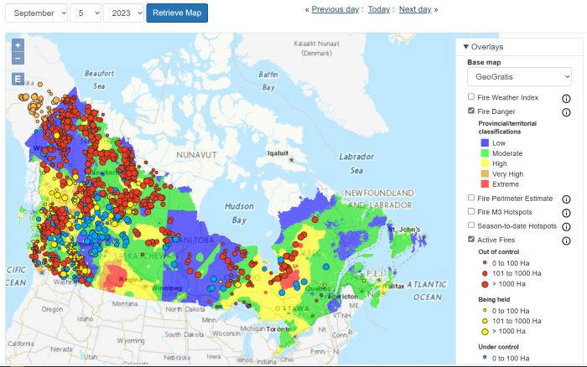

Yan Boulanger and two other Canadian forest fire services scientists, Jonathan Boucher and Sandy Erni were included in a group of researchers whose studies showed that climate change doubled the likelihood of extreme fires. This is because of the dry bushes, leaves, twigs, and trees which are great fuel for forest fires.
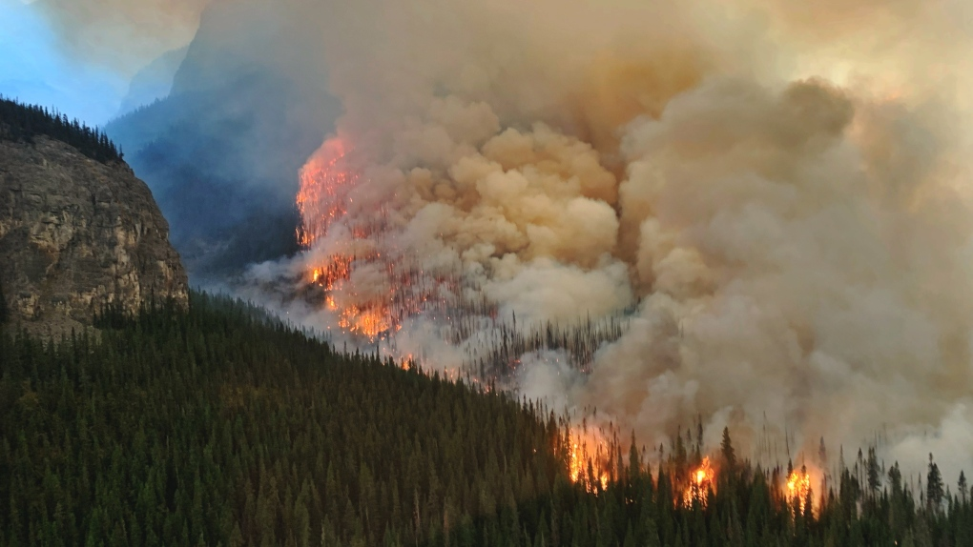

Mar 11, 2024
Wildfires. This time it's all about the smoke. I am not adding a web address because I learned all this from my teachers previously. [In grade 4] Anyway, wildfire smoke can actually affect your health a lot as we experienced last year when we had to stay inside until the smoke cleared. My class actually turned yellow when there was a 10+ day. Usually, we measure smoke on a scale from 0-10. 0-3 is okay. 4-7 is kind of in the middle, you probably shouldn't go outside, but it isn't too bad if you do. 8-10+ is extremely bad, where you should not go outside, and close all doors and windows.
Here are some symptoms of wildfire smoke inhalation: Sore throat, Eye irritation, Runny nose, Cough
People with lung problems, the elderly, and children are more likely to experience more serious health problems from inhaling wildfire smoke.

Mar 13, 2024
Today I filled out most of my CYSF subjects, including the method, conclusion, and problem.

Mar 14, 2024
Today I did a lot of the computer work such as filming my presentation, and I also did a lot of formatting.

