Day 1 9/24/2023
Finding Topic
Pollution is a problem this planet is facing, humans tend to put garbage in wrong bins and this leads to bigger problems because even the recycled items, if they are put in the wrong bin, will end up in the landfills. This is why Today I decided that I would make an innovation that is a garbage bin that can sort trash with any trash thrown at it. My question is, Can a homemade garbage sorting dustbin positively affect the environment by making sure that waste gets sorted properly?
Day 2 10/2/2023
Hypothesis
Today, I have come up with a hypothesis (an educated guess of my question). My hypothesis is: If I make a smart dustbin that sorts garbage properly, then it will have a positive impact on the waste problems our planet is having, because humans tend to put trash in the wrong bin and all waste (recyclables and compost) will end up in landfills. This has a negative impact on the environment and making sure our waste is disposed of properly would decrease the waste in the landfills.
Day 3 10/8/2023
Planning sheet
Today I have made a logical reasoning sheet showing what I am doing in a flow chart.
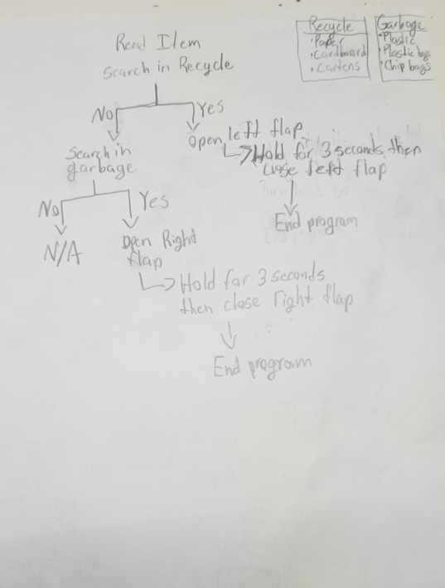
Right now I only have two different segregations, this allows me to use a flap. I may expand later on to 3 different segregations and then I will have to use a turning mechanism which can be a bit more complex than a flap. I am planning to use a camera and raspberry pi to make a video analysis, this will scan the item I am putting in it to accordingly drop it in the correct bin. The coding module I am planning to use is python, the code is to tell the raspberry pi and my model what to do and what item to put in what bin.

Day 4 10/16/2023
Background Research
- I have come up with my first 2 background research questions and have made my first one. My first question is the history of trash cans and my second is trash levels today.

- I have finished my first background research question, this is it:

The first ever appearance of a trash can was in England in the year 1875. This wasn’t the regular trash can you see today, this was just for storing the ashes of burnt trash instead of storing the trash itself. The bins were made of metal, wood, or even buckets people had lying around. 1897 was the year the first self propelled garbage trucks. These were ordered by Chiswick (town in London) district council. The first ever plastic trash can showed itself in the year 1930. To make these plastic trash cans there was a new type of plastic that was said was good for the job, this plastic is called polyvinyl chloride. In 1950 the first ever trash bag was invented for a more convenient way of taking out trash, instead of just bringing the entire bin, the bag could just be brought for easier transportation. But even in 1965 there were a lot of trash problems, the U.S government enacted the solid waste disposal act, this called in the nation for better ways of sorting trash. In 1968, two years later, we got the idea of using different trash bins for different purposes, recycling, garbage, and compost.
Day 5 10/22/2023
Background Research
- Today I did about half of my second background research question, which is the trash levels today, so far answering this question I have found that it has a lot of quantity sources with a lot of numbers.

- This is approximately half of my trash levels question:

In Canada, there are too many people putting trash in the wrong bin, most simply out of laziness to put it in the right bin. This is costing recycling programs around the country millions of dollars. One in three pounds (0.45kg in 1.36kg) of trash put in the recycling bin actually shouldn’t be there. Cities in Canada with very dirty recycling (Edmonton and Toronto) can have contamination increases by 25 percent. It's very expensive to process contamination as recycling, it can even get up to $4 million for a city to do this

Day 6 10/25/2023
Background Research
- I have finished my second background research question, I will put it as the half I did and it with the entire question.

- This is just the half I have done today:

All this has become a big issue because China, which is the biggest importer of recyclables, banned importing 24 different types of waste to prevent environmental disasters in the country. One of the waste items they banned from importing was paper and this became a problem for the rest of the world. "Something as simple as a piece of paper with a coffee stain on it, that piece of paper a year ago would have been recyclable," Today that's actually garbage". These are words from Jim Mckay because of the China importation ban.

- This is both today and three days ago’s progress together answering the full question.

In Canada, there are too many people putting trash in the wrong bin, most simply out of laziness to put it in the right bin. This is costing recycling programs around the country millions of dollars. One in three pounds (0.45kg in 1.36kg) of trash put in the recycling bin actually shouldn’t be there. Cities in Canada with very dirty recycling (Edmonton and Toronto) can have contamination increases by 25 percent. It's very expensive to process contamination as recycling, it can even get up to $4 million for a city to do this. All this has become a big issue because China, which is the biggest importer of recyclables, banned importing 24 different types of waste to prevent environmental disasters in the country. One of the waste items they banned from importing was paper and this became a problem for the rest of the world. "Something as simple as a piece of paper with a coffee stain on it, that piece of paper a year ago would have been recyclable," Today that's actually garbage". These are words from Jim Mckay because of the China importation ban.
Day 7 10/28/2023
Background Research
- I have completed my third background research question and it is how python and raspberry pi are going to work together in my project.

- This is my paragraph:

I am using the coding language called python to run my project and for it to work. I also am using a small computer called raspberry pi. A raspberry pi connects the code from a computer to a module that runs on code. It can also be used for browsing the internet, taking photos and videos, making spreadsheets, and creating games. What I’m using this mini computer for is object detection. Using a raspberry pi camera, I can connect it to a computer and do code on python to make the camera detect objectFor example, if the camera detects a person, it will show what it saw by putting a box around it and labeling it by saying “person” above it. Now obviously this won’t make it so it labels everything correctly, some things are too specific for the computer to process. We can fix this by a long but simple process, all we need to do is take multiple pictures of the item I want the raspberry pi to process and label and then do further code with python and then whenever the camera detects that object, it will label it. I am using object detection because I need my smart dustbin to identify which type of waste goes in each bin and I need a camera to identify this to code some servo motors to move and place the trash in the correct spot. This wouldn’t be possible if my module didn’t know what type of waste is placed.

- I have also decided what my last background research question is going to be, it is Trash segregation problems today.
Day 8 11/1/2023
Background Research
- I have done my last background research question today which is probably the most important one because it's what my entire project is about and what it’s trying to fix. This is the trash segregation problem today.

- This is my last background research question:

The main reason I am doing this project is because of trash segregation problems. I had already explained the trash levels today and how many Canadians are putting trash in the wrong bin. Now I'm going to talk about why this is such a problem. Dangerous stuff like needles, dead animals, and bear spray are put in the recycling and it costs Canada lots of money to decontaminate them and all that money is wasted because it all ends up in the landfill either way. It costs Canada millions of dollars to decontaminate and segregate trash. Clagary’s contamination rate for residential recycling is 13% of all of Canada and the only cities with a higher contamination rate are Edmonton, Toronto, Halifax, and Fredericton. Toronto’s contamination rate is the highest at 26% because trash segregation is the worst over there. This is all just because of people that put wrong things in the recycling, the process of sorting trash and decontaminating items thrown in the wrong bin costs a lot more than we would expect. In Toronto itself, it costs about $600,000 - $1 million per year, that's a lot just to decontaminate trash. This is why segregating trash is very much needed and otherwise Canada is going to keep wasting money on just segregating trash.

- This one too had lots of quantity sources because it is showing the levels today just like my second question, the trash levels today.

Day 9 11/15/2023
Planning Sheet explanation
- Today I wrote an explanation to the planning sheet I have made in the past

- This is my explanation:

This is the first planning sheet I have made, it is showing every step in detail of what I want my smart dustbin to do when different types of garbage are placed in it. The computer won’t know what the item is, so I would put all the different types of trash in a random order but in its section and the code I will make will scan different types of items in the order I have made it in. Then it will use object detection to find the item I have placed in the smart dustbin. Then the computer will see which section it is in (garbage or recycle) and will ask itself, is it in recycle, if the answer is yes then it will do as I have written. Open the left flap (because I am planning to put the recycling portion on the left side), hold for three seconds (so the recyclable has enough time to fall into the bin, tilt back to normal, and end the program. If I am able to do this method then I can try to move onto a more complex method which involves having three different sections (recycle, garbage, and bottles). For this, the flap method won’t work and will need a turning method which involves much further code and angles (for example, 30 degrees right) to get to the different sections.
Day 10 11/23/2023
Procedure
- Today I wrote my procedure on how to install python on a windows 10 computer as python is needed in my project.

- This is my procedure on how to install python:

- With a windows 10 computer, go to the python website (python.org)
- On the homepage there will be a spot saying “Download the latest version for windows” and below that is a button saying “Download python” and the newest version, i am using version 3.11.4 but download whatever the newest version is.
- Once it has downloaded, click the exe, this will open up the install prompt. Before clicking install make sure to look at the bottom of the prompt and check the box that says “Add python to PATH” and then click install.
- Wait for python to install and once it's done, close the install prompt.
- To make sure that you have python installed go to the windows command prompt by searching it in the windows search bar which is left of the taskbar.
- When you're in the command prompt, type this, “python --version” (make sure to have one space between “python” and the first dash and no spaces between the two dashes and “version). It should look like this:
- If you did everything correctly it should respond with the version of python you have, and this means you have successfully installed python to your computer!
Day 11 11/25/2023

Procedure
- I have written a procedure on how to install python on a windows 10 computer, but we need an efficient place to write that code. I could write it in the python terminal but it is way more organized and clean in an IDE (Integrated development environment). So this procedure is on how to get the IDE I used which is visual studio code. This is an IDE made by Microsoft and is completely free.

- This is my procedure on how to get an IDE (visual studio code)

- To get visual studio code (the free IDE I am using) we first have to go to the website, code.visualstudio.com.
- On the main page click “Download for windows” (stable build).
- When the download is complete, click on the exe which will bring you to the setup process.
- Click on “I accept the agreement” and click next.
- Go with the default location and click next until you get to “select additional tasks”, make sure to tick all the boxes on this page then click next.
- On the final screen hit install.
- Once the installation is complete, then click on finish on the last screen, make sure that the box saying “Launch Visual Studio Code” is checked before you click finish.
- If you did everything correctly you will be dropped in visual studio code and on the welcome screen. If you want to go back to this screen, click the help button and go to welcome.
- Before we can code, we need to install python to visual studio code, go to the left and look for the extensions icon, this is what it looks like:
Click this button
- In the search field above the pop up that shows once you click on extensions, search “python”.
- Click on the top option and check if it is by microsoft, if not select another until it is.
- Click on install.
- When python is installed, we need to select an interpreter which is going to be the python version you installed. To do this click “Ctrl Shift P” at the same time to open the interpreter search field.
- Search “python: select interpreter” and click the option available.
- Then it will show the version of python you have installed and click on that.
- Once you have selected the version of python as your interpreter, you are all set to start coding on visual studio code!
Day 12 12/14/2023
Raspberry pi connection
Today I connected the raspberry pi to a monitor to code with python on it. This would put the code I have with python to the raspberry pi and to my module. For my raspberry pi to connect to my monitor I watched a youtube video on how to do so, here is the QR code to the video I used.

Day 13 12/16/2023
VNC remote connection
This process for the raspberry pi to create its own window needs a monitor, a keyboard, and a mouse. I first tested connecting this on my parents monitor because I don’t have a monitor, I have a computer with a built in pc and fan so it wouldn’t work. To make it more convenient for me and my parents I would have to do it on my own computer. To do this, I have to connect remotely to VNC. it shows in the QR code above on how to do so. It wasn’t working though. I knew it wouldn’t be such a problem though if I couldn’t as I could just do it on my parents monitors when they weren’t working.

