Notes page Experiment/innovation
Project title “Edible Water Bottles, used as water balloons”

a process in which one or more substances, the reactants, are converted to one or more different substances, the products. Substances are either chemical elements or compounds. A chemical reaction rearranges the constituent atoms of the reactants to create different substances as products.
When two or more molecules interact with one another. For example if you mix one hydrogen atom and two oxygen atoms you get a chemical reaction which makes water.
Like degradable bags, biodegradables are often still plastic bags that have microorganisms added to break down the plastic. Compostable bags are made of natural plant starch, and do not produce any toxic material. Compostable bags are made from natural plant starch.
Degradable bags are made from plastic with chemicals. Degradable bags get broken up into small pieces which can be hundreds. It makes it extremely difficult to pick up.Compostable vs degradable and biodegradable bags

There is another way to make edible water bottles. Instead of using calcium lactate you can also use calcium chloride but it will just do the same thing.

Edible water bottles where made by a group of university students in london. Now they own a lab where they constantly try to make edible water bottles better. There lab is constantly finding new ways to make edible water bottles.
Yes water balloons are fun but they can take a toll on the environment. So that is why I am doing this project. To make water balloons that don’t have a bad effect on the environment. To make sure edible water bottles work as water balloons I am going to measure the splash radius of normal water balloons and my water balloons. To do this I am going to to put a peace of paper on the ground out in my back yard. And I will drop each water balloon three times. If the homemade balloons have a bigger or maybe even the same splash zone( I will be using cm). Then the experiment would be successful.

America along uses approximately 50 billion plastic water bottles per year. With only 25 percent of them are recycled. That is another reason why you should make edible water bottles. By doing this you can help the environment by doing a really simple thing.
You can just keep a bowl of edible water bottles in your fridge. And they are really easy to make.There is almost know reason not, go on amazon and just buy the ingredients.

Sodium alginate is extracted from cell that come from brown algae that grows in cold water areas. Seaweed grows alginate to add flexibility to seaweed. That is why you find more alginate content in troubled waters.

Calcium lactate is made by mixing two ingredients lactic acid and calcium hydroxide.
Questions for the expert
- How does a chemical reaction work?
- How small can I make the balloon?
- Is there a way to make it stronger?
- What are the environmental impacts of water balloons/plastic?
- Is an Edible Water Bottle a good alternative?

Dr. Shawn Loo, PhD (Contaminant Hydrogeology)
What effect do you think having edible water bottles of different sizes might have on their strength?
· The polymer that is created will likely be stronger with a smaller amount of liquid inside. This is because as the volume of water increases the surface area tension decreases.
Do you think using edible water bottles is a good alternative to plastic water bottles or even latex water balloons?
· I do not like water bottles of any type and do not think they are necessarily needed. However, in some applications (like the example of the marathon) where individual serving sizes are needed it is better than paper or plastic cups.
What impact do latex water balloons have on the environment and our water systems?
· Latex balloons are very bad for the environment. They make their way into water systems and are swallowed by animals that can choke on them. The latex does degrade but it takes a very long time. Plastic water bottles take even longer. It would be good to have an alternative that is compostable.
We also talked about experiment design and some ways to measure the strength of the water bottles.

Research questions
- Who came up with the idea for edible water bottles
- Can you by them
- Are there problems with the edible water bottles
- Is there health benefits
- Are there currently any other uses for this product
- How many water balloons are produced worldwide per year
- What are the dangers of using water balloons
- What is the impact of water balloons on the environment
- What is the difference between biodegradable and compostable
- Is there any environmental benefits
- What is calcium lactate
- What is sodium alginate
- What is a chemical reaction
- What happens to the molecules
- Why does it form a sphere
- Can you fill them with other liquid

Answers
- Rodrigo García González, Pierre-Yves Paslier and Guillaume Couche came up with the idea at a college in London. Now they have a lab where there trying to revolutionize the water industry.
- It is only available in some global events because it is in very early stages.
- There is no problems with edible water bottles all the ingredients are perfectly safe for consumption.
- Calcium lactate is edible but some scientist warn against eating it because in has a small toxic rating and may have some complications.
- There is no current uses for edible water bottles other than the fact that you can eat them.
- 45 to 50 million balloons a produced in california per year. Over a four year span the top selling water balloon company made 31 million dollars from there product.
- There have being cases of young children swallowing water balloons and chocking this has led to some law suits to the company bunch a balloon.
- Water balloons have a bad effect on the environment when they get into are lakes,rivers and oceans.
- Biodegradable is designed to break down in a land fill, compostable materials need certain conditions.
- The edible water bottles are biodegradable
- Calcium lactate is a food additive, it is added to foods for longer shelf life
- Sodium alginate is made from brown algae it only gels when it comes in contact with calcium
- a process that involves rearrangement of the molecular or ionic structure of a substance, as opposed to a change in physical form or a nuclear reaction.
- Both ingredients mixed together makes a edible membrane around the water
- The shape came fro the culinary world, were they would make ice balls and surround it with brown algae with calcium lactate, the ice will melt and that is how some chefs store water
- You can put almost any liquid in side the water bottle

Materials
- sodium alginate 1 gram
- Calcium lactate 5 grams
- Big bowl filled with 4 cups of water
- Smaller bowl with one cup of drinking water
- Bowl with any amount of water
- Immersion blender
- Curved spoon
- Big Slotted spoon

Procedure
- Take your bowl of 1 cup of water and pour 1 gram of sodium alginate
- Then take your immersion blender and mix the sodium alginate in the one cup of water
- Set the mixture aside for 15 minutes
- Take 5 grams of calcium lactate (you may need to crush it into powder if it did not come that way) and put it in the bowl containing four cups of water
- Mix well make sure that the calcium lactate is completely dissolved
- Once dissolved take your curved spoon and scoop up some of the sodium alginate solution
- Then put it into the calcium lactate bath
- Gently stir the solution for three minutes and thirty seconds
- After three minutes take your big slotted spoon and take out your bubbles
- Then put the bubbles and put them in the bowl with any amount of water to settle the reaction for about 5-10 seconds
- There you go edible water bottles

*Extended the amount of time the water balloons were in the calcium to 15 mins to make stronger.

Trial
This was my first trial I made two small water balloons and two big water balloons. The shell was a little weeker then expected. It was because I did not ster the calcium lactate into the sodium alginate long enough. Oh and by the way it was disgusting. I used the big ones as water balloons. The first did not work very well but the seconds one worked perfectly. And I ate the small ones.

Observations:
The balloons were very gooey when popped, it felt like slime. They did not look like spheres because they were not strong enough. It was really entertaining to watch the bubbles form in the water it was also satisfying. When I threw the bubble in the sink the first one did not splash but it did burst because I just dropped it in instead of throwing it. But I threw the second one pretty hard and it splashed all over the sink it looked like it may have a bigger splash then a normal water balloon. The water balloons had a long thing that was about an inch long that looked like a string. it made it easier to hold .
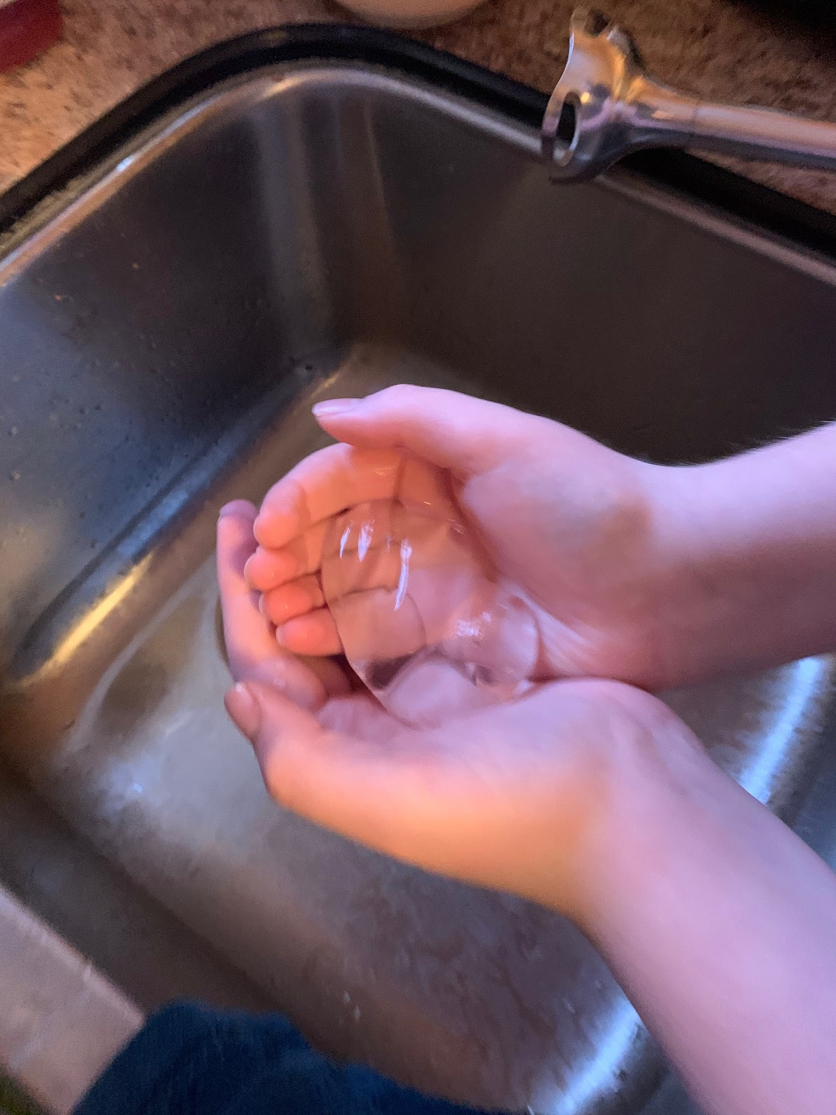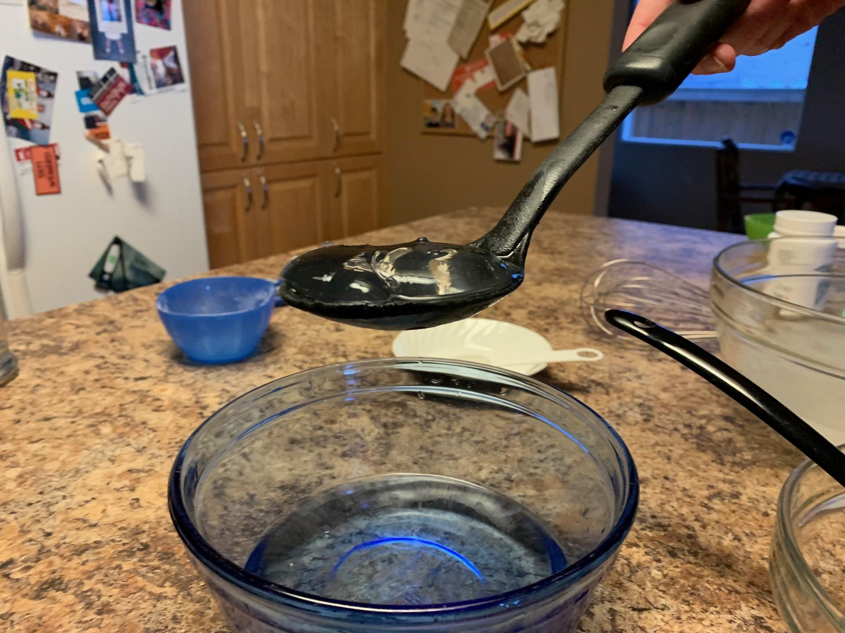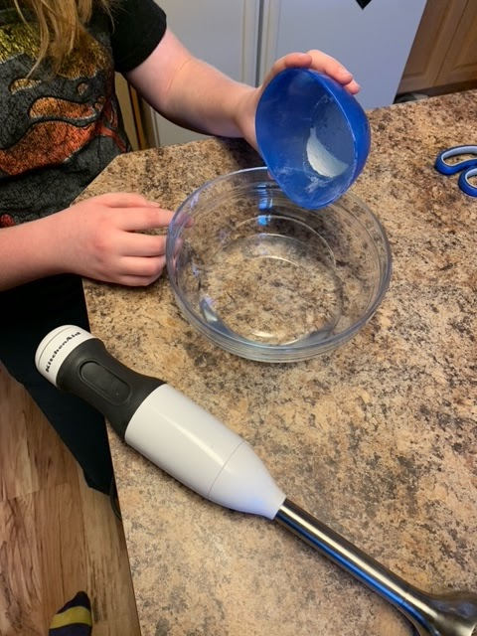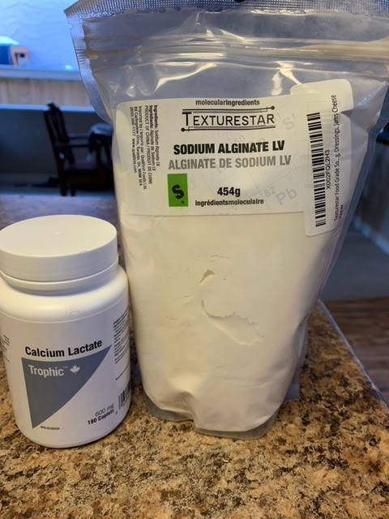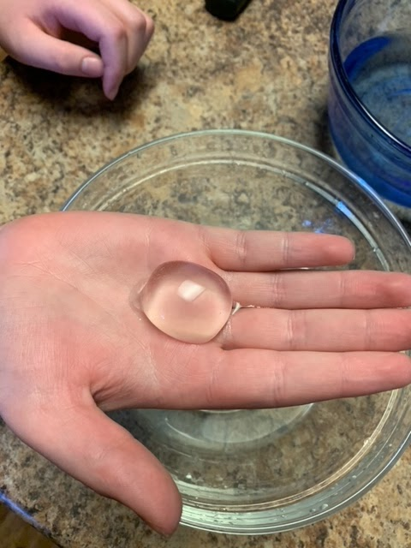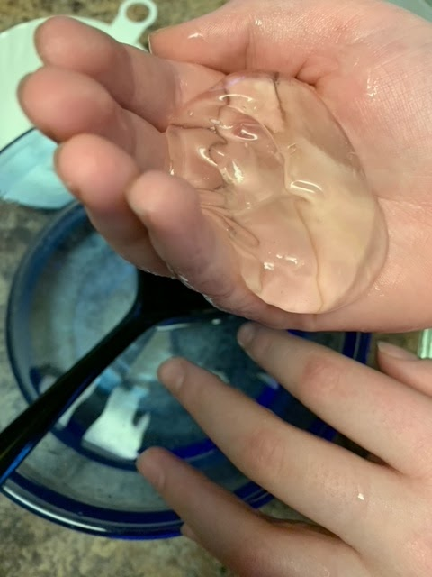

Making the water balloon
Observations
I used green food coloring to make the bubbles more visible in the water, it worked. The balloons where 7cm by 6cm. Instead of three and a half minutes I tried 5 minutes then 10 minutes I did not eat it because in the trials I tried to eat it but it did not taste very good. Maybe it was because I messed something up.
The experiment:
This is where I used real water balloons.

Hypothesis
I believe I will be able to make the edible water bottles work as water balloons because they have a thin shell that breaks on impact. The optimal edible water bottle to use for a water balloon will contain 60 ml of water.

Extra Research
This process is a simple chemical reaction. It begins with two main ingredients: sodium alginate and a calcium solution (I used calcium lactate). When sodium alginate is put into the calcium solution, the calcium ions immediately react with the alginate to form a gel. The sodium alginate is a sphere when placed in the calcium lactate bath and the result of the reaction is also a sphere. 3dprint.com/7166/molecular-gastronomy/
Some animals that have been killed by balloons are birds, whales, sea turtles, bighorn sheep and other wild and domestic animals. An animal can starve after eating a balloon because it blocks its intestines. Even though latex balloons may be marked as biodegradable they are full of chemicals and take at least four to five years to break down. https://balloonsblow.org/fact-sheet/
Surface tension and weakening of the “water bottle”
Surface tension is an effect where the surface of a liquid is strong. The surface can hold up a weight, and the surface of a water droplet holds the droplet together, in a sphere shape. This property is caused by the molecules in the liquid being attracted to each other (cohesion).
Surface tension is responsible for the shape of liquid droplets. Although easily deformed, droplets of water tend to be pulled into a spherical shape by the cohesive forces of the surface layer. In the absence of other forces, including gravity, drops of virtually all liquids would be perfectly spherical. https://kids.kiddle.co/Surface_tension#Liquid_surface
A sphere gives the smallest surface area for a given volume. When drops become larger, gravity deforms their spherical shape. This puts pressure on the polymer shell. When the edible water bottle sits on a plate, it forms a circle. Surface tension pulls it into a circular shape but gravity pulls it flatter. So the polymer would have to be stronger to hold the water with weaker surface tension. https://spark.iop.org/more-surface-tension-effects

Materials
Add measuring cup
Bathtub or other large tub
Measuring tape
Plastic lid (margarine container)

Procedure
Making the edible water bottles – done
Procedure – Balloon Drop
1. Fill three latex water balloons with 120 ml of water.
2. Hold the water balloon at a height of 10 cm.
3. Drop onto the bathtub surface.
4. Record whether the water balloon broke at this height. If it did not, repeat by lifting it up 10 more centimetres. Continue this process until the water balloon breaks. Repeat this process for all three of water balloons.
5. Make 12 edible water bottles – (3 of each volume – 15 ml, 30 ml, 60 ml, 120 ml)
6. Hold the 15 ml edible water bottle at a height of 10 cm.
7. Drop onto the bathtub surface.
8. Record whether the edible water bottle broke at this height. If it did not, repeat by lifting it up 10 more centimetres. Continue this process until the water bottle breaks. Repeat this process for all three of the 15 ml edible water bottles.
9. Repeat the procedure for the edible water bottles of different volumes.
10. Calculate the average height when the water balloons broke and the average height when the water bottles broke for each volume of water.

Procedure – Balloon Squeeze
1. Fill three latex water balloons with 120 ml of water each.
2. Place a water balloon on a kitchen scale.
3. Place a plastic lid on top of the water balloon. Use your hand to apply downward force on top of the lid. Make sure to slowly apply this pressure to the water balloon.
4. Record the number of grams displayed on the scale when the water balloon breaks.
5. Repeat this process for all three of water balloons.
6. Make 12 edible water bottles – (3 of each volume – 15 ml, 30 ml, 60 ml, 120 ml)
7. Place the 15 ml edible water bottle on a kitchen scale. Record the weight of the water bottle in grams. Then zero the scale.
8. Place a plastic lid on top of the water bottle. Use your hand to apply downward force on top of the lid. Make sure to slowly apply this pressure to the water bottle.
Record the number of grams displayed on the scale when the water bottle breaks.
Repeat the procedure for the edible water bottles of different volumes.
Calculate the average weight when the water balloons broke and the average weight when the water bottles broke for each volume of water.

Procedure change:
Made smaller water bottles because 120 ml was too big.
5ml, 15 ml 30 ml 60 ml

