Logbook
Feb 24

Acknowledgements:

We extend our heartfelt gratitude to a number of individuals who played important roles in the success of our project.

Foremost, we would like to express our thanks to Allison Ghosh, our science fair coordinator. and Karen Riel, our science fair supervisor. Mrs. Ghosh's and Mrs. Riels support, guidance, and updates on crucial dates and deadlines contributed to our finished project. Their motivation inspired us to excel in our work. Special thanks to them for assisting us in organizing our experiment, making it a rewarding experience.

A shoutout goes to our participants. Their cooperation won't be forgotten. Without their dedication, this project would not have been possible. Their contributions have truly made a lasting impact.

Finally, we extend our thanks to our parents, whose encouragement provided the extra motivation needed to push us forward. Their support was a driving force behind our success.
Together, these individuals have formed a vital network of support, and we are truly grateful for the effort that has brought our project to success.

Citations
Mathematics Anxiety: University of Cambridge https://www.cne.psychol.cam.ac.uk/what-is-mathematics-anxiety#:~:text=Mathematics%20Anxiety%20is%20a%20negative,solving%20of%20mathematical%20problems%20in%20%E2%80%A6
Math Anxiety: What Is It and How to Overcome It - Medical News Today https://www.medicalnewstoday.com/articles/math-anxiety-definition-symptoms-causes-and-tips#symptoms
Why Do People Get So Anxious About Math? - TED Ed: Lessons Worth Sharing https://ed.ted.com/lessons/why-do-people-get-so-anxious-about-math-orly-rubinsten
What Is a Dangerous Heart Rate? - Healthline https://www.healthline.com/health/dangerous-heart-rate#:~:text=A%20typical%20resting%20pulse%20rate,heart%20beats%20in%20a%20minute
6 Reasons Your Heart Rate Is High - Hackensack Meridian Health https://www.hackensackmeridianhealth.org/en/HealthU/2022/02/24/6-Reasons-Your-Heart-Rate-is-High
What Is Mindfulness Meditation: Find the Answer - American Institute of Health Care Professionals https://aihcp.net/2012/04/23/what-is-mindfulness-meditation-find-the-answer/
What Is Movement Meditation - American Institute of Health Care Professionals https://aihcp.net/2012/10/17/what-is-movement-meditation/
Benefits of Physical Activity - Centers for Disease Control and Prevention https://www.cdc.gov/physicalactivity/basics/pa-health/index.htm
Child's Average Attention Span by Age from Toddler to Teens - Ready Kids https://readykids.com.au/average-attention-span-by-age/
The link between music and memory (our previous science fair project).
Movement Meditation - YouTube: Helen Andersson Seers https://www.youtube.com/watch?v=4MLCf9b_OdQ
10 min super deep meditation music: Connect with spiritual guide : Deep Healing- Youtube Deep breath relaxing music https://www.youtube.com/watch?v=cF-w7jzVWcM
10 MIN Guided Meditation to Clear Your Mind and Start New Positive Habits - YouTube: Boho Beautiful Yoga https://www.youtube.com/watch?v=uTN29kj7e-w
Multiplication Facts to 100 (100 Questions) (No Zeroes and Ones) (A) - Math Drills https://math-drills.com/multiplication/multiplication_facts_to_100_no01_001.php
Meditation: A simple fast way to reduce stress: Mayo clinic https://www.mayoclinic.org/tests-procedures/meditation/in-depth/meditation/art-20045858#:~:text=Focusing%20your%20attention%20is%20one,mantra%20or%20even%20your%20breathing.
10 reasons why people don't meditate: Positive psychology : https://positivepsychology.com/10-reasons-why-people-dont-meditate/
5 reasons why concentration is important for meditation https://www.successconsciousness.com/blog/meditation/why-concentration-is-important-for-meditation/#:~:text=Successful%20meditation%20requires%20good%20concentration,meditation%20easier%20and%20more%20effective.
The seven different types of meditation- (Which one is the best for you) Youtube: https://www.youtube.com/watch?v=H37BDUyCEe0

Application
Our study could have several real-world applications. This includes:
Educational Interventions in Schools:
Our study provides valuable insights for addressing math anxiety in schools, which affects a significant portion of students. By incorporating our findings into educational programs, such as tailored meditation sessions before exams, educators can create a supportive environment conducive to learning. These sessions can be customized to suit the age group and attention spans of students, offering brief yet effective techniques to manage anxiety. By empowering students with tools to cope with math anxiety, schools can enhance academic performance and promote overall well-being.

In Workplace Stress Management:
The implications of our research extend to the realm of workplace stress management, offering actionable strategies for organizations. By integrating task-specific meditation sessions into the workday, tailored to the nature of employees' tasks, companies can enhance focus and productivity. Additionally, conducting wellness workshops that educate employees about stress management and introduce evidence-based meditation techniques can foster a positive work environment. Through these initiatives, organizations can support employee well-being and improve overall workplace satisfaction and performance.

By implementing these detailed strategies, both in educational and workplace settings, the Mind Over Math project can contribute to countless solutions to reducing math anxiety and improving overall well-being.

Dec 28

Big Question:
Which style of meditation helps reduce the amount of math anxiety we get before doing a few math exercises?."

Dec 29

Background Research
University of Cambridge: What is mathematics anxiety? Mathematics anxiety is a negative reaction to mathematics. This condition can be anywhere from a mild tension to a strong fear. In the UK, 2-6% of secondary school students suffer from extreme math trauma while other people suffer from more mild levels of it. Math anxiety does not only occur in classrooms but also when we have to use math in real life situations. Also, math anxiety only applies to mathematical areas. Not just studies in general. “It is unique in this regard as there are not many widespread conditions for other specific content such as reading, writing, or history.
Medical news today: Math anxiety what it is and how to overcome it: Math anxiety is a fear of solving math problems. It's not a medical condition but a way of describing anxiety that occurs in specific situations. Math anxiety is so common! Over 93% of adults say that they have experienced it. The symptoms of math anxiety include worry, tense muscles, increased heart-rate, sweaty palms, or headaches.
Connection: Another symptom of math anxiety is that your memory could go blank. This is something we found out last year when we were doing our previous science fair project.
Healthline: What is a dangerous heart rate? A resting heart rate is when your heart pumps the minimal amount of blood your body needs. This happens when your at rest. Here is a table that shows the average resting heart rate for adults. Its based on age.

Age range (In years) | Average resting heart rate.
18-20 | 82 bpm
21-30 | 80 bpm
31-40 | 79 bpm
41-50 | 75 bpm
51-60 | 74 bpm
61-70 | 73 bpm
71-80 | 74 bpm
80+ | 78 bpm

Here's one for kids
Age range | Resting Heart Rate
Newborn- 3 months | 80-160 bpm
3 months- 2 years | 75-160 bpm
2 years-10 years | 60-90 bpm
Over 10 years | 50-90 bpm

Along with age, there are a few other factors that can affect your heart rate. This includes temperature, pain, medication side effects, anxiety, body positioning and smoking side effects. However, you can estimate an adult's resting heart rate by subtracting their age (in years) by 220.

Jan 3rd
Hackensack Meridian Health 6 reasons your heart rate is high:Stress, hypothyroidism, anemia (lack of red blood cells), medication side effects, addictive substances, and smoking side effects are all things that can affect an adult's resting heart rate.
TedEd Why do people get so anxious about math?: When some people do math, their heart beats faster, their palms start to sweat, their stomachs hurt and they can't focus. This phenomenon is called math anxiety and researchers believe that 20% of the population suffers from it. A lot of people believe that they're bad at math so they are anxious about it but it's often the other way around. Some people who have faced math anxiety have gone on to win the Fields Medal (the highest award in mathematics). Psychologists believe that this is because of decreasement of working memory due to anxiety. If you use your working memory to worry about math, how are you going to use it on the math itself? Thankfully, you can stop this. Short breathing techniques, writing down your worries, and even a short walk can fix this. “Anxiety isn't a reflection on your ability, but something you can conquer with time and awareness.”
Youtube. 10 minute guided meditation to clear your mind and start new positive habits: To calm down, first assemble yourself in a comfortable space, and start thinking about exposing yourself for your wellbeing, your mind. Listen to the calm music and close your eyes leaving all the hard emotions and memories for now. Breathe in air and exhale it, but be sure to not tense your muscles. Proceed to let all the negative harmful emotions leave your body as you exhale. Think of how you created a good reality for not just others but for yourself as well. Think this: "My decisions today will define my tomorrow". As you hold that thought be aware that you are capable of love, peace, happiness and gratitude. Slowly open your eyes and return your attention to the present moment.

Jan 14
AIHCP What is mindfulness meditation-find the answer: "Mindfulness meditation" is a special way of focusing your mind that you might see in health magazines. To get what it means, you first need to understand regular meditation and what "mindfulness" is. Meditation usually involves sitting quietly and thinking about one thing. Mindfulness meditation takes it a step further, making you pay close attention to your own thoughts and what's happening around you without being hard on yourself.
So, when people ask, "What is mindfulness meditation?" they're usually wondering about its perks. Studies say it can help handle stress, lift your mood, make your immune system stronger, and help you manage your feelings better. Even if you only spend 10-15 minutes on it each day, it can make a big difference. In our busy lives, where we're often doing many things at once, mindfulness meditation is praised for bringing us back to the current moment.

To give it a go, find a quiet spot without distractions. Sit comfortably, close your eyes, and focus on your breath and what's around you. Let thoughts come and go without getting too caught up in them. Pretend you're an observer, just calmly watching everything without judging.
Mindfulness meditation also encourages letting go of the ego – thinking everything is about "me" or "mine." It works in three steps: first, noticing what's around you, then paying attention to your body, and finally, watching your thoughts and feelings. The good feelings you get from mindfulness meditation stick around even after you're done meditating, shaping how you see life and deal with different situations.

AIHCP: What is movement meditation:Instead of just sitting, movement meditation is about doing slow and careful moves in different positions. It's like paying super close attention to your body and what's going on around you while you're moving.
Remember that cool feeling on the beach when you're playing with sand? Movement meditation lets you keep that focus while you're up and moving around. It's not about striking specific poses; it's about moving slowly on purpose while staying in the moment. Here's a step-by-step guide to give it a go:
- Get comfy and sync your breath with your body.
- Put your hands on your body, really feeling your breath.
- Stand up nice and slow, checking out how your body changes.
- If something feels weird, either fix it or just notice it.
- Go through each part of your body, from the of your head to your toes, feeling all the sensations.
- Try some arm moves, like reaching for an imaginary fruit, paying attention to each little move.
- Walk around, paying attention to how your feet, legs, hips, and stomach feel with each step.
- Sit back down and pay attention to your body crunching and bending, syncing up your breath again.
This is just one way to do movement meditation. You can mix it up by touching things, dancing, or doing your regular tasks with a mindful twist. If sitting still is a bit too tricky for you during meditation, movement meditation is your jam—it helps you concentrate, chill out, and stay focused. With practice, you'll get more tuned in to your body, notice any health issues, and be way more in the moment with what's happening around you and the people you're with.

Youtube: Movement meditation-Begin by standing with your feet hip-width apart, hands joined in front of your heart. Inhale, lifting your arms, and exhale, bringing your palms together in front of your heart. Repeat this motion, focusing on grounding your feet. Now, position your hands by your waist with palms facing up, bend your knees, and inhale, drawing your hands up to the top of your lungs. Exhale, bending your knees. Continue this sequence, emphasizing the connection between rooting and rising energy. Transition into lateral movements, stepping to the side as you inhale and shifting your weight while exhaling. Explore the freedom to move in any way that resonates with you, all the while experiencing the rising and rooting energy throughout your body. Allow yourself to enter a more spontaneous flow, tuning into your body, breath, and movements without excessive verbal guidance. Relax your mind and surrender to the natural rhythm. Return to the center, drawing your hands to the top of your lungs, then exhale, rooting down and bending your knees. Inhale, connect with your center, and exhale. Draw your arms over your head, press your palms together, and exhale. Repeat this sequence and notice the sensations in your body. Consider this meditation as a practice you can revisit, adapting its length and incorporating music as desired. Finally, bring your hands to your third eye, the realm of dreams and intuition, then place them over your heart. Gratitude for joining, and peace and Namaste to you.

Jan 15

Centers for disease control and prevention:Benefits of physical activity Regular physical activity is crucial for overall health, benefiting brain health, weight management, disease prevention, and muscle and bone strength. Regardless of age, abilities, ethnicity, or size, everyone can experience the positive effects of physical activity.

Engaging in regular physical activity offers cognitive benefits, enhancing thinking, learning, problem-solving, and emotional well-being. It contributes to improved memory and reduces feelings of anxiety and depression. Furthermore, physical activity plays a crucial role in reducing the risk of cognitive decline and dementia. Thus, incorporating physical activity into daily routines not only promotes mental clarity and emotional balance but also serves as a protective measure against cognitive deterioration and age-related conditions like dementia.

Ready kids: Child's attention span by age from toddler to teen: Attention span is the duration an individual can concentrate on a specific task. A general guideline suggests an attention span of two-three minutes per year of age for children. Factors such as hunger, interest, environment, and distractions play a role in determining a child's attention span, which can vary from one child to another.
At ages eight-ten , children have an average attention span of 20–30 minutes, reflecting increased mental development. Teenagers' attention spans vary, with an average of twenty-four to thirty-four minutes, influenced by personal interests.

Jan 26

Hypothesis:
We think the group doing movement meditation will do the best (with lower heart rates and less anxiety). Here's why: we tend to have short attention spans, especially in 5th and 6th grade as we can only focus for about 20-30 minutes. By moving around during meditation instead of sitting still, it's easier for us to stay interested and have fun. This is something that mindfulness meditation usually doesn't offer. Also, light exercise can offer cognitive benefits such as anxiety reduction, enhanced thinking, a stronger memory, and emotional well-being. This is why we believe that movement meditation will have the best results.

We believe that the mindfulness meditation group will yield the second-best results. By embracing mindfulness meditation, we aim to release judgmental thoughts about ourselves and others, fostering an environment conducive to reduced anxiety during the math test.

Contrastingly, we anticipate that the group not practicing any meditation at all will experience less favorable outcomes due to the absence of the benefits associated with both movement and mindfulness meditation which we explained in the previous two paragraphs.

In summary, our research leads us to the conclusion that movement meditation will likely yield the most favorable results, followed by mindfulness meditation in second place, while the absence of meditation may result in the worst outcome.

Variables:

Manipulated Variable:
The independent variable in this study is the type of meditation practiced by the participants. There are three levels of this variable: movement meditation, mindfulness meditation, and no meditation at all. Each participant will be assigned to one of these three groups.
Responding Variables:
- Heart rate: The dependent variable includes the heart rate of the participants, measured during the 5-minute math test. We learned that the higher the heart rate of an individual is, the higher the anxiety levels.
- Test scores: Another dependent variable is the performance of the participants on the math test. This will be measured by the number of correct answers given within the given time frame. Lower scores indicate higher levels of math anxiety. We learned this when we were doing our background research.
- Survey results: The responses collected from the participants through a survey will also serve as dependent variables. The survey will include questions about their perceived anxiety levels before and after the math test, as well as their subjective experiences with the meditation techniques.
Controlled Variables:
- Amount and difficulty of questions on the test: To ensure consistency across groups, all participants will receive the same 100 one-digit multiplication test.
- Time given to complete the test: Each participant will have exactly 5 minutes to complete the math test, controlling for any potential time-related confounds.
- Time to do meditation: All participants will be allocated the same amount of time for meditation, which is set at 10 minutes. This consistency ensures that the duration of meditation does not influence the results.
- Time to record resting heart rate: The time allocated to record resting heart rates will be standardized across all participants to ensure uniformity in data collection procedures.
- Background noise: The testing environment will be controlled to minimize background noise, which could otherwise interfere with participants' concentration and heart rate measurements.
- Age group: All participants will be fifth to sixth-grade students. Although this age-group varies a bit more than it should, it's as controlled as we could get (see sources or error for more details).

Procedure:
- Firstly, we categorize our test subjects into three groups: movement meditation, mindfulness meditation, and a control group with no meditation. We will do this by recording our participants' names and providing each with a unique number to protect their privacy. This list will be securely destroyed at the conclusion of the experiment.
- For our initial group of ten test subjects, we will conduct a short assessment of their health conditions, specifically looking for hypothyroidism and anemia, and document any current medication usage. This information will be recorded in our logbook to ensure that we can keep track of all the sources of error for our experiment.
- Following the health assessment, we will use heart rate watches to measure the resting heart rate of each subject for a duration of two minutes. Subsequently, participants will engage in three ten-minute sessions of mindfulness meditation (We will set the mindfulness meditation video to the 1.25 speed to keep the movement and mindfulness meditation videos within the same time limit). After the meditation sessions, we will again use the heart rate watches to monitor their heart rates during the math test. The math test will consist of 100 single-digit multiplication questions that will have to be done within five minutes. Upon completion of the task, participants will be provided with a short survey to gather subjective feedback. The questions will be "On a scale of 0-10 (0 being no anxiety and 10 being extreme anxiety) how did you feel before and after the math test?". The second question will be "What do you think of the meditation technique we practiced?".
- This process will be repeated with the next group of ten subjects, but with a slight modification. Instead of mindfulness meditation, participants will be instructed to follow along with a movement meditation video during the designated meditation sessions.
- Following the same protocol for the final group of ten test subjects. However, this group will not engage in any form of meditation practice. Because of this, we won't ask this group the second question of the survey.
- Finally, after collecting data from all three groups from the heart rate measurements, test results, and survey answers, we will compare the results from the three different groups.

Observations:
Mindfulness Meditation

Subject | Do you have any mental or physical conditions? | Have any of you practiced meditation before?
2 | No. | Only like… Once a month.
3 | No. Why are you asking? | No, not really. Our teacher sometimes makes us do it but only once a month or so.
4 | No. | No.
6 | No. | Our teacher sometimes makes us do it but not to often
7 | I have some minor ADHD. | Nah.  I think it's a bit cheesy.
8 | No. | No.

6/11 test subjects attended this session. Only subject 2 has been calm during this meditation session. All of the other grade sixers and one grade fiver is trying to force it. They think it's pretty weird but they are trying their best. Everyone else is smirking about it. Some people are also whispering. Subject 4 even laughed out loud. There were many distractions during this session like the bells and students coming in from recess. In conclusion most people think that the meditation was pretty weird but one person felt calm about this.

Feb 14

Second session: Only 3 people came today. Two of them are grade fives and one of them is a grade sixer. They are doing better than yesterday. They are still finding it annoying, but they are trying to practice it at their best. Unlike yesterday, everyone is doing the deep breathing exercise but are still getting distracted during other parts of the video.

Feb 19

Third session: 6/11 test subjects attended this session. There has been loads of improvement since the first session but not as much as I hoped. 3 people are still not focusing throughout the video. Subject 4 in particular is having the most trouble with the meditation

Feb 21
Subject 2 resting heart rate = 70 bpm
Subject 3 resting heart rate = 86 bpm
Subject 4 resting heart rate = 93 bpm
Subject 6 resting heart rate = 89 bpm
Subject 7 resting heart rate = 87 bpm
Subject 8 resting heart rate = 78 bpm

Subject 2 heart rate during test = 115 bpm
Subject 3 heart rate during test = 89 bpm
Subject 4 heart rate during test = 112 bpm

Feb 22
Subject 6 resting heart rate = 95 bpm
Subject 7 heart rate during test = 112 bpm
Subject 8 heart rate during test = 78 bpm

subject Number | Classes attended | Heart-rate before and during the test in beats per minute | Test score | How did you feel before and during the math test? | What did you think of the meditation we practiced?
2 | 3/4 | 70-115 | 35/100 | Scared! It felt like an important exam! | I think I improved over time but to be honest, it wasn't for me.
3 | 4/4 | 86-89 | 100/100 | Scary but it was not that bad. | It actually helped me calm down. I think I improved a lot. I might even use this later on!
4 | 3/4 | 93-112 | 99/100 | OMG! Super scary! I couldn't focus! Like at all! | No offense but it was kind of cheesy.
6 | 3/4 | 89-95 | 99/100 | Totally fine | The music was nice. Was calm.
7 | 3/4 | 87-112 | 100/100 | It was scary. | Meh. Pretty boring.
8 | 4/4 | 78-83 | 21/100 | Unlike other tests I wasn't actually that stressed.. | Don't tell this to anyone but it actually helped, even though it was weird at first.

Movement meditation
Subject | Do you have any mental or physical conditions? If so, are you on any medication? | Have any of you ever practiced meditation before?
1 | Not that I know of. | Nope. I never do that.
2 | No, I don't have any of those conditions. | Not at all.
3 | No I don't have it | Yes i do it every day
5 | No i don't have any | No, I don't do it.
6 | No i don't have any | No, I don't do it.
7 | No i don't have any conditions | No i don't do meditation often
9 | No, I don't have any, but I did have some surgery 2 years ago. | No i don't do it much

Feb 13 2024
Subject 9,3 and 1 attended the first meditation class.some interferences occurred such as students, and school bells. Some distractions were when the participants were talking to each other, stopping in the middle of the meditation and whispering.
Feb 14 2024
Subject 9,3 and 1 attended the second meditation class. Some interference occurred such as students, and school bells. Some distractions were when the participants stopped in the middle of the meditation and whispered to each other. They improved a bit more than the first meditation session.
Feb 20 2024
Subject 9,5,6 and 7 attended the third meditation class. Some interference occurred such as students, and school bells. Some distractions were when the participants stopped in the middle of the meditation and whispered to each other. They did improve in the meditation from the last 2 sessions.
Feb 22 2024
Subject 9,5,6, 7,1, 2 and 3 attended the fourth meditation class. Some interference occurred such as students, and school bells. Some distractions were when the participants stopped in the middle of the meditation. They did improve in the meditation from the last 3 sessions and stopped talking and whispering to each other.
Subjects 9,1 and 3 were all experimented on Feb 22 2024 with the heart rate watches and multiplication and division 5 min tests. After getting the resting heart rate of each participant, 1 has 87 beats per min, 3 has 84 beats per min, and 9 has 79 beats per min. Before the test the participants had to move to a different room to do their test since the music room is going to be used for a class. After the 5 min math test, subject 1 had 93 beats per min, 3 had 87 beats per min, and 9 had 82 beats per min.
Feb 23 2024
Subjects 2,5,6, and 7 attended the fifth meditation class.Some interference occurred such as students, and school bells. Some distractions were when the participants stopped in the middle of the meditation. They did improve in the meditation from the last 4 sessions and stopped talking and whispering to each other.they had also tried doing the meditation with no stopping.
Feb 26 2024
Subjects 2,,5,6, and 7 attended the fifth meditation class.Some interference occurred such as students, and school bells. Some distractions were when the participants stopped in the middle of the meditation. They did improve in the meditation from the last 5 sessions and stopped talking and whispering to each other. They had also done the meditation with no stopping.
Subjects 2,5,6 and 7 were all experimented on Feb 26 2024 with the heart rate watches and multiplication and division 5 min tests. After getting the resting heart rate of each participant, 2 71 beats per min, 5 76 beats per min, 6 65 beats per min, 7 73 beats per min. The room that we were doing our experiment in was loud which could have affected the focus as well as the experiment as it was done in a different environment. After the test we got the heart rates of our participants which are 2 83 beats per min, 5 69 beats per min, 6 93 beats per min, and 7 73 beats per min.

Subject | Classes Attended | Heart rate before and during the test in beats per minute | Test score | How did you feel before and during the test? | What did you think of the meditation we practiced?
1 | 3/4 | 87-93 | 84/100 | I felt a bit scared | It was ok
2 | 2/4 | 71-83 | 98/100 | I felt really nervous | It calmed me down a little bit during the test
3 | 3/4 | 84-87 | 94/100 | I felt nervous | I was good and it calmed me a bit
5 | 4/4 | 76-60 | 31/100 | I was pretty nervous | I felt like I was in some magical world.
6 | 4/4 | 65-93 | 35/100 | I felt tense | It was ok
7 | 4/4 | 69-73 | 94/100 | I felt scared | It calmed me a bit during the test
9 | 4/4 | 94-95 | 100/100 | It was fine. | It calmed me a bit during the test

No meditation Feb 26

Subject | Do you have any mental or physical conditions? | Have any of you practiced meditation before?
1 | No but I was sick recently. I just had regular advice. | No.
2 | No | No
4 | Nah | No
6 | Umm. No | Also… No
9 | No. | No I don't do it
11 | No, I'm good. | No.

Subject 1 resting heart-rate = 89 bpm
Subject 2 resting heart-rate = 91 bpm
Subject 4 resting heart-rate = 70 bpm
Subject 6 resting heart rate = 82 bpm
Subject 9 resting heart rate 101 bpm
Subject 11 resting heart rate = 83 bpm

Subject 1 heart rate during test = 111 bpm
Subject 2 heart rate during test= 108 bpm
Subject 4 resting heart rate = 96 bpm
Subject 6 resting heart rate = 99 bpm
Subject 9 resting heart rate = 119 bpm
Subject 11 resting heart rate = 107 bpm

Subject | Heart-rate before and during the test bpm | Test score | How did you feel before and during the test?
1 | 89-111 | 99/100 | The test was scary but I do this in class so yeah.
2 | 91-108 | 100/100 | Two thoughts. Yes, the test was scary. Two: Why did I have to get consent! I'm only twelve! Was the watch a bomb or something?
4 | 70-96 | 99/100 | It was fine with me.
6 | 83-107 | 11/100 | Scariest experience of my life.
9 | 118-119 | 98/100 | Kind of scary
11 | 82-99 | 71/100 | Super scary.

Feb 27

Analysis:
https://www.mayoclinic.org/tests-procedures/meditation/in-depth/meditation/art-20045858#:~:text=Focusing%20your%20attention%20is%20one,mantra%20or%20even%20your%20breathing.

Different types of meditation may incorporate various components to aid in your practice. These elements can differ depending on the guidance you follow or the instructor leading a session. Here are some common aspects found in meditation:
- Focused Attention: Concentrating your attention is a fundamental aspect of meditation. This focus helps to liberate your mind from the multitude of stressors and concerns. You might direct your attention towards a specific object, an image, a mantra, or even your breath.

- Quiet Environment: For beginners, finding a tranquil environment can facilitate meditation. It's beneficial to minimize distractions, such as avoiding the presence of television, computers, or cellphones. With increased proficiency, you'll find that meditation can be practiced anywhere, even in high-stress settings like traffic jams, hectic work meetings, or long queues at the grocery store. These moments offer valuable opportunities for meditation practice.

- Comfortable Position: Meditation can be practiced while sitting, lying down, walking, or engaging in other activities. The key is to find a position that is comfortable for you, enabling you to derive maximum benefit from your meditation session. Maintaining good posture during meditation is also advisable.

https://positivepsychology.com/10-reasons-why-people-dont-meditate/

In contrast to many other things in life, whether we succeed at meditation depends entirely on how we approach it. It doesn't matter how much practice we've had or how good we are; if we go into it without expecting too much or trying to force specific outcomes, then we can still get something out of it.
Meditation isn't something you achieve; it's more of a journey. Sure, it has its perks, but the real benefit is in the process itself. The trick is to enjoy that process. Forget about being hard on yourself or comparing yourself to others. Once you see that meditation isn't about ticking off achievements, you might find it more enjoyable.
Lots of folks think meditation is tough because they think they're supposed to fight their thoughts or clear their minds. Meditation is more about just noticing your thoughts coming and going without getting too caught up in them.
There's no need to struggle or push thoughts away. If you try to fight your thoughts, they just get stronger and leave you feeling more stressed. Instead, gently steer your mind back when it wanders, and you'll find it starts to calm down naturally.
Meditation is just about keeping your focus going. Your mind might quieten down as a result, but focusing too much on achieving that can make it harder to stay relaxed and present. Instead of trying to completely empty your mind, mindfulness meditation is about staying focused on one thing, moment after moment. With practice, it can leave you feeling calmer and more centered
Forget about trying to clear your mind or make it quiet. Just follow the meditation instructions and let everything else be. Some people think they need to start with a calm mind to meditate. They'll say, "My mind's too busy; I can't meditate.
But that's like saying you need to be fit before you hit the gym.
You don't need a calm mind to meditate. If anything, having a busy mind is even more reason to give it a go. After meditating for a while, you'll realize nobody starts off with a calm mind.

https://www.successconsciousness.com/blog/meditation/why-concentration-is-important-for-meditation/#:~:text=Successful%20meditation%20requires%20good%20concentration,meditation%20easier%20and%20more%20effective.

Here are five compelling reasons why maintaining focus holds importance in the practice of meditation:
- Essential for Effective Meditation: The efficacy of meditation hinges greatly upon one's ability to concentrate. Without steadfast focus, the mind is prone to meander aimlessly, detracting from the intended meditative state.

- Time Management: A lack of concentration often results in the squandering of valuable meditation time through mental distractions such as daydreaming or looking into the future. Enhanced focus facilitates optimal utilization of meditation sessions, minimizing the intrusion of extraneous thoughts.

- Reduction of Mental Clutter: Concentration serves as a cognitive purifier, expelling the clutter of stray thoughts and distractions that impede the meditative process. This mental clarity engendered by sustained focus fosters a serene and tranquil mental state conducive to meditation.

- Overcoming Mental Distractions: Concentration acts as a formidable defense mechanism against the onslaught of mental diversions that commonly besiege individuals during meditation. By fortifying one's focus, practitioners can effectively navigate through intrusive thoughts and maintain alignment with their meditative objectives.

- Attainment of Inner Peace: The cultivation of concentration transcends mere cognitive discipline; it facilitates the attainment of inner tranquility and harmony. By anchoring awareness to the present moment, individuals can transcend the chatter of the mind, paving the way for solid states of inner peace and self-realization.
In summary, concentration stands as the linchpin of successful meditation practice. Mastery of this fundamental skill unlocks a realm of profound calm, clarity, and personal growth within the practitioner.

In our experiment, the application of concentration in meditation directly relates with the outcomes observed among participants. While some individuals experienced benefits from the meditation sessions, others did not. This common outcome can be attributed to the varying levels of concentration exhibited during the practice.

Upon reviewing our meditation session notes, it became evident that certain participants struggled to maintain focus. Instances of whispering, giggling, and looking around were documented, indicating a lack of concentration during the sessions. Such behaviors not only disrupt the meditative atmosphere but also hinder the ability to derive meaningful benefits from the practice.

Drawing from the principles outlined in the analysis, it becomes apparent that concentration serves as a crucial component in the effectiveness of meditation. Those who were able to concentrate and anchor their awareness to the present moment likely experienced greater success in reaping the benefits of meditation. Conversely, individuals who allowed their minds to wander or succumbed to distractions would have found it challenging to attain the desired states of inner peace and mental clarity.

Sources of error

We encountered a few sources of error when conducting our experiment.
Some people showed up to more classes than others, especially in the movement meditation groups where attendance varied a lot. This difference in attendance could mess with our data, making it harder to trust the results. Knowing who showed up regularly and who didn't might give us clues about how engaged people were with the meditations. Maybe next time, we could consistently remind and get our test subjects so that we could avoid the major differences of the attendance to meditation sessions, giving everyone an equal amount of days to finish the experiment as well as providing us and the reader clearer results.
Variability in testing environments should have been a controlled variable. However, due to lack of space and time we had to conduct the experiment in different places. In our study, we had mindfulness meditation in the library, movement meditation in the music room, and a control group with no meditation in the library as well. This setup might've caused differences in noise levels, lighting, and overall vibe, which could have resulted in different levels of relaxed and focused participants during meditation. That could affect their heart rate readings and test performance. Also, differences in the way a room is built and setted up might have affected how comfortable people felt and how well their attention toward the meditation techniques, possibly messing with how effective the interventions were. Building on, things like temperature and air quality might've been different between the library and music room, which could've messed with participants' physical responses and overall experiences. Also we did one movement meditation session in a classroom due to trickster residency. The sound levels between the music room and the classroom during lunch time were not comparable since the classroom was much louder. In summary, our testing conditions weren't consistent, which could've messed up our study's validity. To fix this in the future, we need to make sure all experimental groups are tested in the same place to minimize how much the environment messes with the results.
Additionally, it's worth noting that the participants in the mindfulness meditation group were sitting right next to their friends. This aspect of the experimental setup could have influenced their experiences and potentially impacted the results, as social interactions can play a role in how people engage with mindfulness practices. We should have remembered to make sure that those in the mindfulness meditation group should not sit close to others similar to the other groups. As for the movement meditation group, it would have been more spread out and also arranged the participants in a way that they won't talk or whisper to their friend as it may affect their concentration and the experiment.
One more thing we realized during our experiment: the mindfulness meditation video ended up being slightly longer than the movement meditation one, despite our best efforts to keep them the same length. It wasn't a massive error, but it might have thrown off the balance a bit. It could have subtly influenced how people felt during the sessions.
Another thing that we've messed with our results was changing the lunchtime recess for the grade sixers. We had to do the experiment when everyone was available, so we ended up shifting around their break time. This switch-up could've thrown off their usual routine and affected how they felt during the experiment. The change in lunchtime could've made some kids feel different during the meditation and math test, which would have messed with our results.
Another thing we noticed was that the time between meditation sessions and measuring resting heart rates wasn't consistent. Sometimes there was a big gap, and other times it was more immediate. Sometimes we measured the resting heart rate 1 minute after the test and other times we measured the heart rate of other participants 10 minutes after the meditation. It made it a bit tricky to pinpoint the exact resting heart rate of the participants.
During our experiment we planned it in a way so that every test subject showed up for the meditation sessions and had enough time to do our experiment, but some didn't show up on some days due to them not knowing, being away, or school clubs. We also didn't have enough time to do our tests with our test subjects due to our heart rate measuring it time which was 5 min, but we changed it in the middle causing it to be a bit inaccurate as well as with the environment as we ran out of time causing a source of error. We tried to even out the amount of days each participant has come since new test subjects came each day making some participants have their test earlier than others or have different amounts of meditation sessions.
Finally, we had just 19 participants in our study. This means that we had only 7 people in the mindfulness meditation group, and 6 people each in the mindfulness and no meditation group. It might not sound like a big deal, but when you're trying to draw conclusions from a study, having a smaller group like that can really make things tricky. With a larger group, you've got more diversity, more perspectives, and it generally gives you a better shot at seeing patterns in your data. But with just 19 people, it's like trying to piece together a puzzle with only a handful of pieces. It's not just about the numbers, though. Having a small group like ours can also mean you're more susceptible to outliers or random quirks in your data. Someone having a particularly good or bad day could ruin your results, and you might not even realize it. Plus, with a smaller sample size, it's harder to say whether your findings would hold up if you tested it on a larger, more representative group.
These were our potential sources of error we had encountered in our experiment.

Conclusion

We did face lots of problems during this project giving some inaccurate results, which will affect our conclusion. Some problems are the number of participants that we were able to gather for our experiment, which was a total of 19 test subjects. We also had a difference in the amount of participants in each group, like for the no meditation and movement meditation we had 7 people in each group, but for the mindfulness meditation we had 6 people which could also have affected our experiment results. Having at least 24 or 30 people attending the sessions would have been better. However, here is what we found out.
From what we had observed and faced in our experiment we discovered that both mindfulness and movement meditation groups had some small changes in heart rate compared to the no meditation when we measured it before and after the 100 questions math test. Though not all of the test subjects had small changes in their heart rate like participants 9,7,5, and 3 from the movement meditation group, or participants 3,8 and 6 from the movement meditation group. We had some big changes in some participants' heart rate as well , like participants 1,2,and 6 from the movement meditation group or participants 2,4, and 7 from the mindfulness meditation group. We had realized that the people who had these big changes in heart rate could have done the other type of meditation, like participants 1,2 and 6 from movement meditation, could have done mindfulness meditation, or participants 2,4, and 7 from mindfulness meditation could have done movement meditation. From what we had learned we finally conclude that the type of meditation simply changes for everyone as it is dependent on their comfortability and interest. We could have proven this by adding it to our experiment which is one thing that we could have done better to get a more accurate result. Another thing that we would like to add is that the interest of the meditater is important in order to slow down their heart rate as their interest plays a key part in their concentration towards the meditation. These conclusions we found were based on our observations and our results, but we also included the website information to support our conclusion, and the information we found in two of them talked about the attention of the meditator.

Informed Consent 2c forms
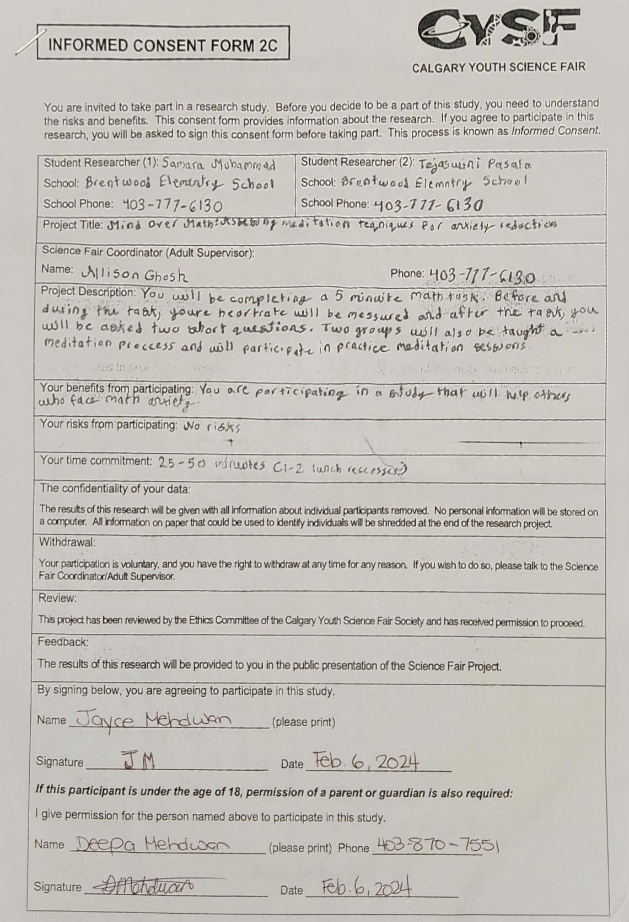

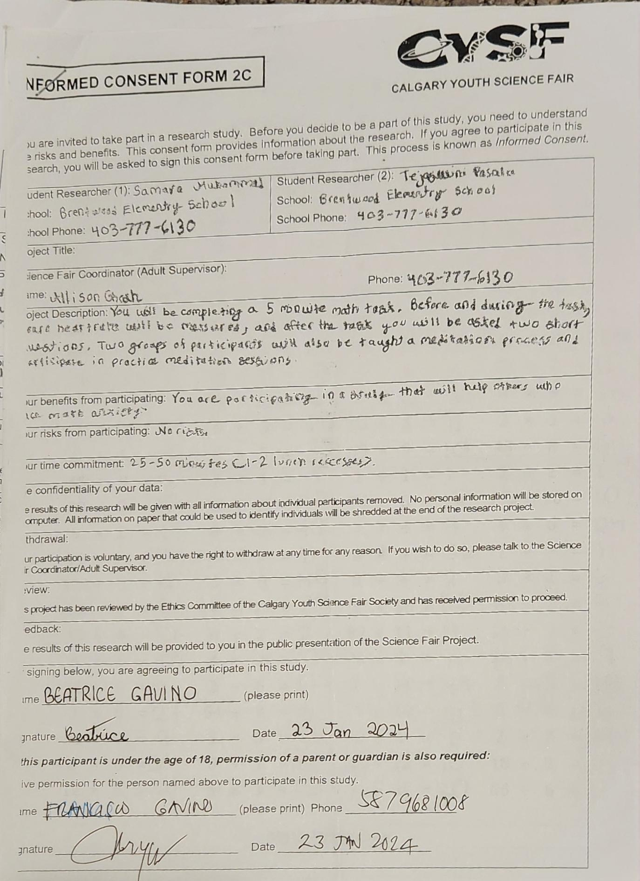

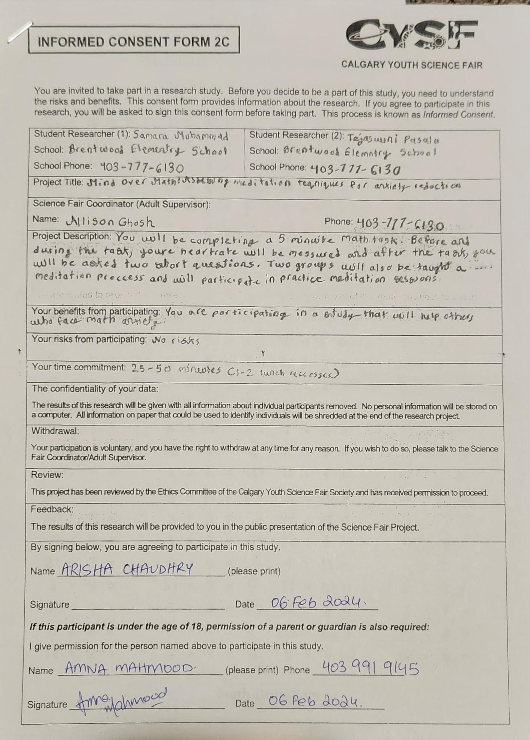
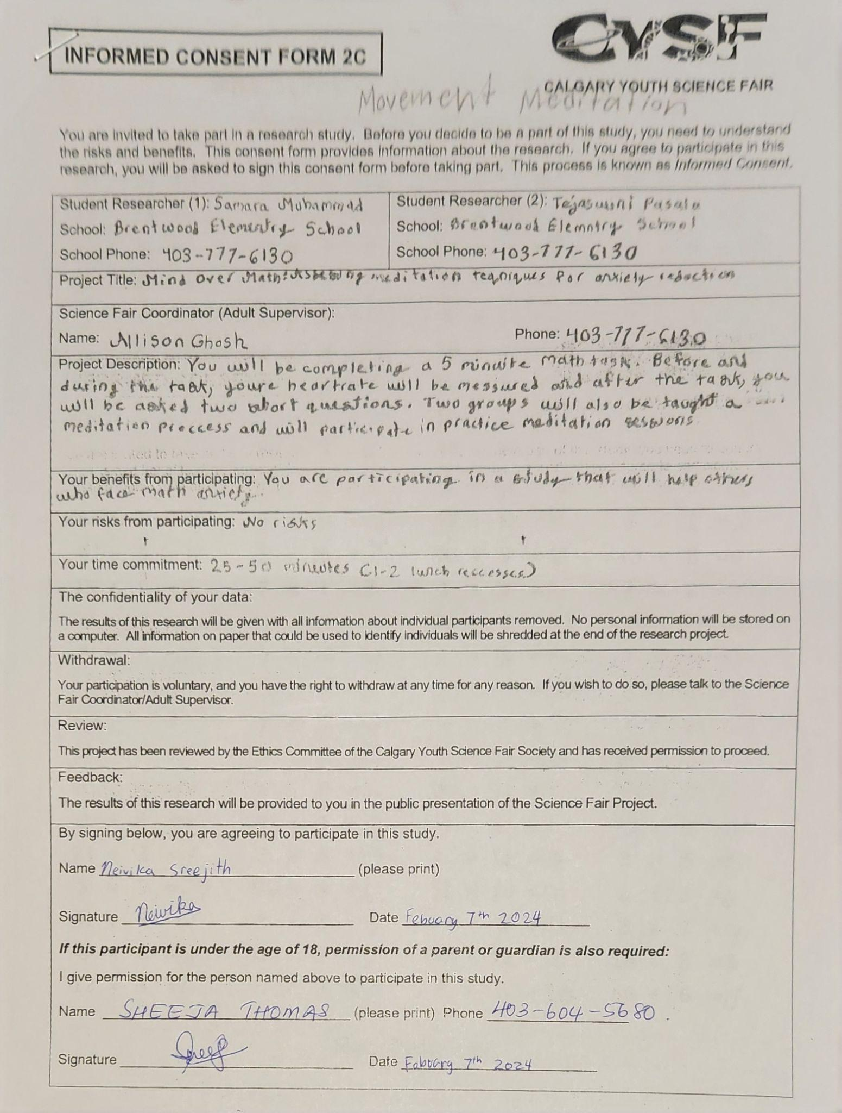
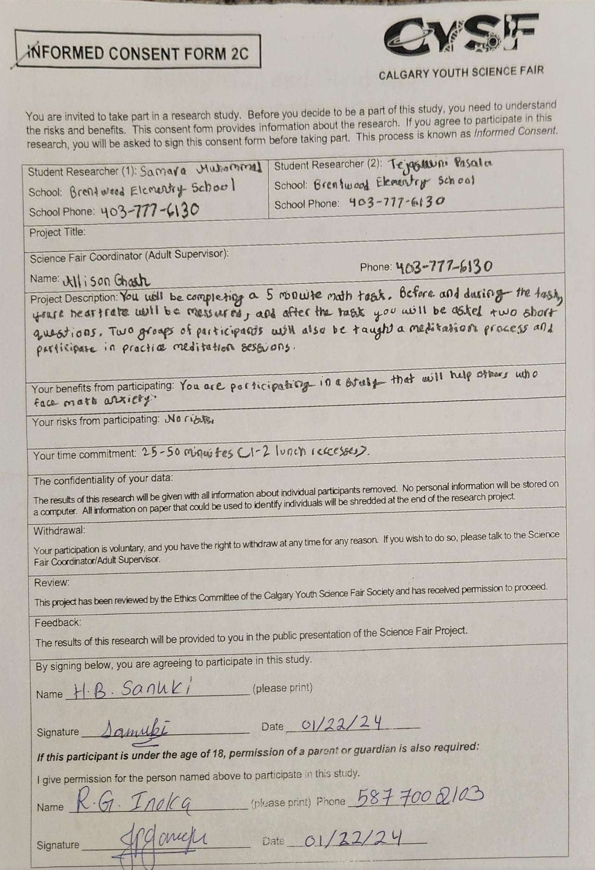
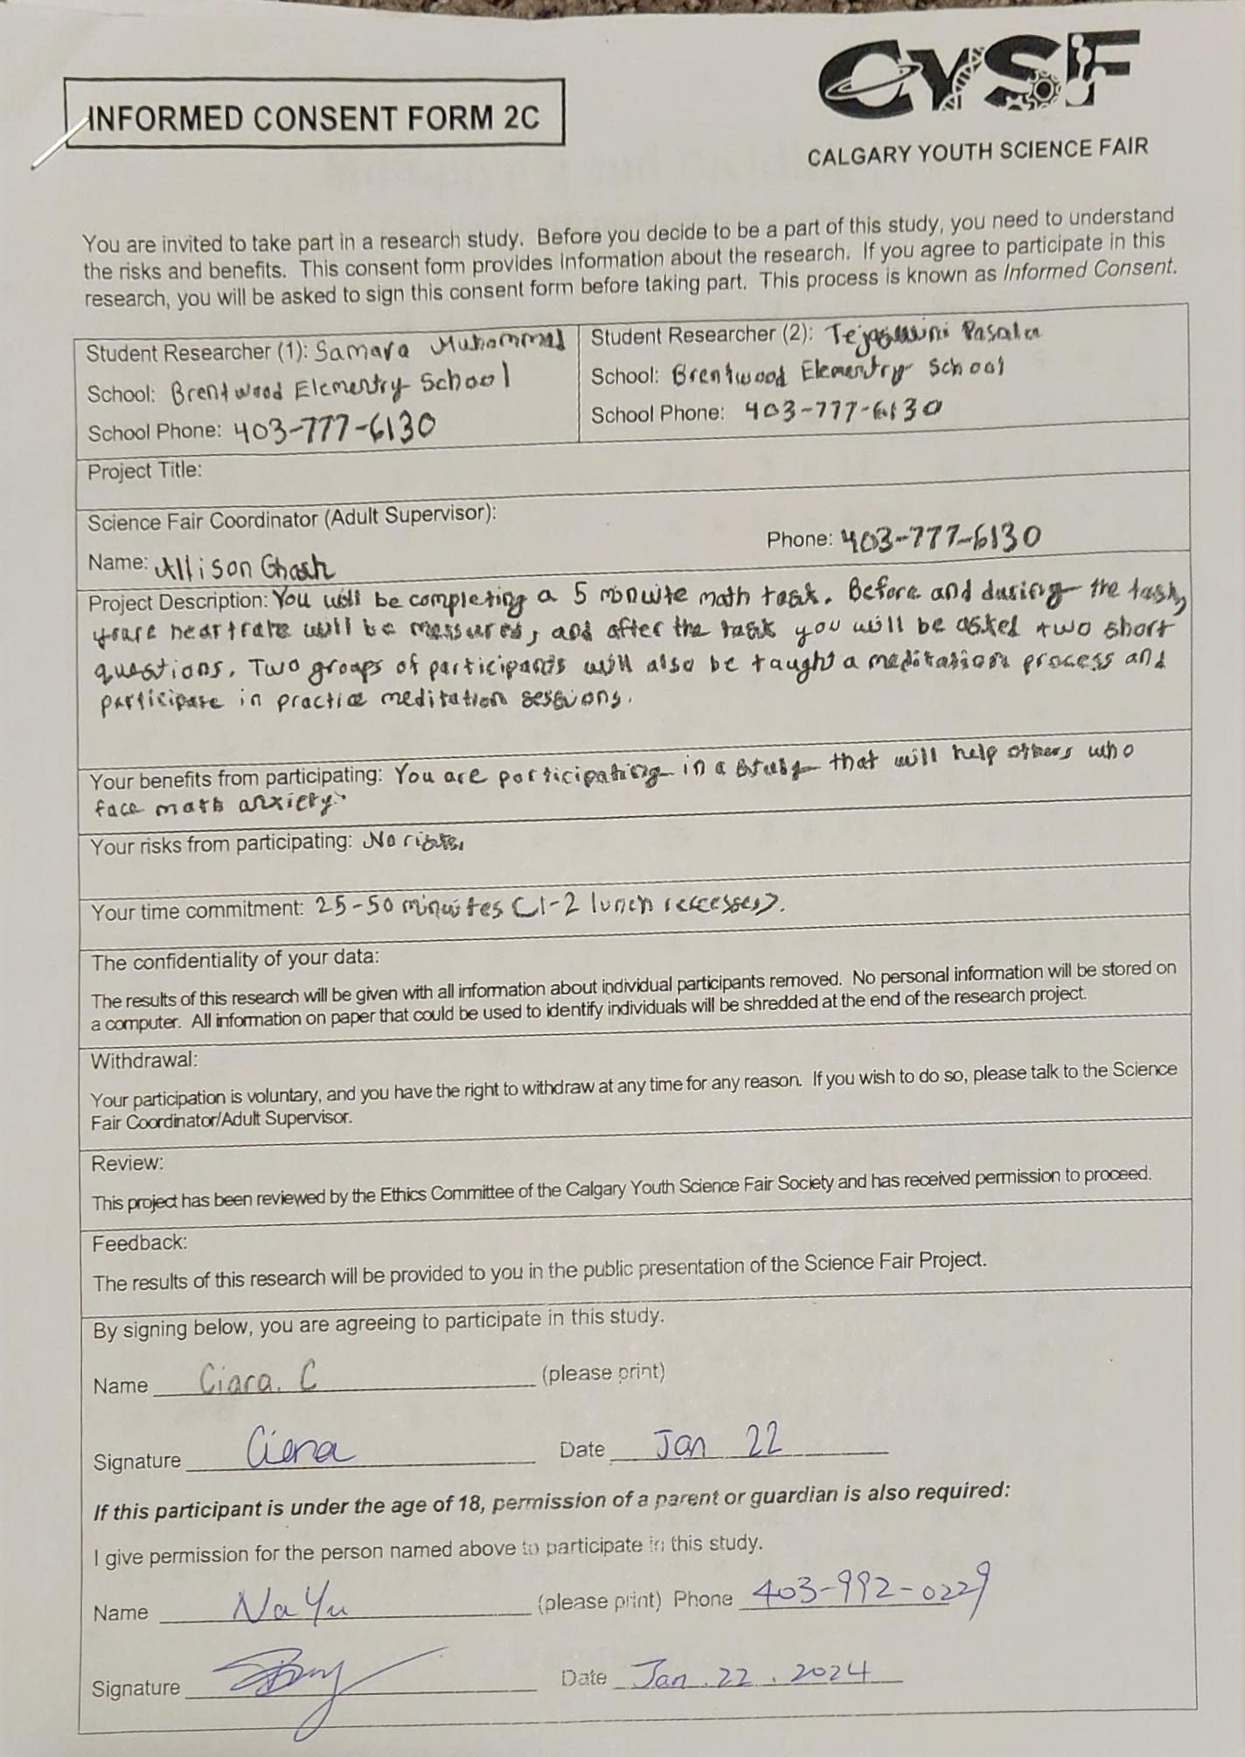
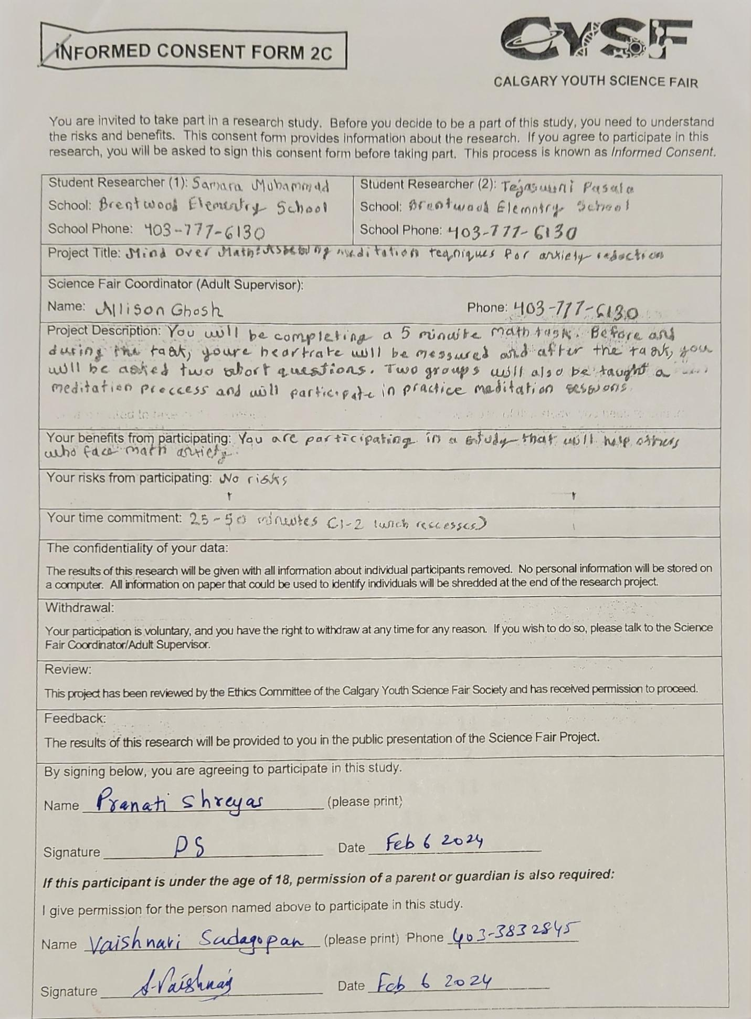

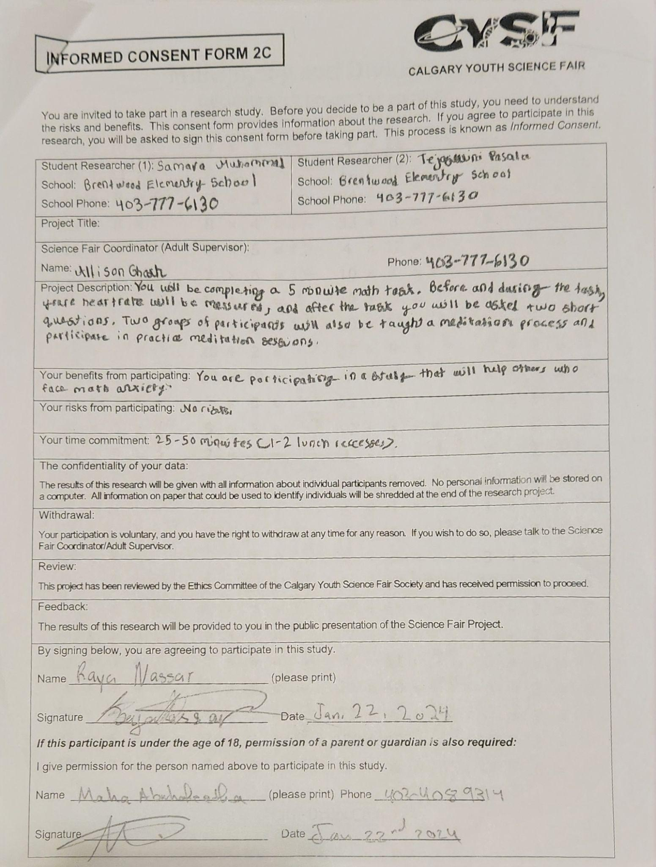
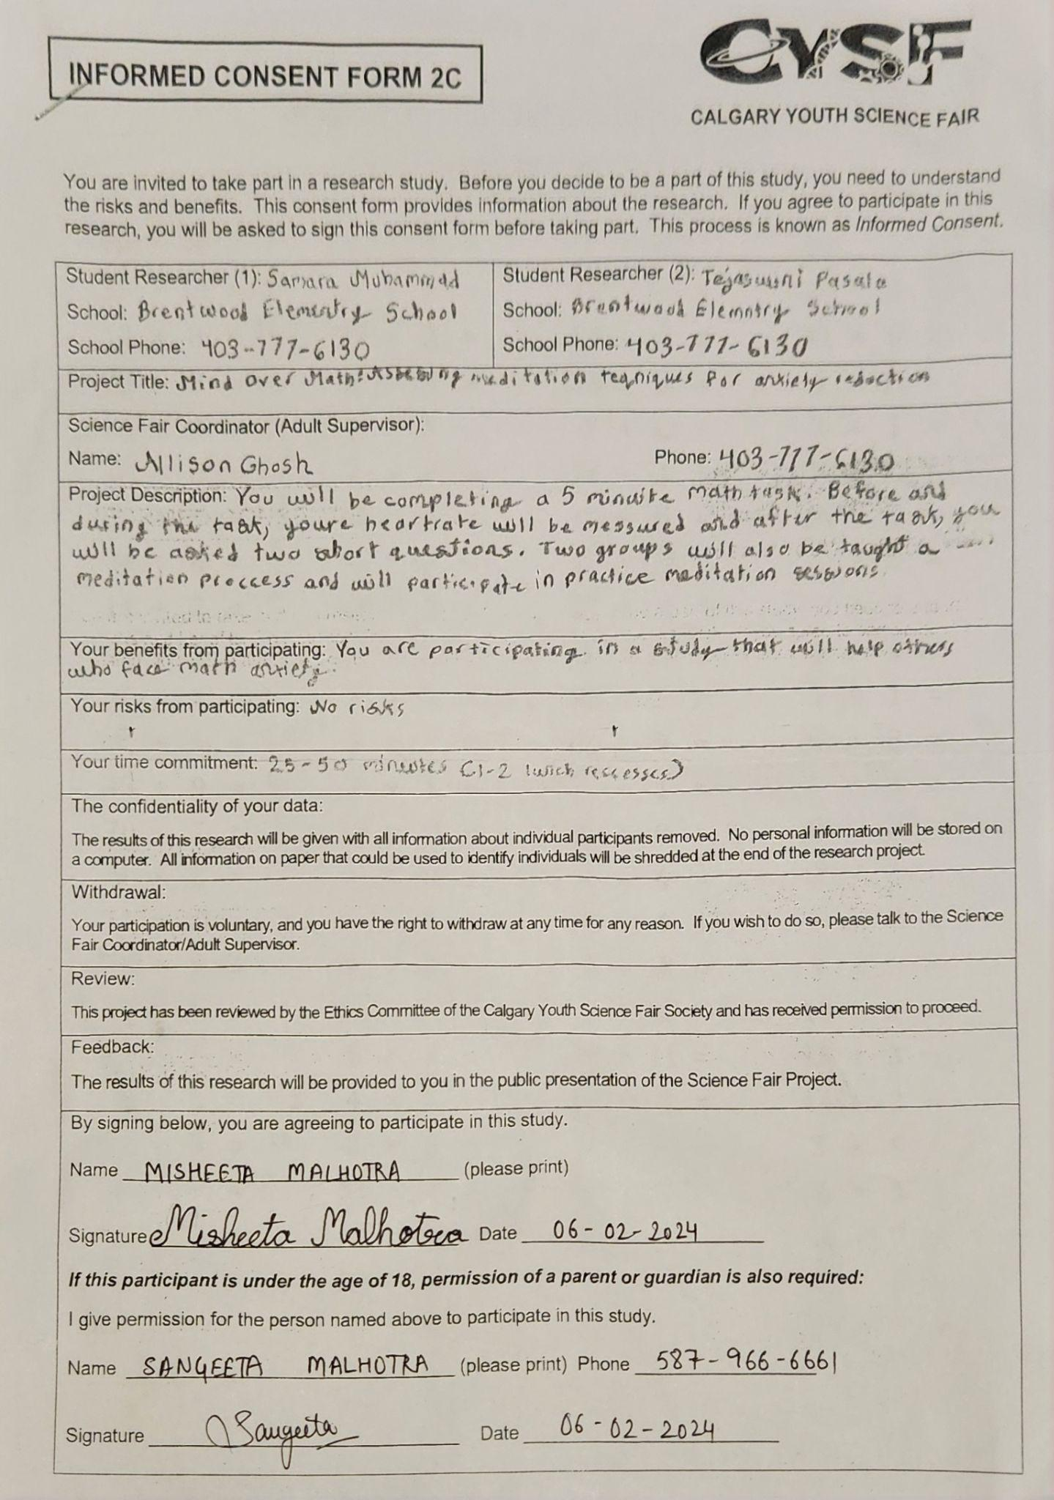
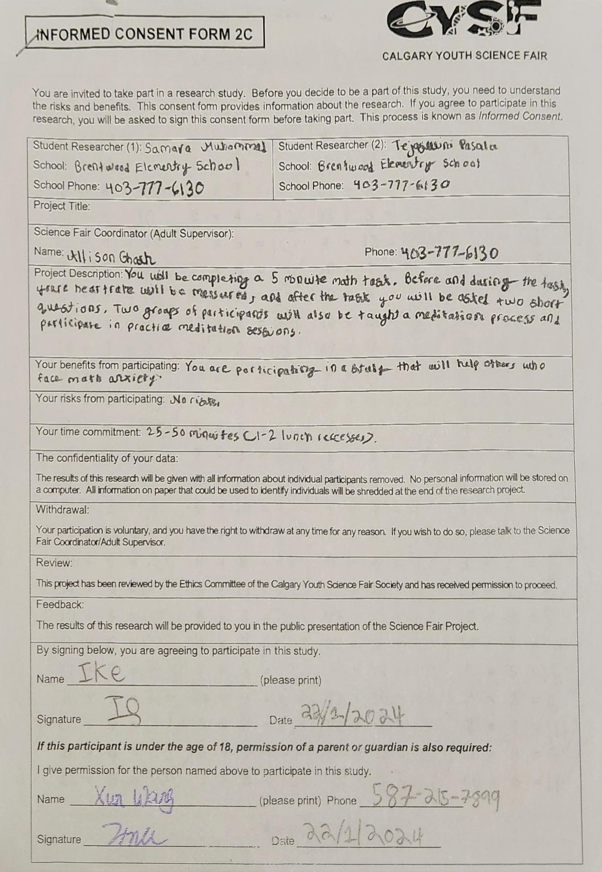
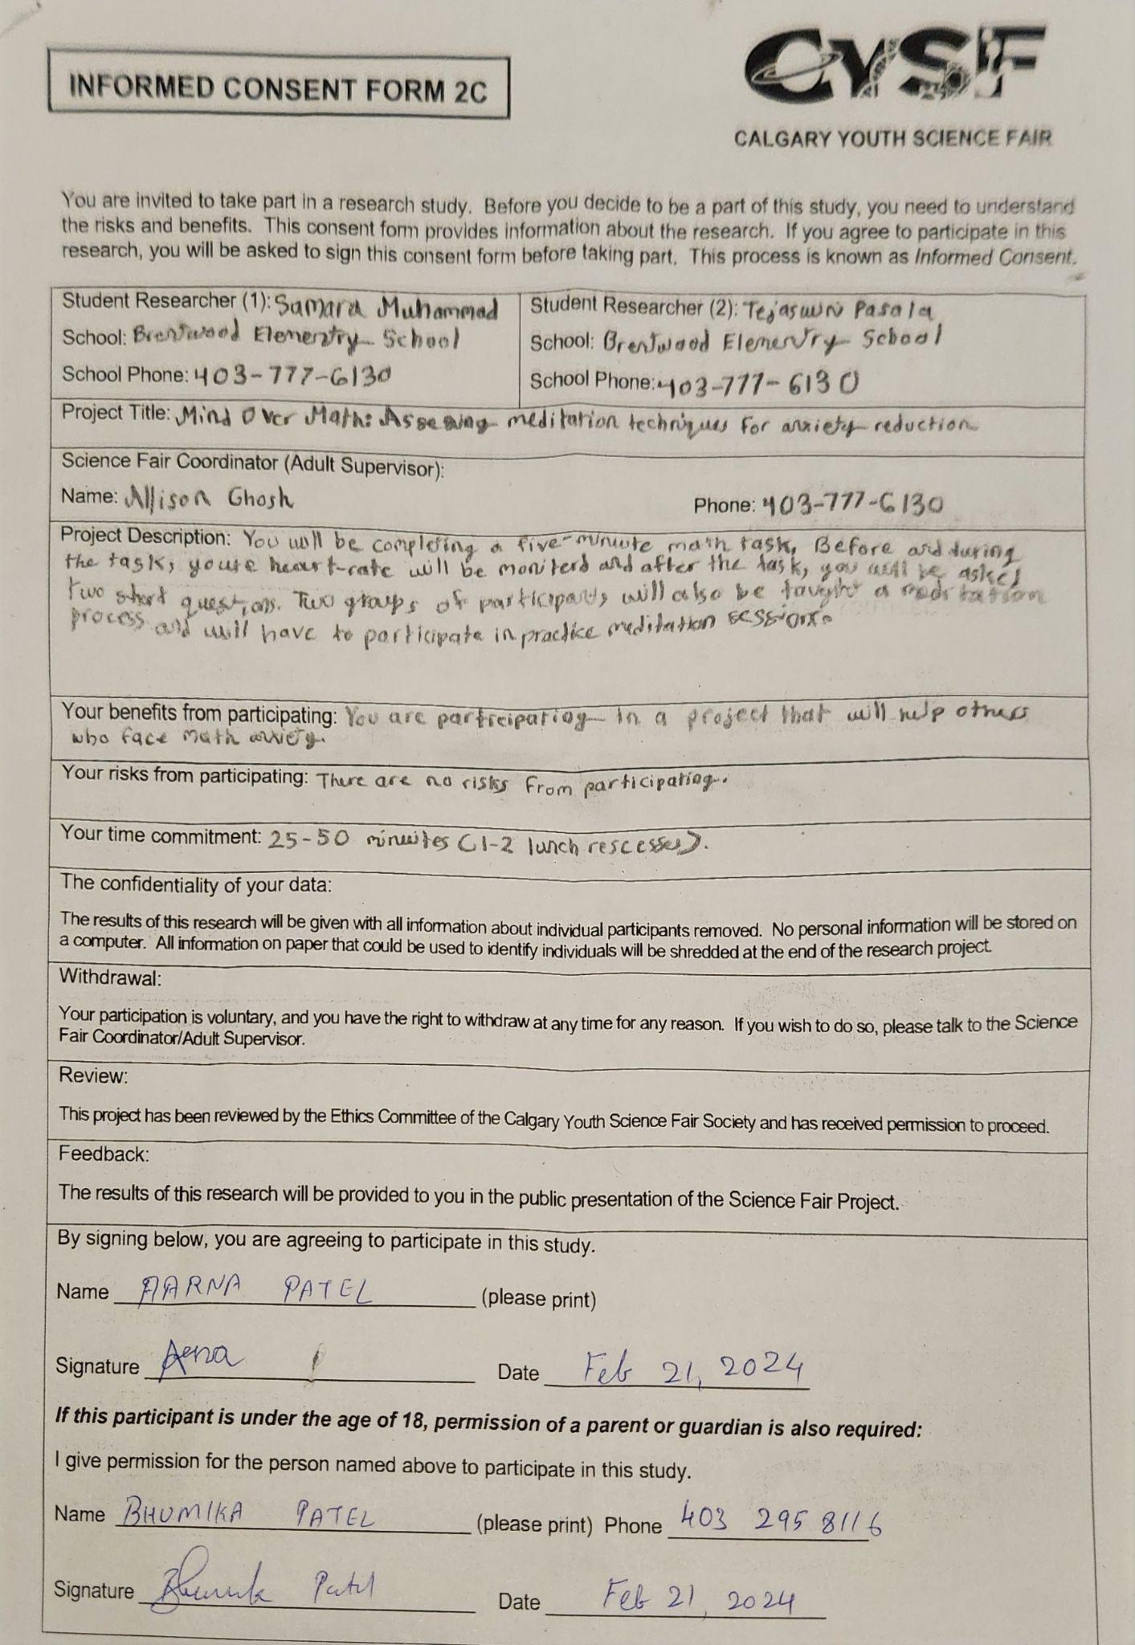
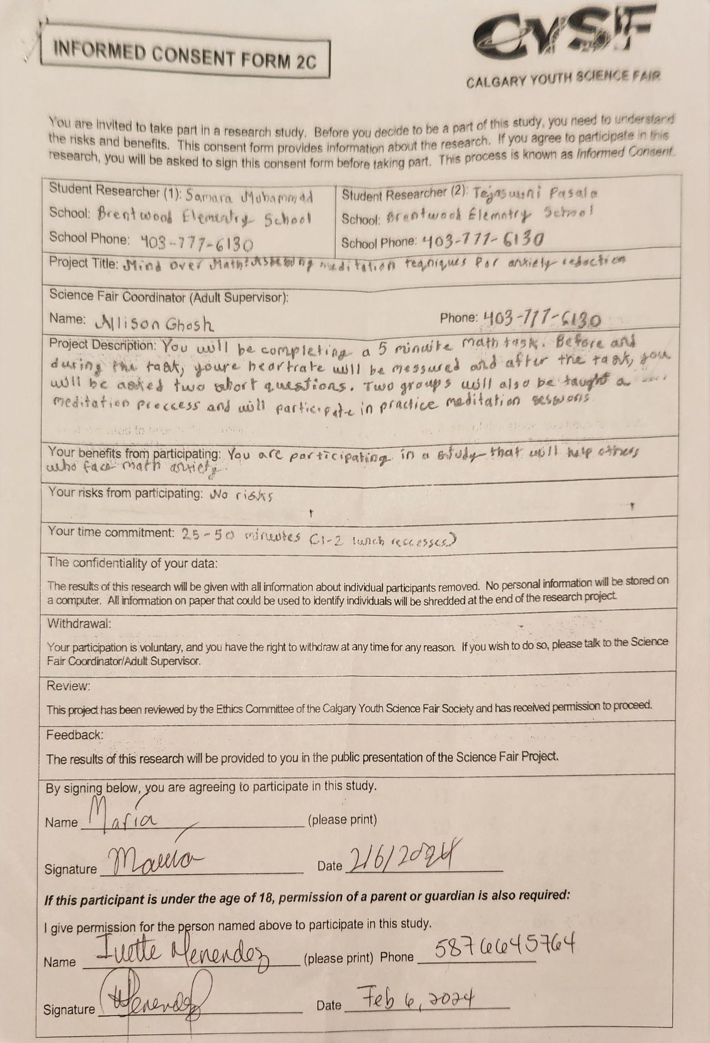
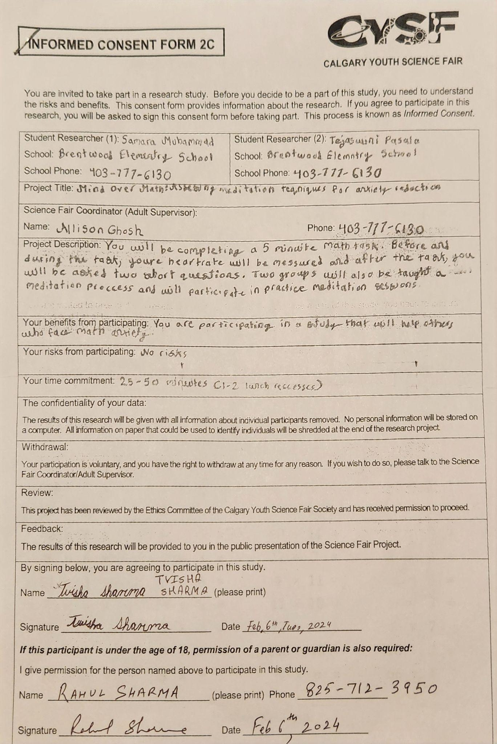
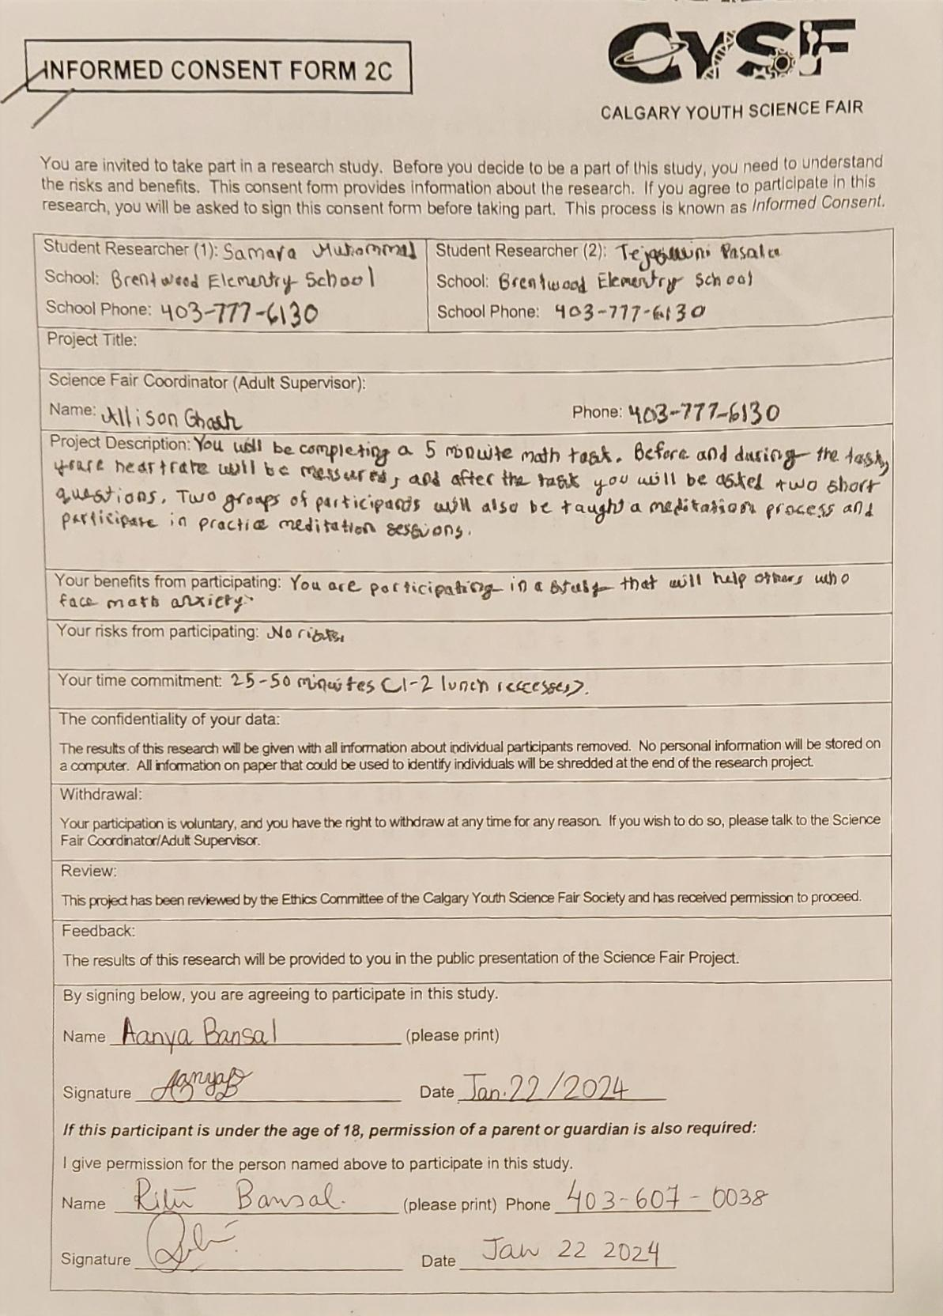
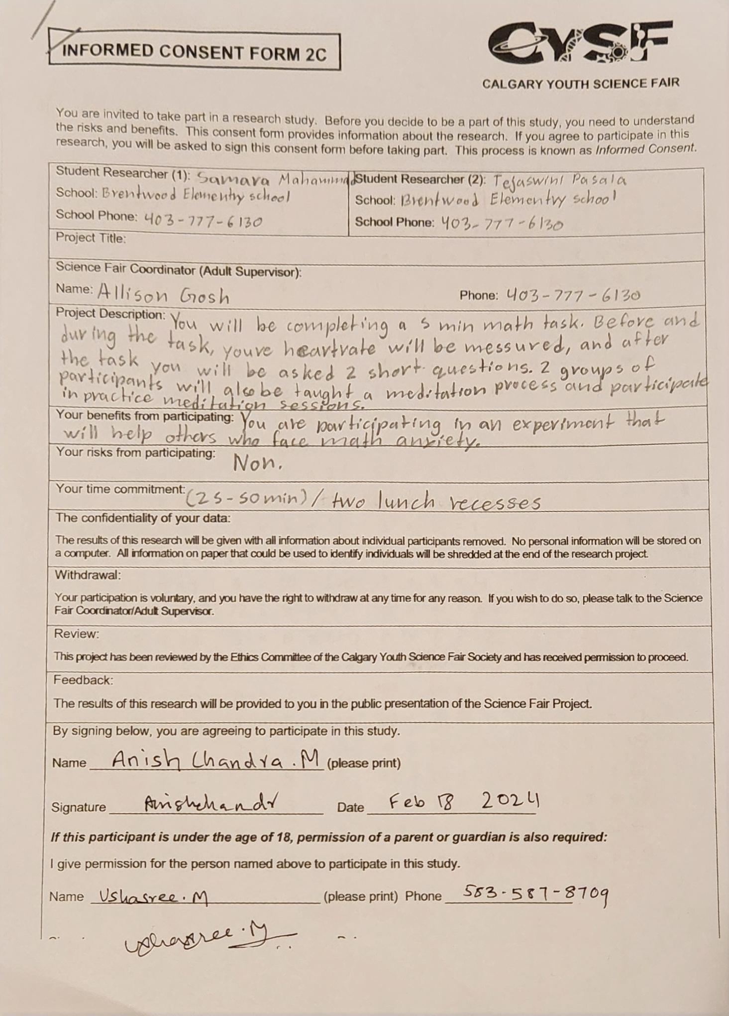
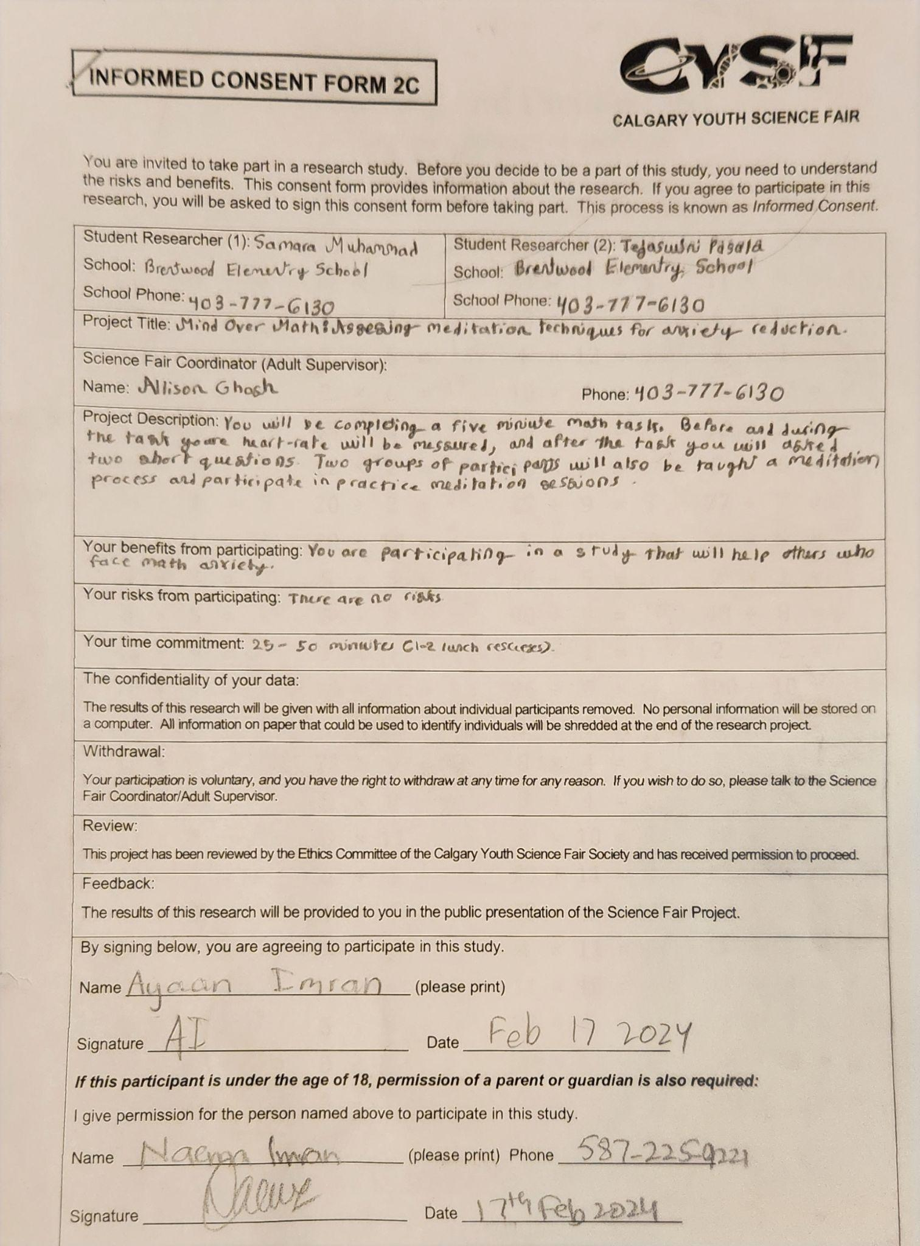
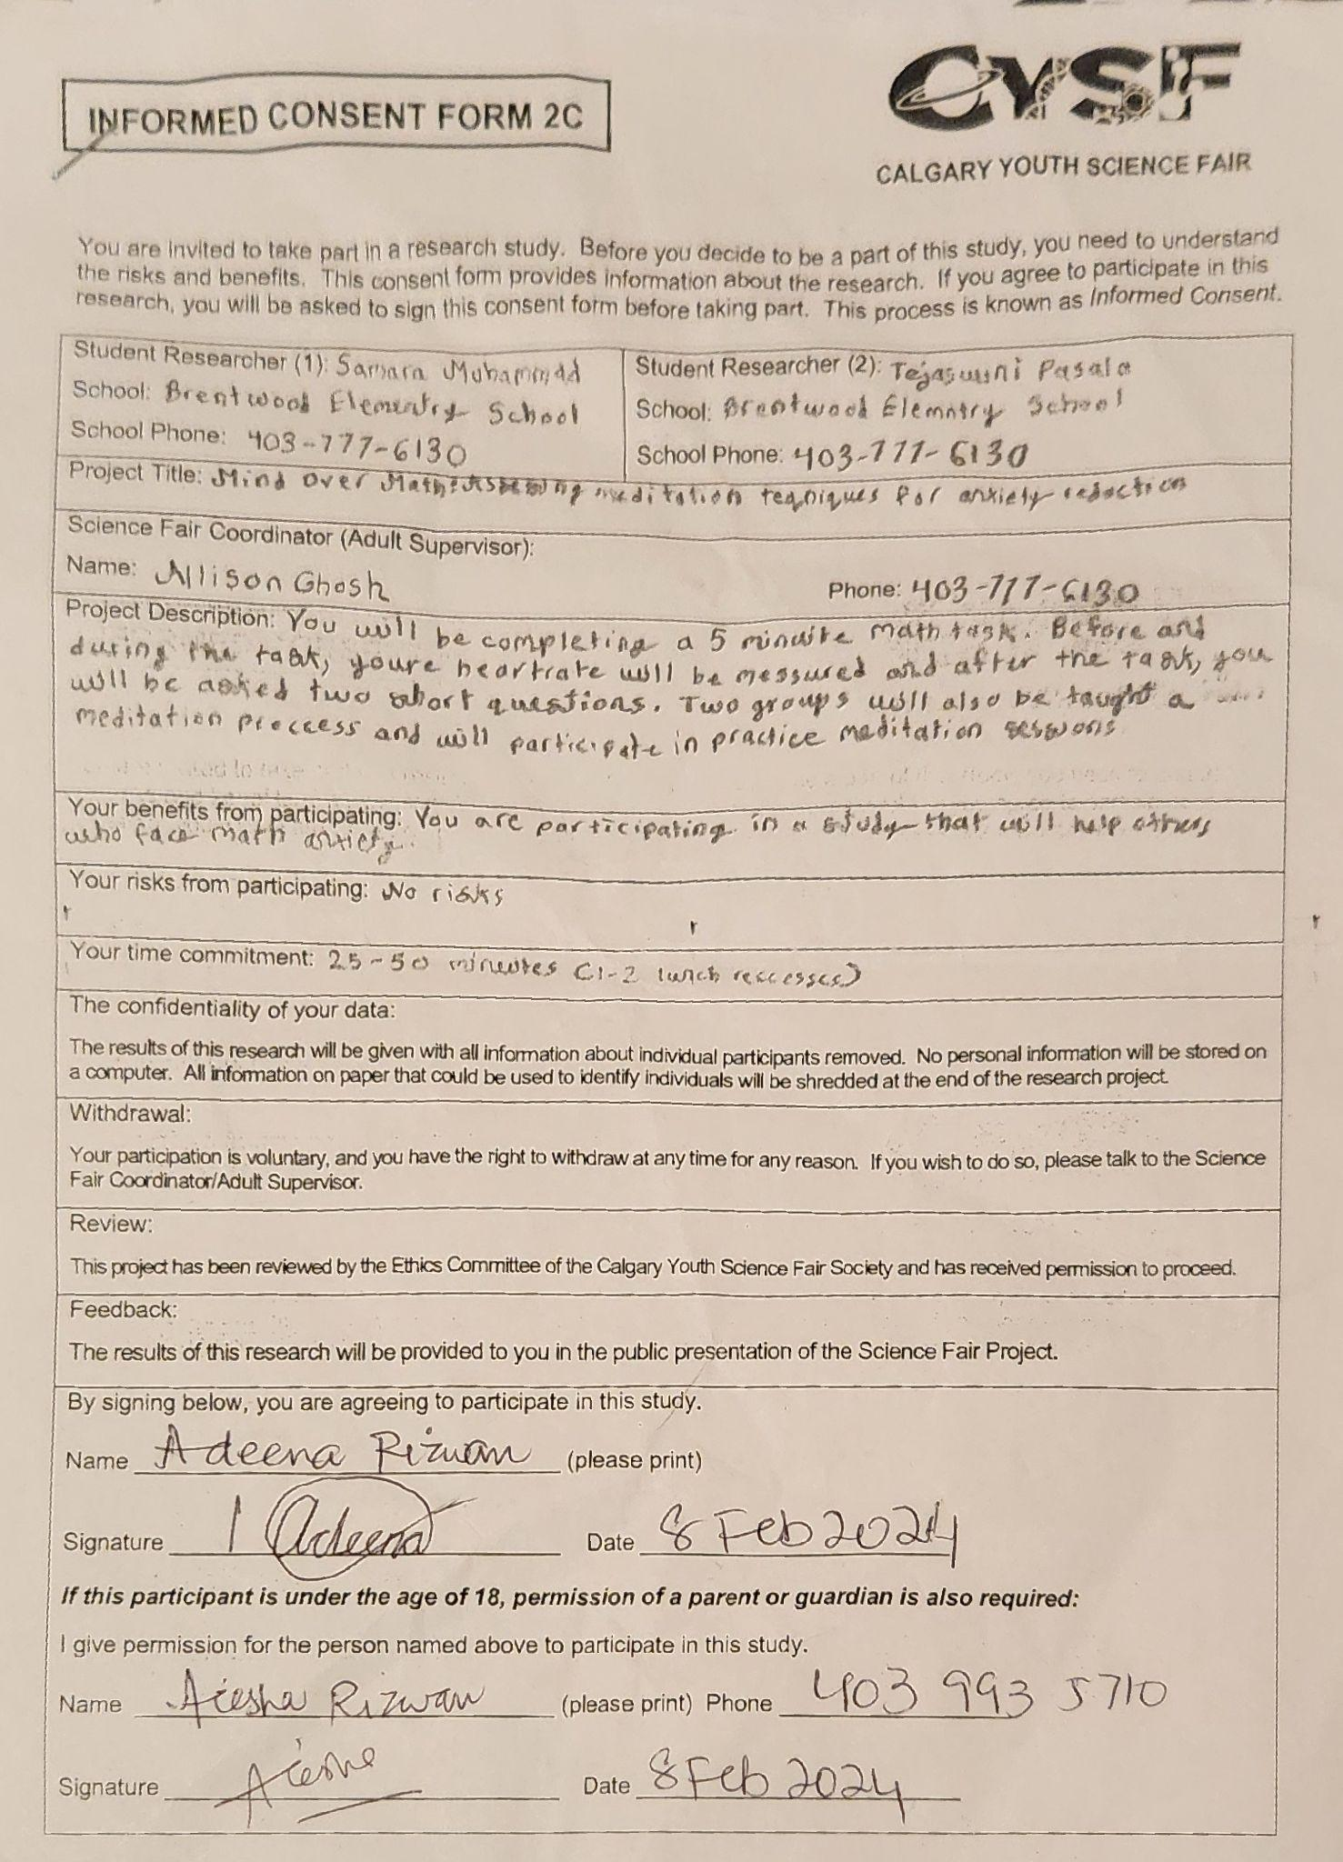
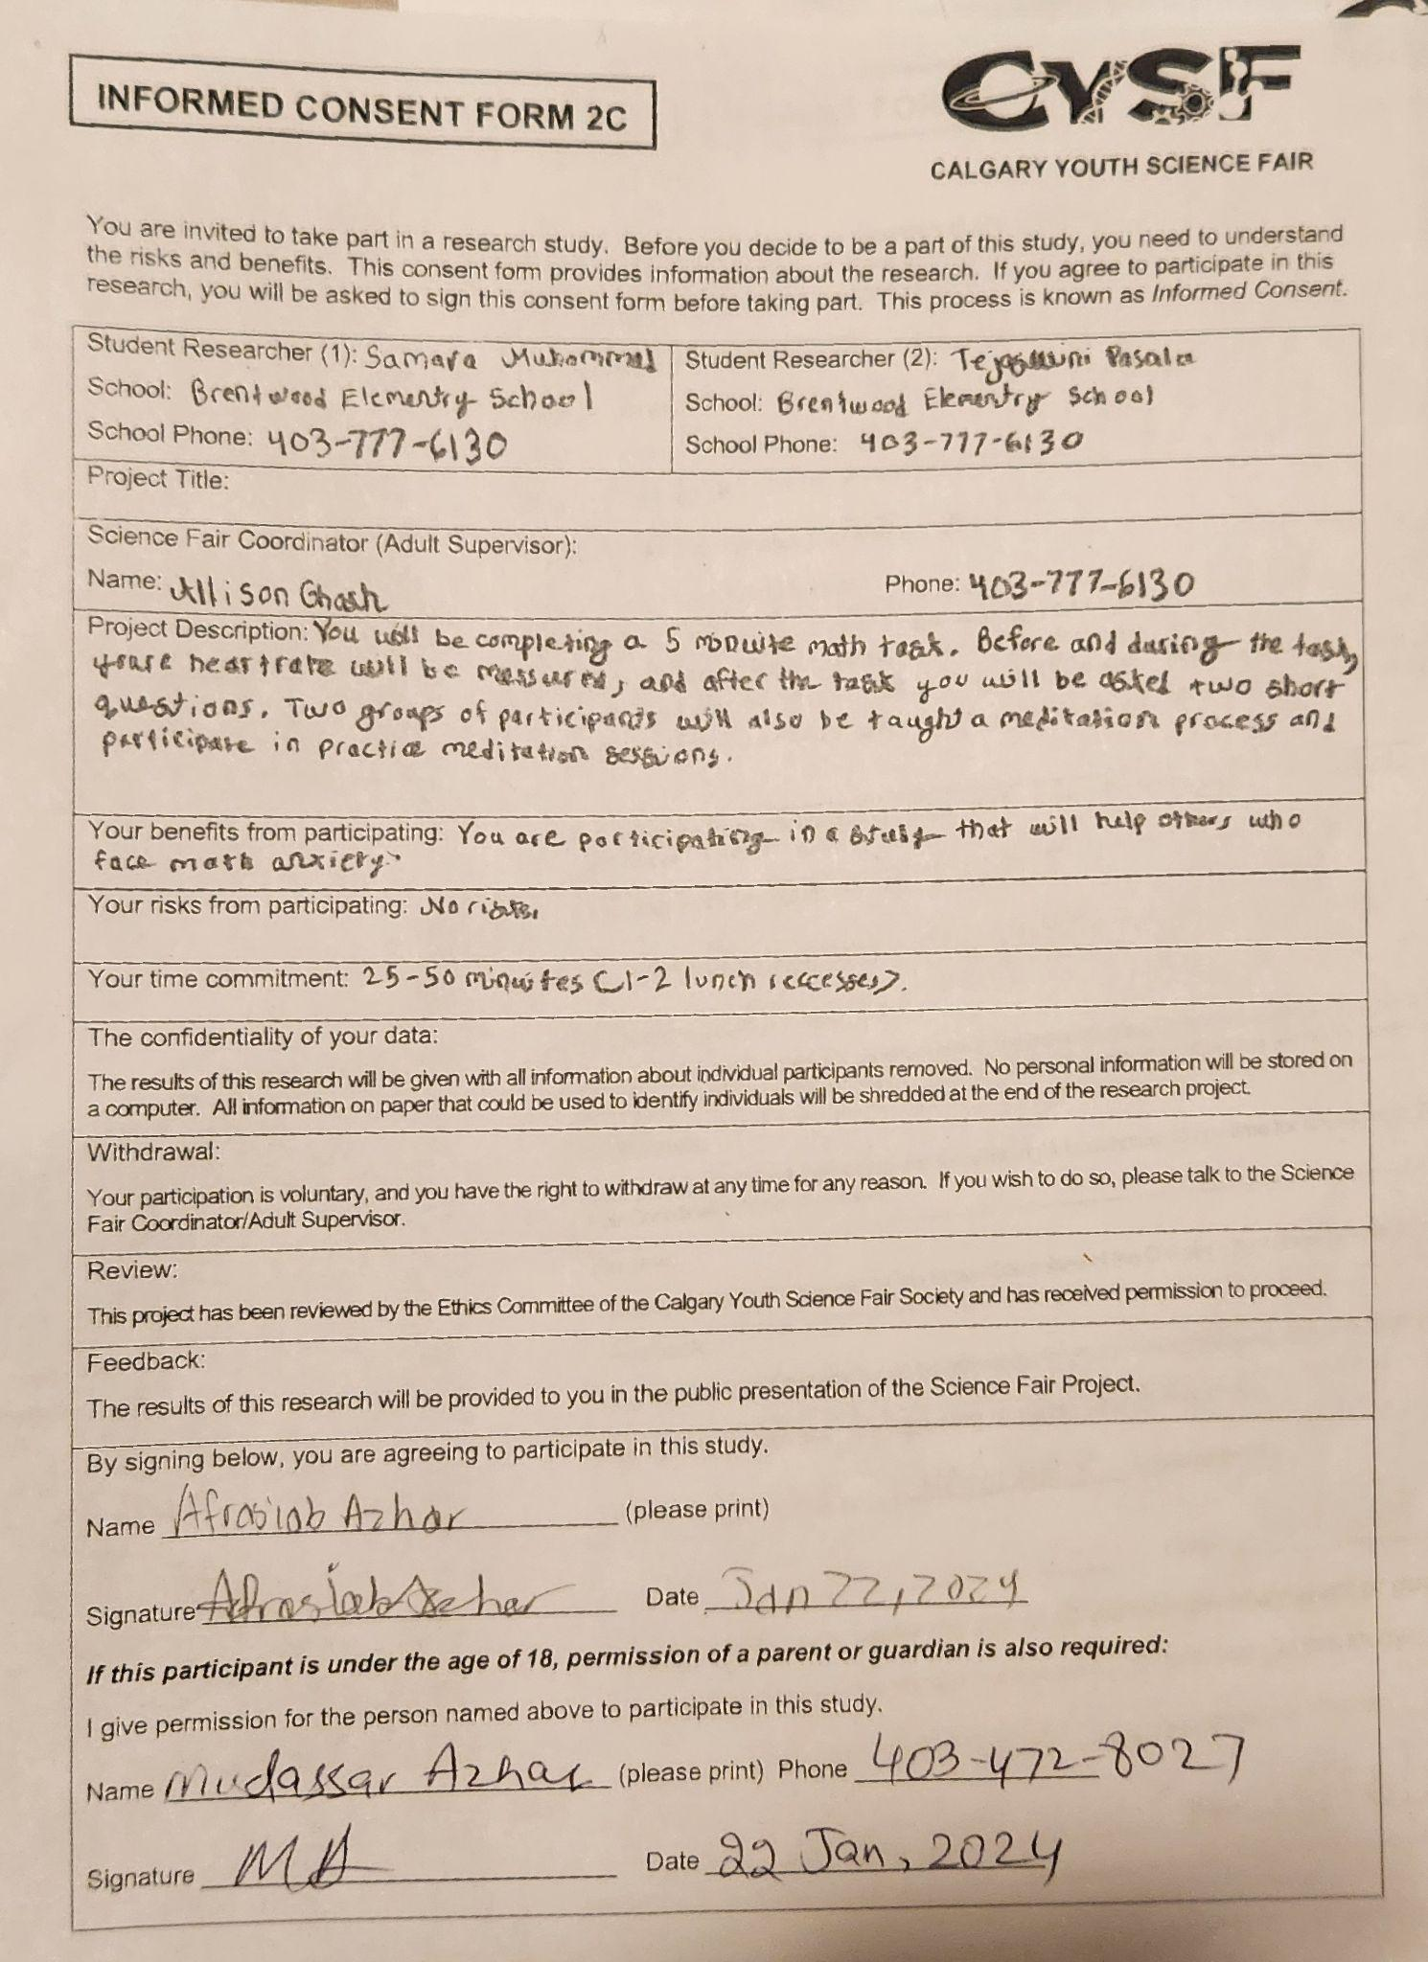
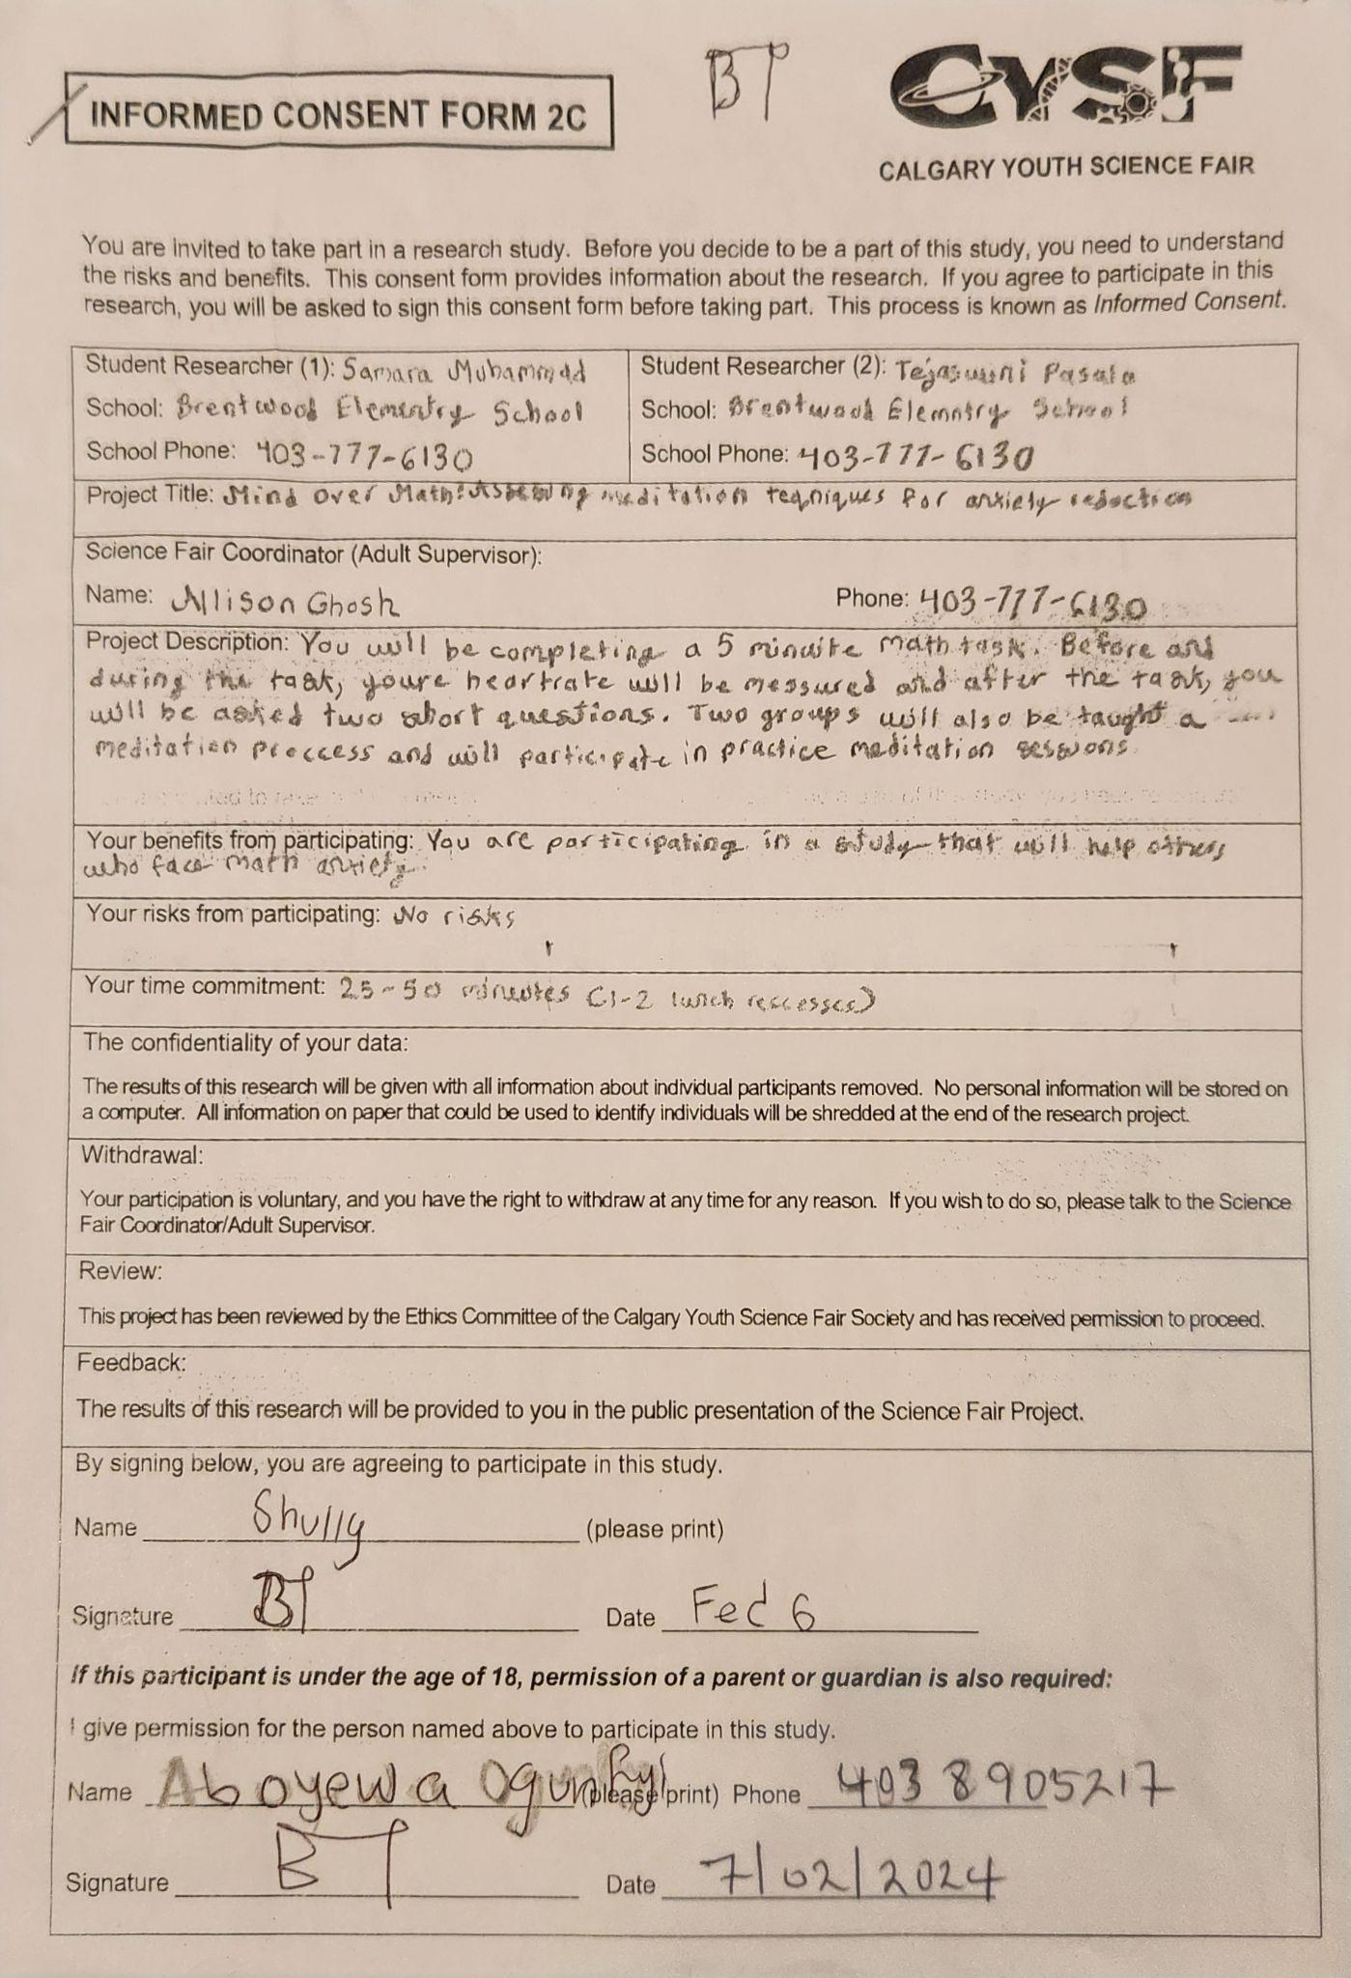

Here are some people who signed the forms, but did not participate.
