The Basel Problem and Limits Logbook
By Ignacio Gimon-Lopez

Ideas:
January 22nd: I think I am going to do a project on the prevalence of Jungian Archetypes within a student population. I am going to ask my teacher if I can test my peers on a test that I designed myself, and compare and contrast it with other studies.
January 25th: As I dug deeper into this area of psychology, my interest has waned. Carl Jung’s books (Man & his symbols, Modern Man without a soul) propose a mystifying conjecture, but it seems to reductionist and rationalist to merit serious empirical attention. Most of the points Jung makes cannot be feasibly tested, and as such, they cannot and do not apply to this science fair. I want something that will motivate me to do and learn Calculus, like limits. I might look into the limitations of limits.
January 27th: After vigorously consulting wolfram alpha, Wikipedia, mathisfun, and more semi-reliable sources (I checked the sources, on the articles I surveyed, scientific papers and books written by mathematicians), I have come to the conclusion that the limitations of limits are few and far in between. However, all hope is not lost, I recently watched a video on the Riemann Hypothesis, and it seems like it might be an option.
January 29th: Everything in Mathematics is connected, and this hypothesis is no exception; the sheer amount of concepts that I need to learn in order to intelligently talk about this hypothesis is mind-blowing. Learning the hypothesis would be feasible if it weren’t for those pesky imaginary numbers and the 2nd dimension to the number line, I am better off doing the Basel problem.

Objective:
- What are limits in math?
- What are their applications with solving the Basel Problem?
- Can one expand the Basel Problem into the realm of Complex Analysis? If so, how?

Method/Research:
Limits (Feb 2)
- A limit is the value a function approaches as the input gets nearer to a value.
- One example of a problem that we can apply limits to is:
- $\frac{(x^{2}-1)}{(x-1)}$
- If x=1 we can work out the equation to be $\frac{0}{0}$, which is indeterminate. (mathsisfun)
- I do not know what I would do without Mathsisfun.com (it is a great website, and any person interested in math should go and take a look. It has been evaluated by professors around the world, and is all around amazing.)

Limits to Infinity (and beyond):
- Infinity is a concept.
- What is $\frac{1}{∞}$?
- Let’s convert that equation into $\frac{1}{x}$.
- We can see that as x increases in value, $\frac{1}{x}$ decreases in value; therefore, the limit of $\frac{1}{x}$ as x approaches infinity is 0.
- This can be written as $\lim_{x→∞}\frac{1}{x}=0$. (mathsisfun)
Infinite Series:
According to “mathsisfun.com,” infinite series are “The sum of infinite terms that follow a rule.” The website then continued to give an example of an infinite series. (mathsisfun)
1/2 + 1/4 + 1/8 + 1/16 + ... = S
Solution to the Basel Problem via geometry:
The solution to the Basel Problem is $\frac{π^{2}}{6}$ , most people know that. However, I found a rather ground-breaking paper detailing a proof for this problem using geometry. This solution was written by Johan Wastlund of the department of Mathematics of Chalmers University. By using trigonometry, Pythagoras, and circles, the mathematician was able to prove the Basel problem relatively easily. The proof uses trigonometry and circles to prove Euler’s solution. Imagine a lake with stars around it with you, an observer at a point on the circumference of the lake. Say that you receive a total brightness of $\frac{π^{2}}{4}$ from the stars. How can we increase the number of stars without decreasing the amount of brightness? We have two things that can help us: the inverse square law and the obscure inverse Pythagorean theorem. Essentially, by using these two tools, we can double the number of stars without decreasing the amount of brightness. As the number of stars approaches infinity, the circle becomes bigger (to a diameter, radius, and circumference of infinity), the limit, as mathematician Ben Hambrecht tells us, (from the observer’s point of view), becomes a line. Then, we cut out the negative numbers in this circular number line, and we get $\frac{π^{2}}{8}$. As the sum only includes positive odd numbers, we multiply the fraction by 4 thirds, giving us the grand total of $\frac{π^{2}}{6}.$ (Hambrecht 2017)
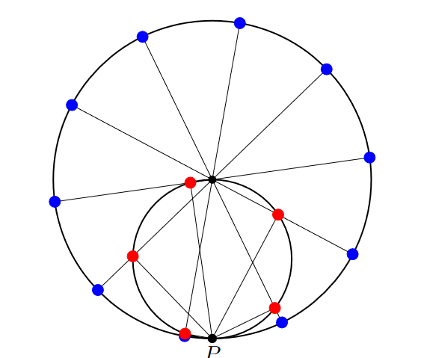
Fig. 1
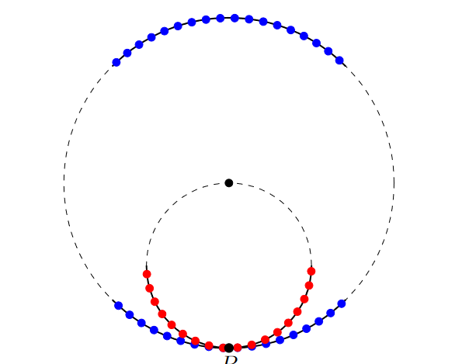
Fig.2
Analysis:
From the above conjecture, one can surmise that, as the mathematician said: “The number line is a limit of an infinitely large circle.” (Hambrecht 2017) Then, it is also assumed that all the stars along the circumference of this circle have the same amount of brightness. After that, it is also assumed that due to the application of the inverse square law, the circle is in a 3-dimensional space, with the stars and the circle like sheets of paper with a height of zero, and the observer being at the point of tangency on an imaginary tangent line.
With this view that the number line is a circle, we can incorporate complex analysis by asking where imaginary numbers can be incorporated within this structure. One way that we can do this is by incorporating a Riemann sphere, satisfying the need to incorporate lateral or complex numbers on the number circle. However, this would imply that imaginary numbers are on the number line, which is patently false. On the other hand, one might assume that as the circle is 2-dimesional and the imaginary components are the depth of the 2-dimensional circle; this would satisfy all the conditions we have placed upon ourselves while implying that the number line is a 2-dimensional projection of the Riemann Sphere. This, furthermore, implies that the number line is a slice of the infinitely large Riemann Sphere, further implying that there are infinite number lines.

Conclusion:
In short, based on the two aforementioned conjectures, one can assume that the number line is a projection of a Riemann Sphere. Limits are the value a function approaches as the input gets nearer to a value. (mathsisfun) Limits’ applications with the Basel problem are in finding the limit of an infinitely large circle in which all the inverse squares of all the odd numbers are contained, then cutting all the negative odd numbers and multiplying by 4/3 to find the ultimate answer: $\frac{π^{2}}{6}$.

Works Cited:
Hambrecht, B. (2018). Inverse Pythagorean theorem. Retrieved March 1, 2021, from https://www.geogebra.org/m/yPExUf7b
Hambrecht, B. (2018, March 02). Why is PI here? And Why is It Squared? A Geometric answer to the Basel problem. Retrieved March 1, 2021, from https://www.youtube.com/watch?v=d-o3eB9sfls
Marianne (2018, July 27). Maths in a minute: The Riemann sphere. Retrieved March 1, 2021, from https://plus.maths.org/content/maths-minute-riemann-sphere
Wastlund, J. (2010, December 8). Summing inverse squares by euclidian geometry. Retrieved March 1, 2021, from http://www.math.chalmers.se/~wastlund/Cosmic.pdf

