- Ways of getting rid of old satellites
- How does anesthesia work?
- How to save dying reefs?
Florida’s coral reef is in crisis. These crabs can help. - Vox
- How can animals medically save our lives? (cancer)
Sea sponges could save our lives, if we don’t destroy them first - Vox
- Lab Grown Blood
Why is there always a blood shortage? - Vox

2023-11-23

Brainstorming with my friends about science fair idea topics. Some that came to mind:
- Understanding the effectiveness of different air filters
- Making my own drone and delivering packages to it

2023-12-14 Final Idea

Me and Jeanne decided to do a project on how to save dying reefs.

Ideas of execution:

2023-12-14

Important Questions
- What are coral reefs and how do they live?
- Why are coral reefs important to marine ecosystems? How do they interact with other organisms?
  - Mention basic symbiotic relationships + roles in marine life both historically and currently
- Why are coral reefs important to the world?
- What is the cause of coral reef deterioration?
- How might genetic engineering help reduce the effects of reef degradation?
- What other factors might help slow coral reef death rates?
- Why is it important to save the coral reefs
- How are coral reefs formed? Their life cycle? How fast can they produce?

Presentation Ideas

Topic: How can we work to stall, or perhaps halt, the rapid declination of coral reefs to save dying reefs?

Plan of Approach:
- research on symbiotic relationships that help coral reefs thrive, genetic engineering in plants/whatever coral reefs are considered (are they plants or animals?? What are they made of??), etc…
- Plan to make a mock coral reef to demonstrate the most effective way based on our research.
- maybe look into how genetic engineering could help reefs build resistance to whatever is killing them
- Actions we can take to save them (climate change, diving conditions, pollution, tourism)

Refined Method:

Background Research
- Gain a comprehensive understanding of the corals under the Acropora genus, including a general knowledge of:
  - Anatomy and life cycle
  - Significant symbiotic relationships
  - Impact on marine ecosystems
  - Causes of endangerment
- Review knowledge of DNA structure and placement within cnidarian species
- Learn about the general components and role of DNA within cells, including:
  - RNA formation
  - Polypeptide chain and protein synthesis
  - Restriction enzymes and their role within DNA technology
- Understand the causes of Acropora coral endangerment, specifically coral bleaching, on a genetic level

Project Method
- Research what CRISPR Cas9 genetic technology is, how it is used, and how it has been used in the past; specifically in circumstances that involve:
  - other cnidarian species similar to Acropora corals
  - direct endosymbiotic partners of Acropora
- Research possible solutions to coral endangerment, specifically (but not limited to) alteration on the genetic level involving heat resistance
- Researching, gathering, and considering the feasibility and consequences of using genetic engineering in wildlife as a temporary, or long-term solution to the effects of climate change
- Researching and analyzing the potential of alternative solutions in comparison to genetic engineering

Basic Research To - Do
- life cycle
- role in the marine ecosystem
- Impact on humans
- habitat
- food sources
- symbiotic relationships
- what are they made of?
- what's killing them?

genetic engineering in polyps - Hasn't been done before.

Basic Research
2023-12-16 and 2023-12-17
Life Cycle
2 Types of Coral Reproduction
- Broadcast Spawners - external fertilization
- mature reefs produce gametes through meiosis, are released into the water when environmental conditions are right
  - usually specific time and date called synchronized coral spawning
- gametes are positively buoyant (they float) and are fertilized as they float upward
- zygote begins to develop, floating around the ocean on a current
- begins mitosis, until the embryo is formed. This eventually forms a larva coral, called a planula
  - planula is a type of microscopic zooplankton, has cilia for movement but not very strong, relies on ocean current for movement.
  - looking for suitable solid substrate for settlement
- finds substrate and begins metamorphosis to become juvenile polyp
  - polyp is a tiny invertebrate with a blobby body and a mouth, surrounded by stinging tentacles
- begins to lay down corallite made of CaCO₃
  - corallite is the skeleton of a coral polyps
  - coenosteum is the skeleton/bone structure holding the corallites of a colony together
  - if coral is considered colonial (made of hundreds of thousands of individual organisms), it will reproduce asexually to increase coral colony size
- the cycle repeats!
- Brooders - internal fertilization
- male brooder coral releases negatively buoyant sperm into the water, which finds unfertilized egg cells inside a female coral (internal fertilization)
  - forms embryo through mitosis, planula is formed inside of the female
- planula released from the egg-bearing coral, planula begins to look for suitable solid substrate
- begins metamorphosis to become juvenile polyp, lays down corallite
- the cycle repeats!

NOTE: It takes more effort for the brooder type of coral to reproduce than the broadcast spawners. However, broadcast spawner gametes have a lower chance of fertilization because of water conditions.

Anatomy:
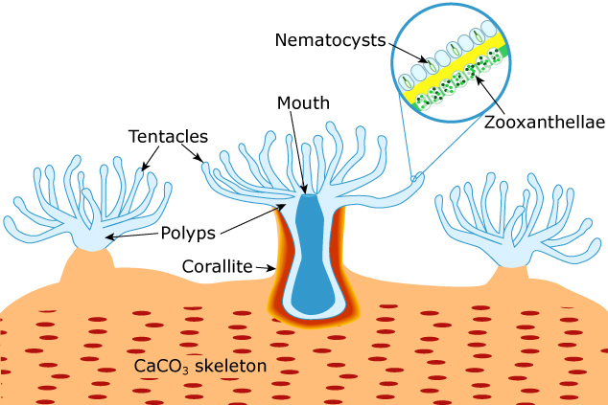
(image taken directly from https://www.usgs.gov/media/images/simplified-coral-anatomy)
- nematocysts/cnidocytes release barbs that contain chemicals that can stun prey, which tentacles will move into the mouth
- zooxanthellae algae helps provide energy through photosynthesis
- corals are connected together through the calcium carbonate skeleton and corallite holding them to the calcium carbonate skeleton
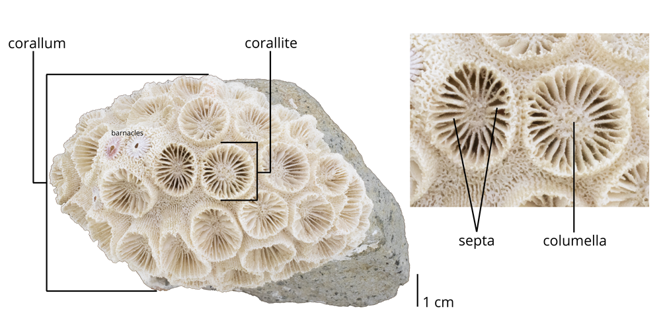
taken from: https://www.digitalatlasofancientlife.org/learn/cnidaria/anthozoa/scleractinia/
- corallum: the entire colony's connected skeleton
- corallite: the singular coral skeleton holding a polyp to the central corallum
- septa: the strands radiating from the center to the outside of the coral
- columella: a column of corallite, only present in some species of corals

Role in the marine ecosystem

Shelter and Protection: According to EPA, over 4000 species of fish rely on coral reefs. They are home to 25% of all marine life. Their unique structure offers protection to organisms at the bottom of the food chain against predators. They are also safe places for spawning grounds as many fishes hide their eggs in hidden openings of corals.

Coastlines: Coral reefs have the ability to reduce coastal flooding and erosion. Coastal flooding happens when low-lying land is submerged by seawater. Flooding and erosion have a serious impact on marine life who thrive in shallow waters. Their low-crested breakwater structure allows them to dissipate incident wave energy. As a result, corals are capable of reducing the power of waves by 97%.

Water filtration: Coral reefs are generally sensitive to any environmental changes, such as temperature and change of pH. As a result, they naturally filter water to improve their surroundings. Many coral reefs are filter-feeders, meaning they are able to filter insoluble pollutants. Hence, pollutants wouldn’t be able to settle at the bottom of the ocean floor nor disperse harmful materials to other marine organisms. Using their microscopic sieves, they are able to eliminate particulate matter. To add, even when corals die, their skeleton is capable of providing some filtration.

Impact on Humans

Economic/Recreational Contribution: The Coral Reef Alliance estimates that coral-based tourism contributes about $36 billion dollars annually to the economy. They are a crucial constituent in the tourism industries of tropical areas such as in America, Australia, Indonesia, and Fiji. These corals attract people from all over the world, which supports millions of jobs and local businesses in restaurants, transportation, and touring. Typically, tourists scuba dive into relatively shallow waters to see these magnificent creatures. It's estimated that approximately two out of three of all tourists in Hawaii are reef visitors.

Corals are also the main food source for parrotfish. These parrotfish break down the corals and release "white sand" that fills beaches. This is also a popular tourist attraction because white sand is associated with luxury, relaxation, and purity in vacation destinations.

Safety Contribution: When new immature papulae begin to build their corallites and develop into mature colonial corals, the new polyps in the colony have strong corallite structure holding them to the solid substrate that they live on. They also have coenosteum structures holding them together, which prevents erosion of coastlines and protects humans living along these coasts from coastal floods.

Food Contribution: Because the coral reefs are home to many tropical marine creatures, they help support prey at the bottom of the food chain. These include the lobster, grouper fish, and snapper fish. As of 2021, an estimated 500 million people depend on reef fish for nearly 20% of their diets.

Contribution to Medicine: Medicinal bone grafting has come from corallite since about 1970, and modern research continues to use coral to help treat diseases like osteonecrosis and in bone replacements. Corallites are ideal for bone grafting because they are very permeable, increasing the chance of acceptance from the host body. They can help create bridges between the new coral and the bone cells of the host by attracting new bone-building cells from the host. This is due to the similarities between the chemical structure of corallite and the human bone.

Habitat

Shallow water corals
Shallow corals prefer clear, warm waters. This explains the magnitude of the Great Barrier Reef in northern Australia. Its warm and relatively clean waters are the perfect conditions for reefs to thrive and reproduce.

Corals reproduce best when they are in minimally moving water. It increases the chance of external fertilization happening because the gametes will generally be in the same area. This means that synchronized coral spawning depends greatly on tidal and lunar cycles. It also depends on global ocean currents. One of the reasons that the Great Barrier Reef is so large is because it is in the north-west coast of Australia. This location avoids the major ocean currents in the area: East Australian current, Leeuwin and Zeehan current, Indonesian Throughflow current, and Antarctic Circumpolar Current.

Shallow water coral reefs also host zoothanthellae, a type of unicellular algae, in their polyps. This algae contains chlorophyll and undergoes photosynthesis, which creates glucose for the coral reef to feed off. This explains why shallow water corals live in the sunlight zone of the ocean. If they move into deeper levels, the zoothanthellae don't have enough sunlight to produce food for the coral to feed off.

Deep water corals:

Little is known about deep-water corals because of the minimal exploration of the ocean floor. What we do know about deep-water corals is that they trap tiny organisms flowing by in the current instead of obtaining nutrition from sunlight. Because they don't depend on warm water or sunlight for food though, they can live in many places around the world, including areas off coasts in northern Europe, Caribbean, Canada, Japan, and America.

Food sources

Coral polyps are nocturnal feeders. They utilize their tentacles to capture small fishes and floating zooplankton (small, aquatic microorganisms). Specialized, stinging cells containing a coiled barbed thread called nematocysts assist corals to effectively catch their prey. Some other corals secrete mucus to collect organic particles. The organic particles will mix with proteins. The coral will come out of its skeleton and deposit calcium carbonate. This builds a coral’s skeleton while developing the structure of the reef. Another very common way corals obtain energy is through their symbiotic relationship with zooxanthellae, a tiny algae. The algae lives in the coral polyps. As algae makes sugars for energy (photosynthesis), the energy will be absorbed by the polyp. Most corals live in clear waters, usually, those waters are nutrient-poor. As a result, 95% of a coral’s diet is produced by algae. Corals release waste through their mouth or is used by zooxanthellae for photosynthesis.

Cause of Coral Population Declines

Bottom trawling

Trawling is a type of fishing that drags a heavy net along the ocean floor to catch fish.The nets can break the corallite that roots corals to their substrate, which uproots and destroys mass amounts of coral. This also greatly affects the seafloor, smoothing it out and changing the ecosystem.

Oil and Gas Spillage

With oil transportation comes oil spills, which negatively impact so many organisms in the ocean. Corals are one of the main species that fall victim to these accidents. When oil comes into contact with corals, it affects their abilities to continue living, reproducing, and growing. Oil can come into contact with corals in multiple ways, including:
- when tides go down, oil floating at the surface touches the corals in the intertidal zone
- rough sea waters mix oil into the water column
- when oil weathers (separates and reacts differently with chemicals in the water) or mixes with sediment, it can sink to the bottom and smother coral

Ocean Acidification From Climate Change

Ocean acidification: the gradual increase in ocean acidity due to high carbon dioxide concentrations in the atmosphere, changing the chemical makeup of our oceans.

The carbon dioxide dissolves in water to create the carbonic acid in the oceans, which tends to react with carbonate. This creates bicarbonate. When this reaction occurs, the levels of carbonate in the ocean drop. Since most hard structures in the ocean, including corallite, need carbonate to form, the absorption of carbonate in ocean acidification greatly impacts coral structures. Because corals form slowly (especially deep-sea corals), it takes years for the corals to recover.

Symbiotic Relationships

Zooxanthellae (zoo-ah-zan-tha-li): Corals share a mutualistic symbiotic relationship with tiny algae, called zooxanthellae. These organisms live within the tissue of corals. Corals provide its waste and protection to algae. For photosynthesis to occur in zooxanthellae inside the corals, corals need to live in clear, clean water in order to absorb the sunlight. Corals use the algae’s products of photosynthesis, such as, glucose, glycerol, and amino acids. Furthermore, byproducts such as oxygen and carbohydrates are also used by corals. As a result, these products help corals produce calcium carbonate to help build their skeletons and develop reefs. In nutrient-poor environments, the relationship between these two organisms is crucial to maintain the growth of coral reefs.

Zooxanthellae influences the color of many corals. The quantity of algae in the coral is a good health indicator of the coral. Coral bleaching occurs when they experience stress due to sensitivity from their environment. They release zooxanthellae and become white. Due to the inadequate amount of zooxanthellae, coral bleaching can lead to a coral’s death.

Cleaner fish: Corals and cleaner fish share many benefits. Cleaner fish eat parasites off of corals which cleans them and promotes good health. In return, cleaner fish are fed.

Corals have many predators such as sea starts, mollusks, sharks, crustaceans, snails and crabs. Corals are the main diet for parrotfish. Using their sharp beaks, they feed on the tissue of corals fo nutrients. Snails have radulas, tongues, which help them extract polyps from the skeleton of hard corals. Similar to snails, sea urchins are easily able to ebay the calcium carbonate structure made by corals. As many prey of large predators hide within corals, they are often destroyed by a predator’s attempt to catch their prey.

What are corals made of?

A coral is made of several polyps and skeletons. Coral polyps are around 1-10 mm long. Polyps are soft and tubular, and they have many tentacles to capture food. Coral polyps use calcium carbonate in a form called aragonite to build their skeletons. Aragonite is found in the shells of many marine organisms. It is more soluble than other forms of calcium carbonate, and helps corals build their skeletons. However, due to its soluble property, aragonite is extremely sensitive to pH. Ocean acidification reduced the number of aragonite, making it harder for corals to make their skeletons.

A coral polyp has the main structure of a cylindrical sac with two layers of epithelia.
The surface body wall: This is any outer layer to protect the polyp from its surroundings.
Basel body wall: This keeps the poly attached to its skeleton.

2023-12-20
Deciding solutions
- Discuss our options for a solution based on our research
- Genetic engineering research - what does it mean/entail, what has been done before?
  - finish by 2023-12-22
- Research that solution
- Make a model????????????? →January

Our ideas to save dying reefs
- use a different substance to replace CaCO3 (aragonite for the corallite)
  - predators damage what lives in the corals
- Find a way to prevent corals from releasing algae (zooxanthellae)
- Adapting the polyps to clone on different surfaces
- Transfer a useful gene of an organism to corals
- Transferring a gene of interest into a common virus that will spread to corals

What is genetic engineering?

Genetic engineering works by modifying the DNA of an organism to alter it’s characteristics using biotechnology tools or techniques. The genome (DNA) is altered either by changing one base pair (A-T or C-G), deleting a whole region, or introducing a new gene. By changing the genome, the gene of a donor organism is transferred to a recipient organism. The recipient becomes a transgenic or genetically modified organism. The goal of genetic engineering is to produce favorable avantages to the organism.

2023-12-23
Here are some methods:

*Vectors: way of getting recombinant DNA into organisms

Using bacteria in a lab
- Commonly used to create insulin for people with type 1 diabetes
- Bacteria are easy to grow and efficient at multiplication
- Transformation: common bacteria easily take up DNA from genes of interest from other organisms. In order for the bacteria to perform transformation, chemicals and temperature changes are used.
- Genes are placed into the plasmid (circular set of extra genes) of a bacteria
- Restriction enzymes cut specific genes in the plasmid to be replaced with the donor gene
- Ligase (an enzyme) bind the molecules together, therefore, sealing the gene into place.
- The bacterium plasmid becomes recombinant DNA (contains plasmid DNA and DNA of interest)
- When the bacteria reproduces, the recombinant plasmid will be inherited.

Virus
- Removing a virus’s own genetic material and replacing it with a gene of interest
- Virus will spread gene of interest to target cells

CRISPR (Clustered Regularly Interspaced Short Palindromic Repeats) - this method is currently used to genetically modify corals
- Fastest, easiest and cheapest method
- Found in the bacterial immune system, originally found defending single-celled bacteria and archaea
Two main components
- snippets of repetitive DNA sequences called CRISPRs
- Cas/CRISPR associated proteins that act as an editing tool which cuts DNA using a special kind of nuclease called Cas9 similar to restriction enzymes.
How it works
- A “guide” RNA is created, it is identical to the gene they want to edit and attaches to Cas9
- Guide RNA leads Cas9 to the target gene, once Cas9 finds the target, it snips that part of the DNA.
- The cell will attempt to repair it by using nucleases (proteins) which join the broken ends of the DNA back together. This process is called nonhomologous end joining. This process is unstable and can lead to mistakes (extra and missing bases).
- As a result, scientists add a template DNA to CRISPR that will guide cellular proteins to use a different repair process called homology directed repair.
- Homology directed repair could repair a defective gene or insert a new one.
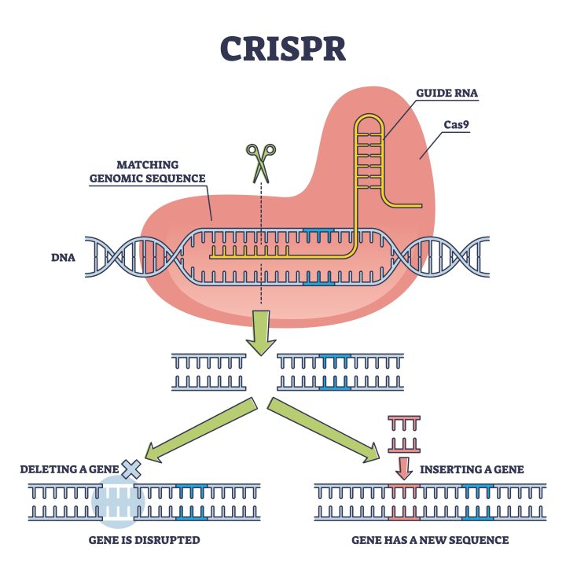

CRISPR – a gene editing tool - Lab Associates

2023-12-23
What Part of the Coral Genome is Altered?

In order to find which part of the coral genome corresponds with a certain type of growth, it is essential to narrow down a type of coral to research. We must also understand the growth and evolution of the coral genome over time, as it is one of the oldest species that are still alive today.

Of the Acroporidae and Montipora Coral
acroporidae
- had about 45%-50% of genetic repetition across the different acroporid species
- roughly 50%+ in montipora, suggesting longer sequences of repetition
- most of repetition types of genetic sequences were in LINE and SINE (long and short interspersed nuclear element of the coral genome)
- most common repetitions are found in the novel genes
  - novel genes = nucleotide sequence that is unknown/in an unknown exon
  - exon = section of DNA
- acropora has most consistent gene organization during evolution in comparison to other scleractinians
  - scleractinian = full grown and matured polyp, in a blob/bell shape

2023-12-29 - Discussion (narrowing the problem)
What type of coral will we focus on? Acropora
What genetic engineering method should we focus on? Crispr
Research or innovation? research
Genetically engineered heat-resistant coral: An initial analysis of public opinion - PMC
Genetic Engineering
Engineering Strategies to Decode and Enhance the Genomes of Coral Symbionts

2023-12-31

Updated problem: How to save dying acropora corals using biomedical engineering?

What has been done so far:
CRISPR used to genetically edit coral | News Center | Stanford Medicine
CRISPR/Cas9-mediated genome editing in a reef-building coral | PNAS

In 2018, Phillip Cleaves, a postdoctoral scholar at Stanford has taken efforts to genetically modify corals with the help of CRISPR. By calculating the spawning cycle of corals, Cleaves managed to successfully collect coral zygotes in Australia.

Target genes:
Red fluorescent protein (RFP) converts blue light into orange-red wavelengths. Red light reaches farther into the coral tissues which contain symbiotic algae. This helps maximize photosynthesis.
Green fluorescent protein (GFP) protects algae from collecting too much sunlight
Fibroblast growth factor 1a (FGF1a and FGF) helps control coral colonization.

Results:
CRISPR was not able to cut off the red and green fluorescent proteins due to having multiple copies of said proteins. However, CRISPR would be able to change genes that were fairly identical to each other through DNA sequencing. One gene copy of fibroblast growth factor 1a is present in corals. Some embryos had the gene significantly mutated.
Crispr shows more success in single-copy genes.
When?
- When do they reproduce?
- When in the reproduction process do we insert CRISPR?

Vocab list
DNA sequencing: determining the order of bases that make up a DNA molecule
Transcription: collective process by which genetic code is read by enzymes in order to produce all of the proteins in an organism

Hypothesis
2024-01-01
If clustered regularly interspaced palindromic repeats technology is successful in genetically modifying acropora corals to be resistant to coral bleaching, then the death rate of coral reefs would be stalled because one of the main death causes of coral reefs would be eliminated.

If CRISPR can be used in acropora corals, then coral population declination would be reduced because the corals would have increased resistance to the effects of climate change (such as ocean acidification and increasing global temperatures)
Experts To Reach out to

https://network.expertisefinder.com/search-experts?query=marine+conservation+biology

simon.donner@ubc.ca - simon Donner, UBC

cdh5@cornell.edu - Drew Harvell, New York

djsmitc@essex.ac.uk - random UK man who did a lot of research

2024-01-03

CRISPR experiment Philip Cleaves
In 2018, Phillip Cleaves, a postdoctoral scholar at Stanford has taken efforts to genetically modify corals with the help of CRISPR. By calculating the spawning cycle of corals, Cleaves managed to successfully collect coral zygotes in Australia. This experiment has been done in effort to, stated by Cleaves, “-use CRISPR/Cas9 with the express interest to start understanding what genes are critical to coral biology.”

Target Genes
Scientists wanted to remove the following genes…
Fibroblast growth factor 1a because FGF signaling (protein that communicates with other molecules outside the cell) helps corals sense the environment which could trigger larval settlement (free-swimming coral larvae attach onto specific substrate) and metamorphosis (change in body structure to transition from a developmental stage).
Red fluorescent protein (RFP) converts blue light into orange-red wavelengths. Red light reaches farther into the coral tissues which contain symbiotic algae. This helps maximize photosynthesis.
Green fluorescent protein (GFP) protects algae from collecting too much sunlight

Design of CRISPR, specifically sgRNAs
The design was to reduce off-target effects (Cas9 cuts DNA that is similar but not identical to target). Endogenous restriction sites (As part of defense, restriction enzymes cut specific DNA sequences) would detect mutations. Furthermore, to prevent toxicity or delay in mutations, corals were injected with in vitro transcribed sgRNAs precomplexed with Cas9 protein instead of vector-driven expression (*genes encoded in sgRNA and Cas9 are placed into target cells using vectors/carriers). This offered a more direct approach.

*think of it like placing Cas9 in a virus which will be delivered into cells

How can we insert CRISPR into corals?
CRISPR ribonucleoprotein is injected into fertilized eggs. The targeted position was far enough upstream (towards 5 prime) in the genes’s coding sequences so mutations would change the reading frame (triple codon when paired with mRNA) and knock out gene function. Also, downstream (towards 3 prime) to avoid functional gene products (either RNA or protein created through expression of a gene). Less than 400 fertilized zygotes were injected with two or three sgRNA/Cas9 complexes, some received the Cas9 protein alone.

What is being altered? Why?
Fibroblast growth factor 1a because FGF signaling (protein that communicates with other molecules outside the cell) helps corals sense the environment which could trigger larval settlement (free-swimming coral larvae attach onto specific substrate) and metamorphosis (change in body structure to transition from a developmental stage).
GFP and RFP proteins respond to environmental perturbations (anxiety/stress). These genes have multiple copies, therefore, could target multiple copies with one sgRNA (single guide RNA).

Results
CRISPR was not able to cut off the red and green fluorescent proteins due to having multiple copies of said proteins. However, CRISPR would be able to change genes that were fairly identical to each other through DNA sequencing. One gene copy of fibroblast growth factor 1a is present in corals. Some embryos had the FGF1a significantly mutated. Crispr shows more success in single-copy genes.

Mutation inductions in 50% of sample continued for several cell cycles (cell duplication and division). Around 50-75% of embryos successfully developed into larvae.
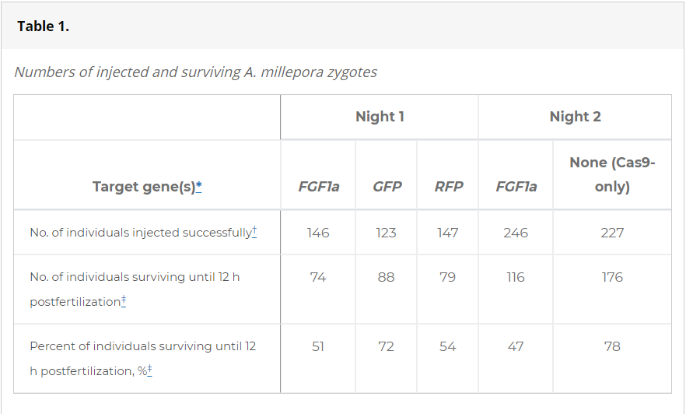

(table taken from CRISPR/Cas9-mediated genome editing in a reef-building coral | PNAS)

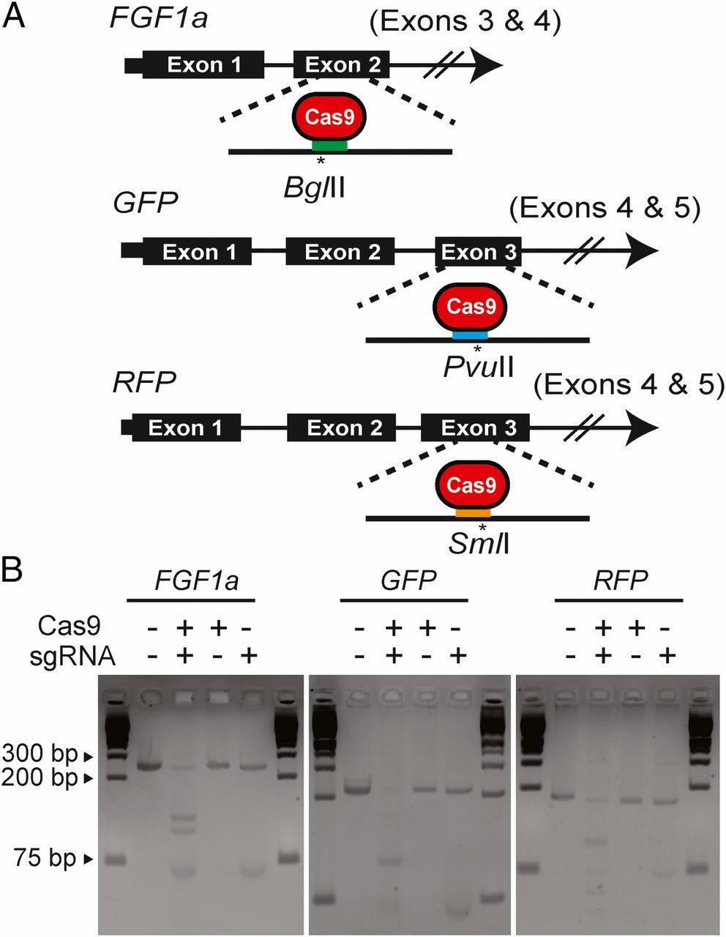
Graph breakdown: Cas9 are found in targeted exons because they are junk segments (Cas9 itself is not part of the intended outcome). Bg/ll, Pvull and Sm/l could potentially be Cas9 cleavage sites/nearby restriction-enzyme sites. + and - signs indicate the presence or absence of either Cas9 and sgRNA.

Credibility of experimental results
- Restriction-fragment-length polymorphism (RFLP) was used to measure larvae mutations. RFLP consists of analyzing the lengths of DNA fragments since DNA sequences varies in each organism. This method helped estimate the fractions of larvae with mutations. The restriction enzyme in some larvae weren’t able to fully cut the DNA at the gene’s restriction site. As a result, some genes lost their restriction sites due to induced mutations.
- To figure out what mutations were induced, PCR-amplified fragments of the target gene that was proven to have a mutation of a larva was cloned. These segments were placed into vectors to be replicated. This showed that the larvae carried both normal and mutated alleles of the same gene. After this experiment, it was concluded that the mediated mutagenesis (induced mutations) in the sea anemone system (Aiptasia) and the Acropora shared similar mutations. Furthermore, mutations occurred in the early developmental stages of the larvae.
- MiSeq amplicon sequencing in short is a method to sequence many DNA fragments at the same time. 4/12 larvae with FGF1a complex and 4/9 with GFP induced mutations at the target site. Around 22% of larvae with FGF1a and 9% with GFP deleted/inserted at least one base.

Following image is taken directly from https://www.pnas.org/doi/10.1073/pnas.1722151115
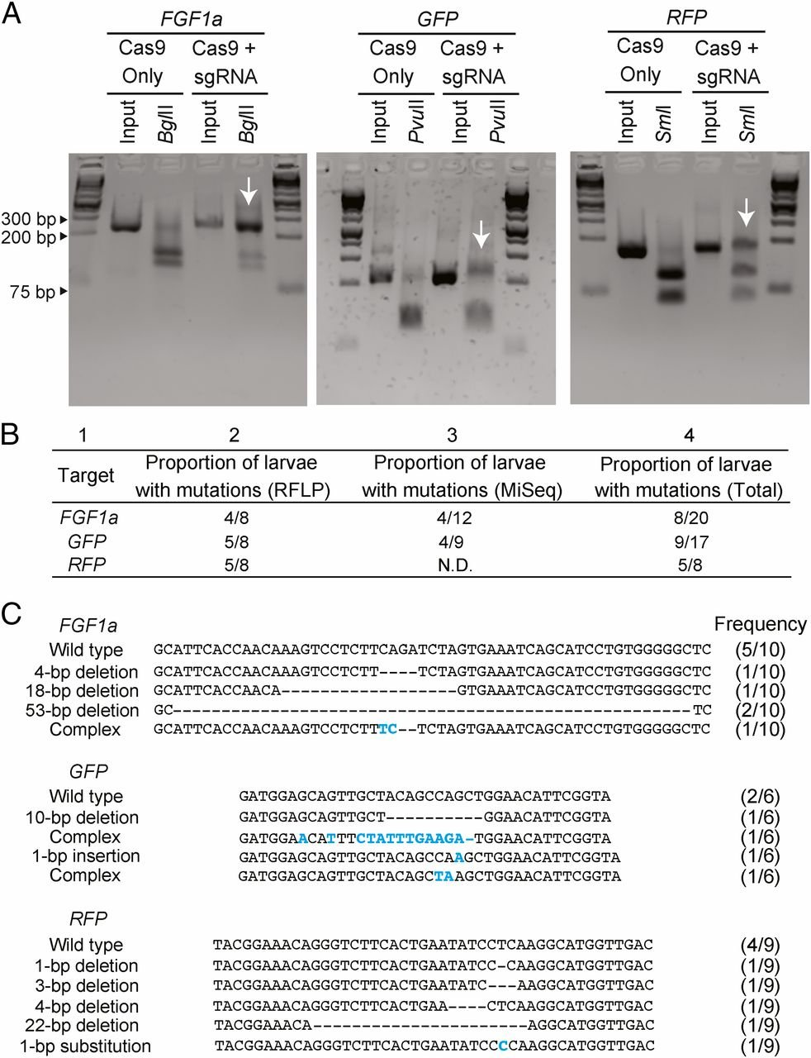
- Genomic DNA of individual larvae is amplified by PCR and analyzed by gel electrophoresis. Interior lanes are one larva, outside lanes are molecular-size markers. Arrows show incomplete digestion of DNA.
- Comparison between sequencing tools
- Mutations shown in each target gene of wild type larva. Base-pair changes in blue and deletions in dashes

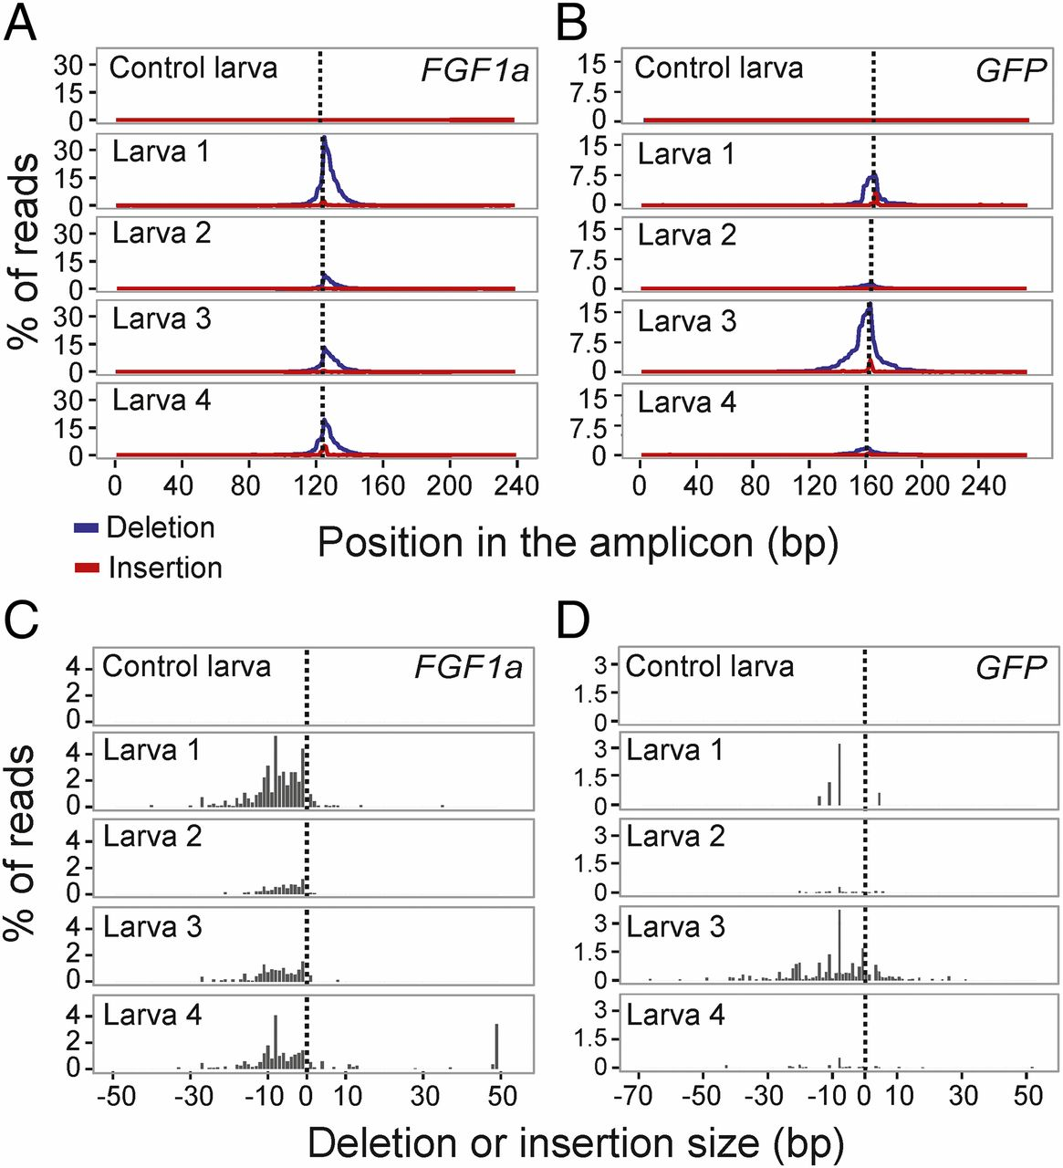

Graphs A and B compare the % of reads to the position in the amplicon. The dotted line is the site where Cas9 is expected to cut. Deletion and insertion of reads peaked near the dotted line. This shows that mutations did occur at the expected site. Graphs C and D show the sizes of the reads that face deletion or insertion.

Problems
Researchers were able to identify multiple paralogs of GFP and RFP (genes that come from duplication of a common ancestral gene). As a result, the same sgRNA induced mutations in different paralogous genes (GFP1 and GFP2).

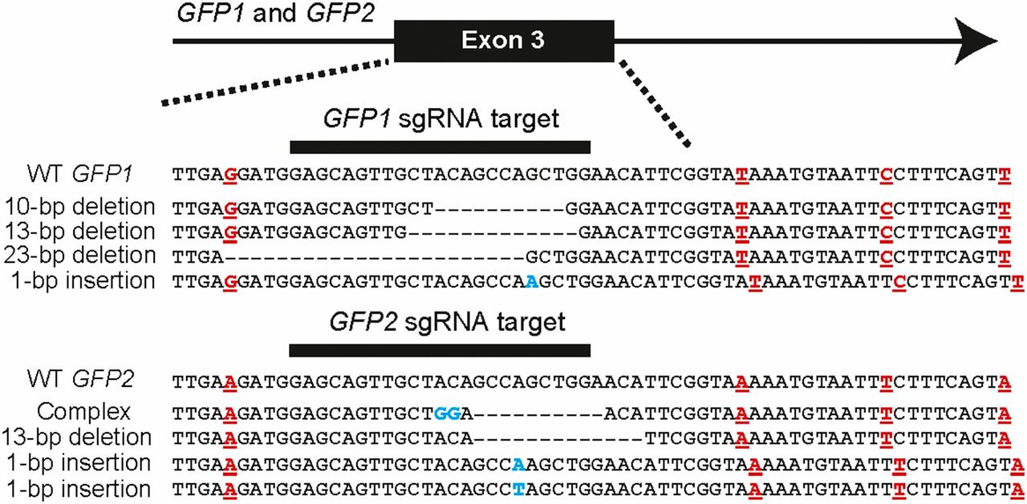
Editing of two paralogs found in a single larvae. Each paralog compares their respective alleles. Dashes represent deleted nucleotides. Inserted or altered nucleotides in blue. Red lettering shows the positions where the alleles differ within a 64-bp segment. Under GFP1 sgRNA and GFP2 sgRNA, each sequence shows a different version of the same genetic sequence. WT is the original sequence.

Phenotypes (observable characteristics of an individual resulting from the interaction between its genotype and its environment) associated with the CRISPR/Cas9 Induced Mutations

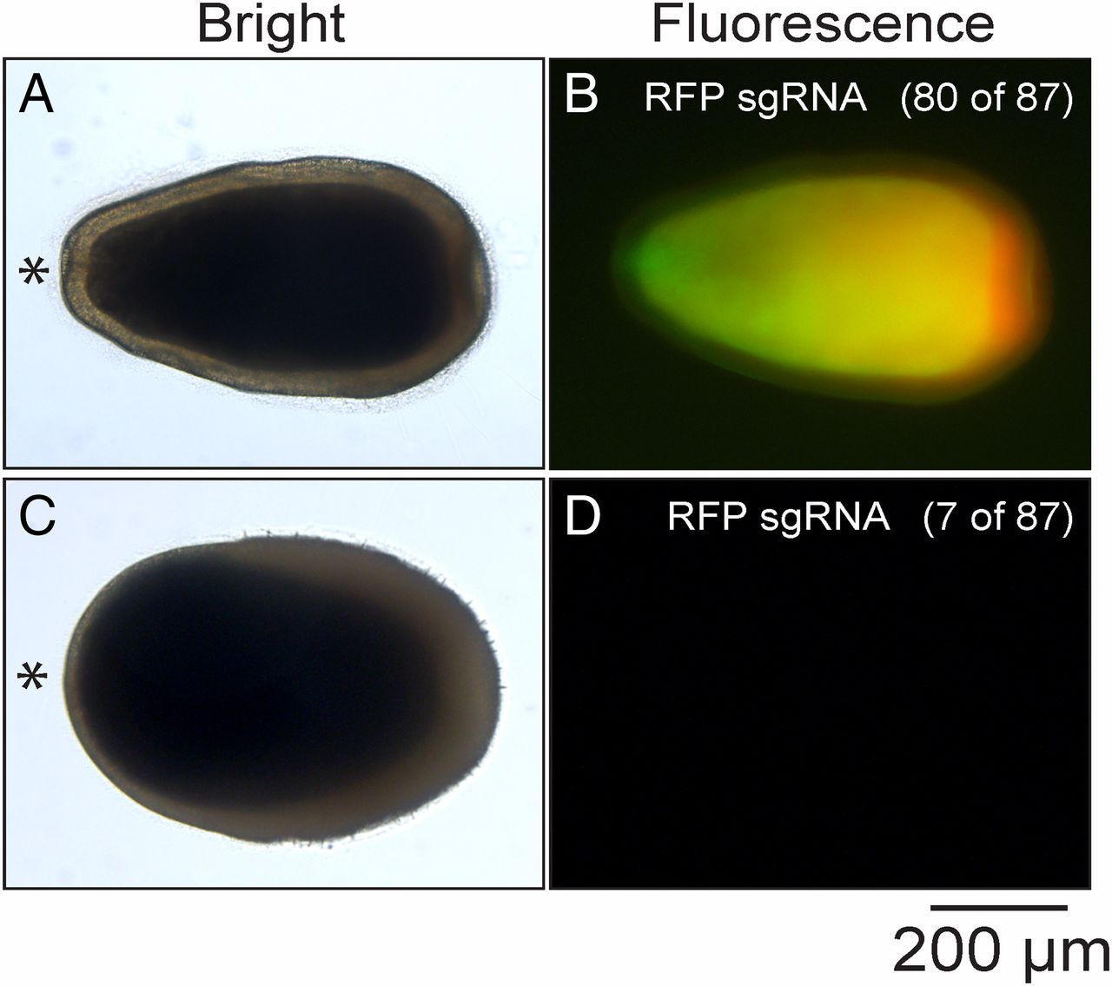
FGF signaling may control metamorphosis in Acropora. Larvae injected with FGF1a sgRNA continued to undergo metamorphosis. Larvae injected with GFP or RFP sgRNA didn’t significantly change their fluorescence patterns aside from seven larvae, which had their GFP or RFP fluorescence absent. Despite, induced mutations in the larvae, there weren’t any major changes in their phenotypes.

A and B are the injected larvae with normal metamorphosis. C and D are the injected larvae with no presence of GFP or RFP fluorescence.

What is coral bleaching?
Corals release algae due to increasing ocean temperatures. Corals look white due to the absence of pigment produced from algae. Without algae carrying out photosynthesis, the corals will starve due to insignificant nutrition and die.
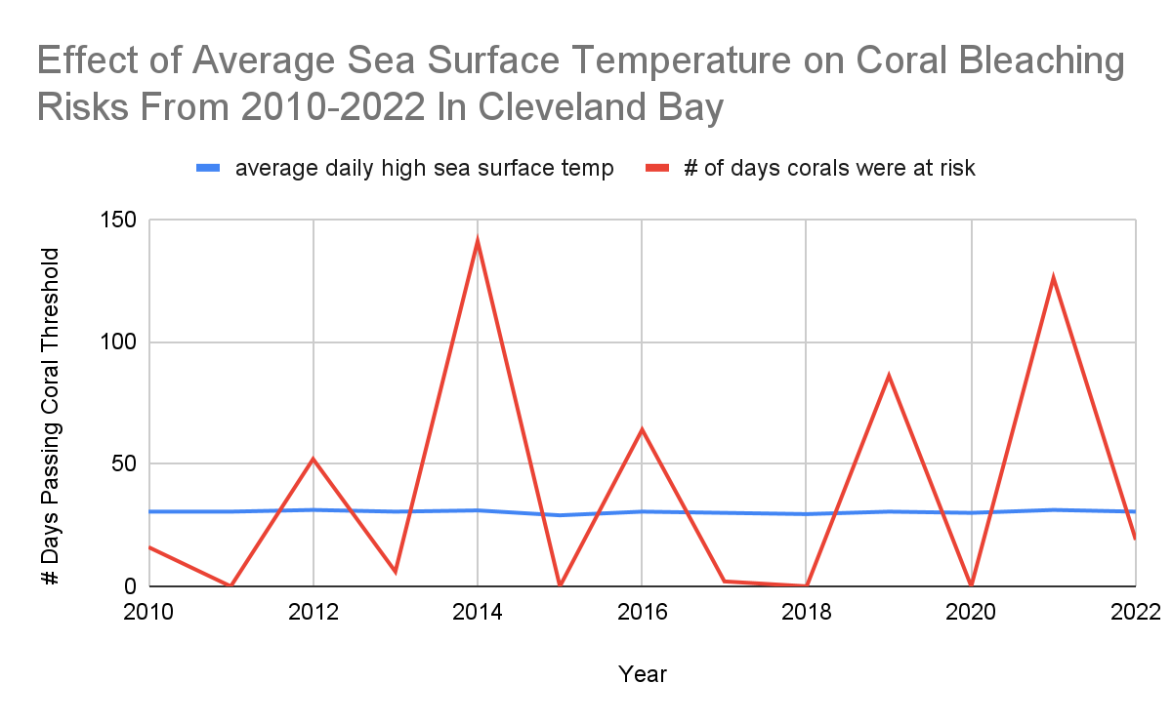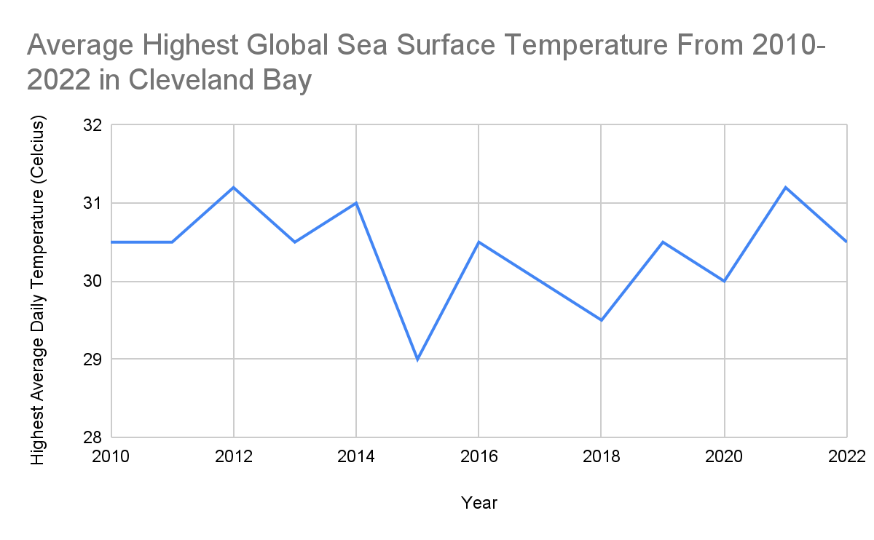

Resources:
CRISPR/Cas9-mediated genome editing in a reef-building coral | PNAS
Engineering Reef Resiliency with CRISPR Gene Editing to Counter Climate Change.
Engineering Strategies to Decode and Enhance the Genomes of Coral Symbionts
https://www.pnas.org/doi/abs/10.1073/pnas.2216144120#bibliography
2024-01-04
Develop theories
- Delivering CRISPR via vectors (virus, bacteria)
- Anemone Aiptasia (prior experiment done before CRISPR project)
Talk to expert
More ideas:
- some problems that might come up for future thinking:
  - ethics of putting in genetically engineered animals into the wilderness

To
Cc | Person
Bcc | Personharmitag@stanford.edu. ,simon.donner@ubc.ca, cdh5@cornell.edu, djsmitc@essex.ac.ukjpringle@stanford.edu
Subject | [MEETING REQUEST] - Coral Reef Expertise
Dear Coral Experts,
We hope this message finds you well. We are highschool students from Dr. EP. Scarlett participating in this year’s Calgary Youth Science Fair. Our project topic is about saving dying reefs with the help of genetic engineering.
We are currently still engaged in research, and we have a couple questions. We would greatly appreciate it if you could join a brief 15 minute Zoom call and answer some questions for us. Your expertise is highly valued, and we believe it would really help streamline our project.
Please let us know what time you are available so we can arrange a quick call. We look forward to the opportunity.
Thank you for considering our request.
Best regards,
Sheena and Jeanne

The Anemone Aiptasia Genome Analysis
- note: anemone is used because its relationship with the zooxanthellae algae is similar to that of the acropora coral

Used flow cytometry to estimate the size of the genome, then Illumina short-read sequencing to obtain genome sequence. Generated sequence was similar to other cnidarians.
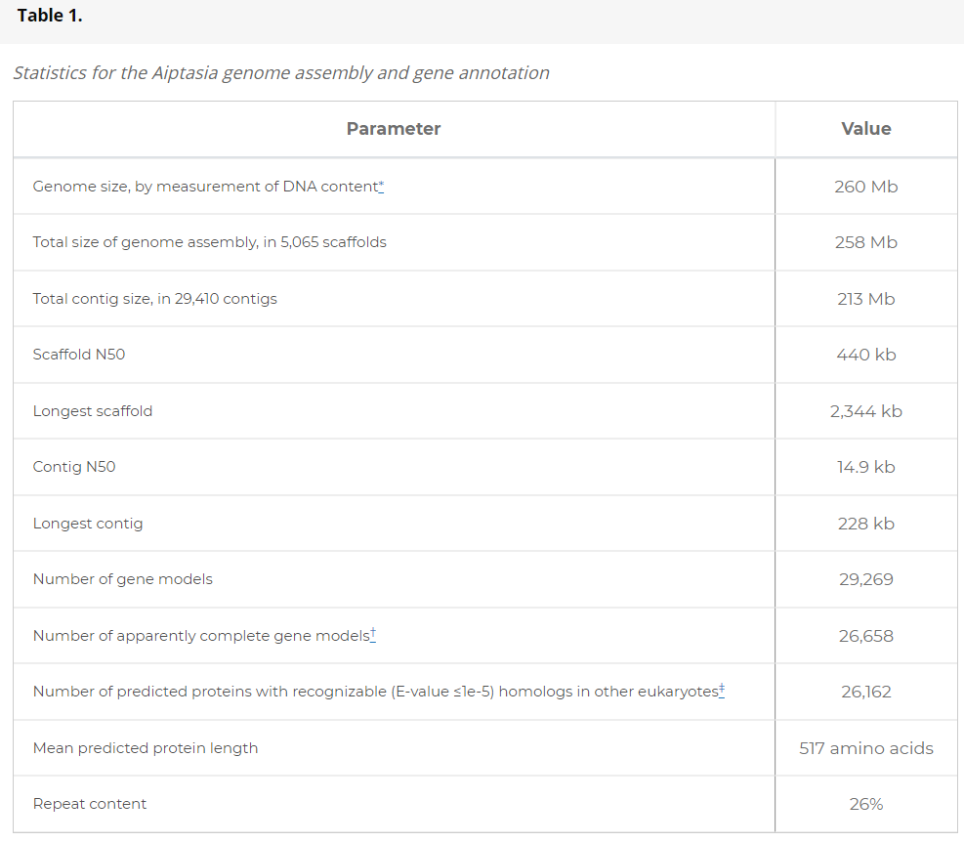
table taken directly from https://www.pnas.org/doi/10.1073/pnas.1513318112

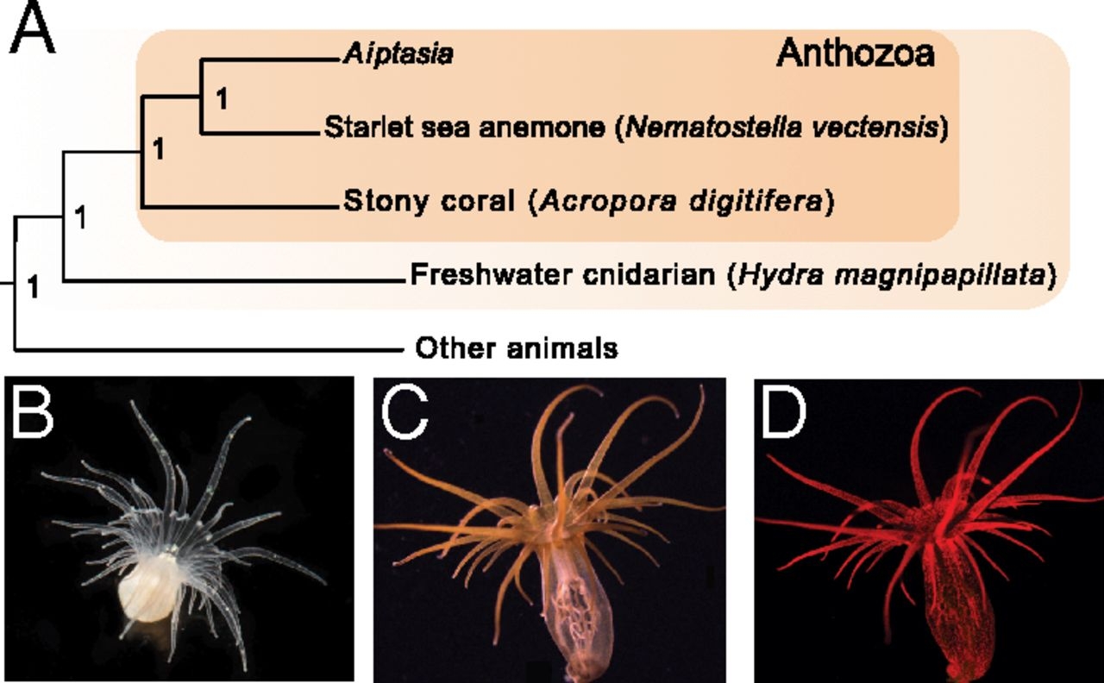
Aiptasia is an ideal model for scientists to study the cnidarian-zooflagellate endosymbiosis because while it contains the relationship with the zooxanthellae algae, it also quickly reproduces asexually under lab conditions. It can live under conditions where there are no dinoflagellate specimens, and it can also be inhabited by different kinds of symbiodinium.
Graph Analysis:
A: Shows the phylogenetic relationship of Aiptasia among other cnidarians
B: Shows an aposymbiotic Aiptasia specimen
C: Shows an endosymbiotic Aiptasia specimen
D: Shows the red chlorophyll of the Symbiodinium zooxanthellae under fluorescence microscopy

01-05-2024
Some vocabulary:
- Mb - megabase, or a measurement of a length of DNA
- Scaffold - structure in DNA, DNA sequencing scaffolds help assemble the sequences of pieces of DNA, chromatin scaffold is the structure in which the DNA is organized in the nucleus of eukaryotes
- cnidaria - invertebrates generally composed of phylum tissue, including jellyfish, corals, and anemones
- contig - short for contiguous sequence
  - When scientists study DNA, it's broken into pieces for analysis. They use bioinformatics tools to put the DNA back together, and the goal of genome sequencing is to get the whole thing in one piece. When DNA is put back together in sections, these sections are called contiguous sequences, or contigs
- gene models - representation and organization of a gene
  - Exons: are translated later into RNA to help build proteins
  - Introns: found between exons, are also translated into RNA but don't contribute to protein structure, intervene between exons
  - Promoters and Enhancers: control level of gene expression (translating the DNA information in a gene into
  - Transcription start/stop sites: the sites where the transcription starts and stops
  - Untranslated regions: ends of the mRNA that regulate gene expression in the protein
- predicted proteins - areas of the DNA that are coded to create proteins
- repeat content - repeated sections of DNA
- Mutant phenotype: Visible or observable characteristic (phenotype) in an organism that is different from the typical or normal appearance
- Restriction site: specific sequence of DNA where a restriction enzyme can bind and cut the DNA molecule
- PCR: polymerase chain reaction makes copies of a particular segment of DNA
- Allele: versions of a gene
- Mediated mutagenesis: Intentionally inducing mutations in an organism with the usage of specific tools.
- genetic up-regulation/down regulation: increased/decreased gene activity/expression
- bp: base pair
- canonical: established pathways with similar/defined characteristics
- putative: thought to be a gene
- DNA motif: segments of DNA that repeat and have an assumed biological function, within a gene
- hit: significant similarity between sequences and gene research
- consensus sequence: the most common nucleotides or amino acids at a specific area of the DNA in multiple organisms
- conservative sequence: for a sequence to have been relatively constant throughout evolution, probably because all organisms need it
- entropy: seeing how common/random DNA sequences are
  - high entropy: high ambiguity and randomness in the sequence, need more information to describe it
  - low entropy: the sequence is fairly clear enough
  - described in bits: sequence is described by the amount of information that you need to describe it
    - "we can only describe this bit of the sequence if we have --- information"

Results of the Analysis: https://www.pnas.org/doi/10.1073/pnas.1513318112#sec-2
- Found that the DNA structure of Aiptasia was very similar to that of non-endosymbiotic cnidarians; however, due to the fact that over 3,000 of the genes had no clear homologous result, cannot conclude that Aiptasia has a closer hereditary relationship with non-endosymbiotic cnidarians than previously thought.
- Aiptasia has a fair amount of genetic repetition, making it a good candidate for CRISPR technologies.
- Missing central-pathway intermediates, but does contain gene that can do cystathionine-β-synthase which means that it can translate cysteine from methionine from the energy supplied to it from zooxanthellae
  - this process is important in amino acid synthesis, detoxification, and metabolism
  - Mystery: although Aiptasia and Acropora are similar, Acropora does not have this gene
2024 - 01 - 05: experts emailed

Prior experiment done by Philip A. Cleaves using Aiptasia model Reduced thermal tolerance in a coral carrying CRISPR-induced mutations in the gene for a heat-shock transcription factor | PNAS
In a sea-anemone (Aiptasia) model system, removed/disabled the target gene: Heat Shock Transcription Factor
- More than 90% of genes in larvae developed mutations
- Mutant larvae survived at 27 degrees but died at 34 degrees, showing that HSF1 plays a significant role in corals surviving at high-temperature conditions
- Wild-type larvae (normal version) showed more resistance when exposed to 34 degrees

Heat Shock: HSF1 and NFkB upregulation
https://www.pnas.org/doi/full/10.1073/pnas.2015737117 → all information and graphs below taken directly from this source
note: under heat shock, corals increasingly regulate HSF1 (heat shock) and NKfB (immunity management) genes

experiment summary: using RNAseq to observe gene expression during heat stress until Aiptasia corals are completely bleached
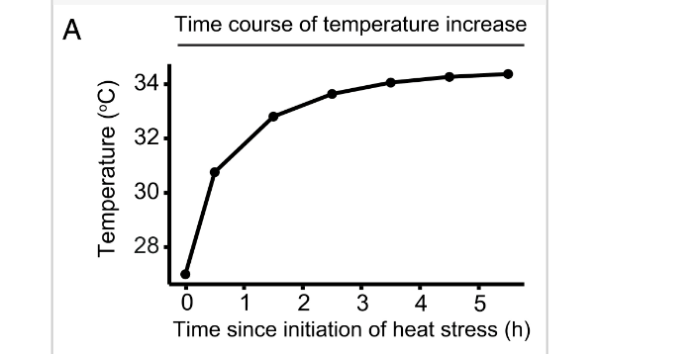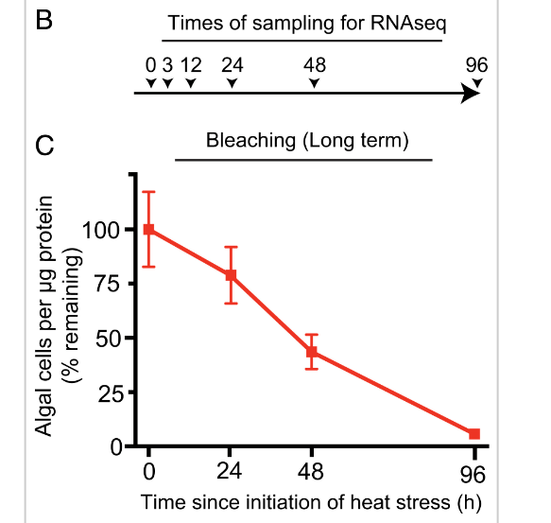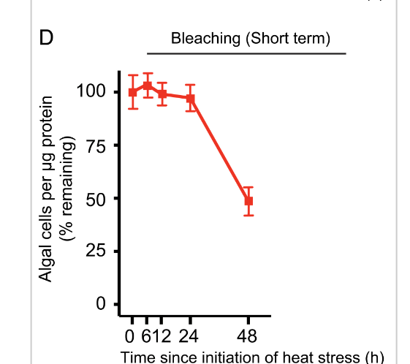
graphs, set 1.

- during heat shock, dramatic and immediate up-regulation of HSF1 and NKfB genes which is reduced later on
  - growth is higher in Aiptasia in symbiotic relationship than aposymbiotic
- for initial peak rise in up-regulated gene activity, the NFkB and HSF1 target genes that were increased dramatically were also similarly patterned in other cnidarians
- most gene expression levels of both symbiotic and aposymbiotic were even at the end because of eventual algae loss as corals became more bleached
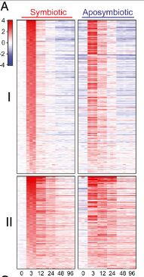
- NFkB-regulated activation of apoptosis and innate-immunity was long thought to be relevant to coral bleaching, but study proves that these genes returned to bare minimum levels far before bleaching is detectable
- graphs (left, set 2):
  - in A, showing the temperature change as anemones were moved to tank with warmer temperature
  - B&C: showing bleached levels in coral over 96 hours
  - D: showed bleached levels in separate coral over 48 hours
    - algae loss is different between C&D graphs at 24 hours, returning to similar around 48hrs, mostly just suggests that bleaching begins to happen at 24hr
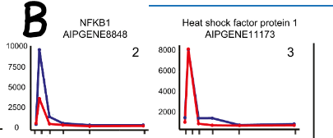
- used DSeq2 (technology that clusters different groups of RNA based on reactions to different conditions) to sort 254 genes into 2 groups, both with initial spike of up-regulation in genes, but group 2 returned to baseline far slower than group 1
  - heatmap A shows the difference in return to down-regulation of genes (red is up-regulated, blue is down-regulated). It seems like in both Aposymbiotic and in symbiotic anemones, returning to regular levels takes about 12 hours in Group 1 and 48 hours in Group 2
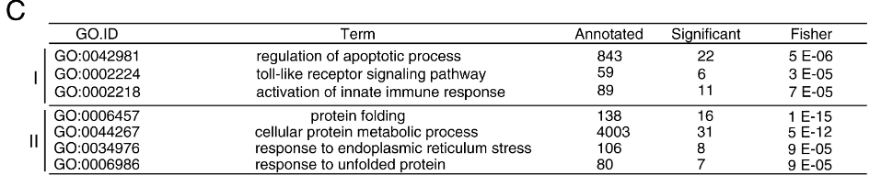
  - Graph B shows a spike in NFKB1 up-regulation is much higher in aposymbiotic species than it is in symbiotic.
- Graph C shows an analysis of the different genes that were up-regulated and their roles within the anemone using Gene Ontology ID technology
- most gene ontology terms in group 1 were related to apoptosis and immunity; group 2 were related to protein folding and ER response

Side note: how to read a heatmap (ex. graph A)
Each column in the rectangle shows the different gene expressions at different times, each row represents a different gene. Red means high gene up-regulation, whereas blue is gene down-regulation.

- no genes, whether aposymbiotic or symbiotic, had particular reactions to oxidative stress despite one of them hosting algae
- algae stress: present even without additional coral heat, some of the genes are upregulated simply because of the symbiotic relationship with the corals
  - even before any bleaching occurs, symbiotic coral genes related to the algal symbiosis are being down-regulated incredibly fast right after the initial up-regulation spike; shut down before algae loss even begins
- important question: how does the down-regulation of symbiotic genes affect the following symbiotic relationship breakdown?
- involvement of NFkB and HSF1 in early up-regulation:
  - found genes with greatest up-regulation: 58 in cluster I, 42 in cluster 2
  - tried to find enriched DNA motifs upstream of RNA transcription start site
    - found 2 motifs that correspond to "canonical binding sites for transcription factors NFkB and HSF1" respectively
    - highly upregulated during heat stress

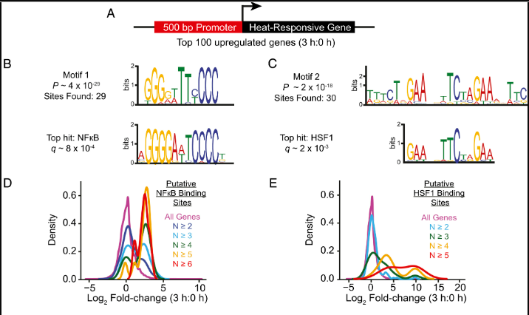
graph set 3
- Graphs B & C show that there is little difference in the genetic sequences between NFkB and HSF1 genes, and the upregulated unidentified genes. We can say with near certainty that these are the genes that were in high activity during the time of heat stress

2024-01-21
To understand the graphs (set 3):
Understanding DNA Consensus Sequences:
What is DNA consensus sequence?
Nucleic acids (article) | Khan Academy.
3 Parts of a Nucleotide and How They Are Connected
- nucleotide parts:
  - nitrogenous bases (nucleotide bases): adenosine, thymine, guanine, cytosine
  - sugar molecule
  - phosphate molecule
- consensus sequence: the sequences of most commonly found nucleotide bases/ amino acids in the examined species
- notation:
  - regular letter represents the base as usual
  - square brackets with two letters [ ] means that either of the bases is in that spot. Does not mean there's a 50% chance, simply that one base or the other is found in that place in the gene
  - curly brackets with one letter {} means that the nucleotide base in that one spot is anything except the letter in the bracket (ex. {A} means that in that spot of the genome, the nucleotide base could be anything except for adenine)
  - N stands for any nucleotide base in that position
  - R stands for a purine nucleotide base
  - Y stands for pyrimidine nucleotide base
  - different nucleotide bases have different molecular structure:
    - pyrimidines: thymine and cytosine. These only have one carbon-nitrogen loop holding them together
    - purines: adenine and guanine. These have two loops holding them together
  - size of the letters in the logo chart signify the percentage of occurrence of the specific nucleotide sequence at the particular place - web logo
    - charts generate a visual of consensus sequence for the different genes

  - density plots of D and E show the frequency of fold-changes (gene expression value changes) in the the genes HSF1 and NFkB respectively
    - gene expression for NFkB increased by five times for most estimated genes!
    - gene expression for HSF1 is less drastic, changes based on N value
- To conclude: Coral bleaching results from the down-regulation of HSF1 and NFkB genes. The reasons for bleaching under the influence of early heat stress aren't clear, but we do know that it is likely that once put under stress, the algae stop giving the nutrients to the anemone. This might make the coral recognize it as hostile, causing it to deregulate the genes that are necessary for the algae within, and eject it from the coral.

2024-01-07
Response from Simon Donner: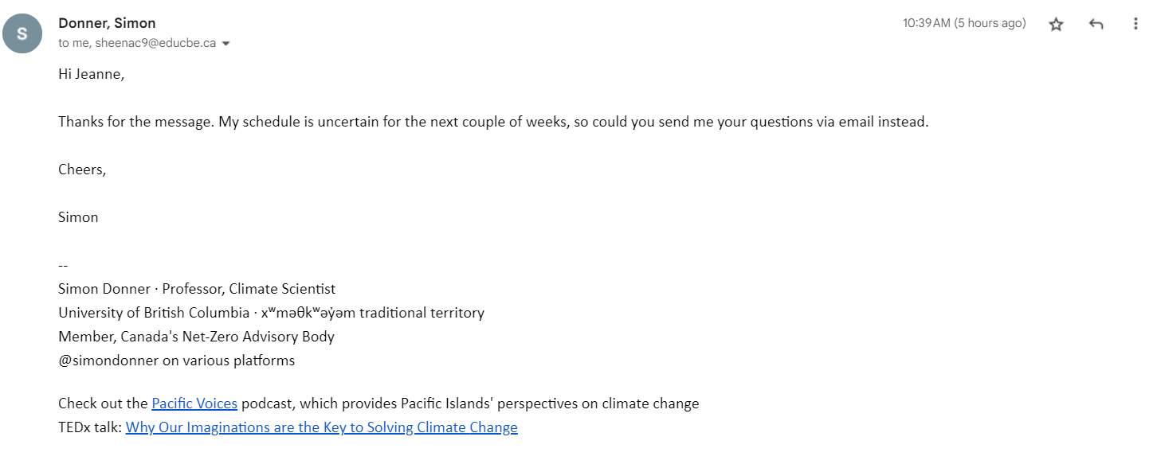
Background of Simon Donner:
- UBC professor
- INCREDIBLE GUY. gave a tedx talk: https://www.ted.com/talks/dr_simon_donner_why_our_imaginations_are_the_key_to_solving_climate_change

Important information: Acropora classification in the taxonomy of living things, from most to least specific
- Species - many many different species under acropora genus
- Genus - Acropora
- Family - acroporidae
- order - stony coral
- class - sea anemones and corals
- phylum - cnidaria
- kingdom - animalia
- domain - eukaryote

Questions for the Experts:
- What is your opinion on using genetic engineering like CRISPR, as a possible method on saving coral reefs? Would you support it?
- What do you think is the most effective method to prevent the effects of climate change (coral bleaching, ocean acidification) on corals and anemones?
- Is coral observation technology advanced enough to allow humans to observe and gather more information about the coral genome? If so, what do you think is preventing marine biologists from learning more about the genome of corals?
- Apart from its symbiotic partners like zooxanthellae algae, what kind of consequences do you think a coral with higher heat resistance could have on its marine ecosystem?
- The effects of ocean acidification on coral reefs is drastic. They cannot produce enough aragonite to thicken their skeletons. Do you think that genetically engineering corals to pull different chemicals from the ocean, instead of calcium carbonate, is more sustainable?
Conclusion:
- Improve gene associated with symbiosis with algae
- add HSF1
- Using virus as vectors

Other Sources
Reduced thermal tolerance in a coral carrying CRISPR-induced mutations in the gene for a heat-shock transcription factor | PNAS

Insights into coral bleaching under heat stress from analysis of gene expression in a sea anemone model system | PNAS

To | simon donner
Cc | Person
Bcc | Person
Subject | Questions Regarding Coral Reefs: Jeanne and Sheena
Dear Professor Donner,

Thank you for your quick response, we really do appreciate it. We have seen a lot of your work, like your Ted Talk and many of the research articles that you have contributed to, and we think it truly is incredible. We are honored that you are willing to lend us a hand in our project, so thank you very much.

Here are our questions:
  - What's your opinion on using CRISPR for saving coral reefs? Do you support it?
  - What's the most effective method to prevent climate change effects on corals?
  - Is coral observation technology advanced enough, and what limits our understanding of the coral genome?
  - What consequences could a heat-resistant coral have on its ecosystem?
  - Is genetically engineering corals to extract alternative chemicals instead of calcium carbonate sustainable for combating ocean acidification?
Thank you again for sparing the time to help us out. It means a lot to us.
Sincerely,
Jeanne and Sheena
2024-01-09
Conversation with Ms. Ulyott (school biology teacher)

Need to research:
- protein synthesis
- DNA technology
- restriction enzymes
- CRISPR

Resources
- crash course
- bozeman science
- amoeba sister
- khan academy

Understanding Protein Synthesis:
Protein Synthesis (Updated) - amoeba sisters
- RNA is created with an enzyme called RNA polymerase that constructs RNA bases to be identical to a template strand of DNA
- this RNA is then bonded together and create mRNA (messenger RNA), which exits the nucleus and attaches to a ribosome
  - mRNA determines which order tRNA attaches amino acids into the protein
- polypeptide chain: chain of amino acids. 1+ chains create a protein

Understanding restriction enzymes:
Restriction enzymes - khan academy

Alternate Viewpoints: P. Donner
Professor Donner, a climate scientist and a professor at the University of British Columbia was against using CRISPR or genetic engineering to modify corals reefs. He states that we are the ones responsible to reduce our ecological footprint in order to prevent coral bleaching. It is crucial to remove the root of the problem (climate change), then finding solutions (ex. CRISPR) to withstand the problem.

Direct Quotations:
What's your opinion on using CRISPR for saving coral reefs? Do you support it?
I'm am comfortable with using new technologies to learn more about the science of corals and their symbionts, and to look for innovations to help corals respond to climate change. However, I think it is likely an expensive distraction that will not results in any real-world benefits to the world's coral reefs, or the people who depend on them, because of the difficulty of deploying any newly engineered corals or symbionts at any meaningful scale in the world.

What's the most effective method to prevent climate change effects on corals?
Climate change, driven by emissions of carbon dioxide and other gases, is warming the oceans and making bleaching more common. People living in the tropics can try to minimize the effect of non-climate stress, things like water pollution, sediment pollution and overfishing, to make sure reefs are best ready for the threat of climate change. But the best long-term solution for reefs is dealing with the cause of climate change -- carbon dioxide and other greenhouse gases. If we want to preserve coral reefs, we have to start working to slow greenhouse gas emissions in Canada and around the world.

Is coral observation technology advanced enough, and what limits our understanding of the coral genome?
The best technology for observing corals are our eyes and our cameras. While there are likely many advances in genomics that can teach scientists more about corals, the major challenges facing coral reefs are more integrative, and occur at the scale of organisms and reefs, and advances in genomics are unlikely to teach us much about the system-level interactions and processes that matter the most

What consequences could a heat-resistant coral have on its ecosystem?
Heat-resistant corals are more likely to survive a bleaching event. Over time, this could change the composition of the reef community, and potentially influence the habitat for specialist organisms, like some small fish.

Is genetically engineering corals to extract alternative chemicals instead of calcium carbonate sustainable for combating ocean acidification?
Likely not. The issue is not sustainability, as much as scale. Even if what you mention is feasible, high-tech solutions inevitably run into the problem of deployment. The proposals for genetic engineering corals and symbionts are often disconnected from the real-world geography of coral reefs. Such technologies, if they work, are likely to only be deployable on specific reefs in high income areas or tourist sites -- they won't help the vast majority of the world's reefs, nor the vast majority of the people in the Global South who depend on coral reefs for their livelihoods.

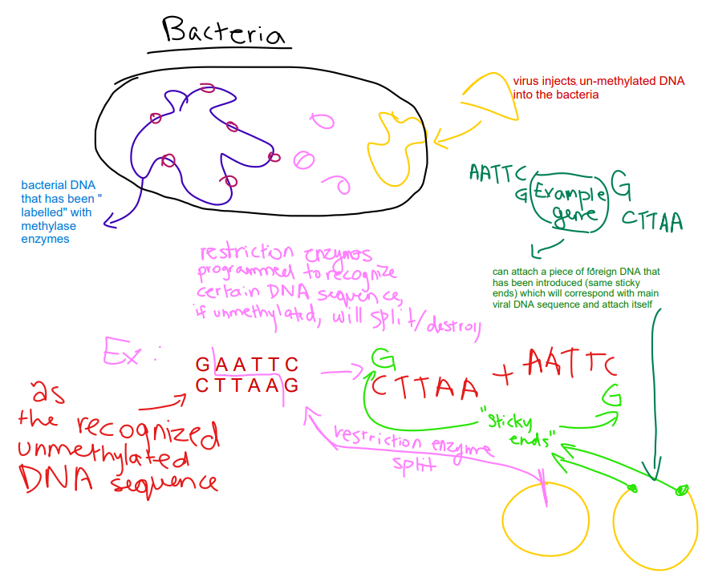
Sheena:
Sources used for research
DNA, Hot Pockets, & The Longest Word Ever: Crash Course Biology #11 (youtube.com)
DNA Structure and Replication: Crash Course Biology #10 (youtube.com)
Restriction enzymes (youtube.com)
What is CRISPR? (youtube.com)

2024-01-14 - Deadline to finish basic protein research

2024-01-24

2024-01-25

Reduced thermal tolerance in a coral carrying CRISPR-induced mutations in the gene for a heat-shock transcription factor | PNAS

Prior experiment done by Philip A. Cleaves using Aiptasia model Reduced thermal tolerance in a coral carrying CRISPR-induced mutations in the gene for a heat-shock transcription factor | PNAS
In a sea-anemone (Aiptasia) model system, removed/disabled the target gene: Heat Shock Transcription Factor
- More than 90% of genes in larvae developed mutations
- Mutant larvae survived at 27 degrees but died at 34 degrees, showing that HSF1 plays a significant role in corals surviving at high-temperature conditions
- Wild-type larvae (normal version) showed more resistance when exposed to 34 degrees

Overview:
sgRNA/Cas9 ribonucleoprotein complexes targeting HSF1 were injected into fertilized eggs of Acropora millepora. The goal of this experiment was to eliminate HSF1 to understand how the gene affects the coral’s heat tolerance by observing its phenotypes. It was suggested that by effectively eliminating HSF1, the resulting mutation would reduced or disable the burst of transcription the occurs immediately after the coral faces heat stress.

Burst in transcription? Corals respond to heat stress by excessive transcription of certain genes.
Design:
Two sgRNAs were made one to target exon 3 and the other targeting exon 9. Target sites were chose to avoid possible complications (off-target effects and alternative transcription start sites.

How was it inserted?
On November 2018, over three nights of spawning, fertilized zygotes were injected with either a Cas9 protein alone or sgRNA1/Cas9 and sgRNA2/Cas9 ribonucleoprotein complexes. Each night 100-300 individuals were injected. Out of the zygotes injected, 68-90% survived and developed normally for 12 h.
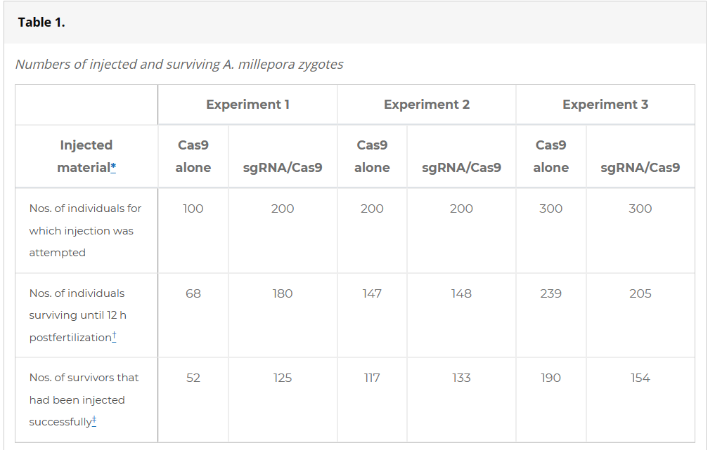

Results: most important note: mutations were successfully induced.
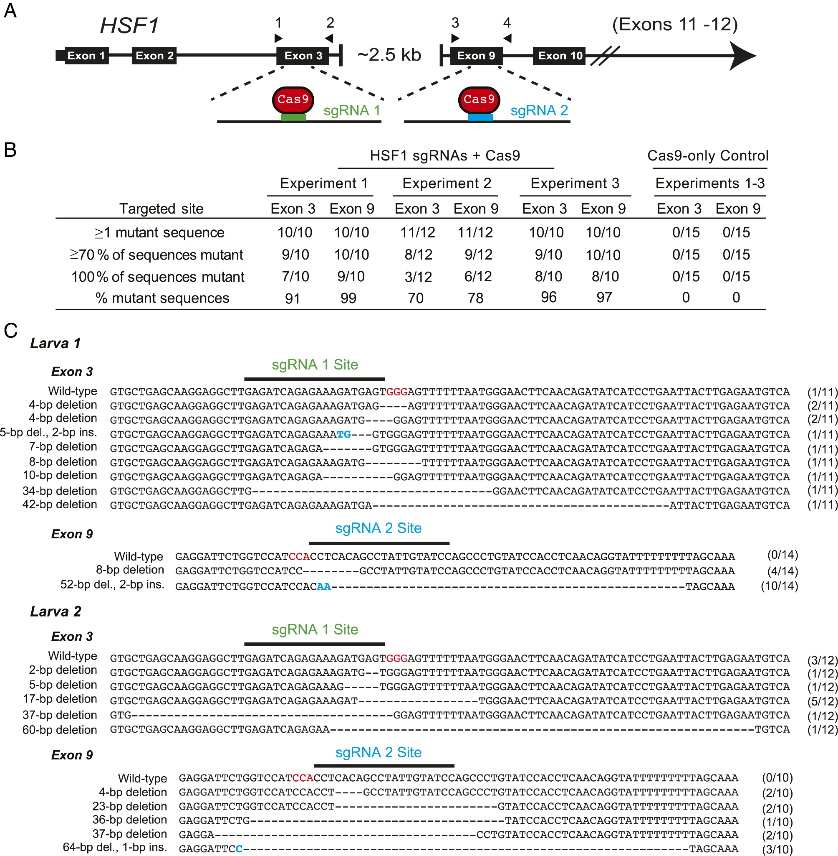
Section A: Cas9 with sgRNA 1 target site is exon 3. Cas9 with sgRNA 2 target site is exon 9.
Section B: shows percentage of larvae with mutations
Section C: Two individual larvae, both larvae show the both exons 3 and 9. Each line under an exon represents a different mutation event. Black bars represent position of sgRNA target sites; nucleotides in red represent PAM sites. Dashes are deletions of nucleotides. Blue letters are insertion/replaced nucleotides.

Table A shows the exons that are going to be targeted by the sgRNAs. Table B shows successful induced mutations. Experiments 1 and 3 show around 99% of mutant sequences, whereas experiment 2 showed around 74% mutant sequences. Cas9-only control group had no mutations (as expected). Section C shows mutation induction occurred during the first cell cycle. During this time, some larvae developed 12 mutant alleles at a single site. sgRNA/Cas9 complexes may of have continued to induce mutations for multiple cell cycles. Although, some wild-type sequences persisted (no mutagenesis). Two-thirds of the mutant alleles lost gene-product function (frameshift mutation). This means that the gene will most likely produce a non-functional or altered protein.

Gene-product function: role of protein or RNA molecule in a gene. Genes contain instructions to make molecules (proteins or RNA molecules).

It is also shown that the sgRNA/Ca9 complexes were able to induce double-strand breaks which led to large deletions at the target site. 13/32 larvae injected with sgRNA/Cas9 complexes had their PCR product amplified (segment of DNA replicated many times). Whereas, the control group had no PCR product. The large deletions are target sites for the PCR product.

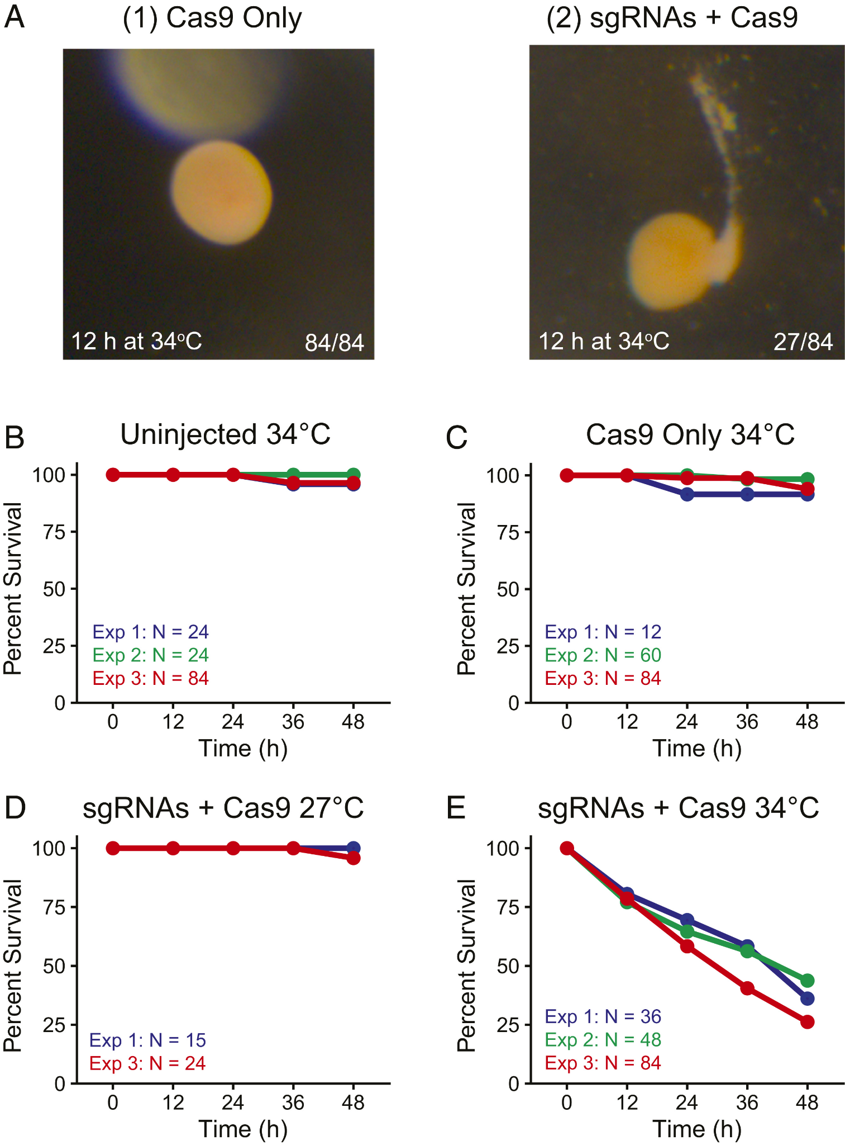
In order to understand the importance of HSF1, uninjected, Cas9-injected (control), and sgRNA/Cas9-injected larvae faced heat stress at 34 degrees for two days. Most uninjected and Cas9-injected larvae survived under these conditions as shown in section A, B and C. There was also little mortality for larvae injected with sgRNA + Cas9 at 27 degrees. Although, the larvae faced significant death in section E. Most sgRNA/Cas9-injected larvae died (two-thirds). The larvae that survived at the 48 hour period were found to have fewer changes in HSF1 gene and a higher proportion of normal (wild-type) gene sequences. Death of the larvae was associated with yolk bursting. Overall, HSF1 plays an important role to maintain stable heat tolerance for corals.

Problems/difficulties:

Due to the lack of research done on the genome of a coral, knocking out one or a few genes may not show a significant phenotypic change. Knocking out several genes by injecting different, multiple sgRNAs could achieve a noticeable phenotype. *Furthermore, mutations happening in two non paralogous genes show a more significant phenotype. Biomineralization (organisms produce minerals to form structures) is difficult to study. We still have little knowledge about the process and genes that aid in biomineralization. Furthermore, biomineralization occurs at a later developmental stage. Microinjection takes lots of work + coral spawning is very rare.

*mutations in gene A leads to a phenotypic change. Another mutation occurs in another non-related gene which leads to a different phenotypic change. These two mutations occurring at the same time will produce a pronounced phenotypic change. This way can give insight to understanding the relationship between multiple genes that lead to complex phenotypes.

Role of the bicarbonate transporter SLC4ү in stony corals - Using CRISPR to Address Ocean Acidification
Role of the bicarbonate transporter SLC4γ in stony-coral skeleton formation and evolution | PNAS

Understanding the role of the SLC4ү gene in stony corals and their role in coral evolution. Using Cas9 CRISPR techniques to remove the gene in order to observe effects of absence of gene on skeletal development.

The formation of aragonite coral skeleton
Calicoblast cells use bicarbonate anhydrase enzymes to pull out water from the calcium and bicarbonate ions in the water. Part of the bicarbonate comes from the coral's metabolic CO2. This forms the aragonite calcium carbonate compound that forms the skeleton of the coral, which is between the substrate and the actual coral flesh.

The SLC4ү gene is also only expressed in stony coral calicoblast cells, suggesting that it plays a key role in skeleton building.

The upregulation of SLC4ү in biomineralization (deposition of minerals in living organisms)

Induced metamorphosis in the polyps by adding pieces of coralline algae, measured the expression of SLC4ү and SLC4ß gene during biomineralization process. Expression of SLC4ү was much greater than SLC4ß. As SLC4ү gene was duplicated as the coral grew, its expression form began to change.
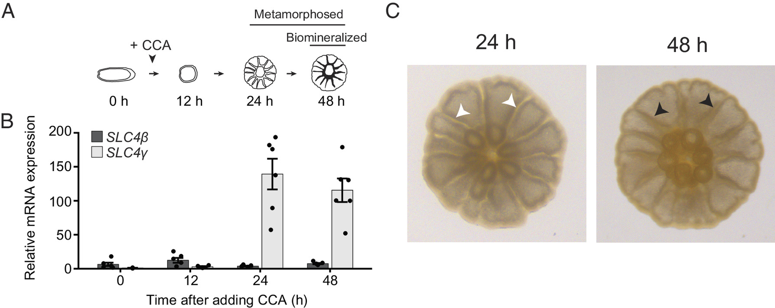
Section A: using CCA (data analysis technique to show the correlation between the variables SLC4ү and SLC4ß expression) to identify that SLC4ү had more expression and played a larger role in metamorphosis
Section B: showing the mRNA levels of each gene for time after metamorphosis induction after specific periods of time. Specific measurements as the dots, but as contrast is increased, additional average ranges are given.

Section C: Example image showing where the septa of the corallite will be grown (indicated by black and white arrows) at different times.

Using CRISPR Cas9 Technology to Remove SLC4ү Gene

Above information suggests that SLC4ү gene is mostly used for bicarbonate transport. Injected new coral zygotes with a fluorescent injection indicator. Also added either lone Cas9 protein, or sgRNA1/Cas9 or sgRNA2/Cas9 ribonucleoprotein complexes. Successfully injected genes were analyzed for skeleton mutation and gene expression frequency.
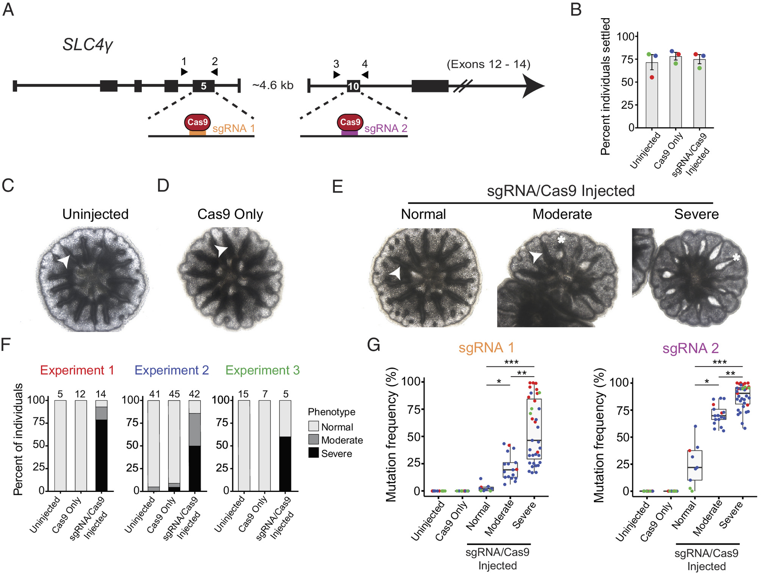
Section A: shows the structure of SLC4ү gene, and where the sgRNAs/Cas9 genetics are targeting (sgRNA1 is targeting exon 5, sgRNA2 is targeting exon 10)

Section B: percentage of corals settled within 3 days, between uninjected, Cas9 protein only injected, and sgRNA injected corals. Three colors represent three experiments
Section C-E: using an inverted microscope, observed the growth of the juvenile polyps. "Normal" meant that all septa biomineralized, "Moderate" meant that 1-2 septa did not mineralize, and "Severe" meant that most septa had not biomineralized. Biomineralized septa are indicated by the arrowheads, and gaps in the tissue are indicated by asterisks.

Section F: Categorizing the different phenotypes as a result of the genetic modification

Section G: Showing the frequency of genetic mutation for each of the conditions. Boxes show first and third quartiles (first and third parts of the data), horizontal bars mark the median.

We can conclude from the experiment that SLC4ү's role in bicarbonate transport is indeed an important function in the formation of coral skeletons from calcium carbonate. Nearly all of the juvenile polyps manipulated by Cas9 sgRNA (regardless of whether it was sgRNA1 or sgRNA2) had severe gaps in their tissues and underdeveloped septae.

CRISPR Cas9 technology allowed the scientists to directly alter the DNA of the coral and directly correlate the genetics to the corresponding phenotype of the coral.

Unexpectedly, some of the highly mutated juvenile polyps showed little external phenotype changes, while some lowly mutated polyps showed extreme changes. For the former, we can assume that this may have been caused by genetic clones in cells surrounding the mutated group; however, this cannot explain why less mutated DNA patterns would cause a larger mutation if all coral polyps from the colony are genetically identical. As the specific details as to how SLC4ү genes transport bicarbonate still remain unclear, it is impossible to determine the exact purpose of the gene.

Ethics of Genetically Engineering Wildlife

Considering Side Effects
The public opinions have gradually become more supportive of genetically engineering wildlife. Despite media stereotypes of genetically modified organisms taking over the world, some now realize that genetic engineering is an increasingly necessary technology that could help save biodiversity amid the climate change crisis. However, if we were to genetically engineer wildlife in the name of conservation, we would not be the first. Previous examples of genetic engineering in wildlife include:

- black footed ferret, genetically engineered against the plague (in progress, haven't been released yet)
  - Sources: Black-footed Ferret Project, Major Milestones - Revive & Restore; Genetic Research Boosts Black-footed Ferret Conservation Efforts | U.S. Fish & Wildlife Service; Black-footed Ferret Project - Revive & Restore; Preserving the Black-Footed Ferret Species Through Gene Cloning and Genetic Engineering – Meeteetse Museums
- American chestnut trees (failed)
  - Sources: Using genetics to conserve wildlife | Pursuit by The University of Melbourne; The Genetically Engineered American Chestnut | CBAN; Genetic engineering was meant to save chestnut trees. Then there was a mistake. - The Washington Post
- Southern Corroboree Frog
  - Source: Genetic potential for disease resistance in critically endangered amphibians decimated by chytridiomycosis - Kosch - 2019 - Animal Conservation - Wiley Online Library

Taking a Closer Look at Each of the Experiments:

The Black Footed Ferret - Selective Breeding for Genetic Diversity… but with clones?
Back in the 1980s, black footed ferrets were already endangered due to plague and habitat loss. Conservationists managed to capture the 18 remaining ferrets, and put them into a captive breeding program to save the population, one of the ferrets being a female named Willa. However, only 7 of them actually bred, Willa not included, which means that the rest of the black footed ferrets today are directly related as cousins or as siblings, which means that there is a reduced amount of genetic diversity. Willa's genetic information was preserved because of her unique genetic material, and 30 years later cloned into a new ferret named Elizabeth Ann. Elizabeth is the first genetically cloned wildlife animal.

Scientists hoped that Elizabeth Ann would be able to introduce new genetic material into the rest of the ferrets, but she had a medical issue. However, they are hoping to create more clones of Willa to hopefully introduce new genetic diversity into remaining ferrets, which will help increase the resistance and adaptability of the species which will soon allow them to be reintroduced into the wild. Without human intervention and cloning, the ferrets would have no chance of becoming independent from humans, if not totally extinct.

The American Chestnut Tree - Transgenics to create disease resistance
Scientists genetically modified the endangered American Chestnut tree to be blight resistant. The chestnut used to be a keystone species in the deciduous forests of both the US and of Canada, but when a new chestnut species was introduced from Asia, it quickly spread the common blight fungus among the chestnut trees.

The genetically modified trees, known as "Darling 58", had been inserted with a gene that would produce an enzyme. This enzyme would have created a chemical that would neutralize the lethal fungus secretion.

However, as the trees were being grown, scientists quickly noticed that most trees they were growing were not Darling 58. The trees were much shorter, died at a faster rate, and were ultimately less resistant to blight than non-altered ones. This was due to the fact that the gene was inserted into the wrong chromosome, which created unexpected effects on the trees' phenotypes. They had unintentionally begun a line of Darling 54 trees, which would not be able to compete with other trees for sunlight. This caused the American Chestnut Foundation (which was funding) to withdraw their support and stopped the project.

Despite the mislabelling, the Darling 54 trees still produce edible chestnuts, and could be used for increasing genetic diversity. This is now a blame game, where the researchers and the federal government and the companies are all blaming each other for the mistake. However, using more caution would have easily prevented the error, and could have genuinely created more Darling 58 trees that are resistant to the disease. The only thing stopping the research is the public opinion and delegation of blame among the higher powers. There was nothing wrong with the actual engineering by itself.

The Southern Corroboree Frog - Using Genetic Technology to Increase Disease Resistance
The Southern Corroboree Frog has been a highly endangered species due to the introduction of a fungal disease called Batrachochytrium dendrobatidis (Bd). If humans continued to use the traditional selective breeding, we would not be able to save the frogs. Using genetic studies, scientists were able to find the immunogenetic differences within the species to manipulate in future generations of corroboree frogs, which could be more effective than simply breeding resistant frogs.

Cane Toads of Australia
The cane toad, Bufo marinus, was first introduced to Australia in 1935 to predate upon the destructive beetles in sugarcane crops, before agricultural pesticides were widely used. The toads quickly became invasive species due to their extreme adaptability to different environments, and their ability to secrete lethal poison into their predators' bodies. There is no way to completely exterminate them in Australia yet. Although not directly involved with genetic engineering, the cane toad is often used as an example of flawed scientific intervention with nature that had catastrophic results.

However, it is important to remember that the incident happened nearly a century ago, and scientific research and experiment policies have grown in a way that would completely prevent another accident from occurring. With the right amount of care, the cane toad incident of 1935 is completely preventable.

Monsanto and Cereal Crops
Although also not related to genetic engineering, the Monsanto cereal crops is an ongoing example of why so many people object against applying "unnatural" science in the real world, especially when it involves the food chain. Monsanto is a company that sells Roundup, a herbicide that is often used by farmers of oats and grains. However, Roundup contains glyphosate, a chemical that is linked with causing cancer. Recent tests in oat cereal brands such as Cheerios and Nature Valley reveal an alarming concentration of glyphosate, which has increased concern about the use of scientific intervention in the production of organisms at the bottom of the food chain.

Very few organisms consume coral reefs. However, genetic engineering might possibly pose a risk to the organisms that do, but there is not enough research to back up either possibility.

Application to Our Own Project
While genetic engineering wildlife faces many challenges, including managing the public opinion, funding, and margins of error, it is one of the most promising solutions to environmental problems such as fungal disease and specimen endangerment. We can greatly mitigate chances of making another error like with the Darling 58 chestnuts if we increase the amount of testing and speed-growth of tester specimens to find potentially unintended mutations, before the specimens are released into the wilderness.

In the context of genetic engineering marine animals such as the coral, there has been a lack of research and technology. The extent of marine genetic modification has only been used on livestock, specifically farmed fish. However, if released into the wild, there has not been any data collected on how modified fish affect their environment. There is a large amount of worry that these modified fish will invade susceptible habitats, such as the case with releasing pet goldfish into rivers. Despite that, there is also a large chance that in the wilderness, modified fish will not be able to survive after being so reliant on humans for the majority of their lives (as in the case of pandas).

Overall, while there are many risks and limitations to genetic engineering, the benefits of doing so successfully greatly outweigh the risks. We must consider the role of genetics in the fight against climate change, because it may quickly become the only method to conserve biodiversity. Especially in corals, genetic engineering could be hugely beneficial to marine biodiversity and have minimal risk. Since most stony coral reefs grow only in very tropical, warm waters, and their growth rate is incredibly slow, the chances of slightly more heat-resistant corals becoming an invasive species is nearly impossible. In corals specifically, it is critical to consider the massive benefit of genetic engineering.

Public Opinion on Genetic Engineering in Corals
The main barrier against using genetic engineering technology is the public opinion and public perception of the ethics of genetic engineering in the wild. Using genetic engineering for restoration hinges on the permission of the public, so it is important to understand the ethical circumstances behind genetic engineering. How supportive is the public of using biotechnologies?

Study 1 - Coral Opinions
Genetically engineered heat-resistant coral: An initial analysis of public opinion - PMC.
The general public opinion regarding coral reefs has been increasingly worried. A study done showed that tourists responded with more negative descriptions after the 2017 coral bleaching event in comparison to the descriptions given before the event in 2013.

This study surveyed 1,148 Australians about the use of genetic engineering in corals after giving the participants basic definitions of synthetic biology and its uses, as well as giving a basic overview of what the proposed genetically remodeled coral would look like. The participants were people representing different types of educational levels, backgrounds, ages, and genders.

Results of the survey
- How much would you say you know about gene editing of coral?
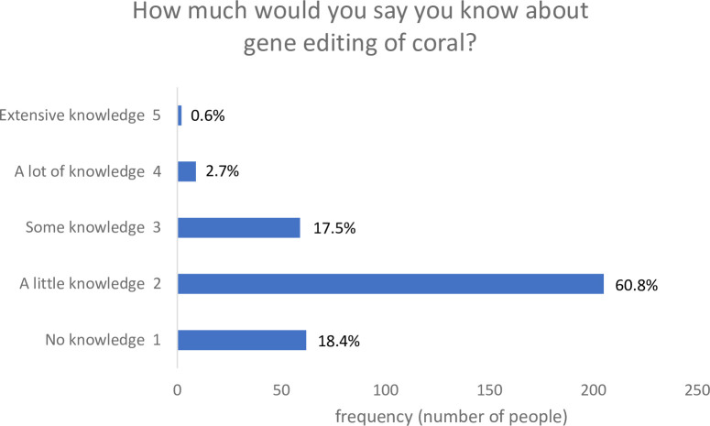
- they found that males reported more awareness than females (34% as opposed to 24%)
- the younger the participants were the more likely they were to be aware of the technology
- education, surprisingly, is not correlated to awareness at all!
- To what extent would you be willing to support this technology?
  - the older people became, the less likely they were to support the use of the technology
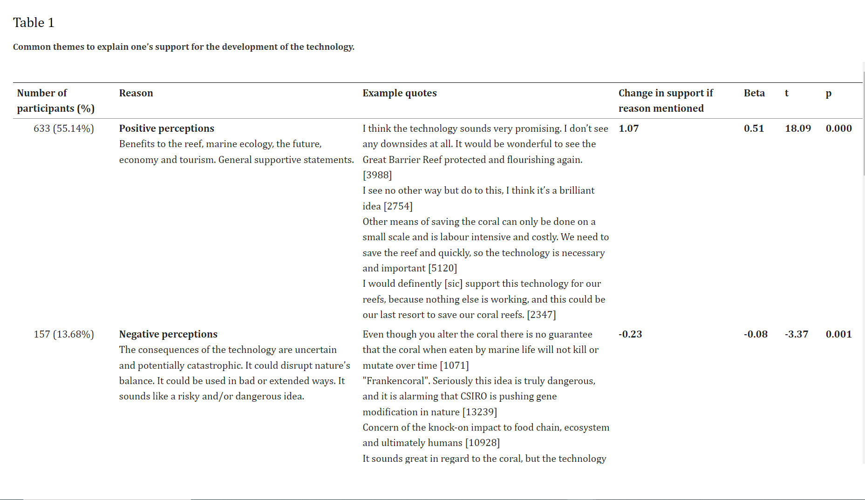
  - females were slightly less likely to support the technology than males
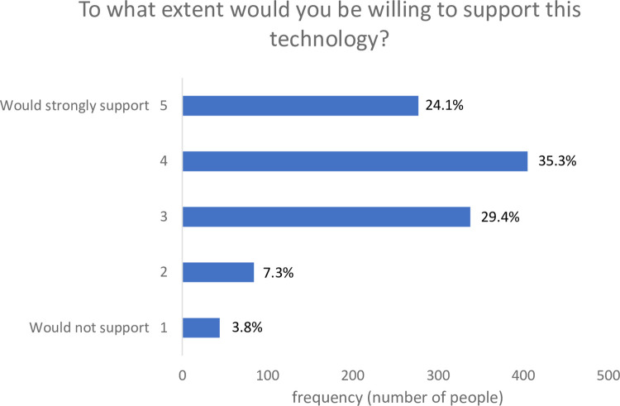
- Why do/don't you support genetically altering corals?
  - information was sorted with multiple regression analysis, which revealed themes in peoples answers. over 50% of participants supported the use of technology.
  - the most common reason for not supporting the technology was the potentially catastrophic consequences in nature and concerning human utilization in other means
  - other reasons that people oppose gene editing tech is the lack of scientific evidence that it will work, the interference with "naturalness" (what's in nature isn't ours to alter), and the concern that it the technology is an expensive "band-aid" solution to the underlying issue of climate change
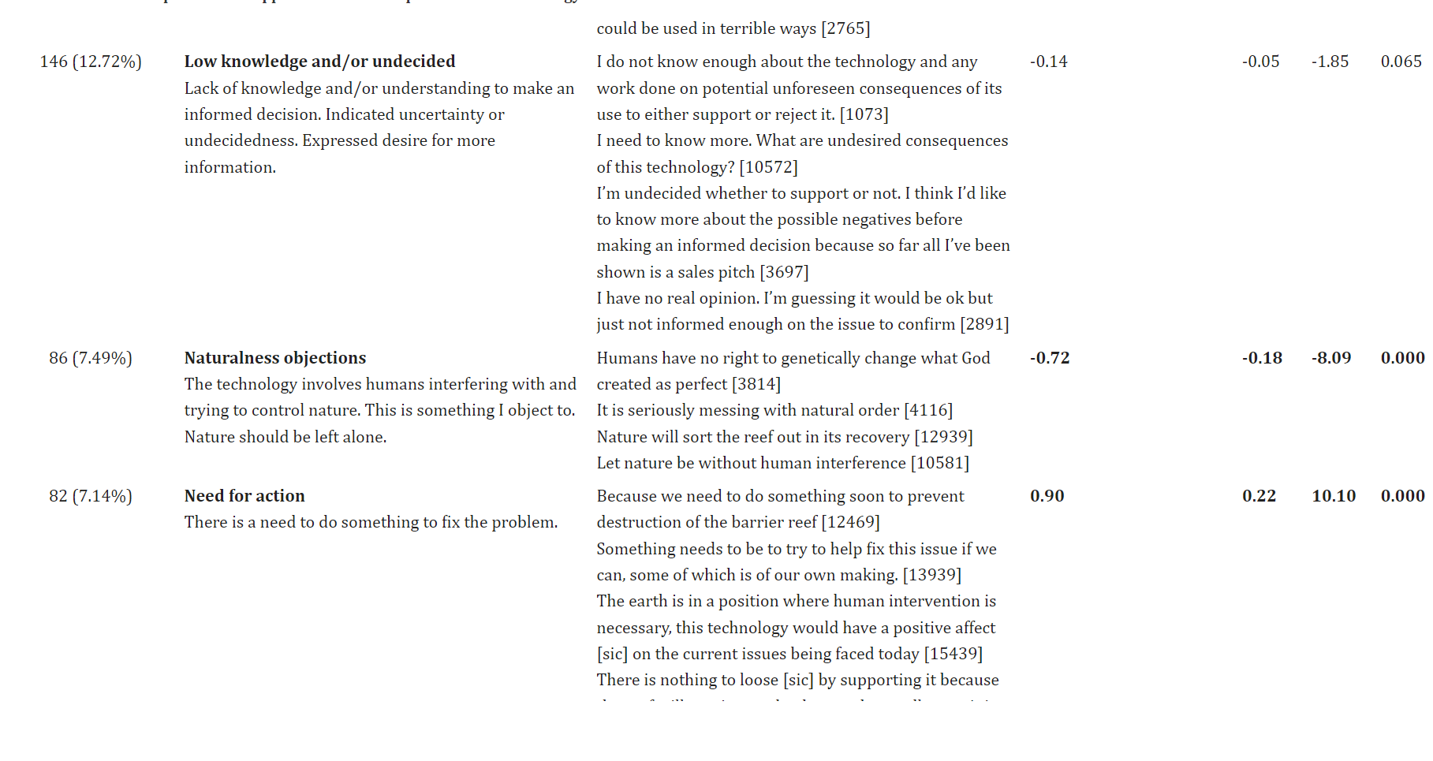
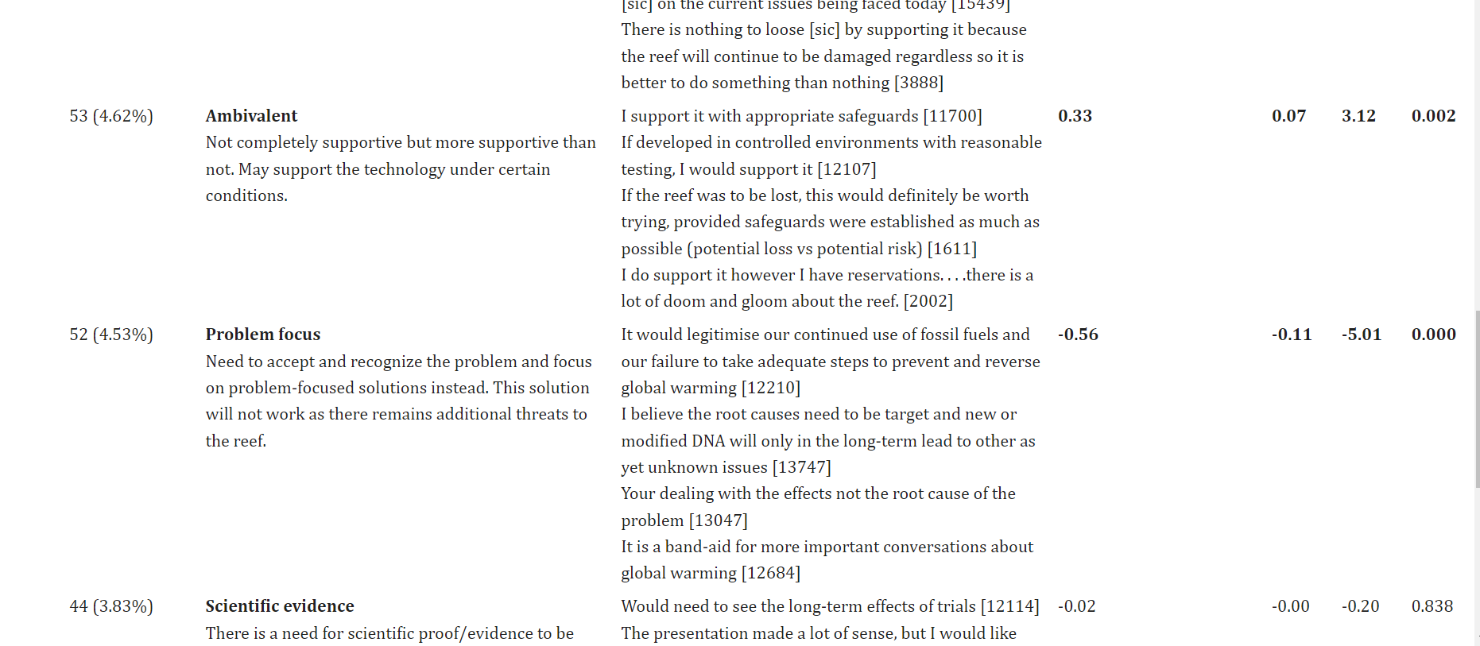
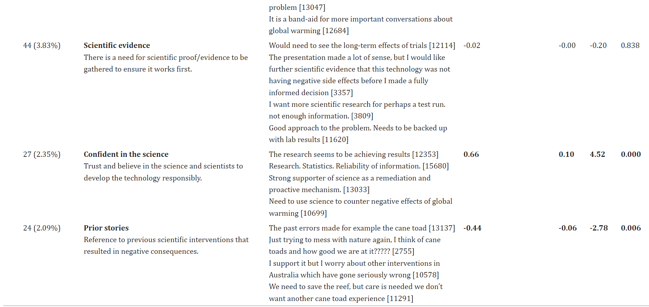

Study 2 - General Opinions

Most Americans Accept Genetic Engineering of Animals That Benefits Human Health, but Many Oppose Other Uses
Brief summary: The general public is more inclined to accept genetic engineering for medical uses, such as cloning organs for transplanting, over technologies that involve bringing back animals that are extinct or for recreational purposes, like changing physical characteristics for aesthetic purposes.

Some Possible Future Research Questions in Coral Endangerment
After gaining a deeper understanding of how genetic alterations directly affect organism phenotypes, as well as other solutions to coral endangerment, we will brainstorm a few solutions the issue:

- How could we use Cas9 CRISPR technology to add more useful genes (such as HSF1 and NFkB) into various Acropora species to increase heat resistance? What other side effects on the phenotype would this have?
- Is genetic engineering wildlife marine animals feasible, given the little knowledge of oceanic biodiversity that humans have?
- Would an increased amount of SLC4ү genes generate larger concentrations of bicarbonate for coral skeletons? Can we alter SLC4ү to gather other chemicals in the ocean to create a different compound for the coral skeleton? Could this clean the oceans a bit?
- Would selective breeding be an alternative method to genetic engineering?

Solutions done so far to Slow Down and/or prevent Dying Coral Reefs in Response to Climate Change

Coral Restoration
The goal of coral restoration is to breed different species of coral in a lab and plant them in the wild on an artificial reef. The University of Miami’s Rescue a Reef is a project that strives to achieve effective coral restoration. The goal is to increase the staghorn coral population by getting individuals to replant them during recreational dives. A coral nursery contains developing corals, small samples are taken to be outplanted. Those samples will be placed in a reef restoration site, zip-tied onto nails. This provides a way to repopulate reefs that have faced degradation. This has improved marine ecosystems, however, this may not be a long term solution. Planting corals that aren’t heat tolerant are constantly threated by the effects of climate change, therefore, this process may not be as sustainable. Planting corals that are more heat tolerant cannot guarantee that the corals will last as future conditions will always change. An ecosystem with a population dominated by one species of coral can easily be wiped out than an ecosystem filled with diverse corals.

The main solution: reducing our carbon footprint

As Professor Donner has mentioned, we are responsible for dying reefs.

The root of dying reefs is anthropogenic activity. We have emitted an excessive amount of carbon dioxide which has led to severe consequences of climate change. Several agreements have been made between countries to improve our carbon footprint (net-zero) which, as a result, will lower rising global temperatures. Here are some actions taken by the biggest emitters to cut carbon emissions.

- Clean energy sources: A huge portion of our energy comes from burning fossil fuels. Currently, many sustainable energy sources, such as, hydro, solar and wind sources are being developed.
- Planting Trees: Trees play a crucial role to reduce climate change. They consistently take carbon from the atmosphere for photosynthesis, and release oxygen. Many countries like the US aims to plant millions of trees each year.
- Promoting public transportation: With the rising cost of living, many countries have decided to cut down on transit fees/tickets to promote public-transport over individual transport.

Finally, here are some smaller ways we can individually use to reduce our own carbon footprint.

- Reuse, Reduce, Recycle
- Using rechargeable batteries
- Turning off unused devices (light switches)
- Shopping local
- Thrifting

Conclusion:
We still haven’t found a sustainable way to properly alleviate dying coral reefs. There are various innovations in fields such as genetic engineering and transplantation to improve coral reefs. However, there is still lots of research that needs to be done to study the genome of a coral and its interactions with its symbiotes to offer a stable approach. Based on the research that has been done to understand the DNA of a coral, it seems that genetic engineering is a promising method that will significantly increase the rate at which we will find a sustainable solution. Nevertheless, humans are responsible for all the damage caused in coral reefs. As we search for a way to increase the resistance of corals to prevent rapid degradation, it is as important for us to take efforts to reduce our carbon footprint. None of these problems would have occurred if we had been more responsible about the environment.

Looking into Electroporation and Chemical Transfection as CRISPR Technologies
Manual microinjection of DNA fragments is tedious, and needs to be done several times to have an actual effect on the phenotype of corals. Transfection allows the study of gene function and protein expression.

Electroporation - Understand Electroporation In Under 3 Minutes
Using a pulse of electricity to create a temporary charge difference between an extracellular solution containing DNA to be transferred, and the intracellular area. This will also create small openings in the cell membrane. The charge difference creates potential energy, causing the new DNA in the extracellular membrane to be sucked into the cell because the extracellular solution contains a more negative charge than the intracellular area. This is because the nucleic acids will be negatively charged, so they will passively move into the cell. The cell will then recover its membrane and contain new DNA fragments.

Transient Transfection QUICKLY Understand Transfection
- not permanent
- introduced DNA cannot be duplicated into other cells
- high expression rate
- use of coiled DNA

Stable Transfection
- permanent
- new DNA will be duplicated into some other cells, but success rate of the transfer is low
- lower expression level
- linear DNA is more effective than coiled

Final Conclusion Plan
2024-01-31
- brief summary of research
- Ideal experiment
- use of CRISPR in the future to help with studies
- application in the real world
- next steps

Notes from Speaking with UofC Mentor
2024-02-05
- Talk more about the ethics of genetic engineering in corals
- Print out most of background research into an organized binder, only relative material on the trifold
- The ideal experiment:
  - Learn even more about CRISPR: Can it upregulate genes/add genes in? Are there any examples of this?
  - Talk about a specific gene on a specific chromosome; how do we go about performing the CRISPR experiment? What would we alter and how would we alter it? Where would we get the genetic material? Could we clone it?
    - Look into HSF1 and NkFB genes
    - Look into how cloning works - cloning sgRNA for CRISPR?
      - looks kind of like black-footed ferret, look into that experiment more
  - How would we implement this into the ecosystem?
  - What benefits would this have?
  - Show off all knowledge collected and applied
- Research vs Data: Research is the concepts we've looked into, data is the results of the experiments that have been run (graphs)

https://www.ncbi.nlm.nih.gov/pmc/articles/PMC9377665/
Advances in CRISPR therapeutics | Nature Reviews Nephrology
First full views of a CRISPR-guided system for gene insertion
https://calgarylibrary.ca/read-learn-and-explore/digital-library/academic-search-premier/

Reliability and History of CRISPR (in general)
CRISPR–Cas9: A History of Its Discovery and Ethical Considerations of Its Use in Genome Editing - PMC

Now that we have gained a basic understanding on CRISPR. It is important to recognize its origin and the ethical concerns if has raised so far. This information is crucial for our understanding to properly judge whether CRISPR will help dying reefs or destroy them.

- CRISPR was discovered in 1987. They were found in the immune systems of archaea and bacteria. Later in the early 2000s, the understanding of the role of CRISPR in the immune system of bacteria came to light. In 2007, an experiment was conducted on lactic acid bacterium to prove CRISPR’s role in the immune system and how it worked.

CRISPR is relatively new, considering that it has only been 30 years since its discovery.

In 2020, the Nobel Prize in Chemistry was awarded to Emmanuelle Charpentier and Jennifer Doudna who discovered the CRISPR/Cas9 system could be used to edit and cut DNA (manipulate the genome of an organism).

CRISPR-Cas9 was used to modify human embryo cells for resistance against HIV, but it was done with little caution and prior research which gained lots of backlash from the scientific community. Some even called for “a moratorium (temporary suspension of an activity) on inheritable genomic manipulations”. No manipulations on the human genome have been attempted since.

What is the PAM? - A CRISPR Whiteboard Lesson

PAM sites defend bacteria from a special type of virus called bacteriophage. Bacteriophages inject their DNA into the bacterial cell which continues to replicate. In bacteria, the immune system has evolved into using CRISPR.

Took hand written notes (see attached)

https://drive.google.com/file/d/1rTuoPDv54HjCoOqQe5gCy2ZeutSHqt2I/view?usp=sharing

Ethics with Ideal Experiment
Genetic engineering of animals: Ethical issues, including welfare concerns - PMC

When we are creating our ideal experiment, we need to take into account…
- Invasiveness of procedures
- Will there be any problems with coral reproduction?
- Number of animals required
- Will this affect the mortality of the embryos?
- Will we have a small number of embryos that survive within a large sample?
- Unanticipated welfare concerns
- Will there be undesirable phenotypes?
Three Rs
- Reducing the number of animals
- Refining the practices to minimize pain and distress
- Replacing animals with non-animal alternatives (if possible)

Multilocus Adaptation Associated with Heat Resistance in Reef-Building Corals - ScienceDirect

Cattle Fetal Fibroblast CRISPR to Knock in Genes
https://research.ebsco.com/c/io475x/viewer/pdf/3cszxgtxuz
locus - a specific area on a chromosome where a specific gene is located
plasmids - DNA ring of bacteria: https://blog.addgene.org/plasmids-101-the-promoter-region
ubiquitous - genes expressed over most of the phenotype

A summary of what was done:

- used CRISPR Cas/9 technology to insert four GFP vectors driven by different promoters that all drive high levels of gene expression into locus Rosa26
- constructed vectors by designing sgRNA with software, and then subcloning the sgRNA onto a mammal-optimized Cas9 expression plasmid
- CRISPR Cas/9 was nucleofected (transfection of nucleic acid information) into prepared cells
- used PCR to mass multiply cells, and amplify and detect magnitude of gene expression

Results
- CAG promoter had the highest expression level, but cRosa26 could support many different promoter types
  - suggests that cRosa26 is suitable for transgene expression with multiple different promoters, and will result in a mostly stable and high expression manner

This experiment was designed to see the expression levels of each promoter in the mammalian locus Rosa26. We can build off of an experiment designed similarly to this one, if we are able to find a "safe locus" in anthozoans (class under phylum of cnidarians that includes anemones and corals).

Cloning: How does it work?

Whole organisms
How does cloning work? - explained in 2 mins! → Dolly the Sheep
- took an egg cell from a sheep, used micropipette to physically remove nucleus
- took somatic cells from mammary gland of another sheep, used electroporation to infuse it into the empty nucleated egg cell of the other sheep
- used electroporation again to stimulate official fertilization in the cell of the sheep
- inserted back into sheep, zygote developed and was birthed genetically identical to sheep that gave somatic cells

How might we apply this to our project?
- genetically engineering coral might be easier, and we can use a similar approach
  - because corals are externally fertilized, if we had access to Aiptasia gametes we could nucleate and electroporate them, and then leave them to develop in lab-developed conditions
- we could use Aiptasia clones as controls if we do not capture enough gametes to experiment on

Cloning DNA - Review
- using restriction enzymes, slicing open a plasmid (creating sticky ends) that can live and reproduce in a host like bacteria
- adding DNA into the plasmid that was cut by restriction enzymes (also has sticky ends)
- bacterial cells are permeable to plasmids, plasmids enter the bacteria (aren't added into the actual DNA of the bacteria, they just exist almost like an additional organelle floating around in the void)
- replication origin in the plasmid will allow it to replicate within the bacteria, and when the bacteria replicates it brings one of the plasmids into each of the daughter organisms
- As bacteria continue to replicate, it creates lots of DNA!

Cloning gRNA for CRISPR in Mammals
https://www.jove.com/v/57998/crispr-guide-rna-cloning-for-mammalian-systems?utm_source=youtube&utm_medium=social_global&utm_campaign=reseach-videos-2022

ligation - process of using sticky ends created from restriction enzymes to add in new DNA
primer - pieces of DNA that help identify part of the genome/specific sequences
oligonucleotides - sequences of nucleic acids (DNA/RNA)

Steps undertaken:
- diluted the lyophilized (freeze-dried) primer RNA oligonucleotides - equal amounts forward and backward into PCR tubes
- mix through vortex machines and spinning
- added digestive enzyme BsmB1-v2 into a guide expression vector, allowed digestion
- used agarose gel to separate DNA fragments with agarose gel electrophoresis
- removed DNA fragments from gel
- begun process of ligation
  - mixed annealed gRNA oligonucleotides from step 1 and 2 with digested guide expression vector, added reaction buffer. Spun to mix
  - added DNA ligase to close the DNA together. Spun to mix
  - allowed reactions to sit at room temperature overnight
- Added E. coli bacteria into mixture, kept cool until reactions had been completed, and then heat shocked for less than a minute. Returned to cool temperatures, and then recovered the culture with a rotary shaker.
- Plated the culture on an antibiotic resistance plate to isolate E. coli that had the RNA inside of it

Cloning gRNA for CRISPR in anthozoans?
Although we could probably use a very similar approach, cloning gRNA for Aiptasia, or anthozoans in general, may have a few challenges.
- since so little is known about the Aiptasia genome, it may be difficult to find suitable materials specific to the Aiptasia anemone, such as
  - bacteria host to clone the DNA
  - DNA ligase
  - digestive enzymes
- it would also be difficult to find an oligonucleotide primer for marine species like Aiptasia

A crucial challenge of gene insertion would be finding a safe harbor locus to insert the new gene into. If we do not have a safe harbor locus, we run the risk of unexpected phenotypes. It's important to find a cnidarian homolog.

Finding the Safe Locus

ROSA26 in Rabbits
Although the only free article regarding gene loci locating is in the rabbit, we should be able to locate the genetic equivalent of the ROSA26 in the Aiptasia anemone with a similar procedure.

Identification and characterization of rabbit ROSA26 for gene knock-in and stable reporter gene expression | Scientific Reports

Quotation from the Article Abstract Outline
"To make the rabbit model more amendable to targeted gene knockin and stable gene over-expression, we identified a rabbit orthologue of the mouse Rosa26 locus through genomic sequence homology analysis. Real-time PCR and 5′ RACE and 3′ RACE experiments revealed that this locus encodes two transcript variants of a long noncoding RNA (lncRNA) (rbRosaV1 and rbRosaV2). Both variants are expressed ubiquitously and stably in different tissues."

Definitions
- Genomic Sequence Homology Analysis
  - finding similarities in the genome of an animal due to ancestral commonality with another animal
  - probably won't work in species that are as different as the mouse to a coral, there seriously isn't enough research for us to know for certain though.
  - https://www.frontiersin.org/articles/10.3389/fevo.2023.1185566/full → a phylogenetic tree that includes cnidarian classification

STUPID PAID ARTICLE: https://www.nature.com/articles/nbt1362

To Do Before the Deadline - March 15th
- begin ideal experiment
- upload research into platform
- create a script that can be spoken in 10 minutes for the slideshow
- create a slideshow
- record the presentation
To do before Judging in Person - April 12th
- complete trifold
- revise project research
- practice presenting to Eva and Helen
- last priority (if time) find a safe locus on Aiptasia

Ideal Experiment
Based on all the research we have done so far, we decided to create an ideal experiment that we would theoretically conduct if we had the resources too. Overall, there has not been sufficient research in genetically engineering corals, nonetheless, the genome of a coral.

The goal of this ideal experiment is to insert an HSF1 gene through the CRISPR/Cas9 method into a safe locus found in the HSF1 gene of a coral. We want to maximize the HSF1 gene expression of the coral, because once down-regulation occurs, it will be less drastic and result in less bleaching as well. Hopefully, this will increase the aiptasia’s resistance to heat stress.

Rough Method Outline
Step 0. - find the locus?
- clone gRNA of HSF1 using CRISPR Cas9 bacteria method on page 51
- clone the zygotes (use original for control groups)
- use transfection (electroporation) to move the gRNA and GFP into cloned aiptasia zygote, or use CRISPR?
- observe development of Aiptasia corals over time

Refined Method

Step 1. Cloning the gRNA of HSF1
- Using distilled water (or through the manufacturer's instructions), dilute equal amounts of forward and backward lyophilized oligonucleotides of HSF1 genes into PCR tubes.
- Using vortex machines, spin the PCR tubes to mix the HSF1 genes.
- Add the digestive enzyme into a guide expression vector solution, and allow digestion for an hour.
- Use agarose gel to separate DNA fragments with gel electrophoresis
- remove extended DNA fragments from the gel
- begin the ligation process by mixing the HSF1 oligonucleotides with the guide expression vector. Add a reaction buffer if necessary, and spin to mix.
- Add the DNA ligase to close the DNA, and spin the mixture to mix. Allow the mixture to fully react overnight at room temperature.'
- Add the bacteria vector into the mixture. Keep cool for an hour until the DNA ligase has fully penetrated the bacteria body, and heat shock for one minute.
- Plate the culture onto a petri plate that contains a toxin that will isolate the bacteria that has the gHSF1 RNA.
- Isolate the gHSF1 RNA

Step 2. Cloning zygotes
- Obtain somatic cells from the male Aiptasia anemone, and an egg cell from the female organism.
- Using a micropipette and microscopy equipment, physically remove the nucleus from multiple egg cells.
- Using electroporation, move the somatic cells into the egg cells. Electroporate once again to remove all contents of the somatic cells except for the DNA.

Step 3. Using CRISPR and Cas9
- Use electroporation and or CRISPR to move the DNA into the genetic material of the zygote.

Step 4. Observing Development
- Move zygotes into a tank with moving water and suitable salt concentrations.
- Observe planulae as they settle along substrate at the bottom of the tank.
- As planulae develop, measure height and gamete development.
- Move anemones away/separate tanks.

Step 5. Exposing larvae to high temperatures.
- Gradually increase temperature by 1.5℃ - 2℃ over 8 weeks (able to trigger bleaching).
*Aiptasia usually start bleaching at around 35℃ (refer to Reduced Thermal Tolerance study)
- Compare heat resistance between wild-type larvae and mutant larvae.

29-02-2024

Step 6. Gradual Release
Assuming successful significant increase in the thermal tolerance of the Aiptasia, public support, government consent, and sufficient financial support, the anemones would be released into the wildlife ecosystem. Before doing that though, the GMAs need to pass a number of tests to ensure that they do not have an unexpected consequence in the wild.
- Monitor the gamete production of the genetically modified anemones and compare it with their non-modified clones.
- Monitor the growth rate of the GMAs (genetically modified anemones), and compare it with their clones.
- https://krakencorals.co.uk/blog/selfsustaining: Using four oxygenated salt-water aquariums, create an imitation of a saltwater ecosystem using live sand. In two tanks, introduce the GMAs. In the other two, introduce the non-modified clones. Gradually introduce organisms that interact significantly with Aiptasia anemones, such as predators like butterfly fish, clownfish, cleaner shrimp, Berghia Verrucicornis sea slugs, and tuxedo urchins. Monitor the health of these organisms.

Significance and Discussion
If this experiment were successful, this would be an incredibly important development in the prevention of coral bleaching on massive scales. Since Aiptasia is strikingly similar to many stony coral species, including Acropora, the experiment's success would open up possibilities of other experiments involving the effects of heat shock in stony corals. This experiment is the tip of an iceberg of climate solutions and genetic technology potential.

Cloning gRNA for CRISPR in anthozoans?
Although we could probably use a very similar approach, cloning gRNA for Aiptasia, or anthozoans in general, may have a few challenges.
- since so little is known about the Aiptasia genome, it may be difficult to find suitable materials specific to the Aiptasia anemone, such as
  - bacteria host to clone the DNA
  - DNA ligase
  - digestive enzymes
- it would also be difficult to find an oligonucleotide primer for marine species like Aiptasia

Sources Used for Rosa26
https://en.wikipedia.org/wiki/ROSA26
Would a Rosa by any other name smell as sweet?
ROSA26 - an overview | ScienceDirect Topics
Safe Harbor Locus (Rosa26 and Polr2a) – Gene Editing Solutions.

Just an idea? Next steps?
- Looking at different symbiodinium living in corals

2024-02-28

Separating background research and project research that will be inserted into the CYSF platform.

2024-03-03

Understanding Cloning

Nuclease: cuts DNA
sgRNA: guides nuclease to cut position

gRNA spacer consists of 20 nucleotides that are upstream along with PAM site.

- Choose 20 base pairs of HSF1 gene.
- Edit cells via expression from inserting a plasmid. This method is more common and less costly.
- Target exons to knock out HSF1 gene. PAM site ends with GG.

Oligo annealing cloning

- Buy two oligos that have the same 20 pair base sequence, along with four extra pairs to allow ligation into the vector.
- Find type 2 restriction enzymes that cut outside their target sequence, which allows that ability to insert a gene.

- Anneal oligos with ligase buffer
- Mix oligos with supercoiled DNA, and run it through a cycling reaction with restriction enzymes.

2023-03-04

Virtual Presentation Setup

2024-03-07

We bought a trifold, yay.

2023-03-08

We worked on virtual presentation and script.

