It Is Rocket Science
Science Fair Project
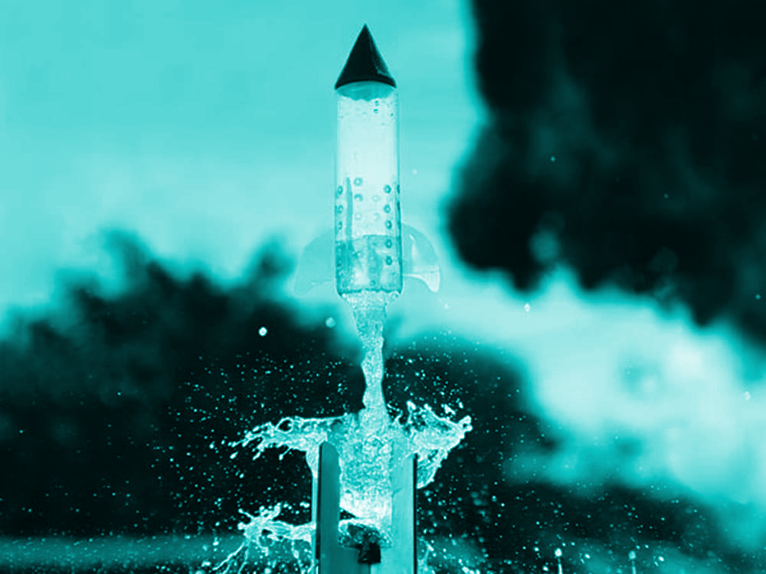
By Zoe Zalmanowitz and Sadie Oppenheim
5th grade science fair
Calgary Jewish Academy
March 2024
Table of Contents
ACKNOWLEDGEMENTS 3
1) SCIENTIFIC QUESTION 3
2) RESEARCH 3
3) HYPOTHESIS 4
4) MATERIALS FOR ROCKET 4
5) MATERIALS FOR LAUNCHER 5
6) PROCEDURE-LAUNCHING THE ROCKET 9
7) VARIABLES 11
8) OBSERVATIONS 11
9) COLLECTING THE DATA 12
Explanation of factors 13
10) ANALYSIS 13
11) CONCLUSIONS 14
12) NEXT STEPS 14
13) SOURCES OF ERROR 15
Problems with the launching 15
14) JOURNAL ENTRIES 16
15) CITATIONS 17

ACKNOWLEDGEMENTS
-Jason Zalmanowitz (Zoe’s dad)
Thank you for guiding us through this project specifically with science.
-Lisa Yellin (Zoe’s mom)
Thank you for being there to help us with questions and answers.
-Robyn Oppenheim (Sadie’s mom)
Thank you for guiding us as far as math is concerned.
-Joe Oppenheim (Sadie’s dad)
Thank you for making us laugh along our journey.
-Mr E. Gelman
Thank you for supporting and drawing out the guidelines of this project.

1) SCIENTIFIC QUESTION
A bottle soars high into the air. It looks like a little rocket. Something is fueling it… Science! In this project, we will build bottle rockets with various materials. We will test different liquids with different densities and see which one flies the highest. We will also see if the substance that wins can be a future fuel for people.

2) RESEARCH
- Chinese pyrotechnicians made bottle rockets in the 12th century AD. Normally, soldiers used them in war. They were set off on the ground to cause a confusion and scare away military horses. Soldiers also launched them into the air attached to arrows.⁵
- These rockets had a pretty similar design to the modern-day bottle rockets.
- “Bottle rockets operate on the principle of Newton's third law of motion, which states that every action has an equal and opposite reaction.”⁶
Density:
Here is a photo that shows corn syrup, water, and oil. The volumes were all the same. Oil is at the top, water is in the middle, and corn syrup is at the bottom, and they are in this position due to their differing densities.
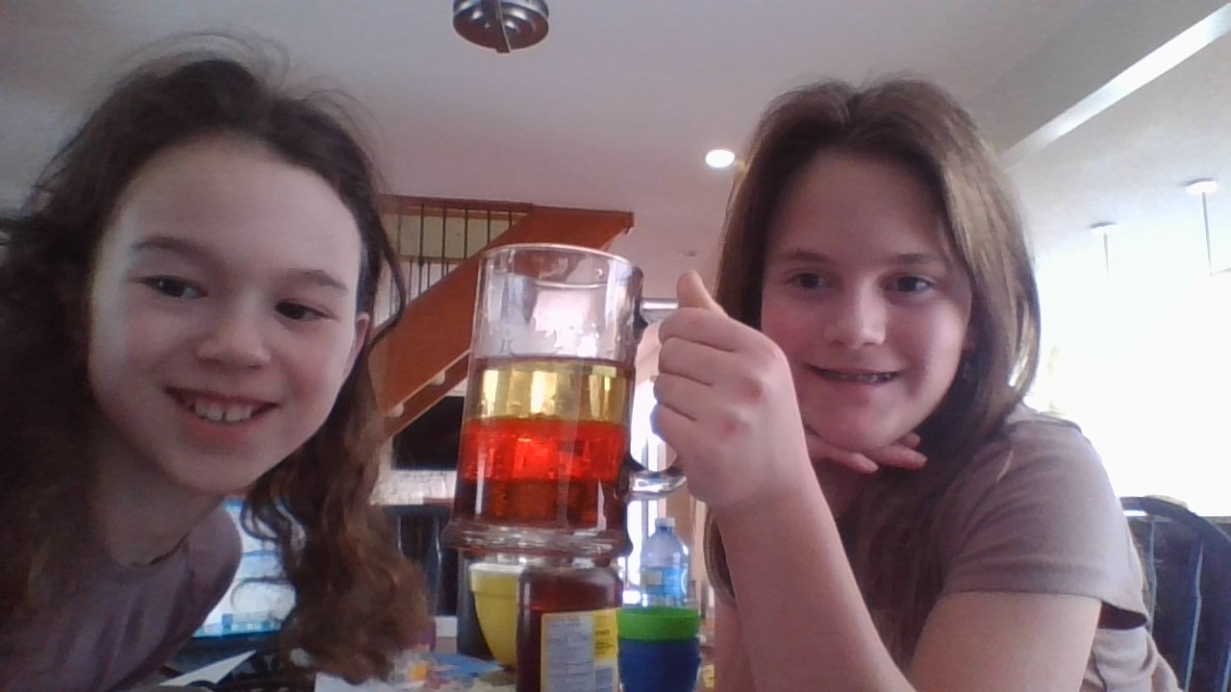

3) HYPOTHESIS
Zoe: I think the denser the liquid the higher the bottles will fly. I also keep in mind that the denser the liquid is the heavier the bottle will be so it’s a little bit of a fifty-fifty chance.
Sadie: I agree. I also think that the weather will affect how high the bottle goes along with how the density of the liquid affects how high it goes.
So…If the liquid is denser than the liquid will go higher because there’s more potential energy in a denser substance.

4) MATERIALS FOR ROCKET
- Liquids (milk, water, corn syrup, rubbing alcohol, coke, canola oil)
- Soda bottles (2 liter)
- Strong plastic
- Bicycle pump
- String

5) MATERIALS FOR LAUNCHER
https://www.youtube.com/watch?v=hJf7DHApz2Y
- PVC Pipe cement.
- A tire schrader valve.
- A 1/2" PVC Slip to Slip Elbow.
- A 3/4" Female Thread to Slip adapter.
- A Hose quick connector with male threads.
- A 1/2" slip to 3/4" slip adapter.
- A 1/2" female threaded cap.
- A 1/2" make thread to 1/2" slip adapter.
- Teflon thread tape
- Electrical Tape.
- About 18" of 1/2" PVC pipe.
- Some scrap wood.
- Two screw eyelets.
- Two U bolts.
- Thin rope

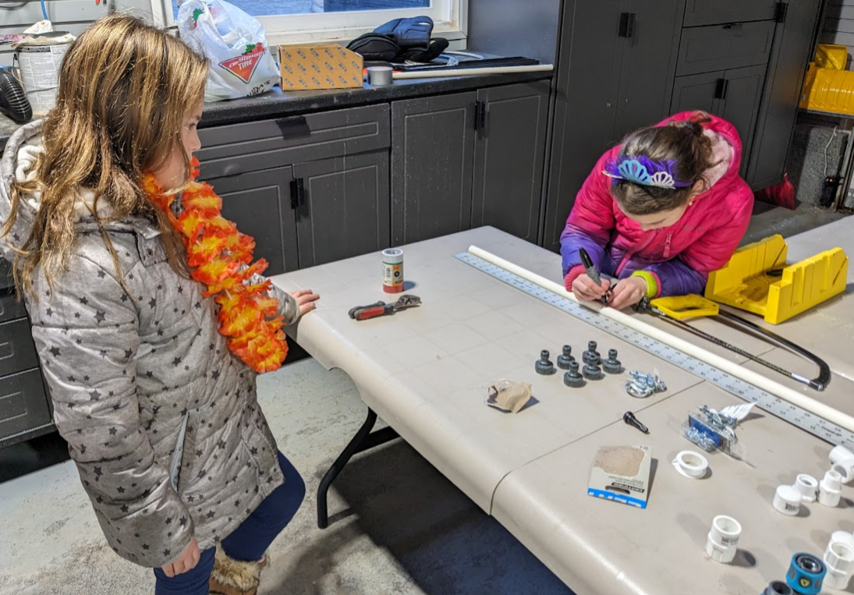
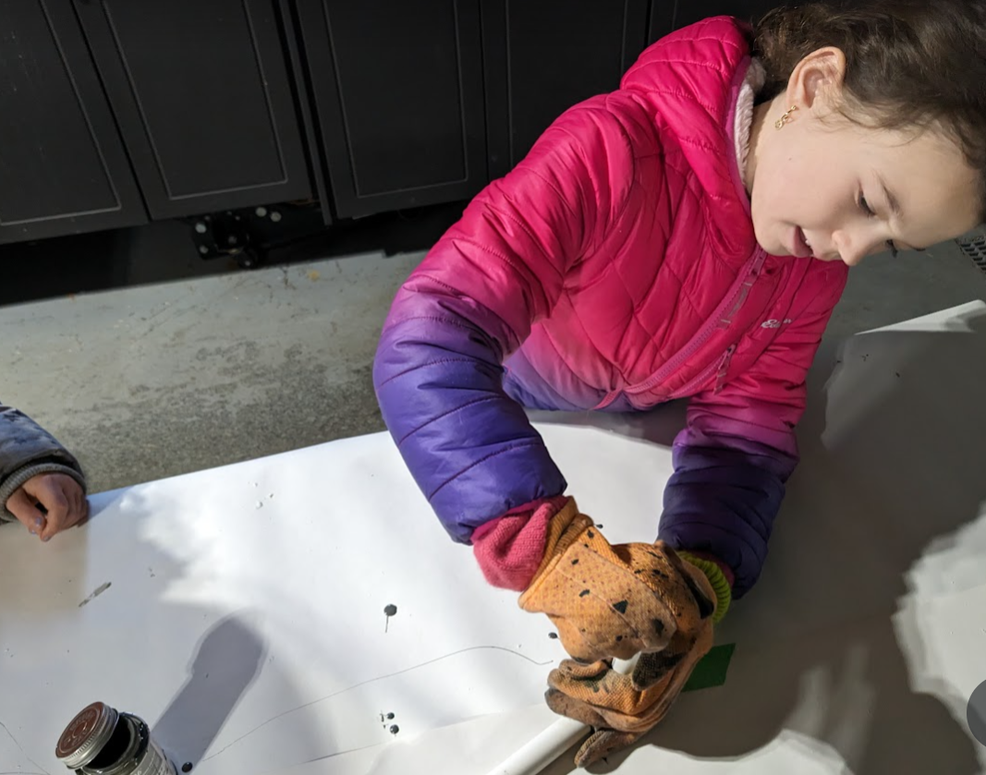
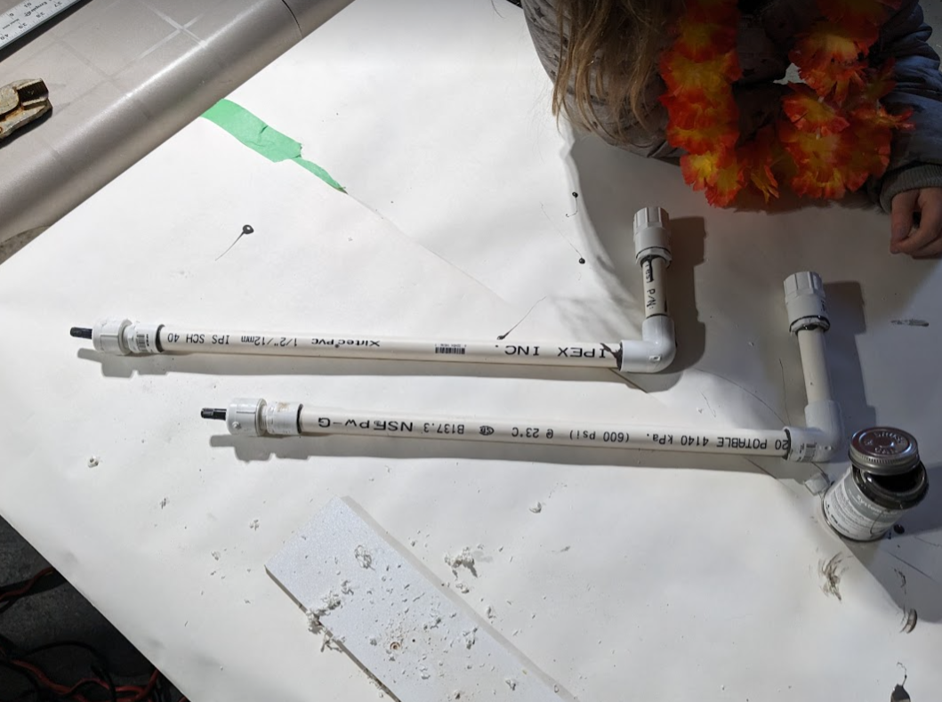
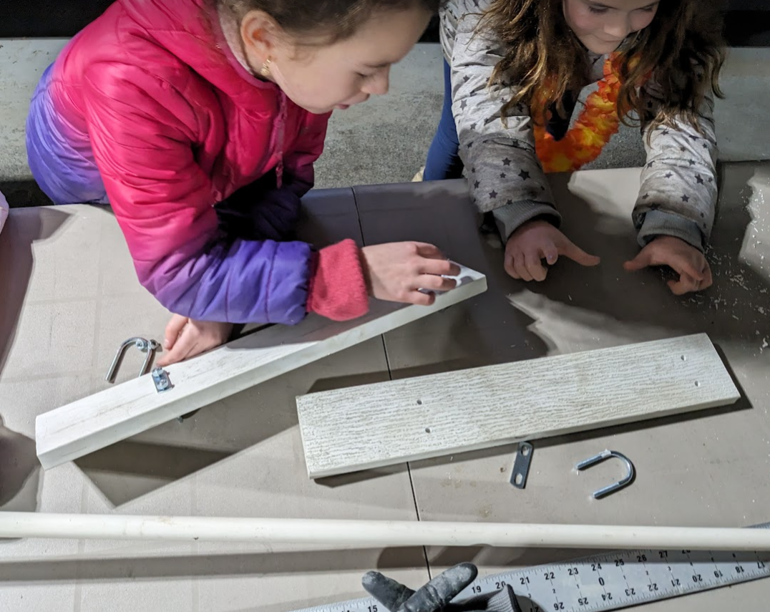
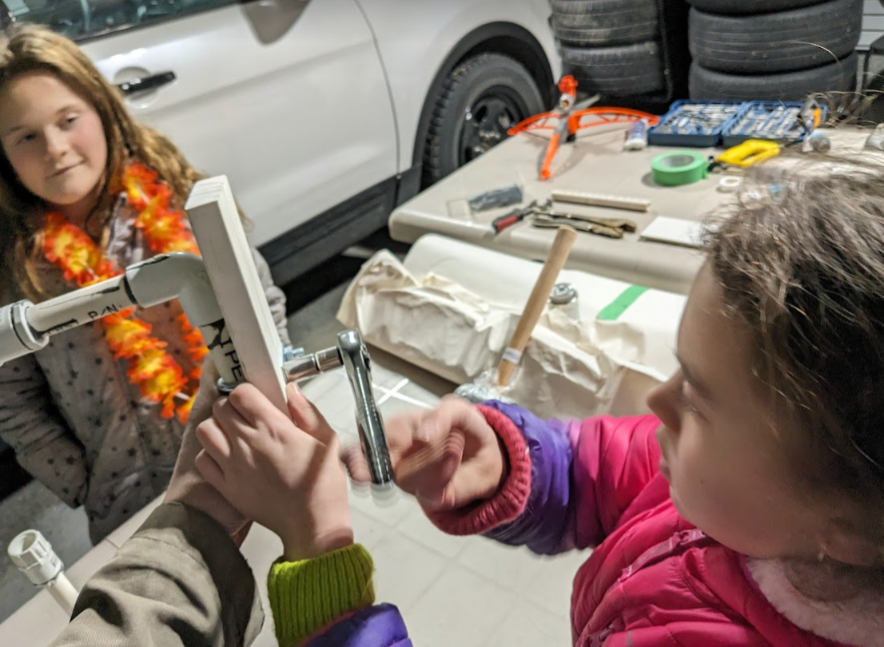
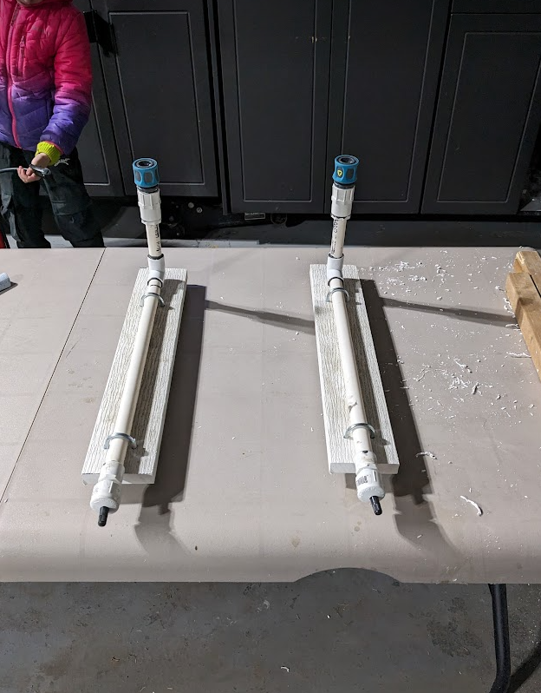

6) PROCEDURE-LAUNCHING THE ROCKET

- Measure out 100 mL of the liquid and pour into the rocket
- Attach rocket to launching apparatus
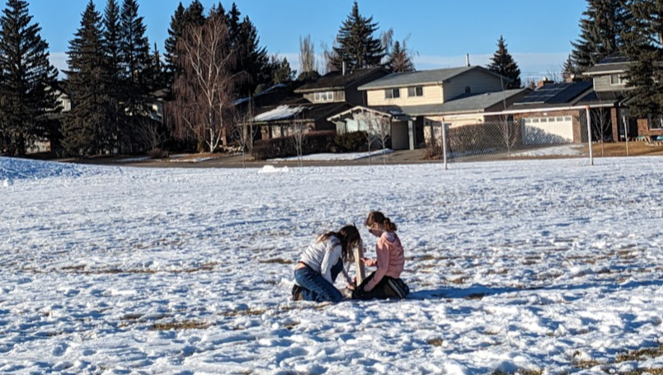
- Pump the bicycle pump until 100 psi of air is in the bottle
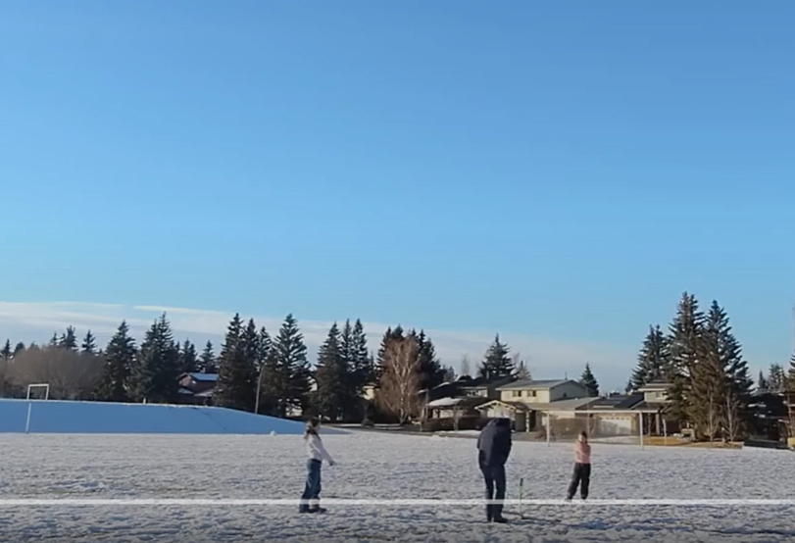

- Lay pump down and clear the area for launch
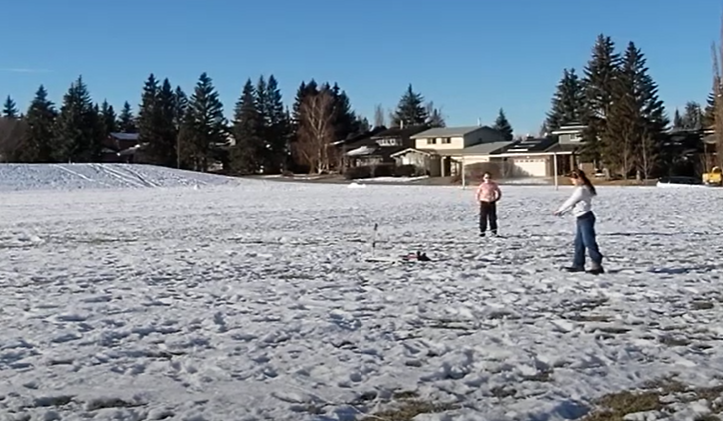
- Launch the rocket
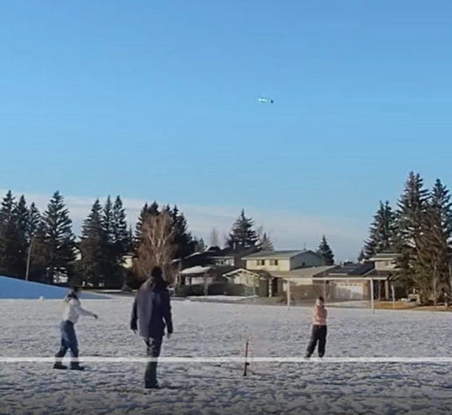

- Record the results

7) VARIABLES
Manipulated Variable: is what a scientist changes in order to see what happens. Also referred to as the “Independent Variable” Our M variable is the liquid and its density.
Responding Variable: is the resulting change that occurs in an experiment that a scientist would be observing and measuring. Our R variable is the airtime.
Controlled Variables: is specifically measured and tracked components in an experiment. These must be kept exactly that same throughout so that your results are valid. Our C variable is the volume of the liquid and the air pressure.

8) OBSERVATIONS
Launching the rockets and measuring height-Filling the bottles and attaching then to the launcher
It was difficult to get all of the liquid in the bottle without a little spillage because sometimes the bottle that we were pouring from had a bigger opening than the bottle we were pouring the liquid into. It was also difficult to see whether the bottle was properly attached or not.

Pressurizing the liquid
We had a few leaks even from the launcher that we made ourselves, so we had to do a few retries on some of the liquids. We also noticed that some liquids bubbled more than others did even though they got the same amount of pressure. This was due to the air surfacing through the water creating bubbles.

Measuring the height was challenging
The altimeter did not work as described, so we could not use that.
We tried measuring the height with string, but the string kept getting tangled.
We tried to measure the height using a technique called proportional reasoning. We used proportional reasoning by pausing the video when the rocket was a it’s highest then measuring the height of me (Sadie) and comparing it to the height of the rocket. That didn't work because with some of the videos we took, the rocket went off the screen.
In the end, we used airtime to calculate the best fuel for our bottle rockets.

9) COLLECTING THE DATA

We collected the data by timing from launch to landing as airtime. Our previous method was using the altimeter (which would have been more accurate) but due to the fact that the altimeter didn’t work, we had to use other methods. After the Proportional Reasoning equation proved unsuccessful, (because on some of the videos that we filmed, the bottle went higher then the camera was directed and while watching was off screen) we decided to use airtime instead. We counted the seconds that the bottle was in the air on camera and that gave us our answer.
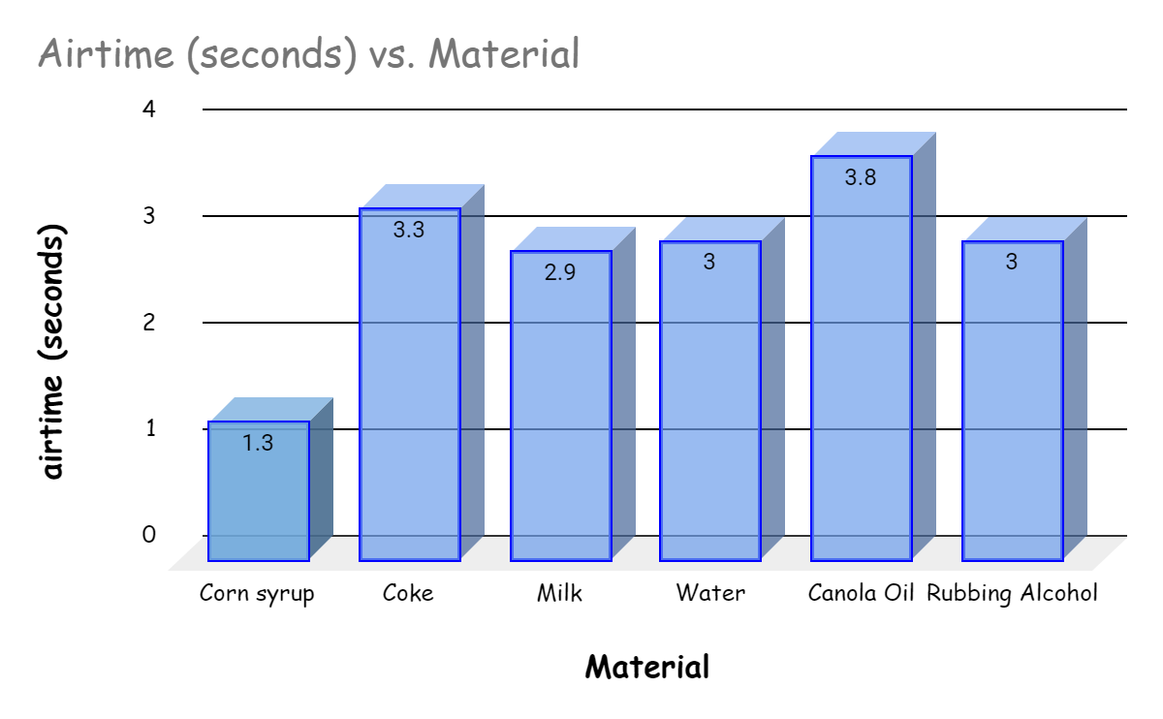

Factors | CORN SYRUP | COKE | MILK | WATER | CANOLA OIL | RUBBING  ALCOHOL
Density  (g/mL) | 1.4g/mL⁷ | 1.042g/mL⁸ | 1.032g/mL⁹ | 1g/mL¹⁰ | 0.92g/mL¹¹ | 0.7854g/mL¹²
Airtime  (in seconds) | 1.3sec | 3.3 sec | 2.9 sec | 3.0sec | 3.8sec | 3.0sec
PSI | 100 PSI | 100 PSI | 100 PSI | 100 PSI | 100 PSI | 100 PSI
Volume of liquid per trial (mL) | 100mL | 100mL | 100mL | 100mL | 100mL | 100mL
Viscosity | 110,000cP² | Because of the lack of third party research and because we didn't have access to lab equipment to test this, we are going to assume that Coca Cola has a viscosity between 1 and 3 because it’s close to water and milk. | 3cP⁴ | 1cP⁴ | 46.2cP² | 2.4cP³

Explanation of factors
-Density is a comparison between the mass and volume of a substance.
-Airtime means how long the rocket stays in the air.
-PSI means pounds per square inch, which is used to measure the pressure
-mL stands for milliliters, which is used to measure the volume of the liquids
-Viscosity is how fast/slow something pours
-cP stands for centipoise, and is used to measure viscosity

10) ANALYSIS
- Corn syrup - significantly more dense than all the others. The airtime was a lot less. This is likely because the airtime and the density could be related.
- Water, coke and milk all had similar densities (since they are all water based), and all the airtimes were similar.
- Canola oil and rubbing alcohol both have densities less than water. The airtimes were not what we expected. This might be because they are not made of water at all.
- Heavy liquids aren't a good rocket fuel as they would just weigh the rocket down so it can’t fly.

We came to this analysis because we took the data from the chart and graph and made a hypothesis. Our hypothesis is no longer based on density but on viscosity. As we know, viscosity is how fast or slow something pours. Items with a lower viscosity flow better and fly higher. An interesting factor is that although the airtime and densities are similar with rubbing alcohol and canola oil, the viscosity is very different.

11) CONCLUSIONS
- Our hypothesis was incorrect because the liquids with lower density flew higher. We think this is because the liquid was light meaning the pressure was able to propel the rocket higher.
- Corn syrup is significantly more dense than all the other liquids that we tested due to its composition and the process by which it is made.
- Water, coke and milk all had similar densities (since they are all water based), and all the airtimes were similar because their densities are similar.
- We’re assuming that Canola oil and Rubbing alcohol had around the same flight time because their densities were around the same

12) NEXT STEPS
We wanted to find out how different densities of different liquids affect how high a bottle rocket will go. We will see if the substance that is in the air for the longest (Canola Oil) can be a future fuel for humankind. People can use Canola Oil for things like fueling your car, heating, and cooling. One thing about Canola Oil is that it is reusable, recyclable, and renewable which makes it a flexible liquid. There’s a downside, though. If an airplane is spewing oil, it will fall a long distance and likely cause quite some damage.

13) SOURCES OF ERROR
Problems with measuring height
-The Altimeter
The altimeter that we were going to use to measure the height did not work, we set it to 0' and it came down at 0’. So then we decided to record ourselves. It’s easy to access and to see visually or time if we need to.
-The measuring string
The string method that we used to measure the height of the rocket did not work because the string kept getting tangled and was not an efficient way to do it. Then we decided to use the proportional reasoning technique because it was a simple and efficient way to measure height.

Problems with the launching
-The Quest water rocket kit
This kit was an absolute failure for many reasons. It was low quality and did not have the structural support to be able to launch rockets. The support legs kept breaking, the latch that let the bottle rocket go also kept breaking, the string was not thick enough and kept snapping, the wings (that were not useful anyway) kept flying off when we launched the rocket, we had many leaking issues and the bottles kept losing air. So we decided to make our own launchers and bottle designs because it was more cost efficient.
-Proportional reasoning technique
We used this technique to try and measure the height by watching the videos but on some of the videos the bottle rocket went higher than the camera was filming. So we decided to measure by airtime so that we didn't have to see the rockets on the screen.

14) JOURNAL ENTRIES
Journal entries were scanned in. Full print outs will be included with the presentation board. You can double click on these to open them though.

15) CITATIONS
1. Water rocket booklet. (n.d.). https://www.npl.co.uk/skills-learning/outreach/water-rockets/wr_booklet_print.pdf
2 Viscosity Chart .https://www.dixonvalve.com/sites/default/files/product/files/brochures-literature/viscosity%20chart.pdf
3. Isopropanol Alcohol Solvent Properties https://macro.lsu.edu/howto/solvents/ipa.htm
4.Product Viscosity Chart https://prosysfill.com/product-viscosity-chart/
5 BlackCat Fireworks - What Are Bottle Rockets? https://blackcatfireworks.com/what-are-bottle-rockets/#:~:text=Chinese%20pyrotechnicians%20developed%20bottle%20rockets,the%20air%20attached%20to%20arrows

6. KiwiCo https://www.kiwico.com/blog/the-science-behind/the-science-behindbottle-rockets

7. Denseme https://denseme.com/density-of-corn-syrup

8. Department of Chemistry
https://chem.washington.edu/lecture-demos/density-column-coke-and-diet-coke

9. Material Match Search Platform https://matmatch.com/learn/property/density-of-milk-weight-per-gallon

10 US Geological Survey Water Density https://www.usgs.gov/special-topics/water-science-school/science/water-density

11 Densme https://denseme.com/density-of-vegetable-oil/

12. Denseme https://denseme.com/density-of-rubbing-alcohol

