Science Fair Logbook Gr.9
Content
1 | Schedule
2 | Problem
3 | Daily Notes & Ideas
4 | Background Research
5 | Contacts & References
6 | Procedure/Method
7 | Data Collection Sheets
8 | Observations/Results
9 | Graphs
10 | Conclusions

December. 26, 2020
Since I am interested in Science Fair, I am going to apply for my school science fair. In order to do so, I have to decide a topic. I have an interest in science, engineering, and technology, not only that, but I also watched a documentary recently called “Inside Bill’s Mind”. The documentary showed about some problems and conservation effects in developing countries.
After thinking some more, I have decided to make a machine which can provide cost effective method for obtaining electricity.

January. 3, 2021
Now I have to work on getting accepted in my school science fair. This process will include preparing a document as to what my project is going to be about, and how it is going to work.
I am going to start researching about how to provide affordable electricity.
While researching, I came across bacteria called electrogenic bacteria. These bacteria are present in the mud and poop, and produce electrons.
I am going to try to make a machine that can convert poop into electricity.

January. 8, 2021
Today I am going to start working on designing my prototype of the machine that converts mud/poop into electricity.
I finished some part of my design, I will need one more day to completely finish the design, and then I can start building it.

January. 15, 2021
Today I am going to finish the full design of my machine.
I have finished the design of the machine, here is how it looks:
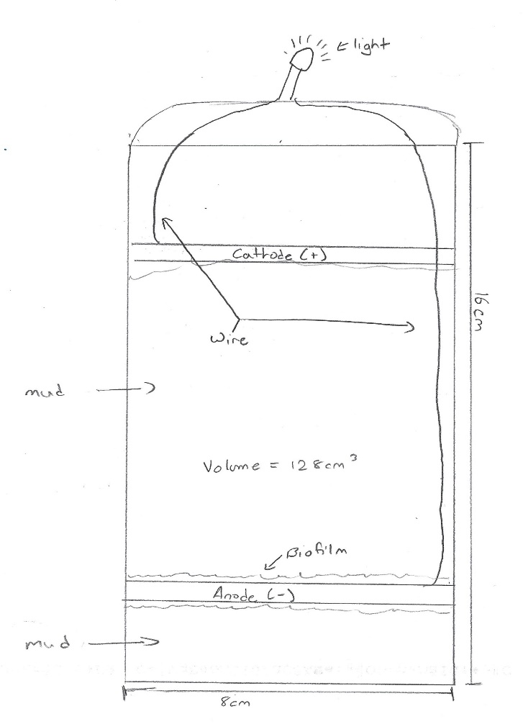
I will need one more day to check over all the part in the diagram.

January. 20, 2021
Today I am going to check the diagram of the machine over, just to make sure everything will work properly.
I checked over the diagram, and it looks good. Today I am also going to finish my ethics due care form 2A.
I finished the form, now I am waiting for approval.

January. 21, 2021
Today I am going to order the supplies I need for my project which include the following:
- Container with lid
- Electrical chip (available at local store – e.g., Walmart)
- Anode
- Cathode
- 2 copper wires
- Mud
- 1V < 5V Light bulb
- Safety Gloves
- 47Ω < 4.7kΩ resistors
These materials should arrive by Saturday the 23nd.

January. 23, 2021
The materials I need to build the machine finally arrived today, and I will start building it right away. I think I should be able to complete building the whole machine in the same day.
I completed building the machine, and it is working. I can see that it is working because the light that I installed on it is flashing.

January. 24, 2021
I have submitted my proposal form to my school today.
I will get the results by the end of January.

January. 28, 2021
I got the results, and I am selected for the city science fair!

February. 10, 2021
Today I am going to take a look at the CYSF platform, and just see how it operates, and the sections in it.
After taking a look at it, I will also finish my ethics due care form 2A.
I finished the form, now I am waiting for approval.

February. 15, 2021
My Ethics Due Care Form 2A was approved today, this means I can work on the other sections now.

February. 17, 2021
I am planning on finishing the Basic Project Info today.
I finished Project Info section, and since the machine is built, I can work on acquiring information, and statistics such as things like which resistor to use, and what quantity of mud is optimal, and where the mud is retrieved from
This will help me complete the other sections in the platform.

February. 25, 2021
Today I am going to a pond near my house to test which type of soil provides more electricity, the soil at the bottom of the pond (wet soil), or the normal dry soil in my backyard.
I just came back with the two soils, now I am going to put both the types of soil into the machine, and will measure which one gives more power.
After reading the results I saw that the muddy soil gave more power compared to the dry soil.

February. 27, 2021
Today I am conducting another test as to how much mud is the best quantity in order to get the most amount of power.
For this test I am going to use the lake bottom soil since it provides more power than dry soil.
I am testing soils of 50 mL, 100mL, 300mL, 250 mL, and lastly 500mL.
After doing the test I saw that the test sample with 500 mL of soil gives out the most amount of electricity. However, I found out that 300 mL of mud can give off enough power to power one regular sized light bulb.
Next, I am going to try to finish a large portion of the questions in the platform.

March. 3, 2021
Since I have all the data I need, today I am going to try to finish the following sections:
- Problem
- Method
- Analysis
It took a long time but I did finish the above three sections. In the analysis section, I explained my results.

March. 9, 2021
The only section I have left to do now, is conclusion, and my video, as well as uploading some pictures.
Today I am going to finish my conclusion portion, and also start thinking about what I am going to do for my video.
I have finished my conclusion section, and I talked about my hypothesis, and the future.
After thinking about the video, I have decided to talk about how this machine works, where it can be used, and its future.

March. 12, 2021
I am making my PowerPoint today, and will voice over it. Not only that but I am also going to explain my project in front of a video camera, and then combine the two together.
I finished making the PowerPoint, and I will voice it over, and get the video taken with the help of my parents tomorrow.

March. 13, 2021
Today my parents are going to record me, and I will voice over the presentation, combine it in iMovie, and then upload it onto the platform.
My parents took a video of me speaking, and I also finished the voice overing part in my PowerPoint. Now I need to combine it in iMovie, and then upload it onto the platform.
I combined the video today, and uploaded it onto the platform. Now I just have the pictures to take, and upload them.

March. 16, 2021
Today I took the three pictures I need to upload.
I have uploaded the pictures, and I am finished my project. Now I have to wait for March. 19.

