Timetable

Date | Work Content
Late Jan | Choose topic  Self education of infectious disease model  Animation design for graphing
Feb, 18 | Viewed Science Fair Webpage  Background Research of general COVID-19 properties
Feb, 19 | Background research of AB policies for COVID-19 control  Background research of math modeling in COVID-19
Feb, 20 | Background research of math modeling in COVID-19  Variables for COVID-19 virus
Feb, 21 | Learning about mathematical models of COVID-19
Feb, 22 | Learn and initial computer programming in Scratch
Feb, 23-26 | Build COVID-19 model in Scratch
Feb, 27-28 | Tuning model and research on intervention scenarios
March 1st | Oneline: Basic information info;  Significant risk form 2B  Problem
March 2st | Online: Method - draft  Research
March 3st | Online: Data - draft  Research
March 4st | Online: Conclusion - draft  Acknowledgement - draft  Citation - draft
March 5th | Add Vaccination model
March 7th | Add Vaccination model to online project
March 8-9th | Review and Modify Online Project
March 10th | Finish banner, project image and participant image
March 12 - 15 | Finish presentation video
March 16-19 | Final check

Topic:
Topic list:
Topics that interests you

List:
-Space: What is in a blackhole?
-Chemicals
-Engineering
-Experiments
-COVID-19
-Nutrition
Why did you choose this topic?

I chose this topic because,
Reasons:
-Mothers influence
-Special moment in history
-Nice opportunity
-Community helpfulness

Background research:
What is COVID-19?

COVID-19 is a deadly virus that can hospitalize you or maybe even kill you. This virus is named after the crown of the sun since it looks like the corona.
Info: (Search: why is the corona virus named the corona virus)
What is an infectious disease?

Things that are considered infectious diseases are caused by organisms. (examples: bacteria, viruses, fungi, parasites, or living organisms in our bodies) It is usually harmless or helpful, very occasionally harmful like this pandemic!
Info: (Search: What is considered a infectious disease)
How does COVID-19 hurt humans?

COVID-19 can potentially cause deaths, usually in the older generations. It may also cause deaths in the middle and younger generations, though least deaths occur in the youngest generations
Info: (Seach: Which type of people does the covid-19 affect the most)
COVID-19 current status (Feb 18, 2021):
Whole world: Confirmed cases : 109 594 835
Confirmed deaths: 2 424 060
Countries, areas, or territories with COVID-19 cases: 223
Info: https://www.who.int/emergencies/diseases/novel-coronavirus-2019
Canada:
New cases: 4 653
Confirmed cases: 831 577
Confirmed deaths: 21 397
Info: https://www.who.int/countries/can/
Alberta:
Cases: 130K
Deaths: 1 798
Info: (Search: How many confirmed Covid-19 cases are there in Alberta)
How does COVID-19 spread?
It spreads through saliva and discharges from the nose, that will happen if an infected person sneezes, coughs, or even breathes!
Info: https://www.who.int/health-topics/coronavirus#tab=tab_1
Symptomatics for COVID-19
Common symptoms:
-Fever
-Dry cough
-Tiredness
Uncommon symptoms:
-Aches and pains
-Sore throat
-Diarrhoea
-Conjunctivitis
-Headache
-Loss of taste/smell
-Skin rash, or discoloured fingers or toes.
Info: https://www.who.int/health-topics/coronavirus#tab=tab_3
Asymptomatic transmission
The Asymptomatic can spread the virus just the same with the symptomatic! These people only have the luxury of low chance of death.
Info: (Search: How does asymptomatic people spread Covid-19)
School and workplace policies
People are permitted to stay inside at all times, though it seems that work, health, and grocery shopping is the exception. Now we are permitted to leave at any given moment in time.
Info: https://www.alberta.ca/coronavirus-info-for-albertans.aspx

Testable questions/purpose
Hypothesis
Materials (None)
Procedure
- What is the SIR model?
- What are the math equations for the SIR model?
- Writing a program in Scratch to simulate the COVID-19 spreading in WDP, and create graphs of the results
- Simulate the scenarios of interventions:
  - Decrease contacts between people in school (have done in this project)
  - Performing Vaccination （future work）
Discussion of What is the SIR model:
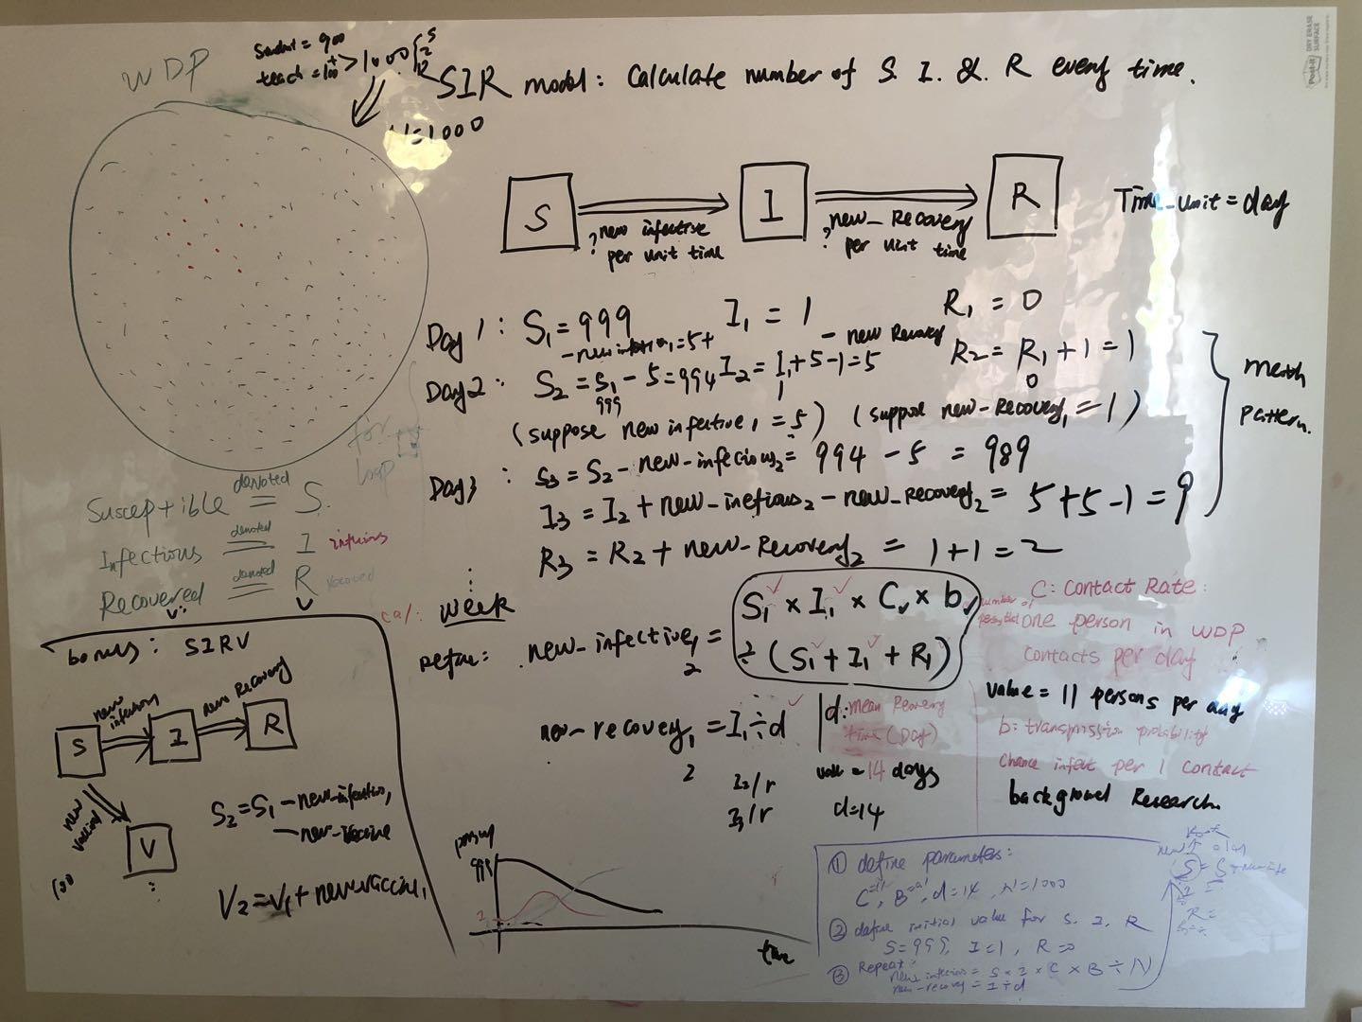
Discussion of how to visualize the model results:
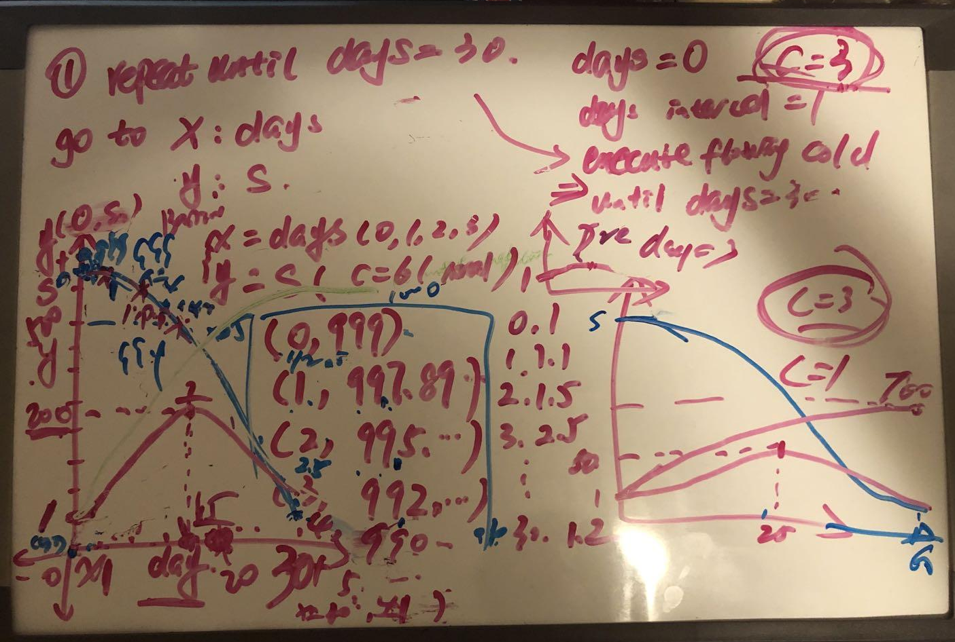
Manually calculate the SIR model of the first 5 days (the first day is I=1):
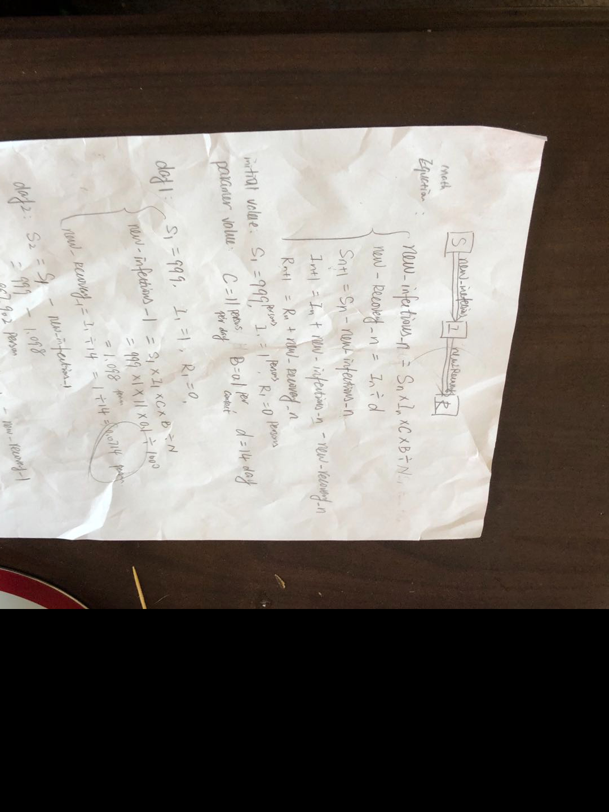

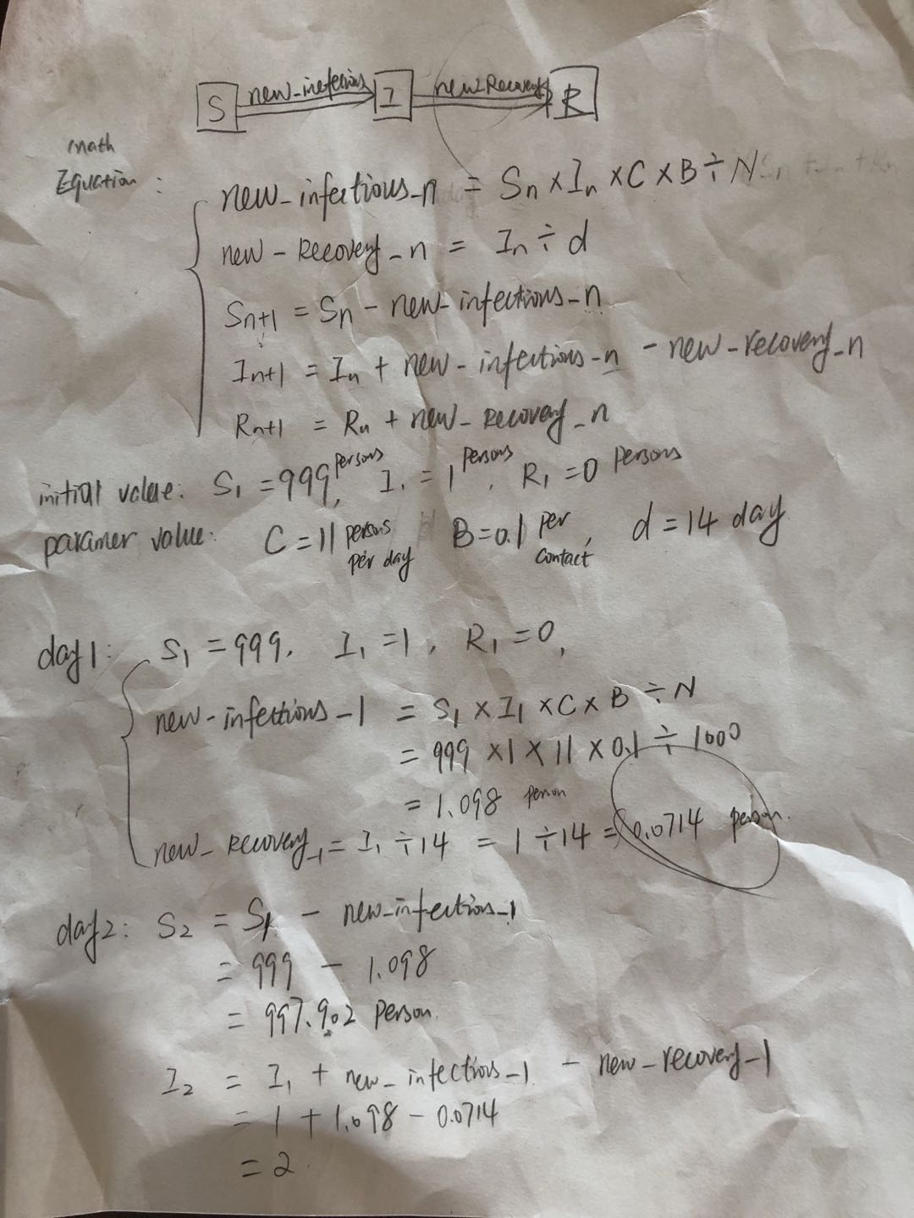
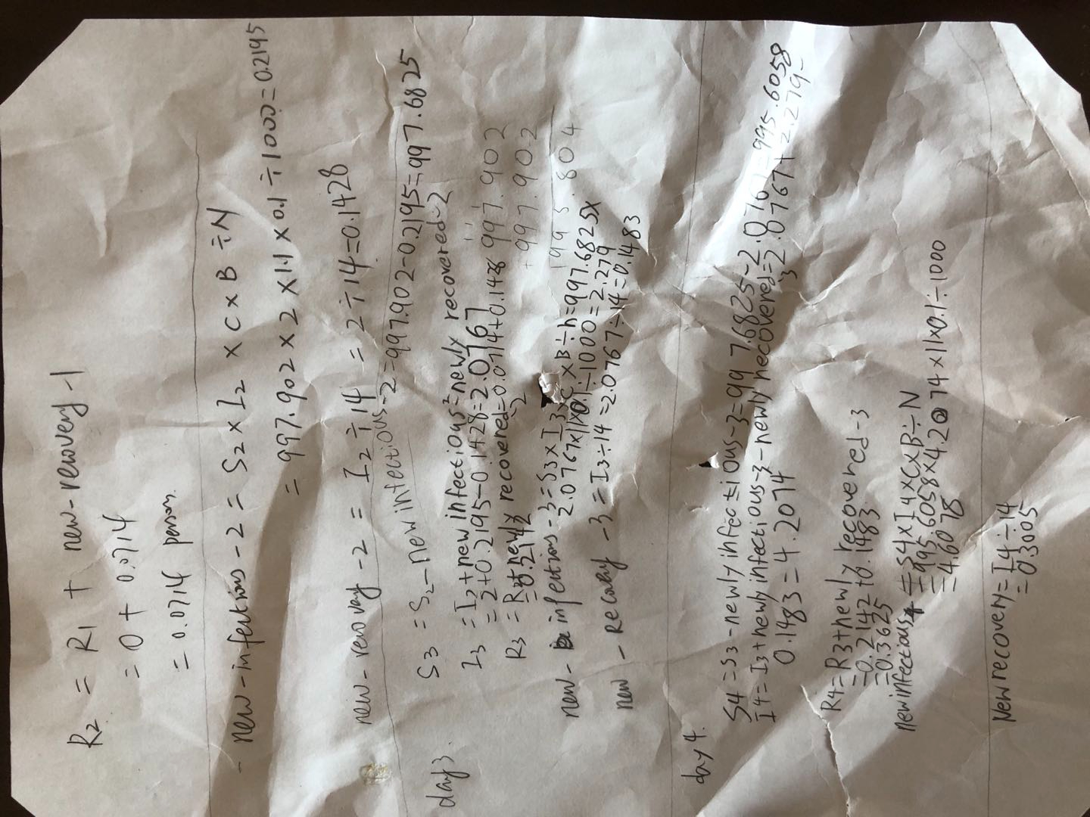
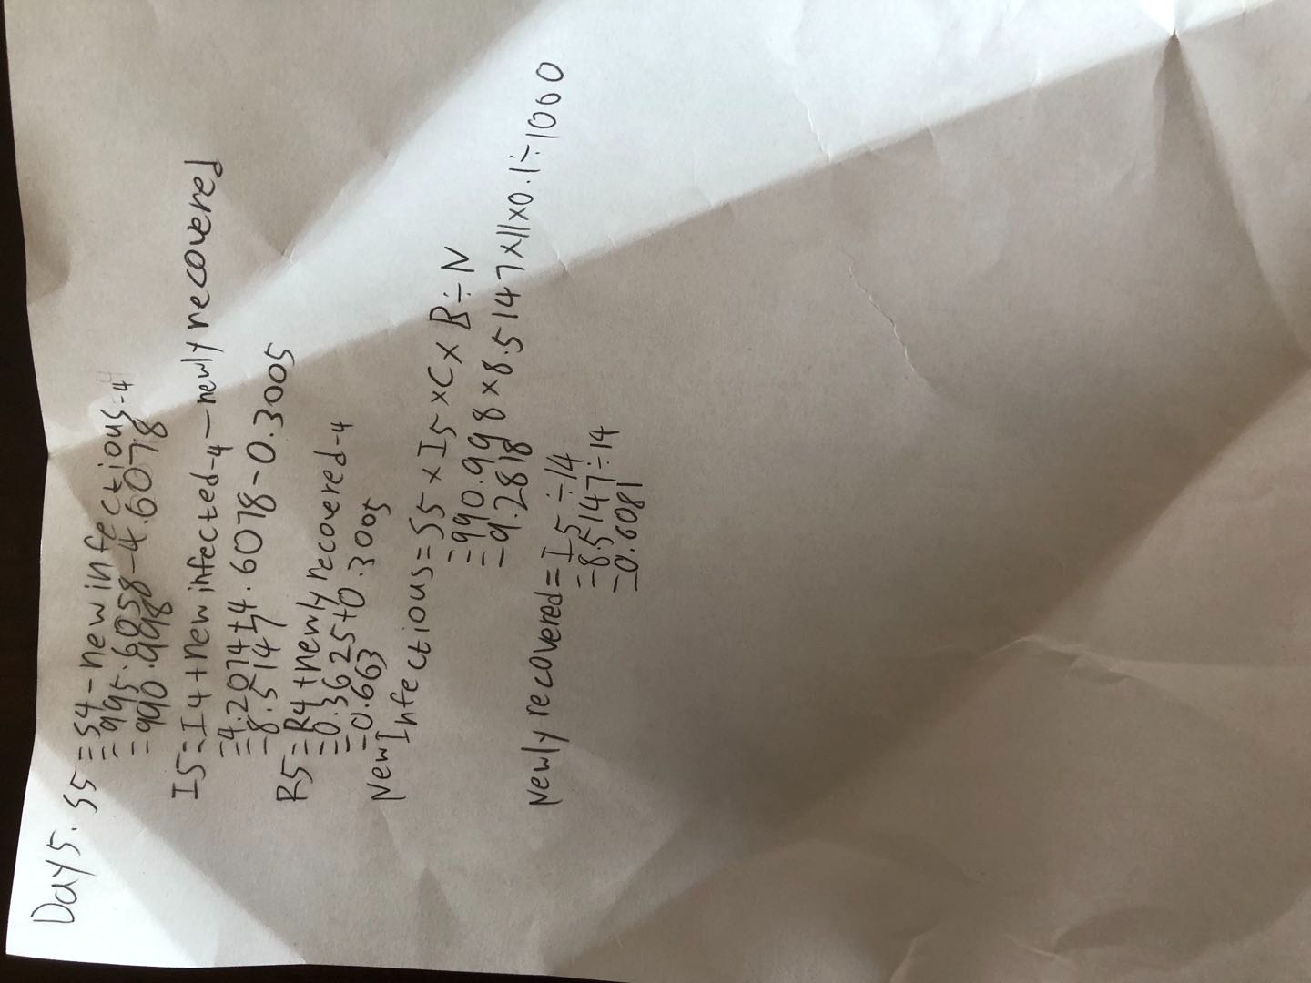
S.I.R Mathematics
W.D.P school members and facility members: 1000
Susceptible
Infectious
Recovered
Or as it’s called in a simpler and the most popular version, S.I.R
S → I → R
W.D.P
Day 1 : S=999, I=1, R=0
Day 1
Explaining
Factors
S1 came from the whole population of the given facility. (in this case a school) (Numbers or N is 1000) So the requirements needed must be met (requirement is at least 1 person infected and is not socially distanced) then the school outbreak will start with day 1. There will be very few people that are infected on the first day!

Equation
Now if we take the total number of people that are susceptible (or S) which is 999, then we'll just assume that there will be 5 more infected (I) each day by increasing! Though we’ll just assume that each day 1 infected converts to recovered (R). So on the first day it is reasonable to assume that there is 999 S, 1 I, and 0 R.
It can be also written down as.
(S)1000-1=999 (I)0+1 (R) 0
Day 2
Explaining
Factors
As said in the first day I will just assume that the I’s will gain 5 each day but lose 1, while R is gaining 1 each day from I’s losses, S will have whatever is remaining of the 5 that I took.

Equation
So if we take S’s number on the previous day which is 999 and subtract it by 5 which is I’s assumed gainings in 1 day! I on first site will seem to have 6 but if we take the subtraction of 1 into consideration for R then there will be 5 for I. S on the other hand has 994 now because of subtracting the 5 for I. R will now have 1 cause of the first child from day 1 recovering and is now in the R section!
This equation will look like.
S2 999-5=994 I2 1+5-1=5 R2 0+1=1

In total this whole thing will go on as long as you please in this order as of now!

Dictionary
Introduction to Contacts per day and transmission possibility

C=Contacts per day
Now that we’ve gone through the assumptions, we’ll have to calculate the actual amount of people! I have calculated from the students perspective they will be contacting around 11 human beings a day! Then that will make 11 contacts per day!

B=Transmission probability
It isn’t exactly obvious with this one, you have to do a lot of background research and work for you to find out just the general. For that I’ll just leave it out because of the endless possibilities!

So, in total you calculate everything like this.
S x I x C x B/(S+I+R)=?
Newly recovered=I/d

And that is the mathematical way of calculating and converting everything by S.I.R!

Computer Programs in Scratch:
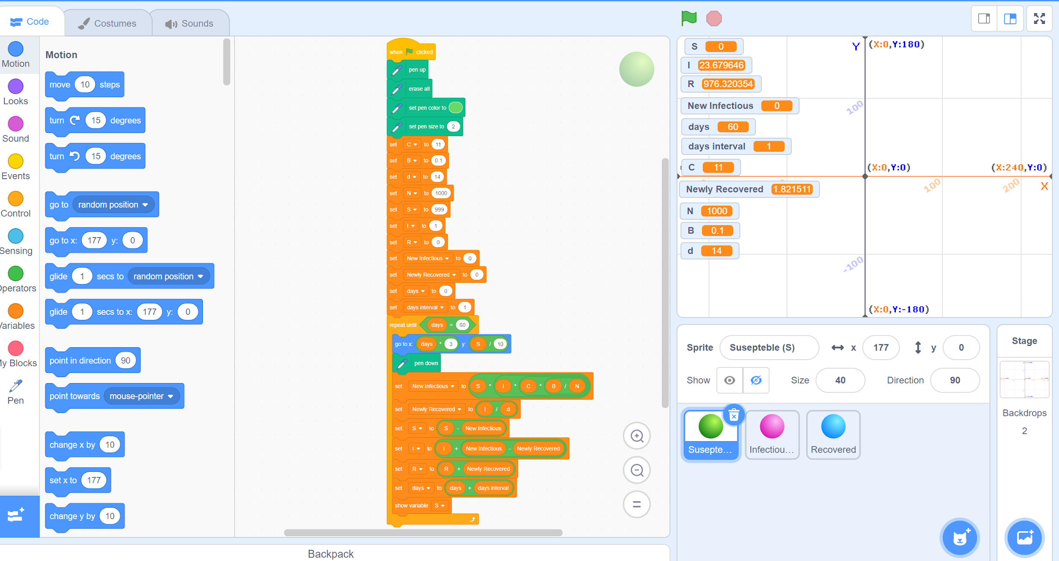
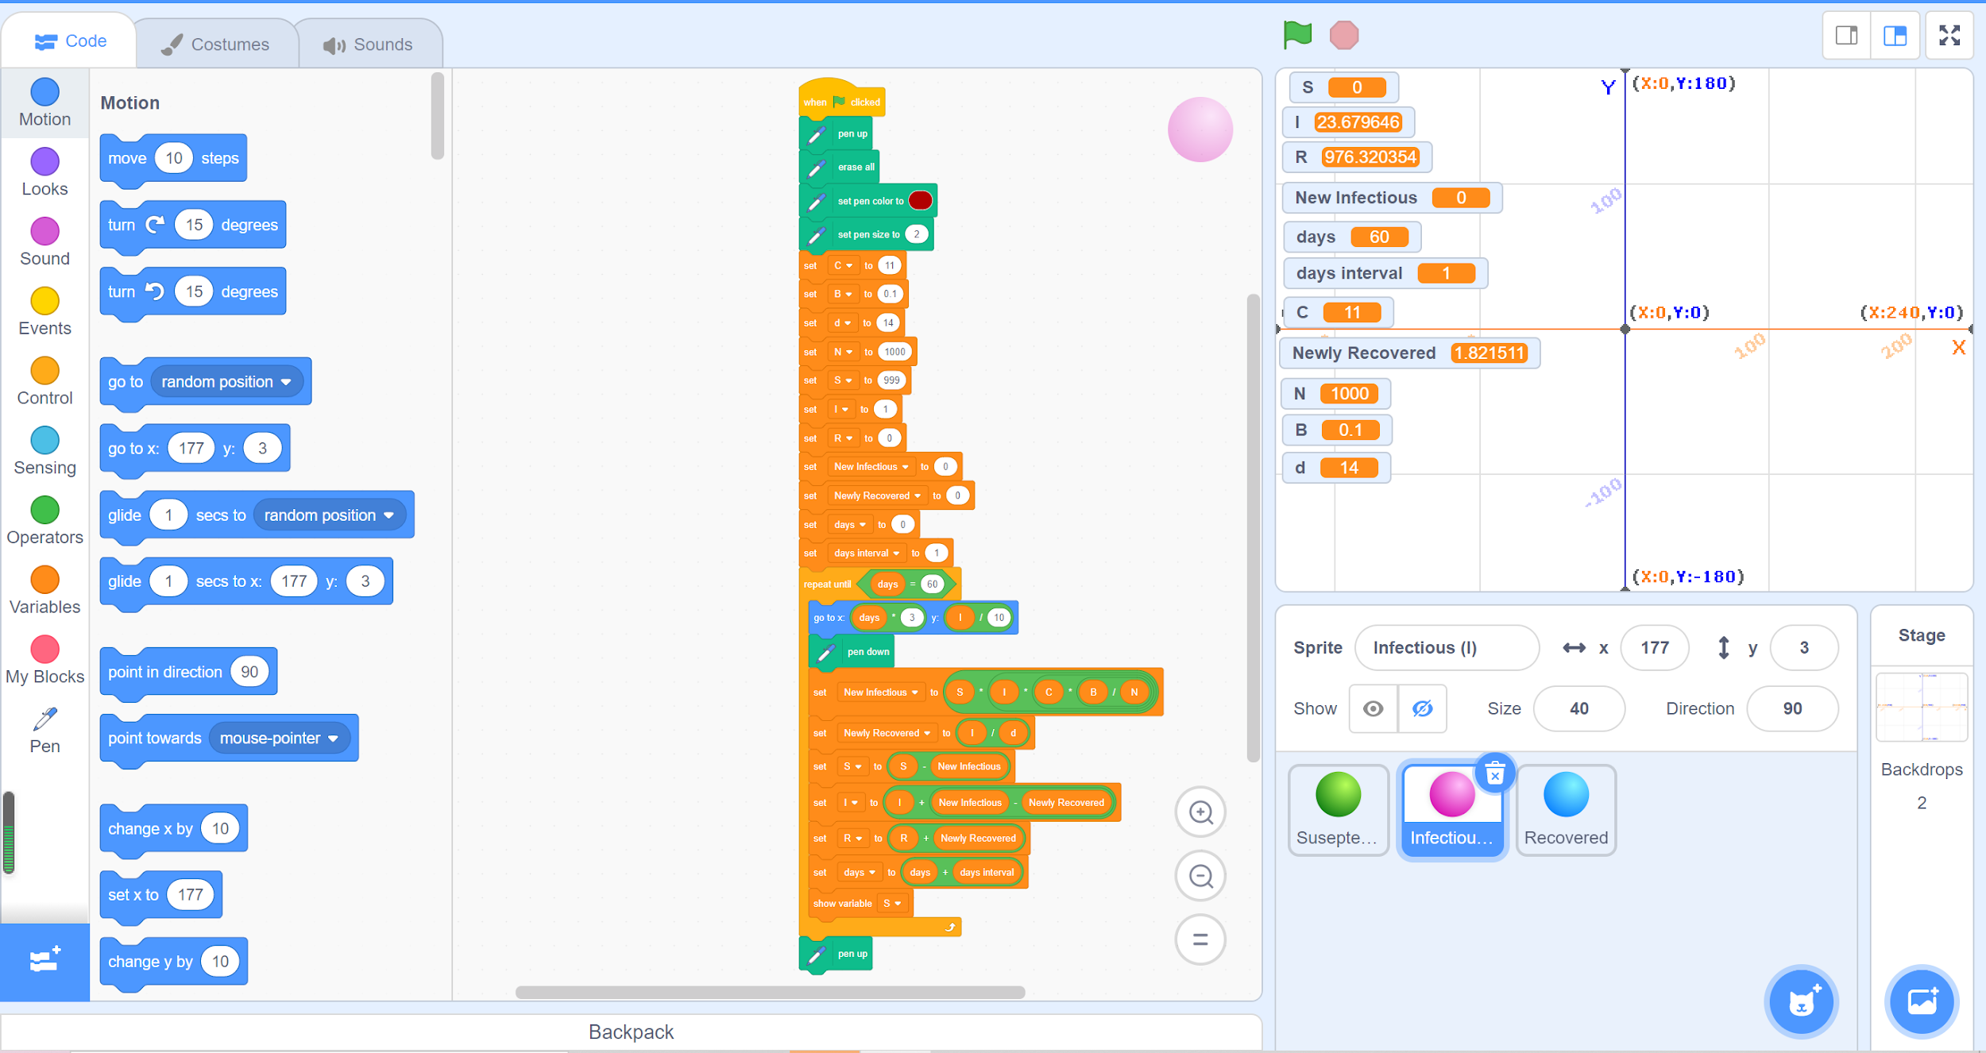
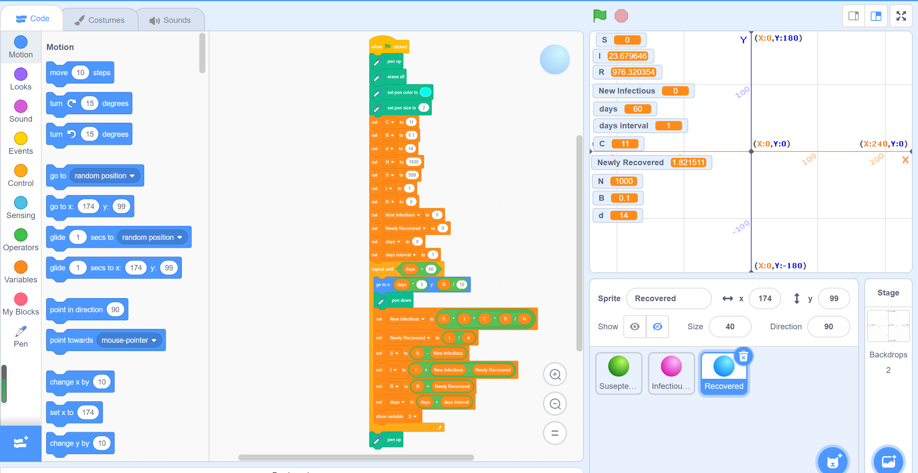

Results:
- Baseline: C=11
S（Suseptable）
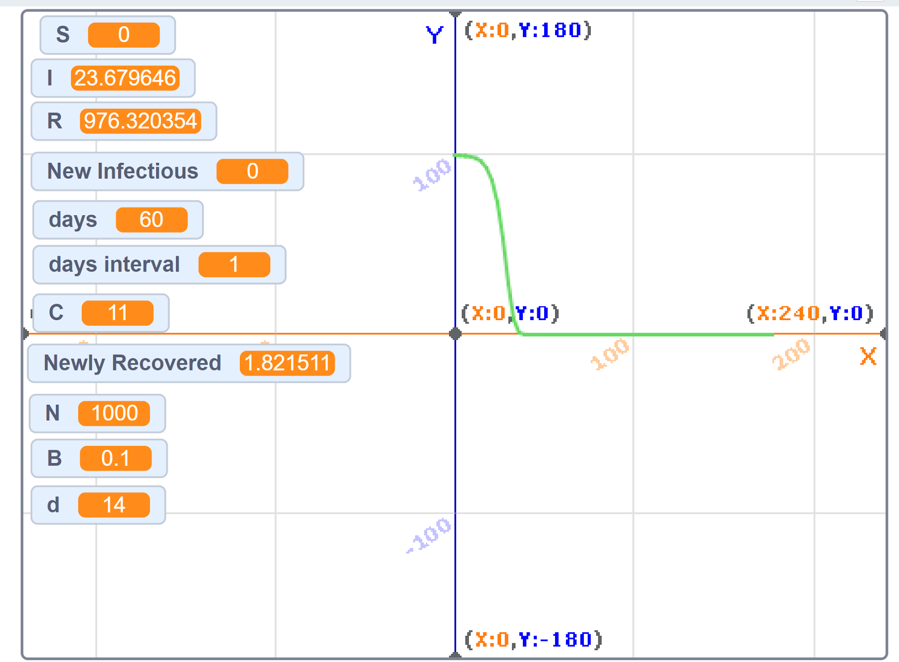

I (Infected)
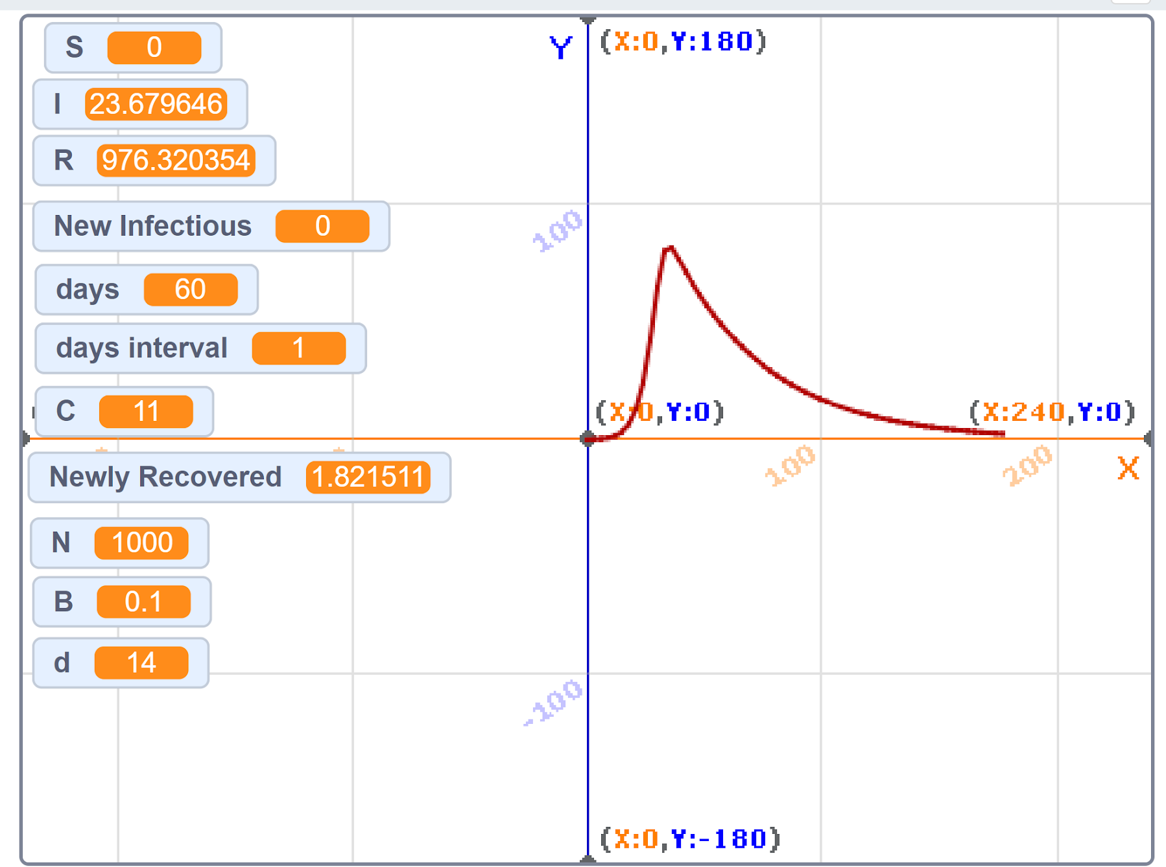
R (Recovered)
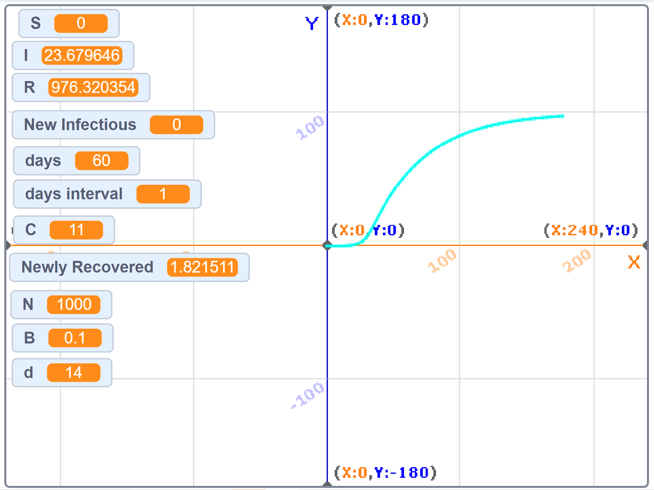
C=8
S (Suseptable)
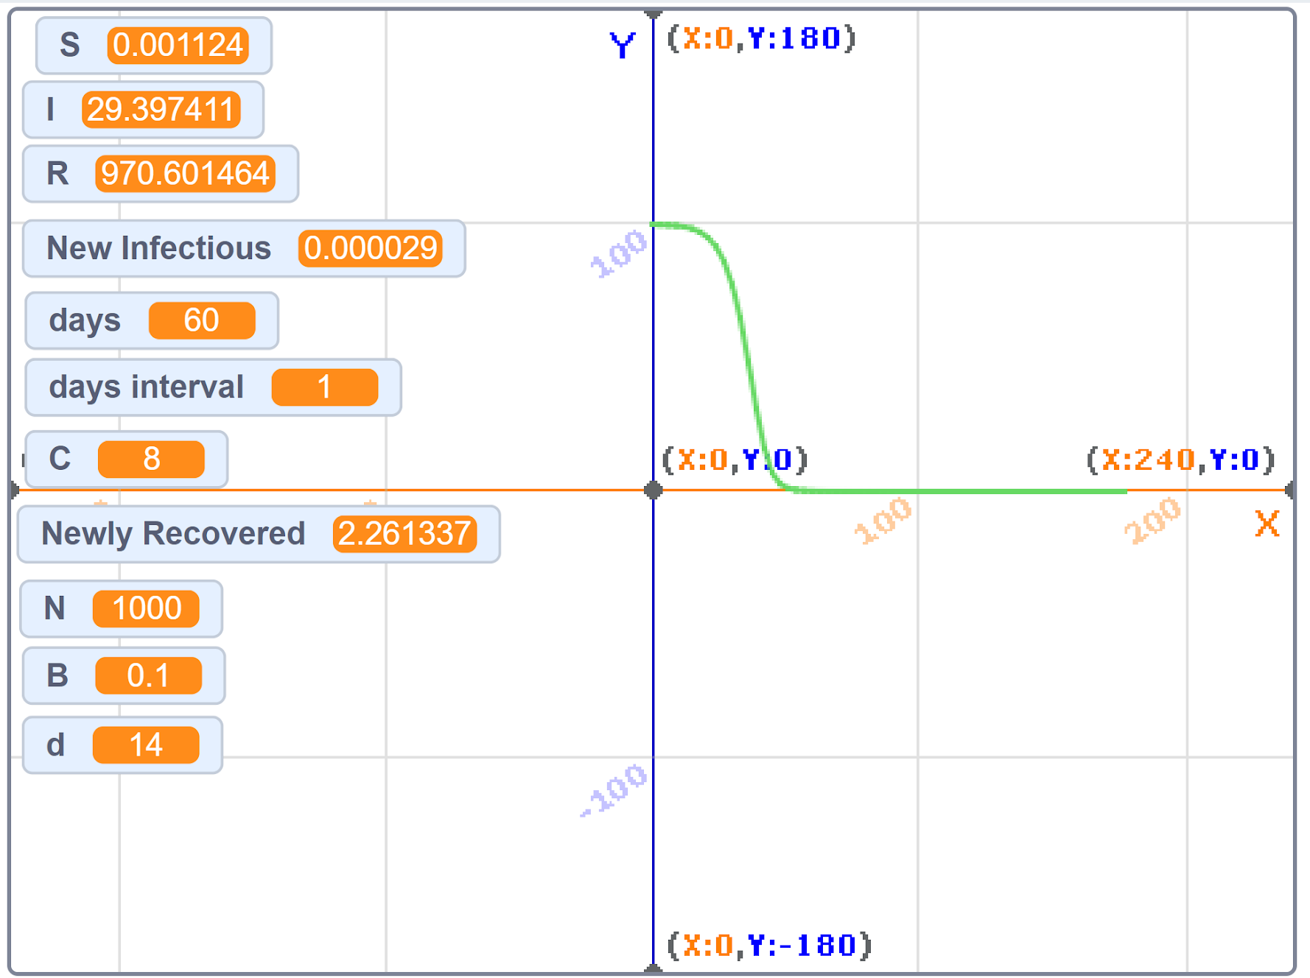
I (Infected)
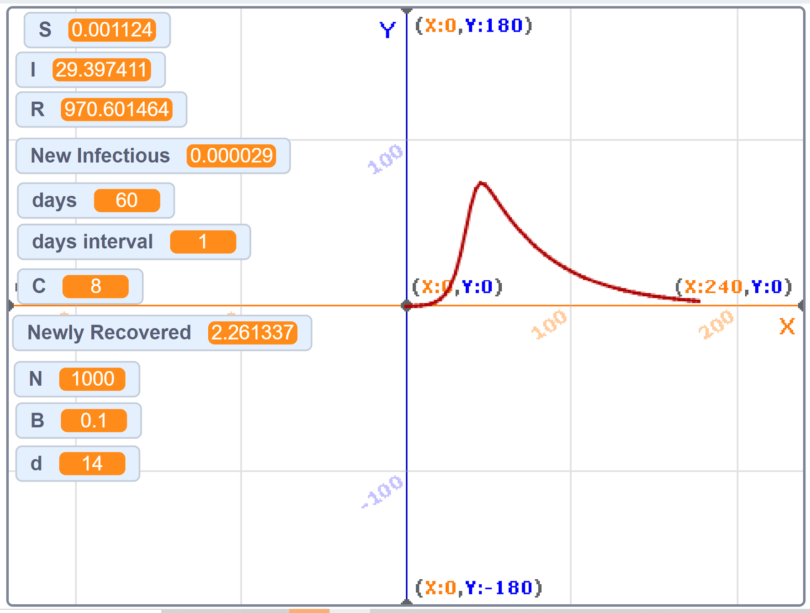
R (Recovered)
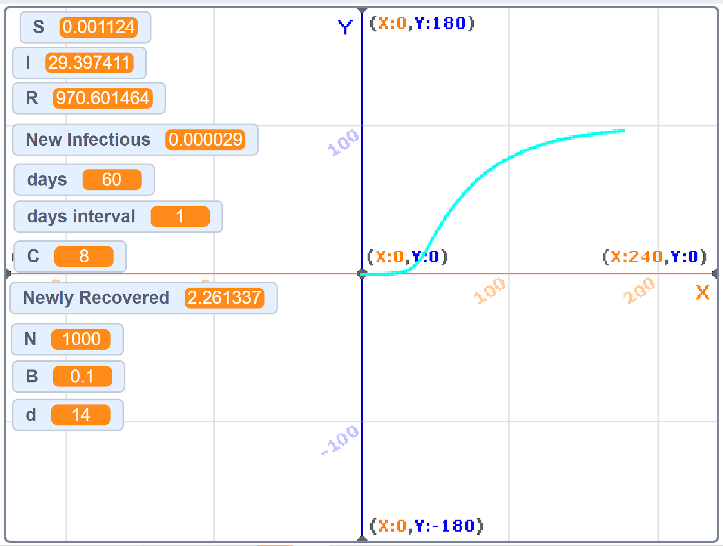
C=6
S (Suseptable)
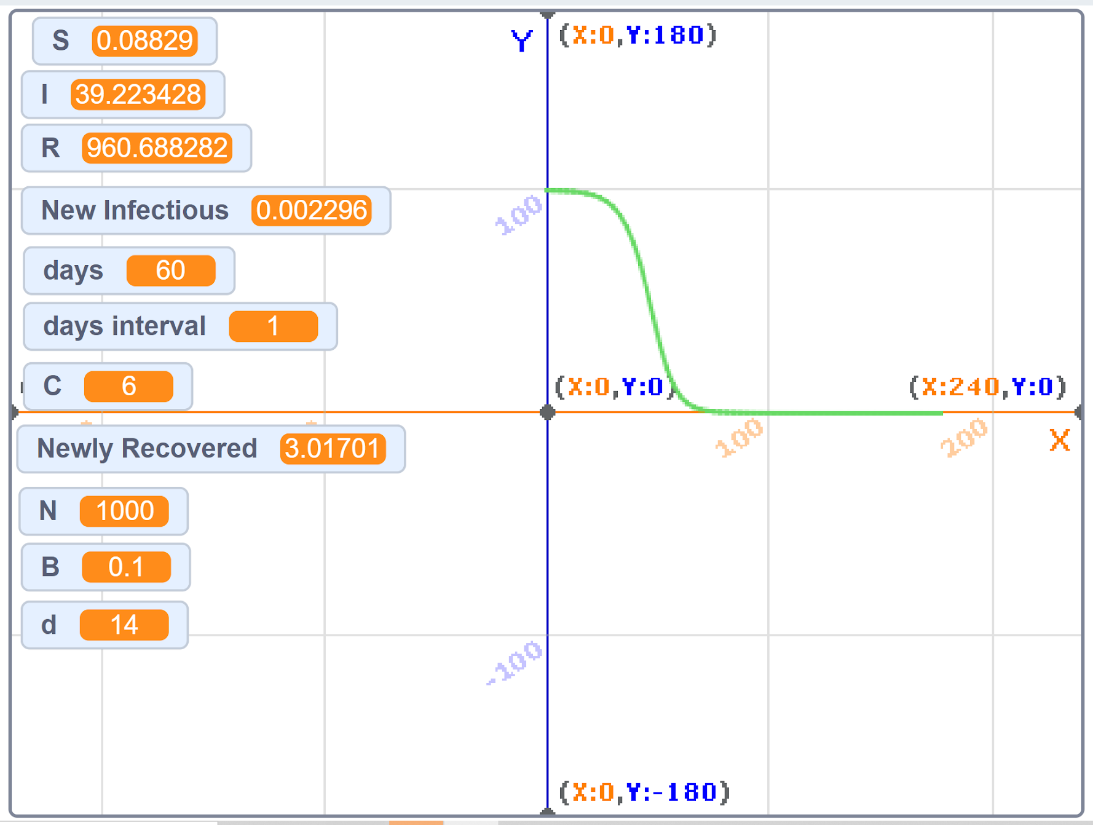
I (Infected)
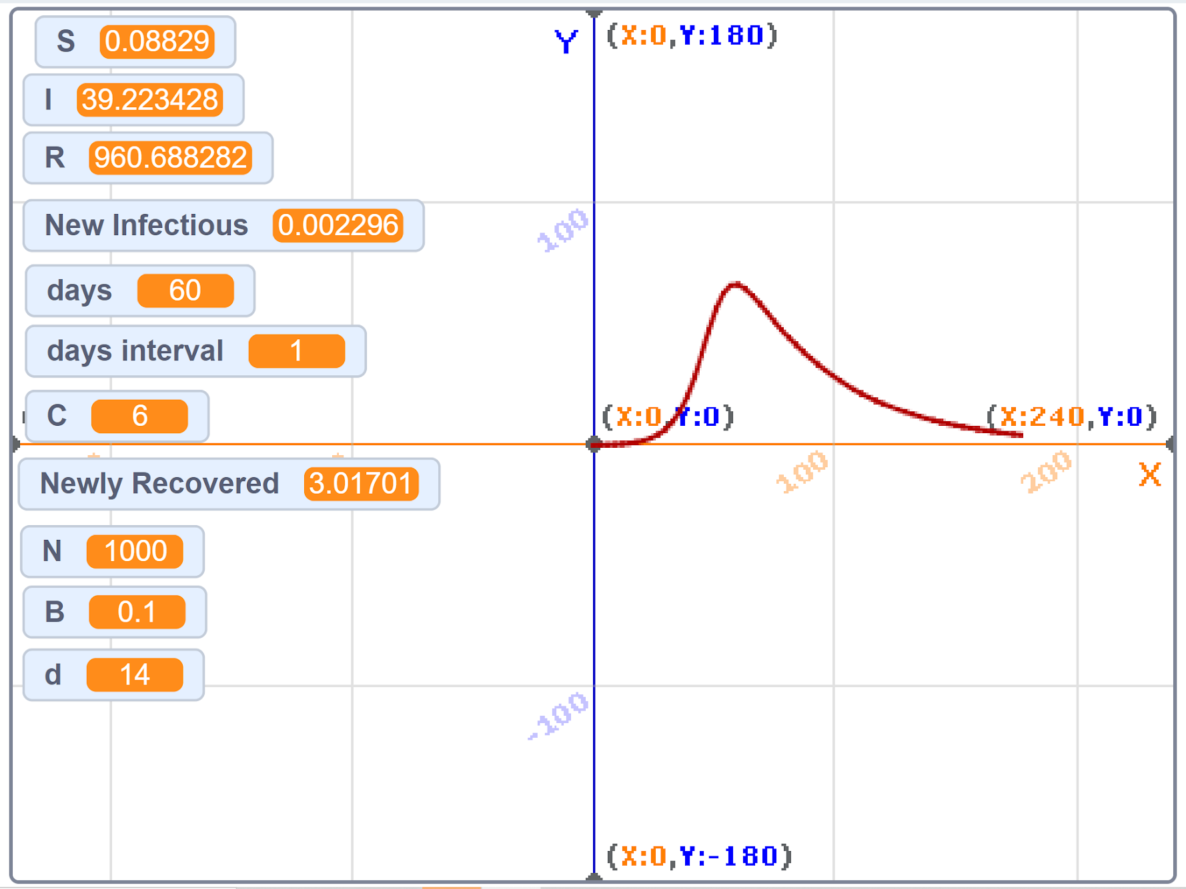
R (Recovered)
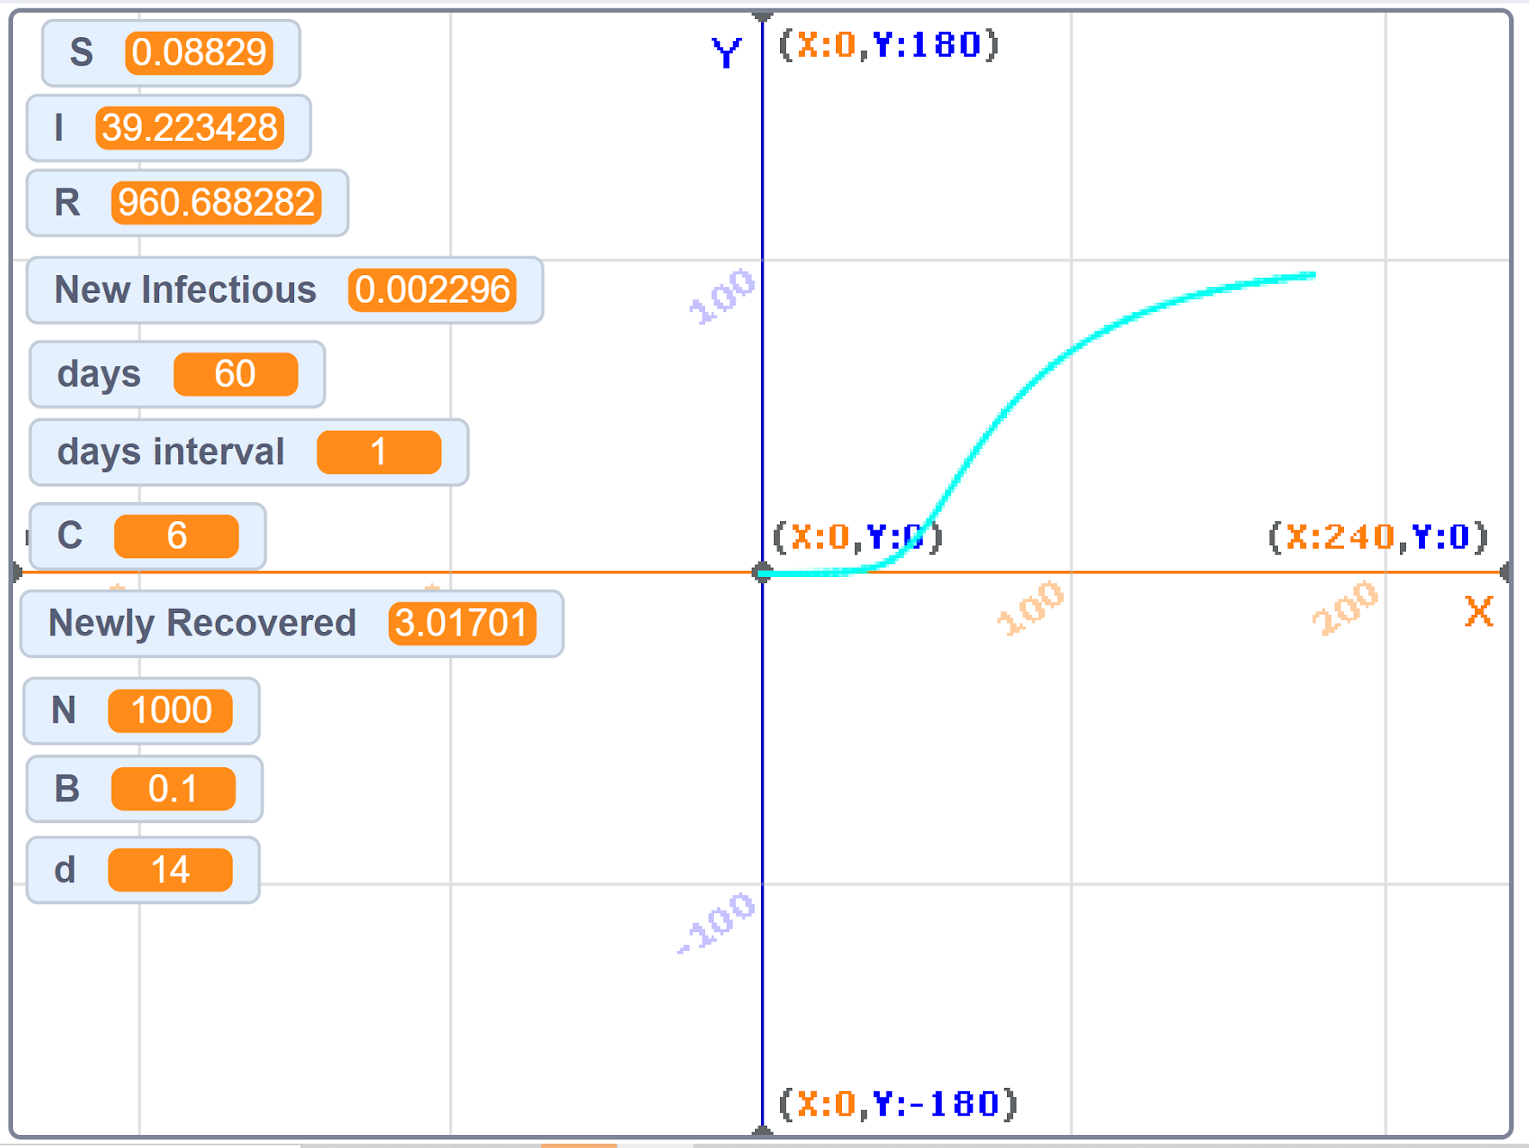
C=4
S(Suseptable)
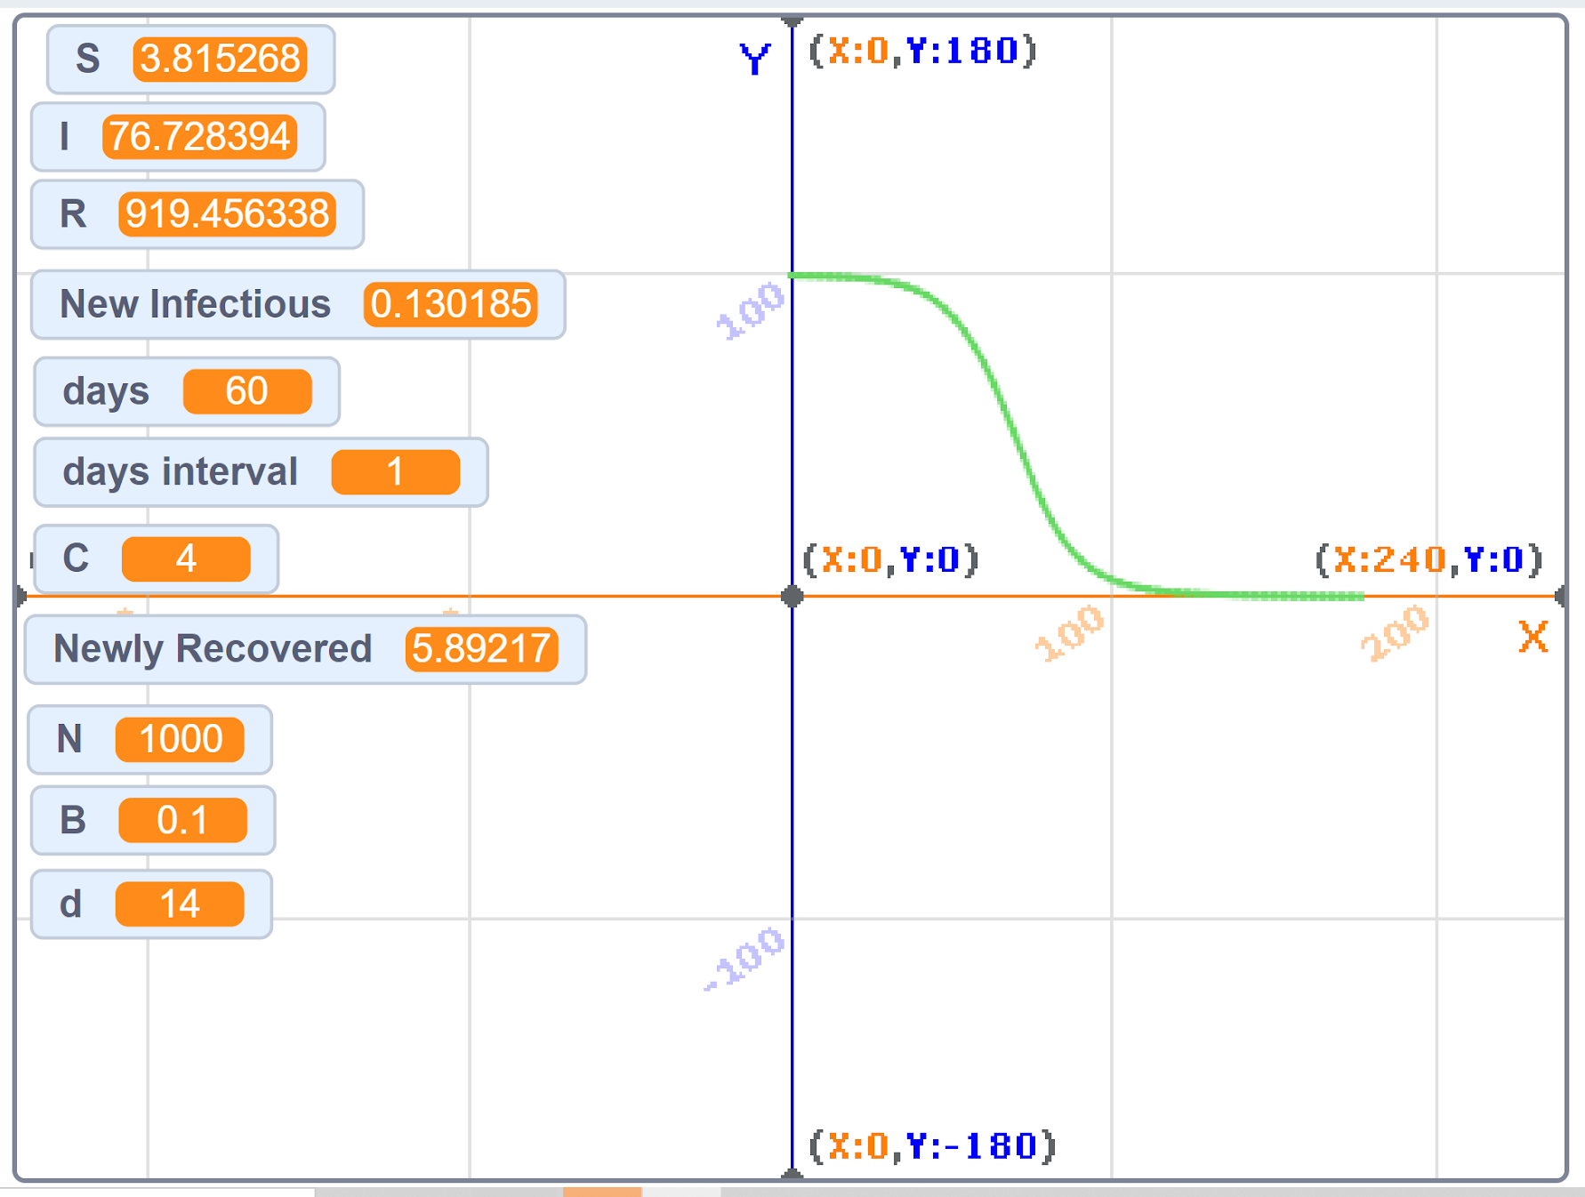
I (Infected)
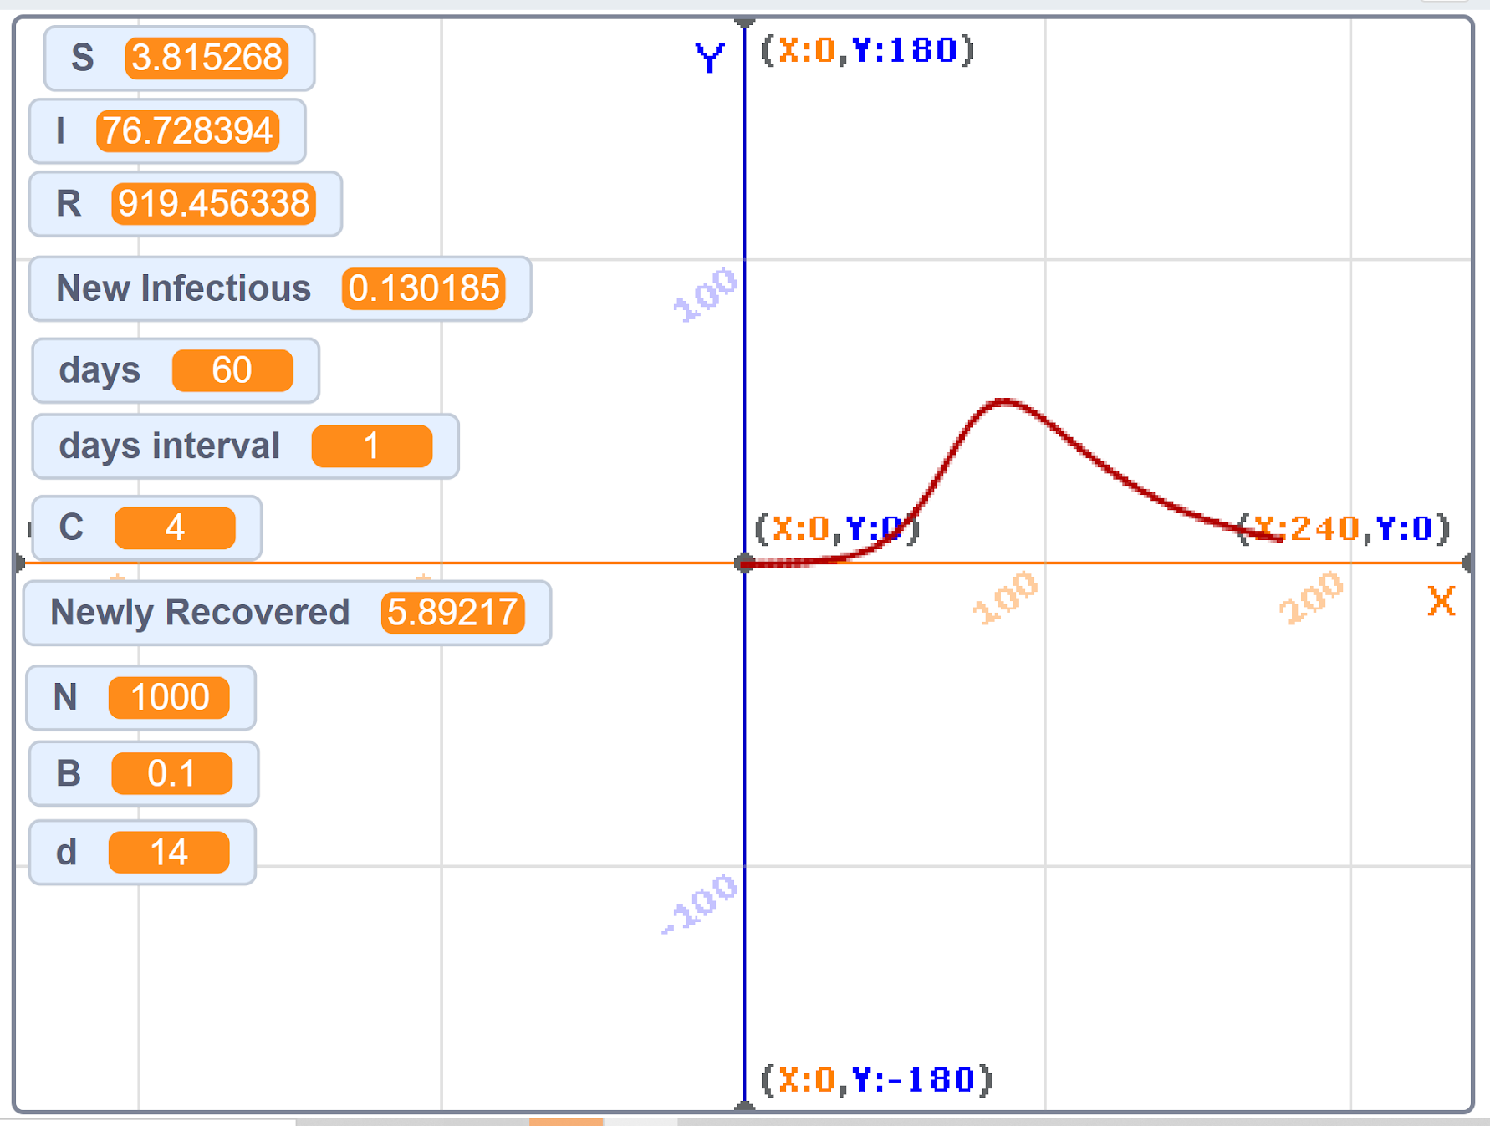
R (Recovered)
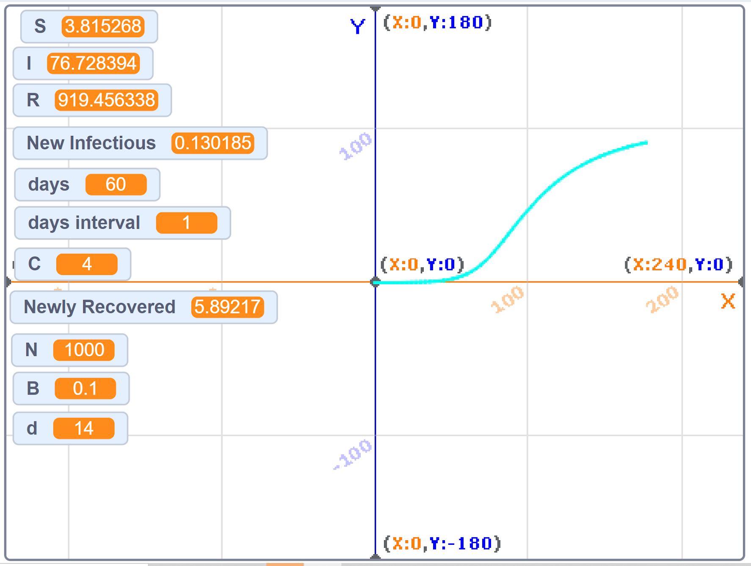
C=2
S (Sustable)
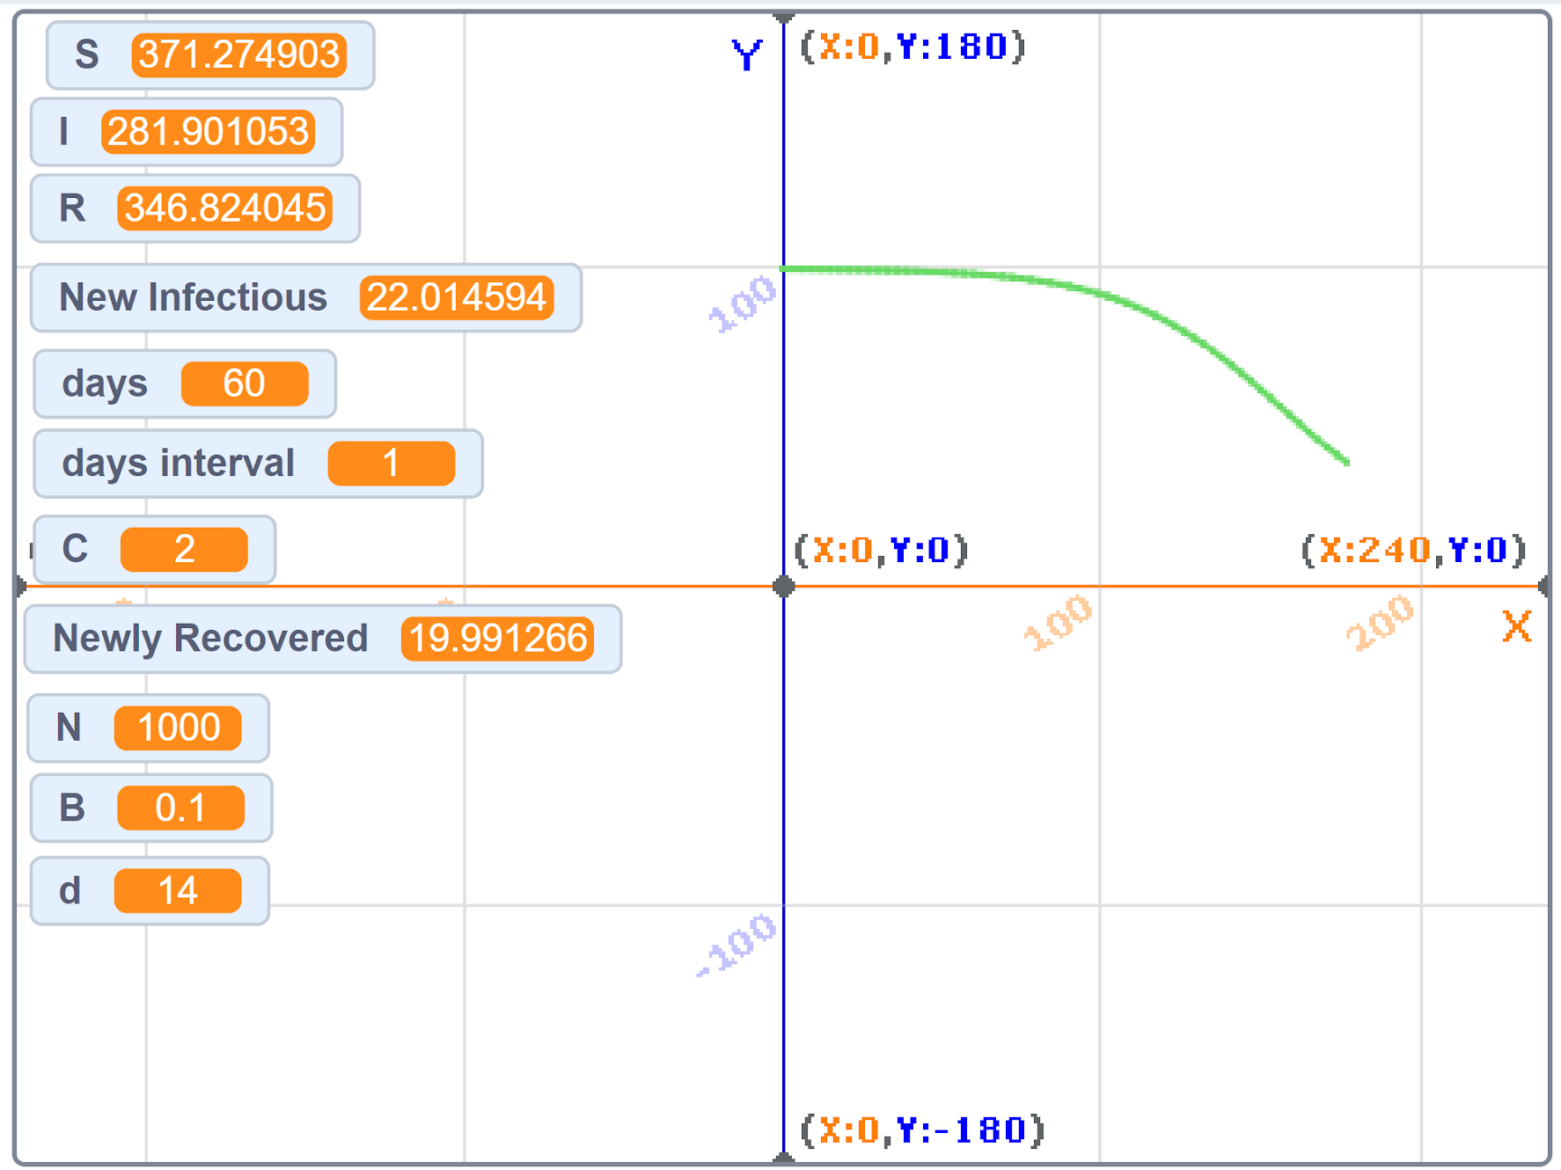
I (Infected)
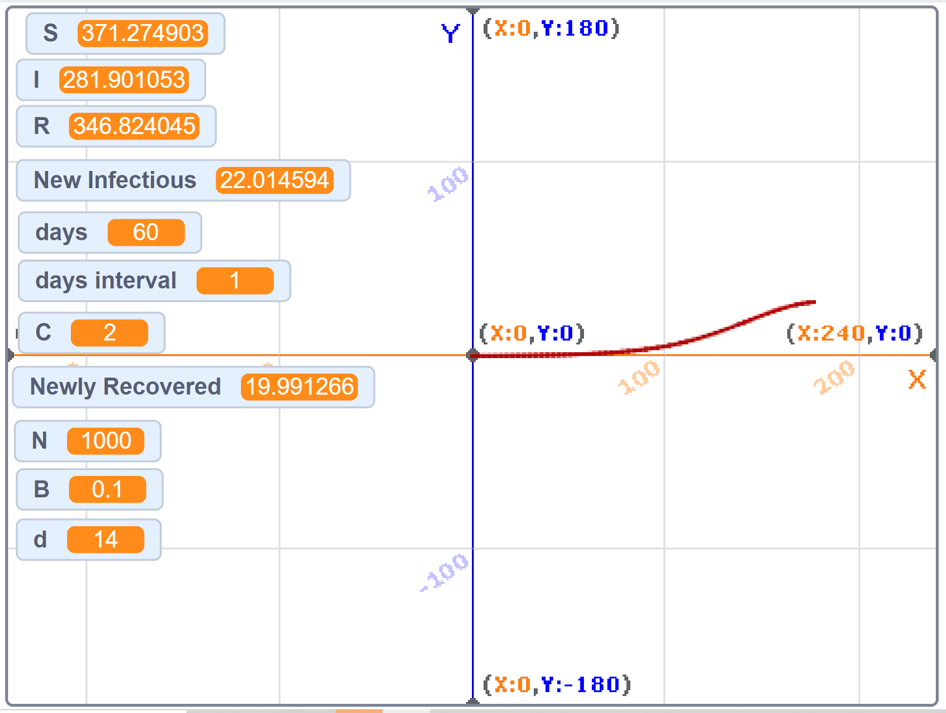
R (Recovered)
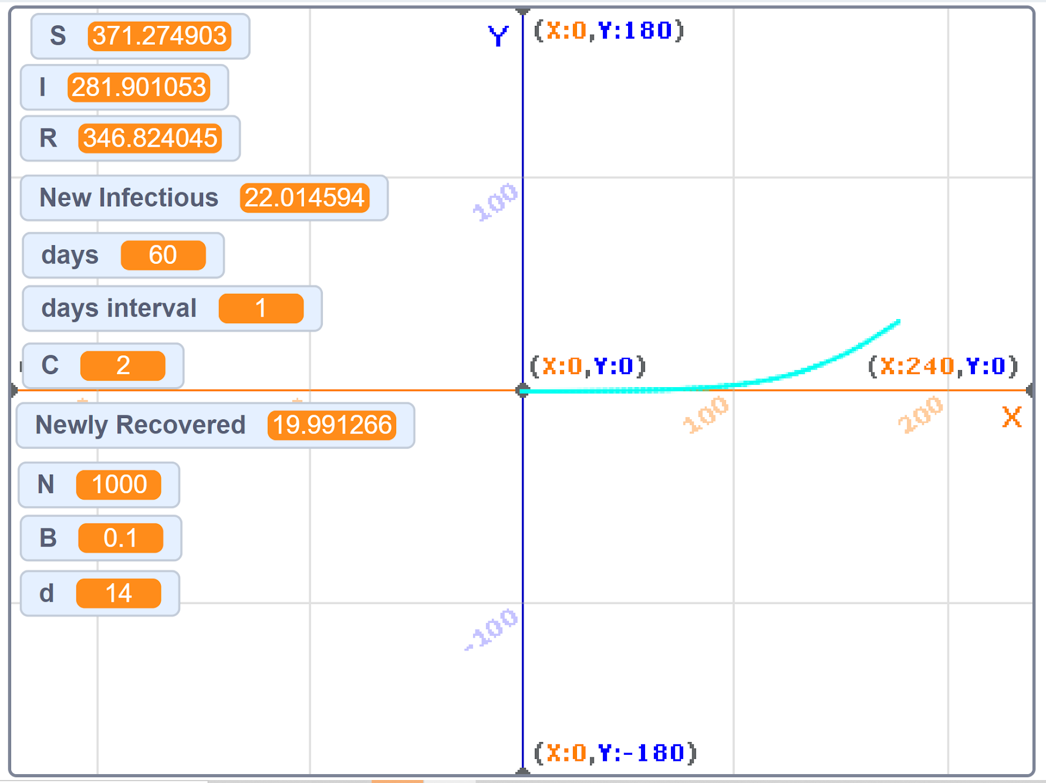

Other bibliography/list of references
[1] Coronavirus disease (COVID-19) pandemic, World Health Organization (WHO)
https://www.who.int/emergencies/diseases/novel-coronavirus-2019
[2] factor values https://scholarcommons.usf.edu/cgi/viewcontent.cgi?article=1368&context=numeracy

