Science Fair Logbook - 2023-2024

How does music affect the brain? - Exploring the relationship between music and the brain

By Mirthika Asok and DeAnne Zhu
Grade 6, Westmount Charter School
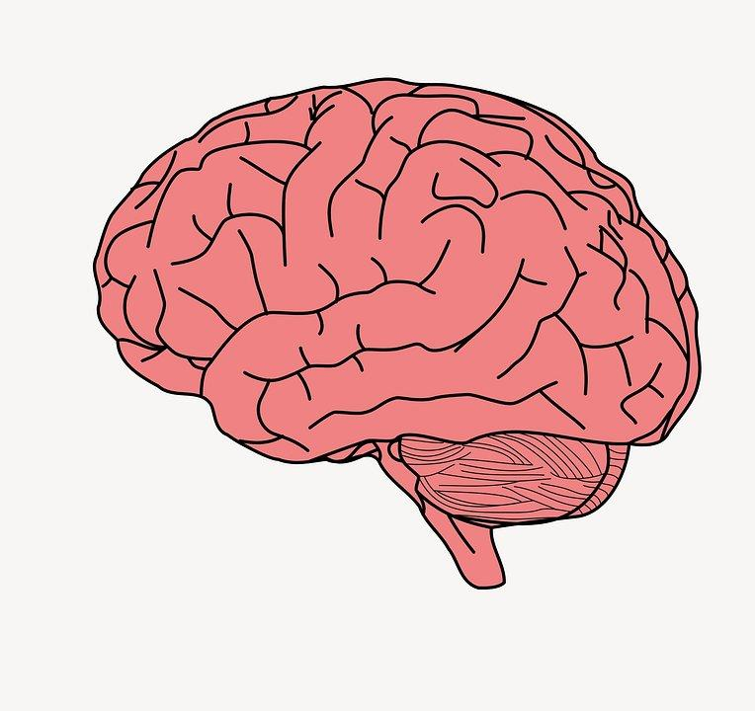

Section 1 - Table of contents, acknowledgements, and timeline

Table of Contents
Page 1: Section 1 - Table of contents, Acknowledgements, and Timeline
Page 3: Section 2 - Ideas, Scientific Question, and Purpose
Page 6: Section 3 - Hypothesis and Variables
Page 7: Section 4 - Procedure/Methods and Materials
Page 8: Section 5 - Research
Page 11: Section 6 - Observations Data
Page 11: Section 7 - Results and Conclusions
Page 12: Section 8 - Applications, Improvements, Further Questions, and New Problems
Page 14: Section 9 - Notes and workings out
Page 14: Section 10 - Bibliography and sources

Acknowledgements
First and foremost, we are extremely grateful to our parents, who have assisted us throughout our journey. Our parents have supported us the whole way through, and helped us through our struggles. They have arranged meetings for this project and drove far to pick up our trifold. We would also like to thank our great teachers Mrs. Lai, Mr. Earle, and Ms. Mah for their assistance this year and hopefully for many years to come. They have helped us a lot to understand Science Fair, and given us lots of tips and ideas. Without them we wouldn’t have even known to write a logbook! We also want to say thanks to Westmount Charter School for being such a caring and inclusive community. Lastly, we extend our gratitude towards all the nice people who volunteered to fill out our survey. We couldn’t have done it without you.

Timeline
We had to finish a big project on time. In order to keep track, we made a list of things that we needed to do, such as the presentation and trifold. We also made a schedule that we had to stick to. Here is our timeline:
- Decide question by Week 4 of August
- Start logbook by Week 1 of September
- Start creating survey by Week 2 of September
- Start research by Week 2 of September
- Start sharing survey by Week 2-3 of September
- Have our question, hypothesis, and procedure decided by Week 2 of September
- Start presentation by Week 4 of September
- Try to have at least 15 people answer the survey by Week 1 of November
- Have a rough skeleton of the presentation by Week 2 of November
- Try to have at least 25 people answer by week 3 of November
- Finish ½ of research by week 1 of December
- Try to have at least 35 people answer by week 2-3 of December
- Start slideshow presentation by week 3 of December
- Finish research by week 4 of december
- Give finishing touches and finalize project by the end of January
- Prepare for presentation during week one of February
- Present at WCS School Science Fair on Friday, February 9, 2024

Section 2 - Introduction (Ideas, Scientific Question, Background Knowledge, and Purpose)

Scientific Question
Our main question can be simplified into: How does music affect the brain?

Background Knowledge
- How does our brain understand music? Well, it's kind of like solving a puzzle. When we hear music, the sound travels through our ears and up to the brain. The first stop is the auditory cortex, which is like the brain's music studio. It's where the brain starts to figure out all the different sounds, like high notes and low notes.
- Our brain has special parts that work together to understand music. It's like having a team, where each member is good at something different, like rhythm or melody. This team works on both sides of our brain, which is pretty cool. As the music moves through our brain, it goes to more complicated areas. Think of it like a video game, where each level gets harder. Our brain figures out more complex stuff about the music at each level.
- But it's not just about the notes and tunes. Our brain connects music to our feelings and memories. That's why sometimes a song can make you really happy or a little sad. This happens because of the limbic system, a part of our brain that deals with emotions.
- Understanding music is also about asking 'why.' Why do we love music? Why does our brain spend so much effort on it? Music doesn't seem to be about surviving, like finding food or staying safe. But still, our brain thinks music is really important. Maybe finding out why we love music can teach us more about our brain and music itself."
- We know that usually people listen to music when they are stressed or angry and get over what they are feeling. We feel relaxed or less sad when we listen to certain types of music.
- However, certain genres and styles are not meant to sound joyful. For example, many pieces of music in a minor key may not be happy. Another example is that songs by composers like YIRUMA and Chopin may be used to convey feelings of mystery, nostalgia, or even frustration.

Ideas
- Originally, we actually wanted to try something about artificial intelligence, but dropped the idea soon after. The topic involves too many aspects that are beyond our capability. There are a few different ways to study brain activities, however, they are not accessible to our research.

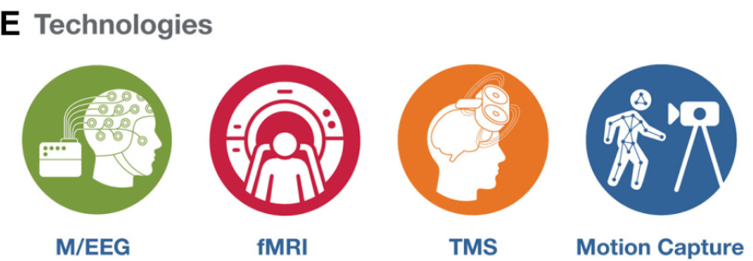

- After that, we brainstormed about other potential topics. We both were curious about the human brain, so originally we were going to do “How do brains work?” but quickly found out that it is very hard and complicated to find information or conduct research.
  - For our scientific question, we settled on “How does music affect the brain?” for a multitude of reasons.
    - First, it’s kind of difficult to find information about the brain itself, and we realized it’s much more preferable to research something related to the brain because we still were lingering on the topic.
    - Second, we both play 2 instruments: the piano, trumpet(DeAnne), and flute(Mirthika).
- On top of that, it would be a better way to conduct research, because then we could just ask ordinary people on their thoughts for a survey or something, whereas if we were to only research the brain, we probably could only ask professionals/online research.
  - Another thing is that we thought that the title sounded catchier, but that’s just a minor concern!
- You can find more information about this in our notes section.
- After we had decided on our question, we considered the different ways to collect data and settled on a survey. The most obvious way to do so was to use Google Forms.
  - In order not to leak information and infringe on people’s privacy, we had to keep all the information private and only use the people’s details with permission.

Purpose
The main purpose of this experiment was to find out how different types of music affected people’s emotions, thoughts, and more . We were really curious about how music makes you feel and why. We wanted to know how different types of music made people feel different types of feelings, and how music made people think different thoughts.

Section 3 - Hypothesis and Variables

Hypothesis
Our main hypothesis was that the majority of people we interviewed would like the genre of classical or pop music the best. We predicted this because of a few reasons:
- Classical music has been around for hundreds of years and is well known for its famous composers, unique style, and different eras, like Renaissance, Baroque, and Romantic, just to name a few. Most of the famous composers we know, like Bach, Mozart, and Beethoven composed classical music and left behind a great legacy.
- On the other hand, pop music, also known as pop, is fairly new, but has taken the world by storm and become very popular(hence the name) in just a few decades. Many famous artists like Taylor Swift, Justin Bieber, and Beyonce usually sing in the pop genre and have many listeners. Additionally, many radios play lots of pop music, so we decided pop was a good hypothesis.
We think the temporal lobe and frontal lobe are the most affected by music, and since most people want to be happy, they will listen to happy music. Pop and classical songs are generally happy, so we predicted that pop and classical music would have the best results in our survey.

Variables

Manipulated Variables
- Our manipulated variable is the people who responded to our survey.
  - The age of participants in the survey ranged from 10 to 60 years old, including elementary school students, mid-high school students, working professionals, and retired people.
  - The type of music that we want to assess and include in the survey questions.

Responding Variables
- Our responding variable is the people’s answers.

Controlled Variables
- Our controlled variable is our survey questions. They don’t change and are constant.

Section 4 - Procedure/Methods and Materials

Procedure and Methods
We decided we would use a survey method using Google Forms to interview people and collect information. Also, in order not to leak information and infringe on people’s privacy, we decided to keep all the information private and only use the information with permission.

Materials
- Google Forms for survey
- Binder for Logbook

Section 5 - Research

Online Research

Day 1
- Started research today.
- Music can make people feel at least 13 different overarching feelings which include: amusement, joy, beauty, relaxation, sadness, dreaminess, triumph, anxiety, annoyance, and feeling pumped up.
- Usually people listen to music when they are stressed or angry and get over it by listening to music. We feel relaxed or less sad when we listen to certain types of music.

Day 2
What are the musical elements that affect brain functions?
- Rhythm and Beat: The brain often synchronizes with the beat of the music. This can influence brainwave speed, potentially affecting states of arousal and relaxation. Rhythm can also enhance cognitive functions and improve motor skills, as seen in music therapy used for stroke victims.
- Melody and Harmony: Melodies, particularly those that are familiar or emotionally charged, can trigger memory recall and emotional responses. Harmony, or the combination of simultaneously played notes, can evoke different emotional responses, influencing mood and feelings.
- Tempo: The speed of the music can impact heart rate and arousal levels. Faster tempos can energize and improve focus, while slower tempos can be calming and aid in relaxation.
- Pitch and Tone: Variations in pitch and tone can affect emotional interpretation of music. For instance, higher pitches are often perceived as happier or lighter, while lower pitches might be interpreted as sad or more serious.
- Lyrics: Words in music can invoke storytelling, convey messages, and elicit emotional responses. They can also stimulate language processing areas in the brain.
- Volume: Loud music can stimulate excitement and arousal, while soft music can be calming and soothing.

Day 3

What parts of the brain trigger when you hear different types of music?

Auditory Cortex- When music enters and then gets shuttled off to the different parts of the brain. It stops at specialized processing units in the auditory cortex. It tracks loudness, pitch, rhythm and things like that.

Visual Cortex- There's visual cortex activation when you're reading music as a musician or watching music.

Motor Cortex- There is the motor cortex, when you are tapping your feet, snapping your fingers, or clapping your hands.

Cerebellum- The cerebellum which mediates the emotional responses.

Hippocampus- The memory system in the hippocampus, hearing a familiar passage, and finding it somewhere in your memory banks.

Day 4
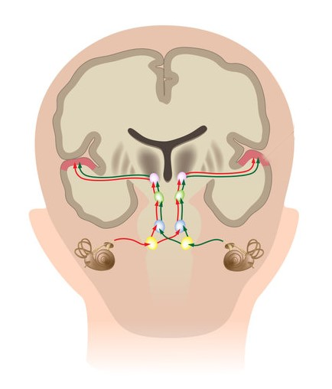
Auditory pathways:
The structures of the cochlea vibrate in response to sound with a specific vibratory pattern. This vibratory pattern (the traveling wave) allows the inner hair cells and their connections to the auditory nerve to send signals to the brainstem and brain about the sound's vibration and its frequency content.

Survey Results
According to our survey, the majority of people love listening to pop music. Reasons they give include…
- “I listen to this type of music because the vocals are really good and it makes me feel really, really happy”
- “I feel this way because when I put on my earphones and listen, these are the only sounds I hear and I feel (at that point) that I can achieve anything.”
People who like classical music say that…
- “because i like the instruments used”
- “soothing, calming and relaxing”
People who like electronic or techno music say…
- “Because it usually has a good beat and makes me imagine cool ideas.”
- “Because music is generally amusing/nice by itself and added with the thrill/kick of the instruments/rhythm, electric/techno music is very fun to listen to, in my opinion.”
People who like instrumental music say…
- “It makes noise that sounds beautiful”
- “I usually listen to music that sounds happy”
People who like rap music say…
- “bc it makes me happy and energized”
- “bc i have energy”

Section 6 - Observations Data
We have observed that many 10-12 year olds love pop and country music and listen to it more often. Usually this is because it is jumpy and has a nice tune. Pop music often has a feel good factor and lights up different parts of the brain. We also recently figured out that music most affects the temporal lobe of your brain and in the temporal lobe, it is mostly the auditory cortex.

Section 7 - Results and Conclusions
In conclusion, we wanted to find out how music affects the brain because we both love listening to music and know many songs and wanted to explore more about how music and the brain are related. Based on our research, we guessed that the temporal and the frontal lobe will be the most affected by music. The reason we thought about these parts of the brain is because we thought most people want to listen to music and be happy. Our experiment/ google form showed that many people love listening to pop music because it is happy, and exciting. Although, according to our graphs, almost everyone hates rock and heavy metal music. Reasons that they give include “It’s too loud and noisy” and “It makes an annoying pounding sound in my head.”. Our hypothesis was therefore incorrect because insead of the temporal and frontal lobe being the most affected by music, the auditory cortex is. We were also incorrect about classical music being famous and people's favorite type of music. Although, we were correct about pop music being the most famous due to its fun and jumpy rhythm. I believe this is because we thought that the frontal lobe is very dominant against the other lobes and it is the biggest.

Section 8 - Applications, Improvements, Further Questions, and New Problems

Applications
- We could apply our research to many aspects of real life, like therapy, anti-stress tools, psychology, and focus tools.
  - For example, maybe a certain type of music or even a soundwave of some sort could be used to heighten attention span or energy levels.
  - Some articles talk about how music can help the elderly and newborn/infant population’s wellbeing.
- Another thing is that maybe many music artists will aspire towards pop and country music in the future, since our survey seems to be showing a big trend towards the pop and country genres.
  - Additionally, many famous singers and songwriters like Taylor Swift have gone down that path, so it seems likely that at least a portion of people will decide to try that too.
  - Find out more about how our brain figures out music.

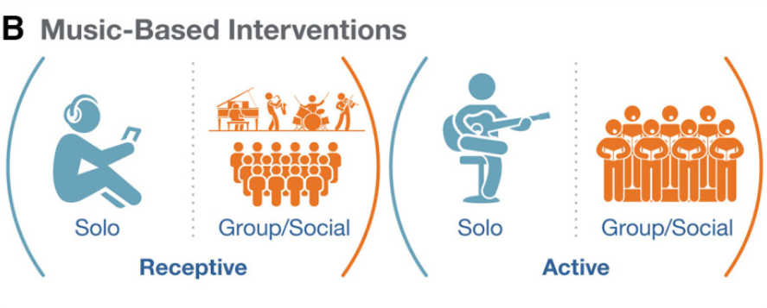

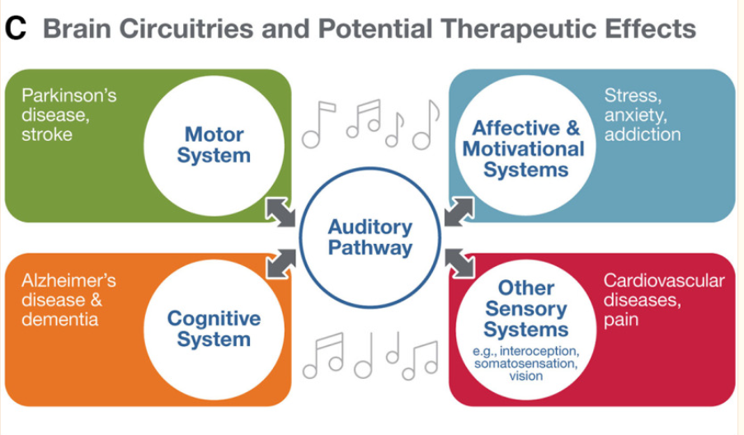

Source: Music and Brain Circuitry: Strategies for Strengthening Evidence-Based Research for Music-Based Interventions - PMC (nih.gov)

There are a few applications:
- Musical training may increase the capacity to foster the development of non-musical skills, such as language development, attention. This implicates potential application of music in promote emotional well-being and focused attention in children.
- Studies support structural brain differences between musicians and non-musicians.

Improvements
- Our experiment could have been improved by clarifying our scientific question earlier on. We had a lot of confusion in the earlier weeks, and it took us a while to get on track.

Section 9 – Notes and workings out
- Aug 26- We think our scientific question might be about AI somehow, but we don’t really know yet.
- Sept 1- We’re deciding that our topic is going to be how the human brain works, because we both agreed that the brain is a very interesting and mysterious topic, and we want to learn about it.
- Sept 5- We’re changing our topic to how MUSIC affects the brain for a multitude of reasons, like how it’s easier to find information, and that we both play at least 2 instruments.
- Oct 6- We started making a survey but couldn't find people to answer it
- November 12- We found some friends who we shared the survey to and got many answers

Section 10 – Bibliography and sources
- Anwar, Y, 2020 January 17, How Many Emotions Can Music Make You Feel? How Many Emotions Can Music Make You Feel?
- Mussila, How Does Music Help Children’s Development? How Does Music Help Children's Development? | Mussila
- Asok, M; Zhu, D, 2023 October 18, Science Fair Project, Science Fair Project
  - This was our very first research document at the very start of the year, when we had just started. We quickly realized we were doing many things the wrong way and changed and improved how we worked, collected data, and more.
- Fink, J. L. W., Why — and How — Music Moves Us Why — and How — Music Moves Us | Pfizer,
- Moawad, H, Collins, D, 2021 August 18 Can Listening to Music Reduce Stress? Research, Benefits, and Genres
- Warren J., 2008., How does the brain process music? (nih.gov) How does the brain process music? (nih.gov)
Clin Med (Lond). 2008 Feb;8(1):32-6. doi: 10.7861/clinmedicine.8-1-32. PMID: 18335666; PMCID: PMC4953706.
- Cheever, T., Taylor, A., Finkelstein, R., Edwards, E., Thomas, L., Bradt, J., Holochwost, S. J., Johnson, J. K., Limb, C., Patel, A. D., Tottenham, N., Iyengar, S., Rutter, D., Fleming, R., & Collins, F. S. (2018). NIH/Kennedy Center Workshop on Music and the Brain: Finding Harmony. Neuron, 97(6), 1214–1218. NIH, Kennedy Center Workshop on Music and the Brain: Finding Harmony - ScienceDirect
- Chatenet, L. G., Jaâfour, O., Learning music in times of lockdown (Radio column), Learning music in times of lockdown (Radio column) – Capian
- Mautz, S., 2019 February 14, Want to Boost Your Productivity? Science Says Listen to Music With These 6 Rules In Mind | Inc.com

- Chen, W.G. et. al. (2022). Music and Brain Circuitry: Strategies for Strengthening Evidence-Based Research for Music-Based Interventions. Journal of Neuroscience 9 November 2022, 42 (45) 8498-8507; DOI: 10.1523/JNEUROSCI.1135-22.2022, Music and Brain Circuitry: Strategies for Strengthening Evidence-Based Research for Music-Based Interventions
- Iversen, John R.,

- Dreamstime, Music Notes Illustrations & Vectors, 57,428 Music Notes Stock Illustrations, Vectors & Clipart - Dreamstime

