Carrie M.
Science Fair Research
2020-2021
------------------------
---RESTARTING

N o t e s

Source: https://nofilmschool.com/Film-color-theory-and-color-schemes

What is Film Colour Theory:
- Film Colour Theory = theory says that specific colours in film can trigger certain emotions from viewers.
  - When these colours are manipulated, they can be used to lead viewer to the purpose of the author to send a message, or make dramatic irony

Colour Wheels:
- Colour wheels = colour circle with organization of colour hues around a circle
  - Shows relationship between primary colours, secondary colours, tertiary colours, etc.
  - Are useful to decide what colours to give to a scene. Decides how the whole set looks (costume, setting, camera shots, etc.)

What goes into colour:
- Hue = “degree to which a stimulus can be described as similar to or different from stimuli that are described as red, green, blue and yellow”
  - Basically what colour it is
- Saturation = intensity of colour
  - How deep the colour gets
- Value = if a colour is dark or light
  - Ex. dark blue = higher value
  - Ex. light blue = lower value

How colours affect emotions
- Red = increases physical energy, vitality, stamina, grounding, spontaneity, passion, stability
  - Mood: anger, passion, rage, desire, excitement, energy, speed, strength, power, heat, love, aggression, danger, fire, blood, war, violence
- Orange = Stimulates creativity, productivity, happiness, optimism, enthusiasm, emotional expression
  - Mood: humour, energy, balance, warmth, enthusiasm, vibrancy, expansiveness, flamboyancy
- Yellow = Increases fun, lightness, humour, personal power, intellect, logic, creativity
  - Mood: wisdom, knowledge, relaxation, joy, happiness, optimism, idealism, imagination, hope, sunshine, summer, dishonesty, cowardice, betrayal, jealousy, covetousness, deceit, illness,
- Green = Supports balance, harmony, love, communication, social, nature, acceptance
  - Mood: health, soothe, perseverance, tenacity, self-awareness, proud, unchanging nature, environment, healthy, good luck, renewal, youth, vigor, spring, generosity, jealousy, inexperience, envy
- Blue = Increases calmness, peace, love, honesty, kindness, truth, inner kindness, emotional depth, devotion
  - Mood: faith, spirituality, contentment, loyalty, fulfillment peace, tranquility, calm, stability, harmony, unity, trust, truth, confidence, conservatism, security, cleanliness, order, sky, water, cold, technology, depression
- Purple = Stimulates intuition, imagination, universal flow, mediation, artistic qualities
  - Mood: royalty, nobility, spirituality, ceremony, mysterious, transformation, wisdom, enlightenment, cruelty, arrogance, mourning, power, sensitive, intimacy
- Pink = Mood: love, innocence, health, happiness, content, romantic, charming, playfulness, soft, delicate, feminine
- Brown = Mood: materialistic, sensation, earth, home, outdoors, reliability, comfort, endurance, stability, simplicity
- Black = Mood: power, sophistication, formality, elegance, wealth, mystery, fear, anonymity, unhappiness, depth, style, evil, sadness, remorse, anger
- White = Mood: protection, love, reverence, purity, simplicity, cleanliness, peace, humility, precision, innocence, youth, birth, winter, snow, good, sterilit, cold, clinical, sterile
- Silver = Mood: riches, glamorous, distinguished, earthy, natural, sleek, elegant, high-tech
- Gold = Mood: precious, riches, extravagance. warm, wealth, prosperity, grandeur

Plutchik’s Wheel of Emotions:
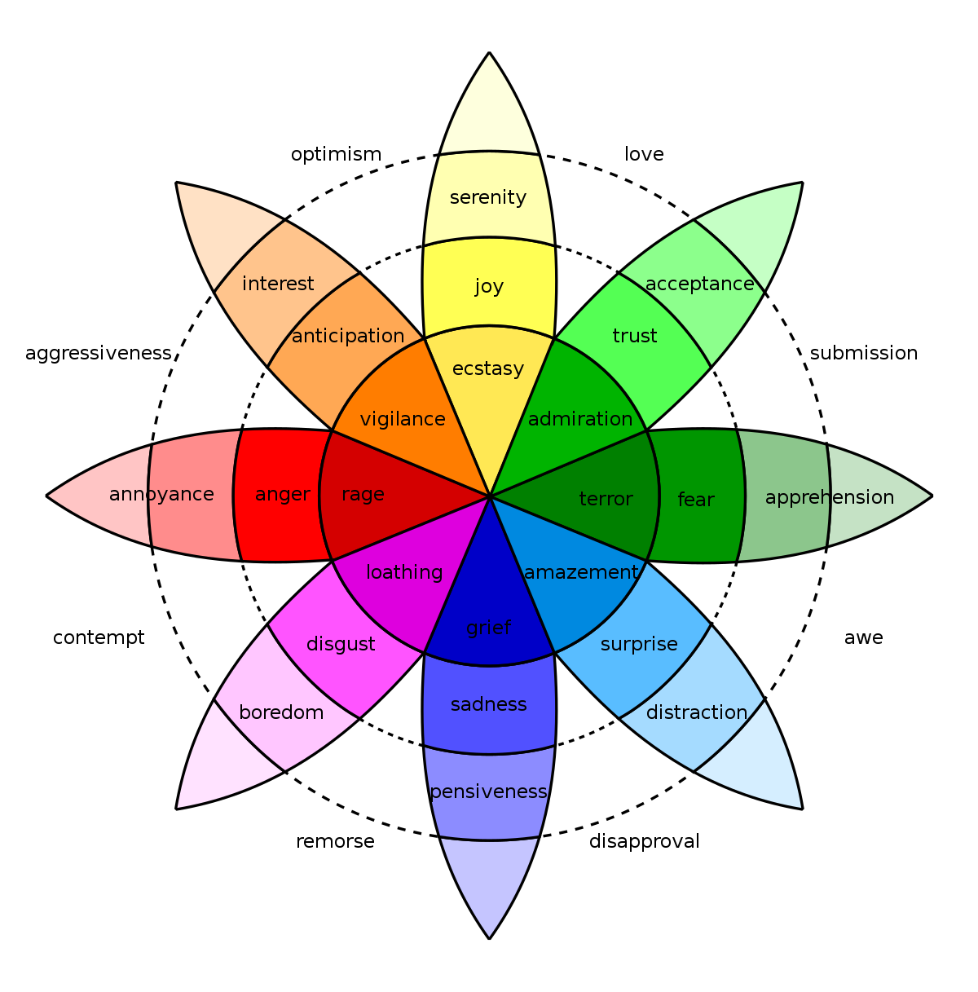

Colour Psychology in Film
- Study of complex emotions based on colour
- Ex. Harry Potter and the Deathly Hallows Pt. 2: movie filtered w/ blues and greens, which are muted, understated, and somber to reflect the sad mood of the movie
- Ex. Frozen: has vibrant colour schemes, relating to warm characters searching for love + acceptance while the atmosphere is cold in snow

4 Colour Concepts
Monochromatic - colour scheme based around one single colour
  - Ex. The Matrix is based around green
  - Can be sad, somber, or bright and cheery
Analogous - neighbouring colours on a colour wheel (either warm or cool colours)
  - Colours find balance/harmony together

Complementary - opposite ends of the colour wheel but still look good together
  - Commonly found in movie posters
  - Complementary colours play with psychology
  - Manipulation of hue/saturation/value is part of tone in movies
Triadic - three colours that are an even distance apart on the colour wheel
Discordant colours = colours that are almost opposite on the colour wheel
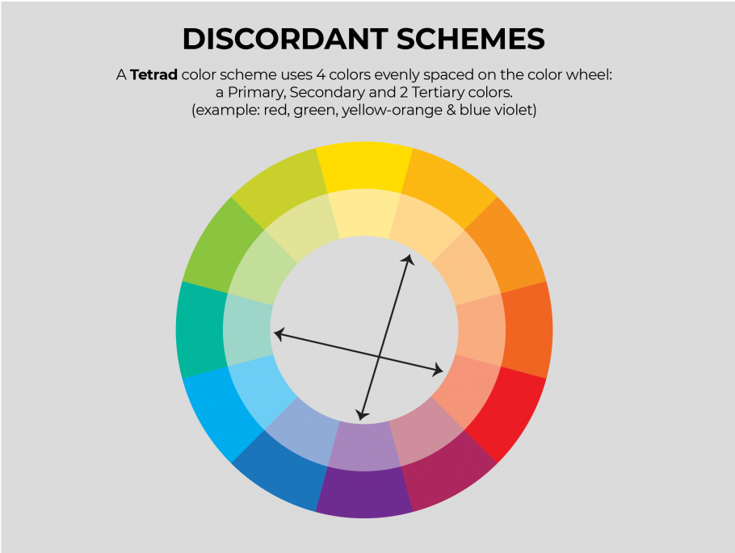

Source: https://www.youtube.com/watch?v=H8czWZTqtmM
- Ratio - the ability to create contrast and make it dramatic/moody
- 1:1 Ratio - highlight + shadow is equally exposed
- 2:1 Ratio - highlight is one step brighter than shadows
- 4:1 Ratio - highlight is two steps brighter than shadows
- 8:1 Ratio - highlight is three steps brighter than shadows
- Lighter images = more friendly, inviting, more comfort with them
  - Way we see things in life
  - Used to the bright, open life outside
  - more afraid to be inside in the dark, not as comfort in the dark
  - Afraid of the dark
- Strong split light
  - Smiling, looking into camera: hard, deep ratio
  - Sad, distant
  - Evil
- Open light - more flat lighting
Quality of light
- Short transition from shadow -> light, hard quality, harder experience
  - Darker and more moody
- Soft transition from shadow -> light, softer light, softer tone, softer experience
  - More beautiful
Warm light - sense of coziness, comfort, feeling of being accepted

Light typically comes from above (sunlight, lights in the house)
- Natural and comfortable
Light that is put below
- Unnatural and unsettling

Source: https://nofilmschool.com/film-lighting-techniques-and-examples

Lighting Techniques:
Natural Lighting - replicates real life + very free
- Natural lights around us don’t move
  - Moves every hour of day
- Natural film lighting = using light available at whatever location
Key Lighting - Illuminates object/actor
- Brightest light in frame
- Most important light source in scene
- Can create dramatic mood using light behind subject
High Key Lighting - Reduces ratio in scene
- Usually creates optimistic/hopeful mood to scene
- Used to create mood/tone
- White tones + bright lights
Low Key Lighting - Emphasizes dark tones + shadows
- Creates ominous + suspenseful tone
- Uses hard source to engulf scene in shadows
- Contrast + darkness
- Lots of contrast images
- Can be used for dark warnings
Fill Lighting - Cancels shadows via bringing out a key light
- Highlights things behind object
- Rack focus
- Put opposite to key light (not as powerful as key)
Back Lighting - Separates actor/object from background
- Makes scene feel more 3d
- Hits subject from behind
- Usually placed higher than subject
- Backlight behind actor at angle = kicker
Practical Lighting - gives depth of area to scene
- Lamps, candles, tv, lightbulbs = practical lights
- Set light corners/faces to help ambiance
Hard Lighting - dramatic effect
- Makes shadows, silhouettes, highlights
- Draws attention to specific parts of frame
- Harsh, souring light coming from direct beam of light source/sunlight
- Makes shadows + harsh lines
- Draws attention to anywhere in frame
Soft Lighting - soft, emotional scenes
- Shows characters in a good light
- Gives characters a younger look
- Reduces shadows
- Aesthetic used by filmmakers to reduce shadows + make discreet shades of light from outer sources
- Can be used as fill light
- Creates illusion of coming from practical sources
Bounce Lighting - larger space of evenly spread light
- Highlights subject without shining directly on it
- Light bounced off of other objects (white objects preferably) from light sources like the sun and lamps
- Can make softer light, fill light, top, side, and backlighting
Chiaroscuro (Side) Lighting
- Creates drama + mood
- Highlights person/object
- Contrast
- Light entering scene from side to highlight subject
- Creates slight fill
- Strong contrast + low key to accent contours of subject
Motivated Lighting - substitute natural light source (sunlight, moonlight, lamps)
- Enhances practical lights
- Mimics natural light sources
Ambient Lighting - creates more light
- Can also change controlled lighting if not done correctly
- Ambient light = some sort of sunlight/lamplight overhead seeping in
- Time of day changes, ambient light changes
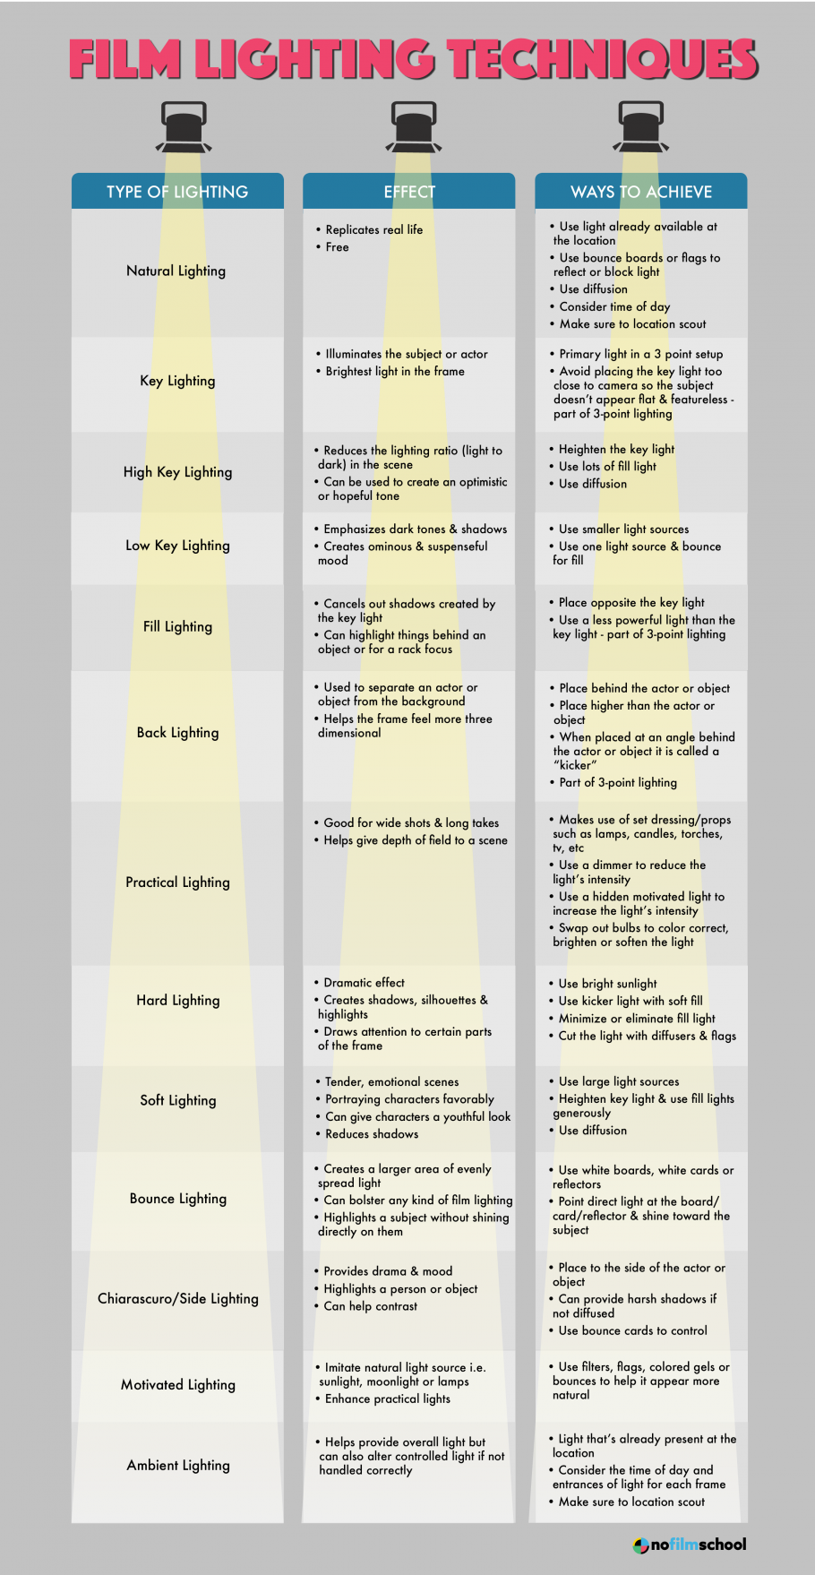

Source: https://engagedscholarship.csuohio.edu/cgi/viewcontent.cgi?article=1378&context=etdarchive

Abstract
- Scene w/ high key lighting cause audience to feel higher levels of positive emotions (happiness, joy, humour)
- Scene w/ low key lighting cause audience feel suspense, mystery, intrigue
- Scene w/ available light cause audience feel realness/grittiness
- Performed experiment testing low-key lighting, high-key lighting, + available lighting
- 162 testers viewed film
- 54 people watched each single piece
- People who watched film in low-key lighting felt more mystery, suspense, malice, intrigue, + other unsettling emotions
  - Also had more emotional response of positive emotions

Intro + Rationale
- Lighting = fundamental element in creating picture
- Light is all the eye sees
  - Only sees light bouncing off items at different colour temperatures, not actual items
- Eye sees light via iris
  - Brain sees world as 3D
  - Camera only sees world as 2D
    - Lighting theory must be used for it to look 3D
- Different lighting techniques developed to fit the different types of genres
  - Used to provoke emotional response from viewers + help narrative
- Experiment made with 3 quantitative/qualitative questions to analyze viewer responses
- High Key, Low Key, Available Light
- Film Lighting said to be one of the structural elements of media

Pg. 13

- Viewers watching film w/ noir style will see:
  - Highly shadowed, dark, high contrast
  - And will feel
  - Danger, suspense, depression, mystery, evil
  - Characters in this mode should be interpreted as having evil intentions, being manipulative, and untrustworthy.
- When using lighting for comedy…
  - Bright lighting set ups
  - Less contrast
  - Slick, shiny look
    - Emotional response: joy, honesty, happiness
  - Characters are interpreted as good hearted, funny, lovable, and heroic
- When using raw realistic lighting…
  - Reality and truth
  - Characters are as if they are from a viewer’s life
- ^^^^Above lighting techniques are used to
  - Enhance plot, characters, theme, style, general mood
  - “One could say that the technical ability and the expressive effectiveness of a director’s or of a cameraman’s work is revealed above all in the lighting” – Bettetini (as cited in Grotal, 2005, p. 2)
- “In visual storytelling, few elements are as effective and as powerful as light and color. They have the ability to reach the viewers at a purely emotional gut level” (Brown, 2012, p. 8).
- History of film lighting: comedies were commonly shot in High Key Lighting w/ ample exterior light
  - Physical in nature
  - Leans toward roughhouse + slapstick
- High Key - lets viewer see all of visual space
  - Flatly lit
  - No shadows
  - Sense of safety/positivity
  - “They are bright, generally set in affluent or fairly affluent environments, where no one lurks in the shadow and everything is bright and visible, even during night scenes” (Frost, 2009, p. 135).
- Low Key - high contrast, dark shadows, and half lit sets and faces
  - stylistic sculpting of dark shadow + bright light
  - “Stylistically shadows prevail, characters walk out of darkness with slashes of shadow across their faces, even during the day, darkness is the predominant feeling. Pessimism and doom are certainties” (Frost, 2009, p. 140).

Hypothesis(s)
- Hypothesis 1:
  - Participants who view High Key lighting will report higher levels of positive emotions than participants who viewed Low Key or Available Lighting. Low Key features stylistic sculpting of dark shadow and bright light.
- Hypothesis 2:
  - Participants who view Low Key lighting will report higher levels of suspenseful emotions than participants who viewed High Key or Available Lighting.

Cognitive Approach
- Analyzes how film impacts audiences’ emotional response
- Light -9 responsible for perception of objects, characters, events or scenes
  - (Grodal, 2005, p. 25).
- If filmmaker can recreate image drawing emotional memories from audience, he/she enhance information related to viewer + overall viewing experience
- Associating shadows with danger, bright lights with enjoyment and safety
  - developed through evolutionary survival
- Filmmakers tap into this primal visual interpretive mechanism to enhance audience emotional response, stimulate narrative interpretation and maximize engagement

Pg. 23
- Space in movie frame lit to persuade viewer perception
  - Objects lit in frame - focus viewer’s attention
  - Shadow amount limit perception
  - Changing lights - change in character/opportunity
- Scene in film - considered new architectural space
  - Lit using perceptual psychology to trigger viewer response/interpretation/mood/behaviour
----------------------
- Psychology has led lighting tests in 24 controlled environments w/ significant results
- If architectural lighting design impacts human perceptions/mood/behaviour in physical world, could also impact audience of film
- Aspects of impact of architecture lighting design on psychological perceptions have been led in psychology
- “Light is a pervasive feature of the environment, which exerts broad effects on human behavior” (Sburlea, 2011, p.1).

Research Question 1
Will participants report feeling differently in the likability of the characters depending on the lighting styles
- Lighting - basic element to see world
  - Significantly impacts way humans see reality
  - Creates mood, perception, attention, feeling + other human cognition manipulations
  - Changes psychological perception of people/places/events
  - Affects interpretation + emotional response

Variables
- Responsive: Different types of audience reactions
  - Emotional responses: suspense, realism, humour
  - Cognitive variables: narrative of character interpretation
- 3 emotional responses - lightheartedness, suspense, rawness
- Lightheartedness: emotional response label for positive emotions
  - Hypothesized to be connected w/ high key lighting
  - 10 positive emotions associated with 35 positive emotions were evaluated by participants on a scale of 1-7
    - 1 = “Not at All”
    - 7 = “Very Much”
  - Participants evaluated their emotions at 3 different time points throughout movie
- 10 emotional statements were combined to make summated Lightheartedness scale (10-70)
- Suspense: general emotional response for feelings guessed to be triggered by low key lighting
  - 10 emotions associated w/ suspenseful emotions evaluated by participants on scale of 1-17
  - 1 = “Not at All”
  - 7 = “Very Much”
  - Participants evaluated their emotions at 3 different time points throughout movie
  - 10 emotional statements were combined to make summated Lightheartedness scale (10-70)

Results
- 54 participants in each group
- High key lighting - 59% (32) men, 41% women (22)
  - Age range 18-72
- Low key lighting - 61% (33) men, 39% women (21)
  - Age range 18-70
- Hypothesis 1 Results:
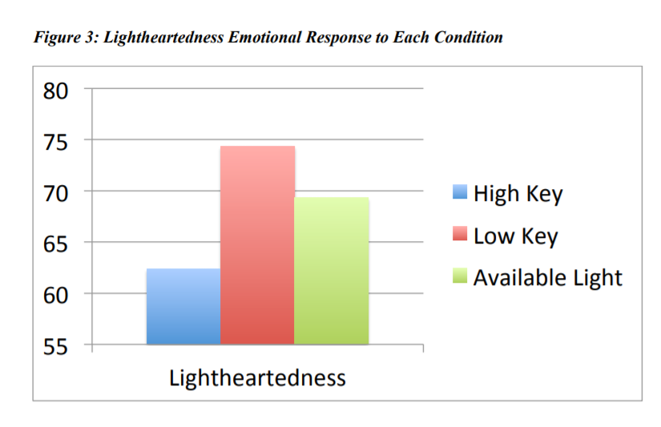
- Hypothesis 2 Results:
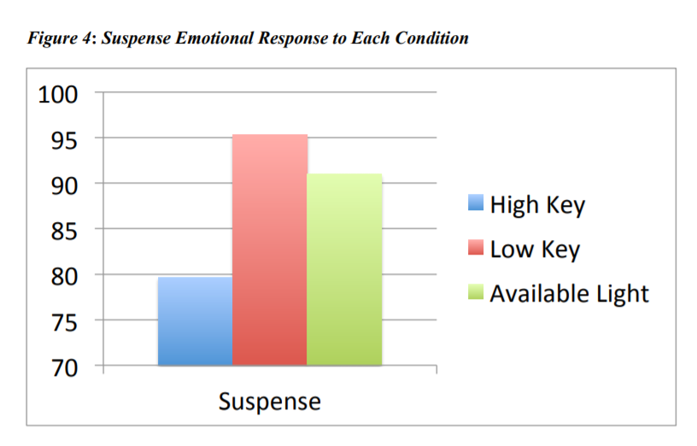
- Assumed Genres
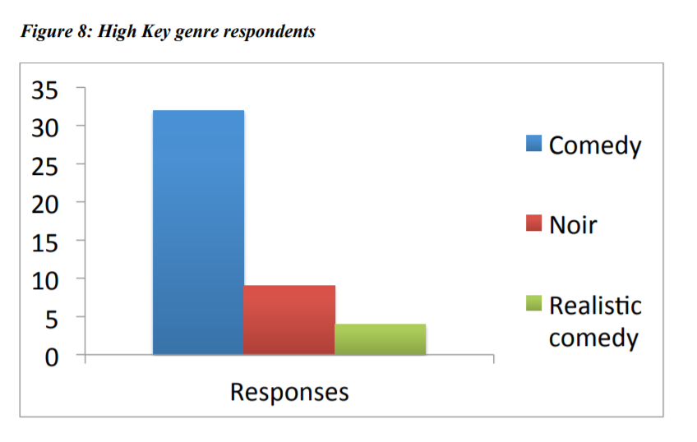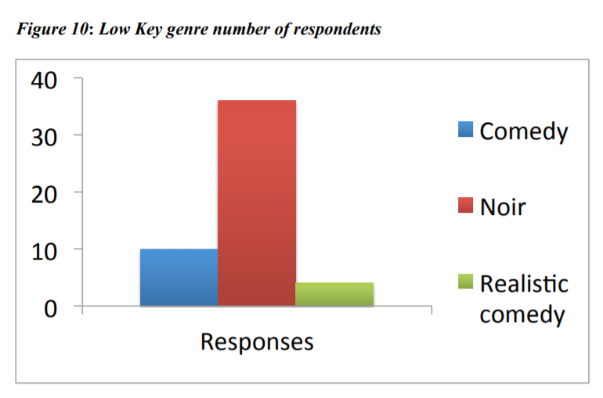

Discussion
- Shows short film w/ noir plot in 3 different lighting styles can change audience emotional response significantly
- Lightheartedness seen to be caused by viewers who watched film with Low Key lighting
  - Could’ve been because film had noir plot, and low key lighting is associated w/ noir
- Suspense strongest in low key lighting
  - Suspenseful plot + lighting style - emotional response w/ suspenseful nature
- Plot creates baseline for creating emotional response, lighting accentuates from plot
- 40/54 (74%) people identified comedy genre for high key lighting
- 36/54 (67%) people identified noir genre for low key lighting
  - Shows most people identified movie genre lighting style > plot
- Rosenthal and Wertenbaker (1964) state High Key + Low Key lighting originated in early days of theater growing from early 2 sources of light available: sun and firelight
  - suggests lighting style may impact perceptions of world + has ability to communicate in many subconscious + powerful ways
- Viewers report low levels of emotional response when the movie was filmed in high key lighting
  - Most identified genre as comedy
- Viewers report to have the highest levels of audience emotional response in low key lighting
  - Most identified genre as noir

Conclusion
- Film lighting has a significant impact on audience emotional response to narrative, (proven by film literature for past 100 years)
- Independently impact viewers’ emotional response to a movie
- Can intensify/mellow emotional responses that naturally come from narrative
  - Show the ability for film lighting to aid in augmenting/softening emotional responses
  - Cannot drastically change the responses into opposite feeling

- Also indication that for emotional response to happen, the film lighting style has to match what the viewer is accustomed to viewing with the narrative style.

Source: https://www.ecmag.com/section/lighting/psychology-light
- Art of lighting—where to position light in a workspace and knowing how it impacts perception
- Research studies indicate that light should be placed where people are going to look, with focus on the brightest part of the field of view.
- Research by John Flynn at Kent State University/General Electric Lighting Institute (1971–1975) found that people, when relaxing, tend to prefer a relatively dim part of a space oriented toward the brightest area, but they prefer a relatively bright part of the space while working.
  - Can influence behaviour. Eugene W. Sucov and Lyle H. Taylor, 1970, subjects would enter a room and walk in the area with the most light. If the light was brighter on the left side of the room, more people would go left.
- Relative brightness is the key to creating focal points in a space.
- Shoppers may be attracted to merchandise with higher brightness.
- In a secluded workspace, strong contrasts can be distracting.
  - Higher uniform brightness is prefered
- Several studies show that most people prefer a higher light level than is necessary for good workflow
  - ^^^^ necessary to know because preference related to satisfaction
- Higher contrast - perception of higher light level
- Too much light can be tiring to the eye
- People tend to prefer more uniform brightness than is necessary to avoid visual fatigue
- Study showing that participants were in a room lit in 4 different ways (overhead/peripheral, uniform/non-uniform, bright/dim, visually warm/cool)
  - Overhead/peripheral - lighting in center of room/lighting on edges of room
  - Uniform/non-uniform - equal/unequal distribution of light
  - Bright/dim - more light/less light
  - Visually warm/cool -
  - Asked to rate it on 7-step semantic scale of opposite feelings (pleasant/unpleasant, bright/dim, spacious/confined, public/private…)
- bright, uniform lighting, (some emphasis on walls) can impact impressions of visual clarity
  - Can be achieved via indirect lighting
    - Shows equality of increasing brightness on walls
    - But some people saw room as dimmer rather than brighter
- Many elements influence human behavior, so its hard to pin down lighting as a deciding factor
- Lighting methods can impact perception
  - Could mean placing lights on walls directly/indirectly can provoke or perception of higher light levels

Source: https://www.ledinside.com/knowledge/2013/12/lighting_psychology_cognitive_and_emotional_responses_to_lighting
- Stimulus = Response of an action
  - Foundation of basic psychology
  - Defines relationship of world around us
  - Ex. pulling finger away from hot pan
- Lighting practitioners goal is getting a stimulus right to control the wanted response
- Detailed + careful characterization of tasks under different lighting conditions (stimulus), and a diverse amount of techniques for measuring visual performance
- Lighting can create excitement in themed environment
- Lighting can help someone navigate through an unfamiliar environment
- Lighting can create a sense of calm + peacefulness
- Lighting can add mystery in a film
- Lighting can change our perception to dislike a room, which we might find likeable if it wasn’t for the lighting

1st Thread: Lighting Psychology
- John Flynn
  - He and his co-workers discovered what was (at the time) new research + analyzing techniques to document understanding of human impacts on lighting
  - Observed human response to lighting by looking at a variety of impressions connected w/ architecture settings to decide which impressions are impacted by changes in lighting stimulus
  - Impressions like space, clarity, privacy, comfort, relaxation, and complexity were affected by changes in lighting
  - Flynn showed that architectural lighting has an important role in human experience than as an activator of task performance
  - Flynn also looked to understand nature of the stimulus that created those responses
    - Identified 4 factors (he called them “lighting modes”)
    - Each mode shows continuum of changes in lighting between 2 opposite things
    - Bright/dim
    - uniform/non-uniform
    - central/perimeter
    - warm/cool
  - Message: as you change lighting stimulus of those modes, you can create changes in human response (impressions)
    - Responses will happen regardless if you planned it or not
  - Designer could focus on specific points of lighting mode
    - Ex. Designer could emphasize relaxation by having non-uniform lighting on perimeter of room. Tone would be warm.
    - Uniform lighting on perimeter of room emphasizes perception of spaciousness

2nd Thread: Environmental Cognition
- Researchers looked to understand factors driving preferences for environments
  - One of them was the want to make sense/understand surroundings
- Kaplans
  - state that when shown a new environment, finding something in the environment that is familiar is a primary goal
  - It's because we want to interpret/understand new environment, and doing this helps us achieve that
  - Typically, when entering a new place that has similarities to other environments that we’ve seen
  - The more familiarity sensed, the more we feel happy and comfortable as we can understand the setting
  - If we discover an unfamiliar/unusual space that has a completely new experience, we find it unsettling and difficult to understand the environment
  - Fundamental human must understand environment is explanation of these experiences (according to Kaplans)
- WOW factor of new environment: uniqueness/unfamiliarity very stimulating + exciting
- Entering very familiar place - creates low preference (“Oh please, not another drab hotel seminar room with boring uniform lighting!”)
  - High familiarity = low preference
- Factor driving our understanding of environment (according to Kaplan) is wanting engagement w/ environment
- Want environment to be interesting, so we can get involved and explore
- Want sense of complexity/mystery
- Purpose of involvement - makes novel environments seem exciting over weird/overwhelming
  - Also makes it so that familiar places are just uninteresting/boring
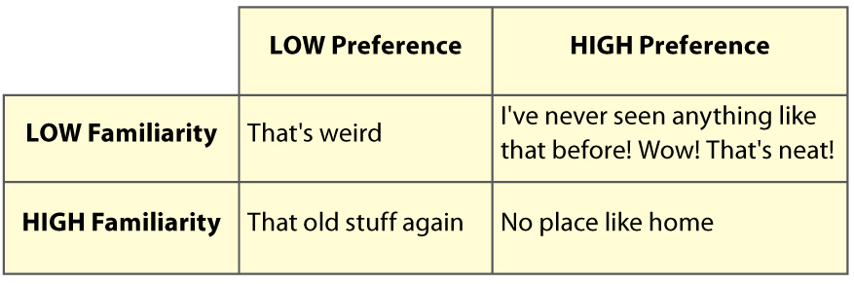
- Kaplan uses 2 key words to get essence of environmental factors that provoke our preference
  - Coherence + complexity
  - Coherence = ability to make sense/understand environment
  - If we can quickly understand environment that is coherent, most likely would develop positive preference for environment
- “It is also important that a change in texture or brightness in the visual array is associated with something important going on in the scene. In other words, something that draws one’s attention within the scene should turn out to be an important object or boundary. . . If what draws one’s attention and what is worth looking at turn out to be different properties, then the scene lacks coherence.” (Kaplan 1988, p. 49)
- Brightness emphasis helps understand environment increases coherence
  - Equals happy space
- Change in brightness that is unrelated to anything significant in visual scene lacks coherence
  - Equals difficult to understand space
  - Reduces preference for space
- Coherence = critical
  - However, place that is entirely coherent but overly simplistic doesn’t create the stimulation + involvement desired
- Complexity in environment gets us to engage and be active with the environment
- Cognitive link between complexity/preference also is seen in music appreciation
  - “When a musical piece is too simple we tend not to like it, finding it trivial. When it is too complex, we tend not to like it, finding it unpredictable – we don’t perceive it to be grounded in anything familiar. Music, or any art form for that matter, has to strike the right balance between simplicity and complexity for us to like it.” - This is Your Brain on Music, Levitin
- Want for a specific level of complexity is in a wide range of stimuli (music, architecture, etc.)
- We want coherent environments that we can easily identify
  - At the same time, also want a good level of complexity to keep our interest captivated

3rd Thread: Emotional Response
- James Russell - developing understanding of human emotional development + response
  - Primary emotional responses determine behavioural responses
  - Human sensory systems process environment + characterize relationships
  - Sensory input mixes with personality to create primary emotional response in 3 areas: happiness person finds in environment, awaking, and power/control people have while in environment
  - power/control response - interesting factors for lighting
    - Depends a lot on how much control we have over environment compared to how we feel environment controls us
    - Automatic vs manual lighting
    - Greater energy savings when people have manual control
    - Negative reactions in automatic control
  - Happiness + awaking = 2 primary ways to respond to environments
  - Whenever we are in new places, we put it in ¼ quadrants defined by 2 axes of happiness/awaking
  - Russell’s work directly connected w/ architectural environments
    - Later studies human emotional response to types of stimuli
    - Emotional responses = fundamental to human condition
  - Russell argues emotional response to stimulus along 2 dimensions of happiness + awaking is a single, integrated response rather than 2 clear responses
  - Words used to describe spaces reflects integrated response
  - For an environment to be stimulating:
    - Must be awaking + pleasant
  - Tense environment:
    - Awakening, but unpleasant
  - Relaxing environment:
    - Low awaking, high pleasure
  - Dreary environment:
    - Low awaking, low pleasure
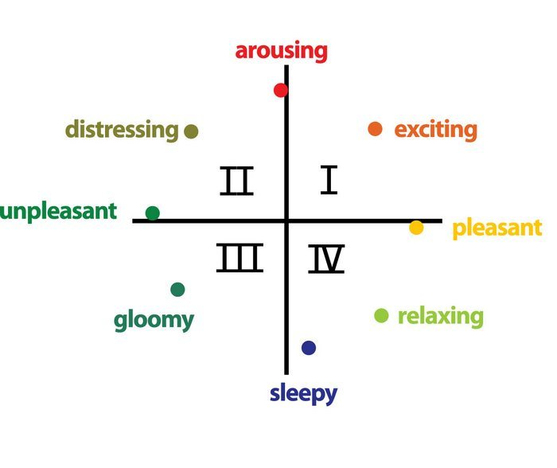

Combining Threads
- Flynn - provides us thread of stimulus described by lighting modes
  - Connected to human response of impressions on environments
- Planes - thread of preference response
  - Connected w/ environmental stimuli that are coherent + complex
    - Understand environment + interesting enough for involvement
- Russell - thread of primary emotional responses to stimuli
  - Response w/ dimensions of happiness + awaking
- Example: conference room
  - Designer wants uniform lighting across tabletop as 1st layer of lighting
    - Increases awaking of environment, which works well for a working environment
  - Designer adds uniform perimeter lighting along 2 walls
    - Reinforces impression of spaciousness
    - Emphasizes architectural boundaries, adding to its coherence
  - Accent lighting on artwork on end wall adds additional layer of light
    - Non-uniformity of layer increases complexity
      - Makes it more interesting
      - Inviting occupant to engage w/ environment
  - Good environment because designer structured lighting solution so it reinforces wanted architectural impressions (Flynn)
  - Balances human needs for coherence + complexity (Kaplans)
  - Levels of awaking + happiness (Russell)

Source: https://measuringbehavior.org/mb2008/individual_papers/SIG_Theuws/SIG_Theuws_Quartier.pdf

Abstract
- Understanding human movement via lighting
- For many years people have been drawn in my light
  - Fire, candles, lamp bulbs, etc.
- Are humans influenceable in the way they move in the build environment, guided through lighting?
- 1st focus - how humans behave (move) under lighting conditions (walk speed)
- 2nd focus - how humans perceive space under certain lighting conditions (emotional based)

Introduction
- Goal of research: development of guidelines for designing lighting in build environments
- 1. Lighting can be designed to guide people’s movement through space
- 2. Lighting can be designed so it has a positive impact on appreciation of space, via perception of the space
- Research suggests commercial spaces are ideal places to experiment with in lighting, humans, + behaviour and emotions
- Most research has been done in office settings
  - Therefore, Hypotheses based on office settings
- Research also suggests shop environments make “retail experience” strongly impacting customer purchase behaviour
- Keeping shoppers longer in stores = increased browsing behaviour
  - Increased impulse to buying things
- 3. ⅔ of purchase decisions are made in the store
- 4. Shop interiors are very important and the interior variables have an individual impact on the customer
- This article talks about light and how it impacts perception of space/movement
- Analyzed how customers respond to retail environment
  - Noted customers react to retail store in cognitive, emotional, biological way
  - Emotional factor - effect of lighting conditions throughout perceptual system
  - Physiological factor - lighting as purely biological influence
- Discusses short term biological effects of lighting on humans
  - Way people act under certain light conditions
  - Which route they take
  - Which speed show shift of body’s circadian rhythm
- Emotional and physiological factors hard to separate
  - Will influence on another
- 1st part of study: survey of literature
- 2nd part of study: controlled environment (supermarket)
- 3rd part of study: development of guidelines for lighting design
  - In commercial spaces

Short overview of theoretical framework

- Factors of studying literature connected to impact of lighting in retail environments:
  - Customer behaviour on basic level: light influences route customers take through store (Taylor and Scovo)
    - People are attracted to light
    - Choose to move to more bright path
  - Light draws attention to products (LaGuisa and Perney)
    - Areni and Kim - experiment with wine bottles in store
      - Bright lighting condition bottles more examined/touched than dimly lit conditions
    - Magnum - lighting influences attractiveness of products in store
    - Summers and Herbert - belts were touched/picked up more with display lighting feature
      - Customer spent more time at display w/ accent lighting
  - Mehrabian and Russell - environments come from environmental psychology based on emotional model
    - Emotions provoked by shop environments related to customer behaviour
      - Also related to buying behaviour
    - Lighting has influence on supposed price level of store (Luomala, 2003)
- Bright lighting conditions + orange walls
    - Low price perceptions
- Soft lighting
  - Higher price perception
- Psychology studies found person’s personality can impact reactions to environment
- Age / gender interacted with lighting _ colour temperature of lighting
  - Causes mood shifts in working environments
- Difference of reactions to lighting based on cultural backgrounds (Kuller 18)
- Spectrum of lighting plays significant role

Hypothesis Development
- Based on theoretical framework
- General spaces: Lighting has an influence on the mood and hence the behaviour of humans in (retail) environments.
  - Lighting has an influence on how spaces are perceived; even in a matter it can arouse positive or negative feelings in the perception of that space.
  - Lighting has an influence on way-finding as well as ones walking speed in a (retail) environment.
- Retail orientated: Positive effect, induced by lighting in retail environments, will encourage humans to stay longer in that retail environment.
  - Positive affect, induced by lighting in a retail environment, will increase the sales numbers of that retail environment.
    - Persistency of lighting and effects might be connected to all other factors that can impact behaviour, perception, movement
    - Lighting considered as one of many factors to determine result
- Without lighting, no space, no build environment, humans kept in dark
- Statement show importance and influence of light + lighting design on human behaviour/perception

Source: https://www.cnn.com/2017/09/01/health/colorscope-black-fear-of-darkness/index.html
Black has gradually made its way from being a color associated with grief and morbidity to one known as a fashion staple that radiates sophistication, she said.
“It has that kind of weight attached to it … that now brings a sense of power to the color … beyond just funerals and grief and widows’ weeds,” Eiseman said.
Today, people wear black as a mark of expensive clothing, to minimize the appearance of their size and to exude confidence, she said.
But the color’s link to gloom still emanates across cultures, for example in American and European mourning practices as well as in fictional depictions of evil – like a witch’s hat or the cape of the Grim Reaper. The origins of this are part of our evolution.
Black is “the color of night,” Eiseman said, “the color of darkness. The color that conceals all.”

We fear what we cannot see
You’re alone at night, cozied up on the couch and watching a movie, with the room a well-lit enclosure; your safety is not in question. There is a gust of wind outside. The trees rattle and scrape against the window. You hear a loud fizzle, and the power goes out.
You’re now engulfed in pitch darkness, and for most people, fear is probably setting in.
“Fear is just like pain. Fear is there to protect us from possible harm,” said Martin Antony, professor of psychology at Ryerson University in Toronto and author of “The Anti-Anxiety Workbook.” “So that fear makes us more vigilant for possible danger.”
Prehistorically, people would have been more at risk of being attacked by predators or by enemies when in the dark, he said. Through evolution, humans have therefore developed a tendency to be scared of darkness.
“In the dark, our visual sense vanishes, and we are unable to detect who or what is around us. We rely on our visual system to help protect us from harm,” Antony said. “Being scared of the dark is a prepared fear.”
Eiseman agreed that “the unknown” is an inherent association that humans make with the color black, as It prevents them from seeing distinct shapes and veils potential threats.
“How we see colors in nature has such an important effect on the human psyche,” she said. “And we know that from the beginning of time, black is the color of night, and it’s the color that could hide any nefarious deeds that might be perpetrated under the cover of darkness.”
This notion is imprinted on us from the time we’re children, she said. However, thanks to modern technology, we’re now able to turn on the light and continue to have fun even at night, she said.
But some never quite shake the fear.

Excessive Fears
Though fear is natural, it may become an issue if it gets excessive, Antony highlighted.
Many of us may experience a strong fear while alone at night in a dangerous part of town, he said, but it’s not as common to feel that way in a dark bedroom.
Excessive fear of the dark can be caused by a variety of factors. It may come from a negative experience such as getting attacked in a dark place. Or it can be caused by something as simple as watching a horror movie, according to Antony.
This fear can then become a phobia – specifically known as nyctophobia – when it begins interfering with relationships, work or the ability to do things they want to do. If someone is unable to leave their house at night, that would probably be categorized as a phobia, Antony said.
Aids can include nightlights or leaving a door open to allow in light from elsewhere, partially restoring vision.
These are called “safety signals,” Antony said. Having a small light on or a friend in the room helps us feel protected and more grounded in reality.
Treatments are also available, including gradual exposure to the feared situation, Antony said. Professionals have their patients rank and order a list of situations they’re afraid of and then expose themselves to each fear until they’re no longer scared.
“If right now they’re sleeping with a nightlight, for example, we might have them buy a nightlight with a slightly dimmer bulb or one with a switch that’s variable,” he said.
But just as the color black can bring fear to most, it can provide security to others – particularly in terms of fashion.
“I think more people think of it as kind of an enveloping kind of color that they can pull around them that gives them a certain degree of security,” Eiseman said. “They can kind of fade into the shadows.”
In a way, there’s an ambivalence built into black, she added. It is up to the individual to either fear what lurks in the darkness or become one with it.
When taking a look at many women’s closets, most are likely to have embraced it.
“Every woman knows that having the black dress in the closet, the black shoes, the black coat, the black anything that we put on, it will work in just about any circumstance,” she said.
So one tip could be to beat your fear by stepping over to the dark side.

Sources:
https://nofilmschool.com/Film-color-theory-and-color-schemes
https://www.youtube.com/watch?v=H8czWZTqtmM
https://nofilmschool.com/film-lighting-techniques-and-examples
https://engagedscholarship.csuohio.edu/cgi/viewcontent.cgi?article=1378&context=etdarchive
https://www.ecmag.com/section/lighting/psychology-light
https://www.ledinside.com/knowledge/2013/12/lighting_psychology_cognitive_and_emotional_responses_to_lighting
https://measuringbehavior.org/mb2008/individual_papers/SIG_Theuws/SIG_Theuws_Quartier.pdf
https://www.cnn.com/2017/09/01/health/colorscope-black-fear-of-darkness/index.html
https://digitalcommons.liu.edu/cgi/viewcontent.cgi?article=1030&context=post_honors_theses
https://www.tcpi.com/psychological-impact-light-color/
https://www.berghahnjournals.com/view/journals/projections/8/2/proj080203.xml?ArticleBodyColorStyles=contentSummary-4024 (abstract)

https://www.tcpi.com/wp-content/uploads/2017/12/Psychological-Impact-of-Light-and-Color.pdf
https://scholar.google.com/citations?user=AVmWQv4AAAAJ&hl=en
“Film lighting and mood” - T. Grodal

OLD PROJECT RESEARCH

Source: https://news.stanford.edu/2015/03/11/dancing-droplets-prakash-031115/
- In some situations, droplets of liquid will start to ‘dance’
  - They can sense each other, move, interact, almost like they’re living cells
- These observations may be useful in semiconductor manufacturing and self-cleaning solar panels
- Chemotaxis = sensing and motility of other living cells
- Food colouring = 2 component liquid
  - Meaning 2 different chemical compounds exist while having different molecular identities
  - In this case the 2 compounds are water and propylene glycol

Surface Tension and Evaporation:
- Droplets dance because of balance between surface tension and evaporation
- Evaporation = molecules on surface of liquid changing into gas and rising into air
- Surface tension = cause of what makes the surface. Makes molecules in liquid tie together
- Water evaporates faster than propylene glycol
- Water has higher surface tension than propylene glycol
- Differences make tornado flow inside droplets
  - Allows them to move and senses its neighbours
- Inside food colouring droplet, water + propylene glycol molecules stay evenly spread out, but differences in evaporation/surface tension make turmoil in droplet
- Dome of droplet, water molecules start to evaporate faster than evaporation-averse propylene glycol neighbors
- This happens faster on lower edges of droplet that are more thin
  - This leaves excess propylene glycol there
  - Leads to peak of dome having higher concentration of water
- Water at peak has higher surface tension to make the droplet tighter so it doesn’t flatten
  - Tugging motion creates falling molecular motion inside droplet, therefore surface tension prepares droplet to roll
  - Evaporation decides direction of this motion
    - Droplets give aloft gas molecules of water, like emitting a signal declaring exact location of a droplet
    - Droplets mix where signal is strongest
- Evaporation gives sensing mechanism
- Surface tension pulls droplets together to what seems like a ‘dance’

Two Component Fluids Rules
- Droplets w/ 1% propylene glycol (PG) and 99% water has same behaviour as ⅔ PG and ⅓ water
  - “Universal rule” to show sensing + motility -
- Add colours to fluids to tell different concentrations of droplets and how they act
- In one experiment, Droplet w/ more PG seems to chase droplet w/ more water
  - Really, roplet w/ more water has higher surface tension tug, pulls PG droplet along
- Another experiment, separated droplets align themselves using signals of evaporation
- Other experiment, black lines drawn on glass sides
  - Lines changed surface of slide and created series of small catch basins
  - Filled basin w/ fluids of different concentrations to make a self-sorting machine
  - Droplets bounced until they sensed fluid that matched their concentration and merged w/ that pool
- Understanding of 2 component liquids can get researchers to see which liquids/surfaces can show these effects
  - Effect is present on larger # of common surfaces
  - Can be copied with # of chemical compounds

Source: https://www.mitpressjournals.org/doi/pdf/10.1162/isal_a_00234
- Droplets have life-like traits that are very popular in artificial life studies
- Life-like traits include: fission and fusion and movement that can be recreated artificially that can be made use of very simplified chemical systems
- The subject of droplets in chemotactic systems can be contacted with biological systems
- An invention that has been made is a chemotactic droplet that can move lightweight objects like hydrogel alginate capsule with living cells as a transporters
- The transporters worked well in a sterile way a variety of bacteria and yeast
- THe protocols are being changed to transport human cell lines
- Eukaryotic cell lines give out surfactants when they are put in the artificial transport system
  - This reinforces the interaction between artificial and living systems
  - It is also a demonstration of how the interaction between artificial and living life can be changed and modified, but how one system can be higher than the other
- In this scenario the living systems give out the surfactants that the droplets need for the object transport and for the artificial system to give transport for other sessile mammal cells
- Prototype cell systems are demonstrations of bottom-up synthetic biology
- Capability to move is property of cells + living organisms
- Motile prototype cells made using easy chemical systems
  - Ex. oil droplet in water or water droplet in oil
- Lively water droplets in oil first introduced by Otto Butschli in 1892
  - Used alkaline water droplets in olive oil to create saponification reaction
- Prototype cell system recreated organization that moved + acted like amoeba
- Many have started creating oil droplet systems as representations of living systems
  - Ex. group of Hagan Bayley in Oxford made 3D custom designs of water droplets in oil w/ strong fluid bilayers creating droplet interfaces as copies of living tissues
- Structure of droplets in porins show active transmission
- Each droplet in system can be improved w/ cell-free systems controlled by light activating protein expression
  - This showed life-like traits like active transmission + protein expression that can be activated in water/oil droplets
- Chemotaxis = stimulated movement to increasing/decreasing chemical gradient, + 1-decanol droplets that make aqueous medium having decanoate at high pH, demonstrating chemotaxis when chemical gradient put in external aqua habitat
- Droplets w/ chemical gradients can solve 3D mazes, which shows rudimentary artificial intelligence
  - Can be compared to eukaryotic chemotaxis
    - Ex. Dictyostelium amoeba move with higher concentration of cyclic adenosine-30,50-monophosphate
    - Decanol chemotaxis moves to salt sources
  - System works in mazes
    - Can be moved to transport artificial things
- Made artificial chemotactic system to be friendly w/ natural living systems by making fraction of hydrophobic alginate capsule as defensive system that can be attached in a droplet to transport.
  - Able to transport Escherichia coli, Bacillus subtilis + Saccharomyces cerevisiae
- Yeast survived transport but wasn’t very consistent/repeatable
- Droplet w/ capsule + live cargo could be changed w/ salt gradients many times w/ capsule attached to droplet
- Chemotactic droplet systems can interface w/ living systems to move live cells in petri dishes
  - Other scenarios possible
- Moving droplets w/ cells could be applied in small environments like microfluidic chips
  - Leads to new generation of technologies for cell screening
- Chemotaxis systems + alginate capsules inexpensive + easy to change + could be applied widely
- Alginate capsule can be exploited to deliver bacteria/enzymes for better bioremediation
- Droplets show transporting to locations that can’t be accessed by humans/capsules could protect bacteria from extreme environments
- Droplets decide transport to locations not available to humans
- Capsules protect bacteria from extreme environment
  - This could also be used for environment planning to test bacterial/enzymatic/chemical treatments, moved by capsules + droplets on systems w/ smaller size
- Expect certain degree of society impact via development of artificial life tech
- Surface tension - property of surface of a fluid that resists external force because of the cohesive forces in the molecules
- Cohesive forces between liquid molecules are cause of surface tension
Websites Found:
https://news.stanford.edu/2015/03/11/dancing-droplets-prakash-031115/
https://www.mitpressjournals.org/doi/pdf/10.1162/isal_a_00234
https://www.usgs.gov/special-topic/water-science-school/science/surface-tension-and-water?qt-science_center_objects=0#qt-science_center_objects
https://physics.aps.org/articles/v1/38
https://aip.scitation.org/doi/abs/10.1063/1.474184
https://www.ncbi.nlm.nih.gov/pmc/articles/PMC5441762/

