Snowstoppers

Weatherproofing  -what is weatherproofing  -test ? | Problem: snow getting into my shoes  I do not want to wear boots
Background research  Mr. Blakney told me about the gater  Mr Blakney asked if we had a sewing machine and told me to think about what kind of fabrics  I want something smaller that can fit into my pocket  I want something that looks better  A man at Bubba’s place said he use to wear a spat over his boots so mud would not get on his pants on his way to church – wiki shows spat is leather with buttons | Supplies:  Fabric  Bubba’s sewing machine

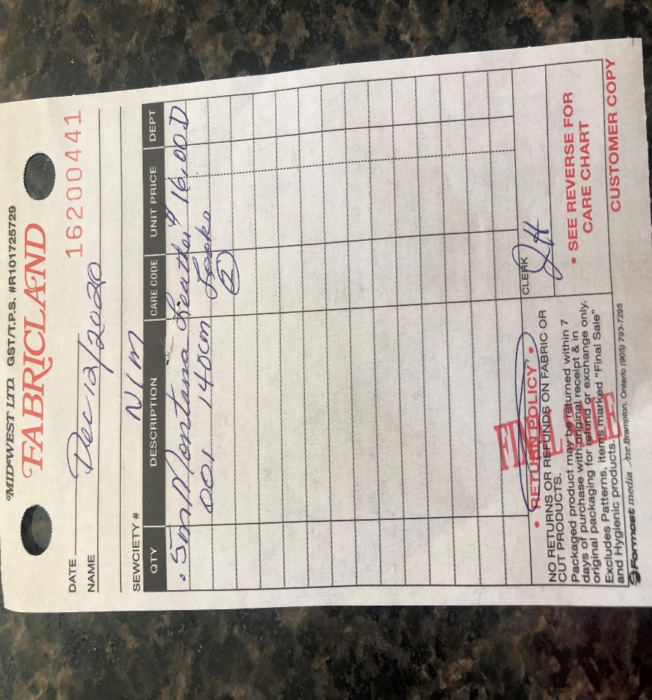

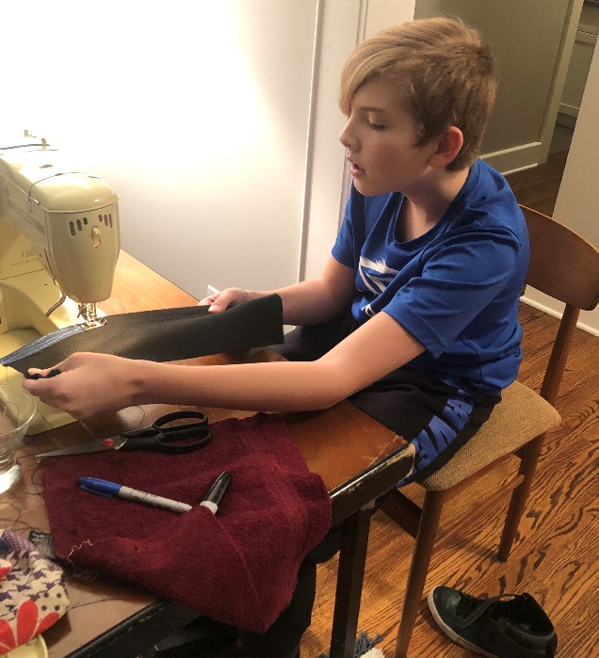Jan 4 – protype one

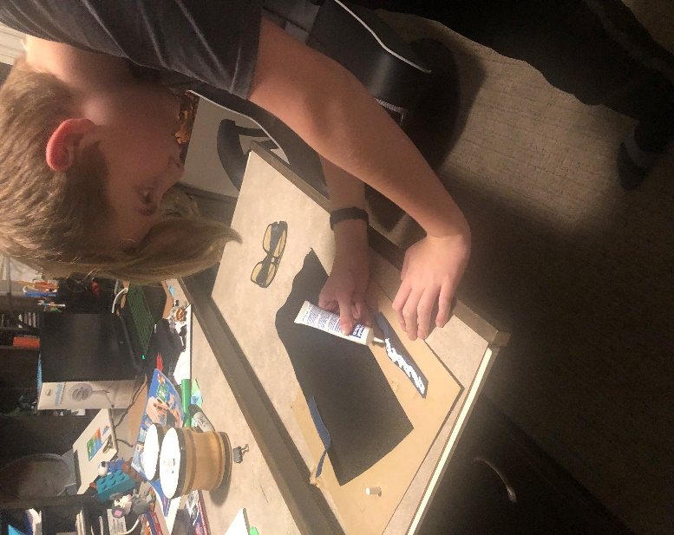
jan 18
fabric glue protype 4

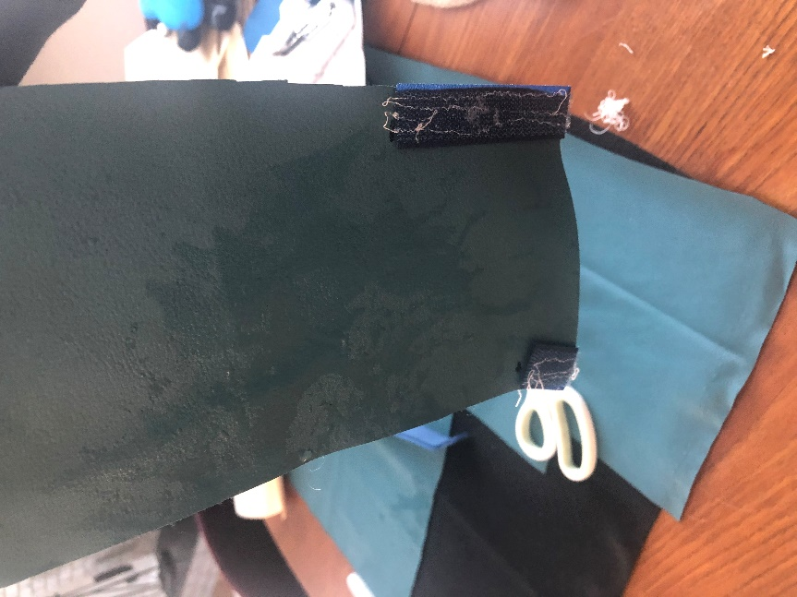prototype 1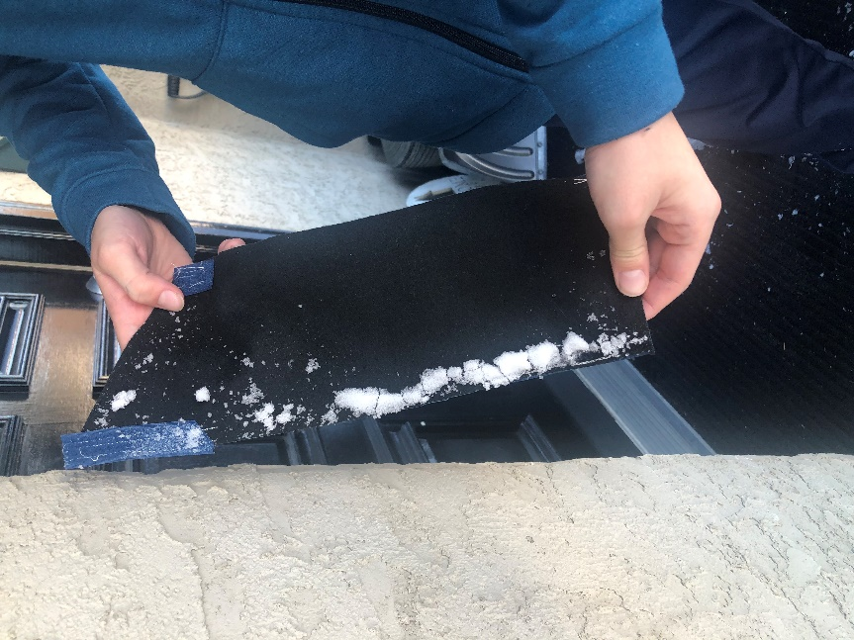prototype 1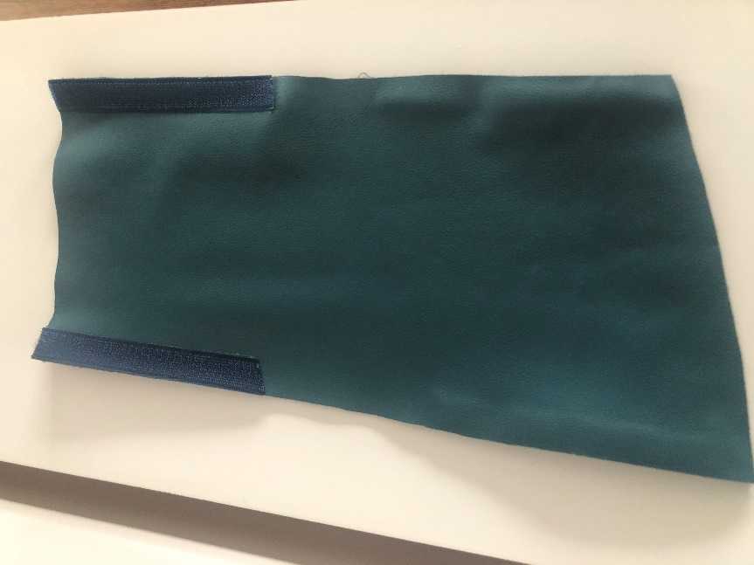 prototype 2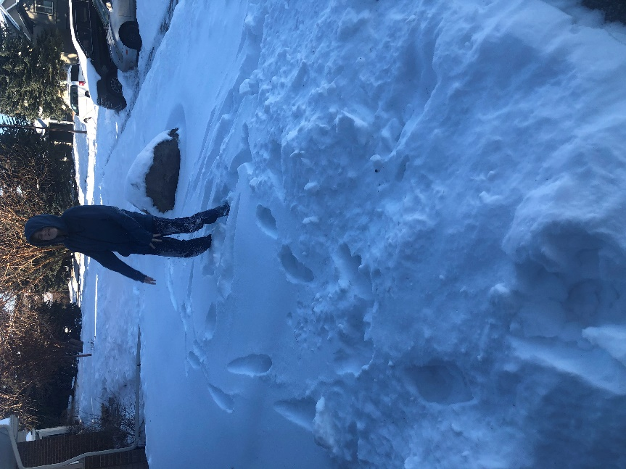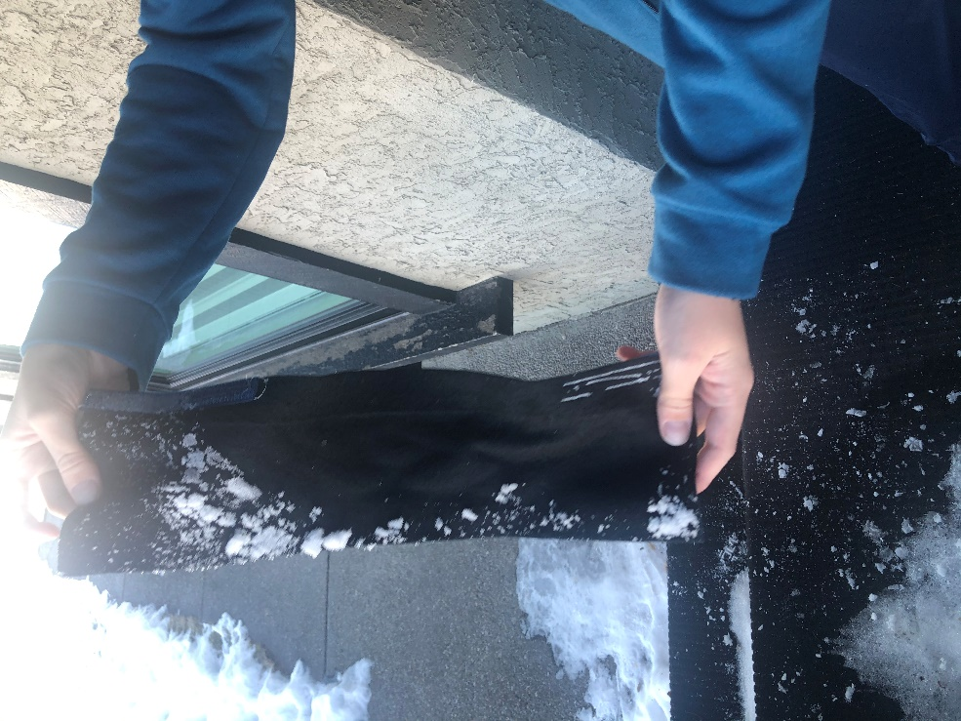P1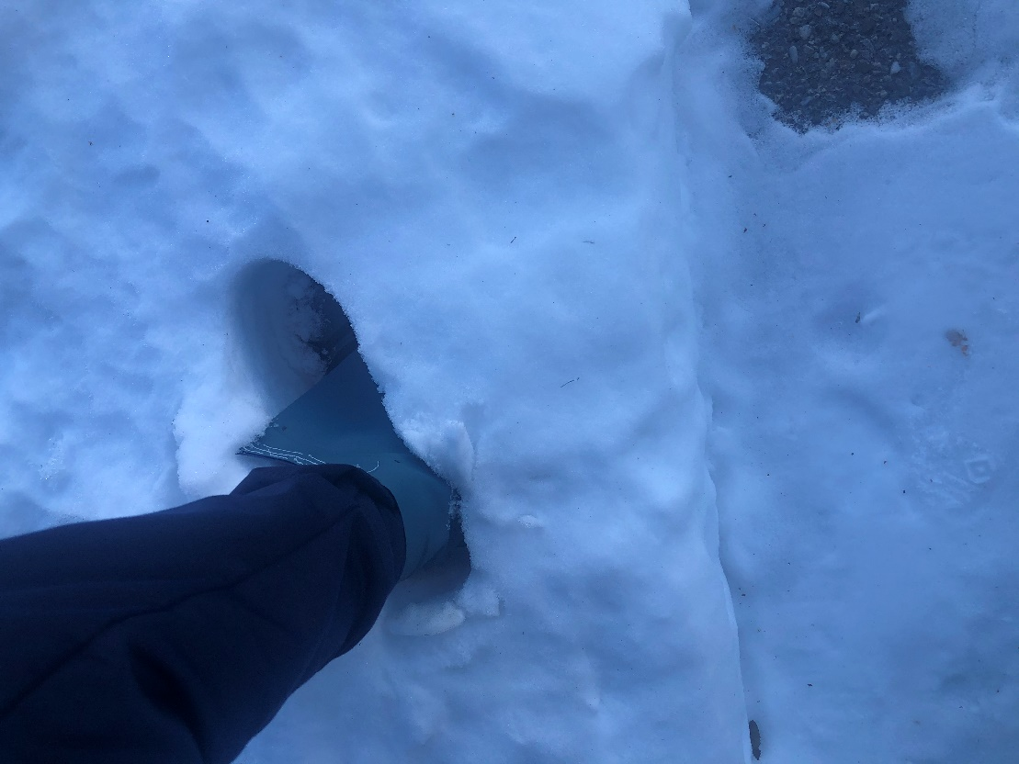protype 3 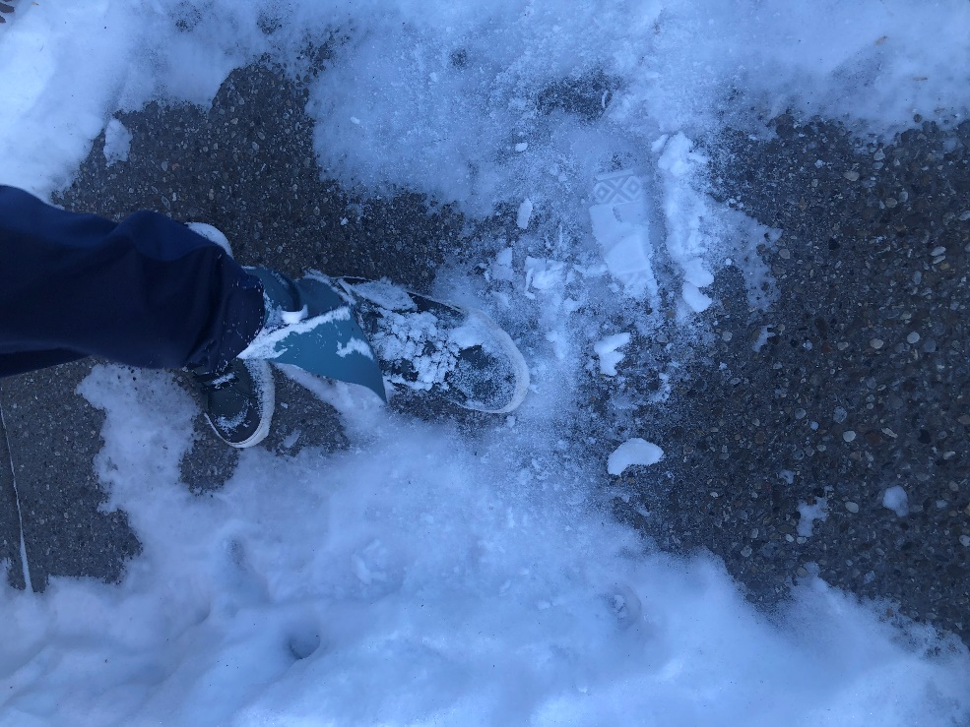p3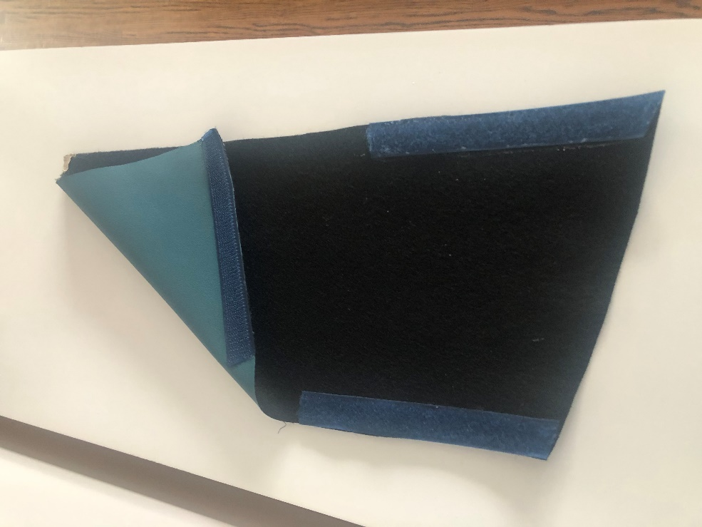prototype 4
