2024 CYSF Science Fair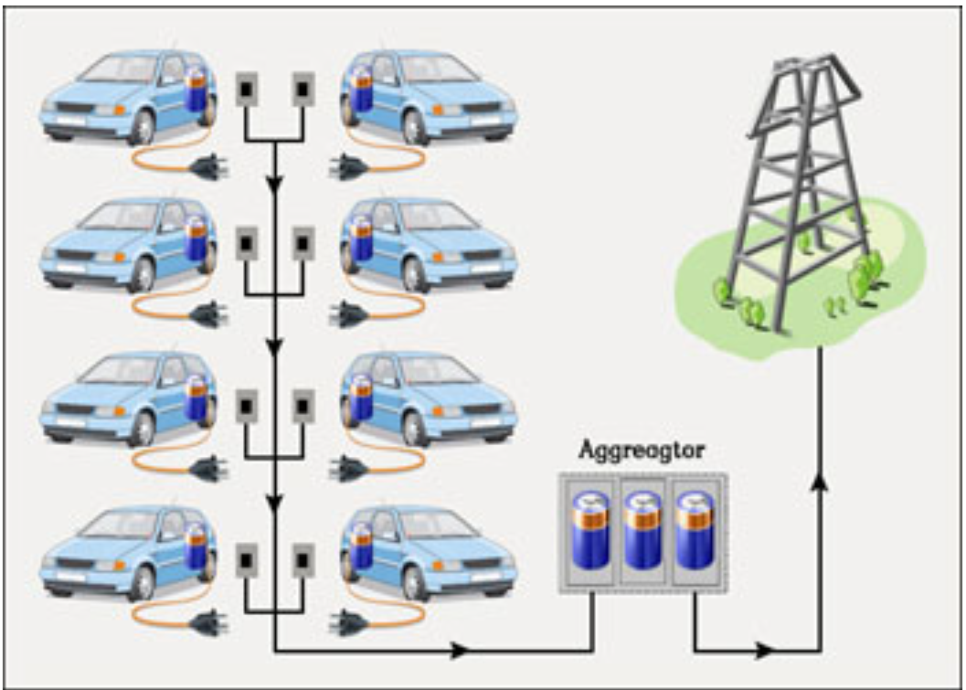

Problem/Question:
The prices of electricity differ significantly between peak hours (peaks) and down times (valleys). The electricity available within a power grid will be wasted if not used during valleys, and there may not be sufficient power to meet the demand during peaks. What can we do to balance the supply and demand of electricity?

Hypothesis:
I think that a good way to balance the supply and demand of electricity is to encourage people to use electricity during off-peak hours, or valleys, which would decrease the demand during peak hours and help balance the electricity grid. I’m going to try to do this using Teslas.
But this isn’t very realistic, because off-peak hours are usually when everybody is sleeping, and nobody wants to wake up in the middle of the night to plug in their appliance. This is where my project comes in.
I thought, “What if I could create an app where it uses code to predict future prices, and then it would schedule your outlet to automatically turn on and off during off-peak and peak hours? And if you get the electricity cheaper during off-peak hours, you can sell electricity to others during the peak hours, right?”
That way, everyone could save money and make money, even when they’re sleeping.

Variables:
Controlled Variables | Manipulated Variables | Responding Variable
Time | Charging schedule | Profit
Prices | Discharging schedule

Procedure
- Use historical data to predict future electricity prices and evaluate the accuracy of the prediction. I’ll test my code by giving past electricity data from 5 different cities.
- Determine the exact timing of buy and sell decisions using the predictions.
- Simulate electricity charging and discharging using a Dyson Vacuum Cleaner
- Calculate average costs and profit from the buy and sell decision.

Observations
- For my first experiment, I noticed that four out of the five cities I trained the model with, the predicted electricity prices each had a pretty high accuracy rate. As displayed in the table and chart below, 96% of the time, electricity prices in London, UK can be predicted within a 10 cents difference from the actual price. Ankara, Turkey, however, had the lowest accuracy rate due to high volatility. Please refer to Appendix 1 for electricity price charts predicted for the 4 regions where their accuracy rates are pretty high.

Price Prediction Accuracy Rates In 5 Different Regions
Tolerable Error (cents/Kwh) | London, UK | Houston, USA | Toronto, Canada | California, USA | Ankara, Turkey
1 | 18% | 30% | 17% | 9% | 3%
2 | 35% | 52% | 33% | 17% | 6%
3 | 50% | 65% | 49% | 26% | 9%
4 | 62% | 72% | 60% | 35% | 12%
5 | 72% | 78% | 69% | 43% | 15%
6 | 81% | 82% | 75% | 51% | 18%
7 | 87% | 85% | 80% | 57% | 20%
8 | 91% | 88% | 84% | 63% | 24%
9 | 94% | 90% | 87% | 68% | 26%
10 | 96% | 91% | 89% | 72% | 29%

- For my second experiment using the Dyson vacuum cleaner, I observed that we could make a decent profit in most of the 5 cities that I tested.
- Using the electricity price predicted for California in my model, I executed the buy and sell decisions based on the forecasted schedule, and scale up the volume of electricity charged and discharged by Dyson to Tesla by applying a multiplier of 1000 (because the number of batteries in a Tesla base model 3 is exactly 1000 times of those in the Dyson vacuum cleaner used in the experiment). As you can see from the table, I can make a profit of $3.15 in a 24-hours span with just one Tesla.
- According to my google search, there were 475,592 Tesla vehicles registered in the State of California as December 31, 2023. Assuming half of the vehicles deploy my strategy, these Tesla owners can harvest a modest $55,882.91 in one day!
- If I charge a 30% royalty, I am making a daily profit of $16,764.87, from one state alone!
- We also saved 2,379,600 kwh of electricity from the power grid by charging it in off-peak hours and discharging it in peak hours and help balancing the power grid with 2.3 million kwh, on a daily basis!

Application
- Using this project, we could:
- Save Money
- Use Smarter Electricity
- Help the Environment
- What would happen if we didn’t try and stabilize the electricity grid?
- If we don't use energy wisely, we could waste more, spend more money, and hurt the environment.
- We might have power outages more often, especially when a lot of people need electricity at the same time.
- Prices could jump a lot when demand is high, making electricity pricier for everyone.

Limitation
- My project focused on just one factor affecting electricity prices, but there are many more elements we should consider
- Our predictions would be better if we had more recent data.
- The charging speed in our Dyson experiment was slower than a real Tesla charger because our power lines at home aren't designed for super-fast charging.
- Some places have regulated electricity prices, so there's no benefit to charging or discharging during peak hours because their electricity grid is already balanced.
- If prices change too much, it's hard to predict accurately.
- If you want to sell electricity to people everyday, you might want to consider the fact that using batteries a lot can wear them out faster, which could affect your Tesla's battery life.

Future work
- Get the latest electricity price data for all regions cost-effectively. That way, our predictions can be more accurate.
- Customize the model for each market by adding green energy sources like solar, wind, and hydro for better accuracy.
- Create an app to connect devices, letting users communicate and schedule actions to optimize energy use.
- Use the Kelly Criterion to make bets more efficient.
- Secure sponsorship from Tesla to conduct real experiments with their cool electric cars.

Conclusion
- Theoretically, we can balance electricity supply and demand using Tesla Batteries and a prediction model in certain parts of the world. However, this may not be economically feasible for certain cities that don’t have much fluctuation.
- Electricity prices can be predicted in certain regions. When predictable, electricity supply and demand can be balanced to certain extent through the Tesla batteries when Tesla owners use my app to buy during off-peak hours and sell during peak hours, and make a profit along the way! Profits are larger in regions where price differentials are bigger.

Appendix 1 Electricity Prices Predicted by the Model

Toronto Canada

London, UK

Houston, USA

California, USA

Appendix 2 Dyson Experiment Results

Experiment 1 Results (using California predicted electricity price)

California Next 24 Hour Charging Schedule
24 Hour Ahead | Predicted Price ($/mwh) | Average Price ($/mwh) | Price Difference ($/mwh) | Charge Capacity (KWh) | Profit | Total Profit in $
1 | 33.77
2 | 28.52
3 | 26.69
4 | 26.26
5 | 27.37
6 | 27.81
7 | 29.62
8 | 33.15 | 29.15
9 | 59.44
10 | 64.70
11 | 48.38
12 | 46.18 | 54.67 | 25.52 | 50* | 1.28
13 | 31.59
14 | 28.49
15 | 13.31
16 | 11.11
17 | 14.35
18 | 15.20
19 | 28.32
20 | 21.74 | 20.51
21 | 39.19
22 | 45.38
23 | 41.59
24 | 41.67 | 41.96 | 21.44 | 50* | 1.07 | $2.35

Experiment 1 Log

ID | Time Interval (minutes） | Battery Temp in °C | Voltage in V | Frequency in HZ | Current in A | Real Current A | Wattage Output in W | Energy in KWh | Wattage input in W | Cost cents/KWh | Cost in $
1 | 0 | 20 | 120.2 | 60 | 0.378 | 0.3 | 31.9 | 0.213 | 36.06 | 2.92 | $0.62
2 | 10 | 21.2 | 121 | 60 | 0.378 | 0.31 | 31.9 | 0.218 | 37.51 | 2.92 | $0.64
3 | 20 | 23.6 | 121.1 | 60 | 0.378 | 0.33 | 31.9 | 0.221 | 39.96 | 2.92 | $0.65
4 | 30 | 23.2 | 121.2 | 60 | 0.389 | 0.34 | 32.5 | 0.226 | 41.21 | 2.92 | $0.66
5 | 35 | 24.5 | 121.7 | 60 | 0.389 | 0.34 | 32.8 | 0.229 | 41.38 | 2.92 | $0.67
6 | 41 | 25.1 | 121.4 | 60 | 0.4 | 0.33 | 31.9 | 0.233 | 40.06 | 2.92 | $0.68
7 | 46 | 24.8 | 121.8 | 60 | 0.4 | 0.33 | 31.9 | 0.235 | 40.19 | 2.92 | $0.69
8 | 51 | 25.3 | 121.4 | 60 | 0.389 | 0.34 | 31.9 | 0.238 | 41.28 | 2.92 | $0.69
9 | 60 | 26.1 | 121 | 60 | 0.411 | 0.36 | 33.9 | 0.243 | 43.56 | 2.92 | $0.71
10 | 70 | 26.8 | 120.7 | 60 | 0.422 | 0.36 | 34.3 | 0.248 | 43.45 | 2.92 | $0.72
11 | 90 | 25.1 | 121.7 | 60 | 0.432 | 0.36 | 35.4 | 0.259 | 43.81 | 2.92 | $0.76
12 | 105 | 27.6 | 122 | 60 | 0.443 | 0.38 | 36.3 | 0.267 | 46.36 | 2.92 | $0.78
13 | 120 | 26.7 | 121.5 | 60 | 0.031 | 0.38 | 15.3 | 0.274 | 46.17 | 2.92 | $0.80
14 | 130 | 25.6 | 121.1 | 60 | 0 | 0.03 | 15 | 0.28 | 3.63 | 2.92 | $0.82

California Tesla Example | KWh |  | Cost or Profit in Cents | US dollar $
Dyson Total Capacity in Wh | 0.067 |  | 2.92 | 0.0020
Scale up 1000 for Tesla | 67 |  | 2.92 | 1.96
AM Trade (buy and sell) | 67* |  | 2.552 | 1.71
PM Trade Deal (buy and sell) | 67* |  | 2.144 | 1.44
Tesla Total Profit in Dollars |  |  |  | 3.15

Experiment 2 Results (using Ukraine predicted electricity price)

Ukraine next 24 Hour Charging Schedule
24 Hour Ahead | Predicted Price (UAH/mwh) | Average Price (UAH/mwh) | Price Difference (UAH/mwh) | Charge Capacity (KWh) | Profit in UAH | Total Profit in USD
1 | 57
2 | 56
3 | 38
4 | 32
5 | 30
6 | 30
7 | 65
8 | 200
9 | 246
10 | 246
11 | 90
12 | 90
13 | 93
14 | 160 | 102.36
15 | 600
16 | 960
17 | 1210
18 | 999
19 | 720
20 | 470 | 826.50 | 724.14 | 50* | 36.21 | 0.09
21 | 140
22 | 68
23 | 70
24 | 26

Experiment 2 Log

ID | Time Interval (minutes） | Battery Temp in °C | Voltage in V | Frequency in HZ | Current in A | Real Current A | Wattage Output in W | Energy in KWh | Wattage input in W | Cost UAH/KWh | Cost in Cents
1 | 0 | 19.5 | 120.4 | 60 | 0.389 | 0.3 | 32.2 | 0.275 | 36.12 | 0.10 | $2.52
2 | 10 | 20.2 | 120.4 | 60 | 0.378 | 0.34 | 32.2 | 0.281 | 40.94 | 0.10 | $2.53
3 | 20 | 20.6 | 120.5 | 60 | 0.389 | 0.33 | 32.5 | 0.286 | 39.77 | 0.10 | $2.55
4 | 30 | 21.6 | 119.4 | 60 | 0.389 | 0.34 | 32.8 | 0.291 | 40.60 | 0.10 | $2.56
5 | 40 | 21.3 | 120.2 | 60 | 0.378 | 0.35 | 33.1 | 0.297 | 42.07 | 0.10 | $2.58
6 | 50 | 22.6 | 120.7 | 60 | 0.389 | 0.36 | 33.4 | 0.302 | 43.45 | 0.10 | $2.59
7 | 60 | 23.2 | 120.7 | 60 | 0.389 | 0.36 | 34 | 0.307 | 43.45 | 0.10 | $2.60
8 | 70 | 23.3 | 119.8 | 60 | 0.4 | 0.37 | 34.3 | 0.313 | 44.33 | 0.10 | $2.62
9 | 80 | 23.9 | 120.2 | 60 | 0.422 | 0.37 | 35.1 | 0.318 | 44.47 | 0.10 | $2.64
10 | 90 | 24 | 120.2 | 60 | 0.422 | 0.38 | 35.7 | 0.324 | 45.68 | 0.10 | $2.65
11 | 100 | 24.8 | 119.4 | 60 | 0.432 | 0.39 | 36.3 | 0.33 | 46.57 | 0.10 | $2.67
12 | 110 | 24.9 | 120.5 | 60 | 0.422 | 0.03 | 0 | 0.335 | 3.62 | 0.10 | $2.69
13 | 120 | 24.5 | 121 | 60 | 0 | 0.02 | 0 | 0.336 | 2.42 | 0.10 | $2.69
14 | 130

California Tesla Example | KWh |  | Cost or Profit per kwh in Ukraine Hryvnia (UAH) | Total Cost in UAH
Dyson Total Capacity in Wh | 0.061 |  | 0.10 | 1.68
Scale up 1000 for Tesla | 61 |  | 0.10 | 6.24
AM Trade (buy and sell) | 61* |  | 0.72 | 44.17
PM Trade Deal (buy and sell)
Tesla Total Profit in UAH |  |  |  | 44.17
Tesla Total Profit in USD (1 UAH = 0.026 USD) |  |  |  |  | $ 1.15
Note*: The volume of electricity charged in Table A and Table B slightly differ is because, in Table A, we assume reserving 30% of total electricity in the battery to optimize batter life, while in the Experiment using the Dyson cleaner, we drain the battery.

Appendix 3 Equipment and Devices used in Experiments.

1. Power Meter Plug
120V AC Electricity Usage Monitor Power Meter Plug 110V-130V Wide Voltage Home Energy Watt Volt Amps KWH Consumption Analyzer
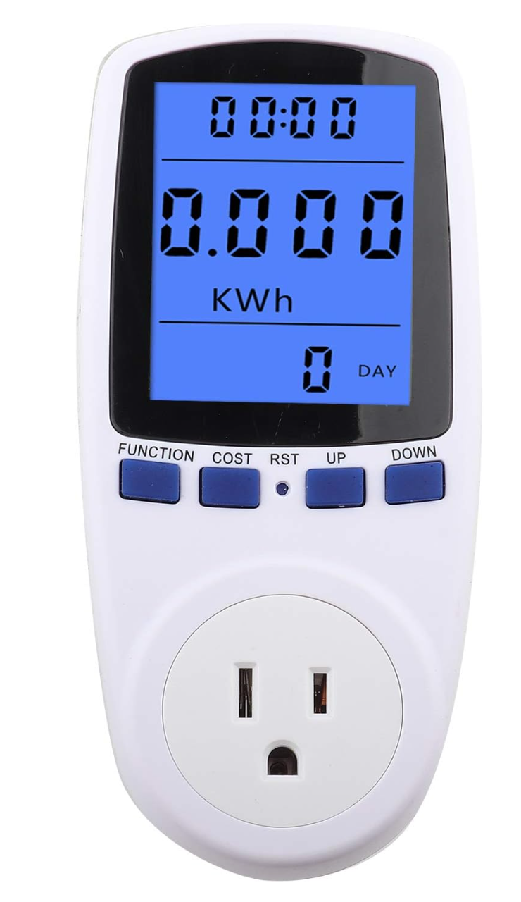

2. Dyson V10 and battery set
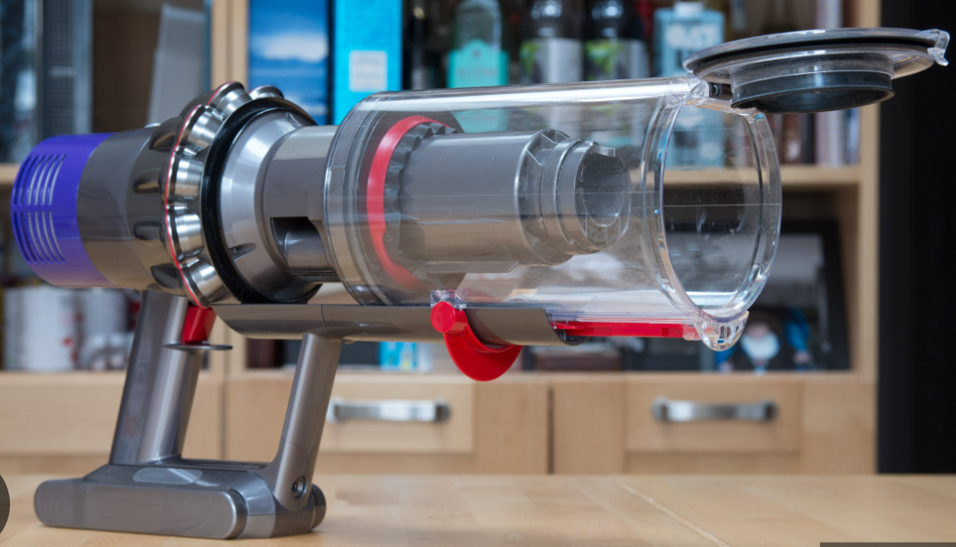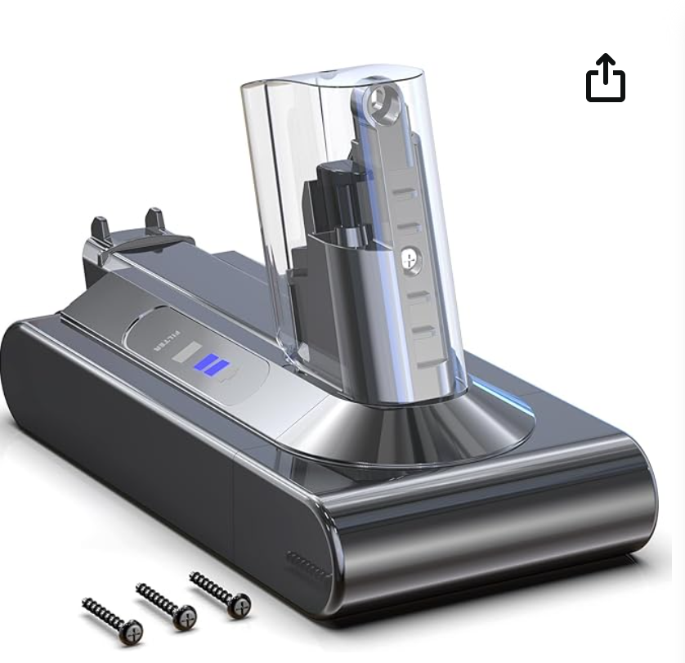

3. 18650 Rechargeable Battery (7 pieces)
  - V 3400mAh NCR18650B Li-ion
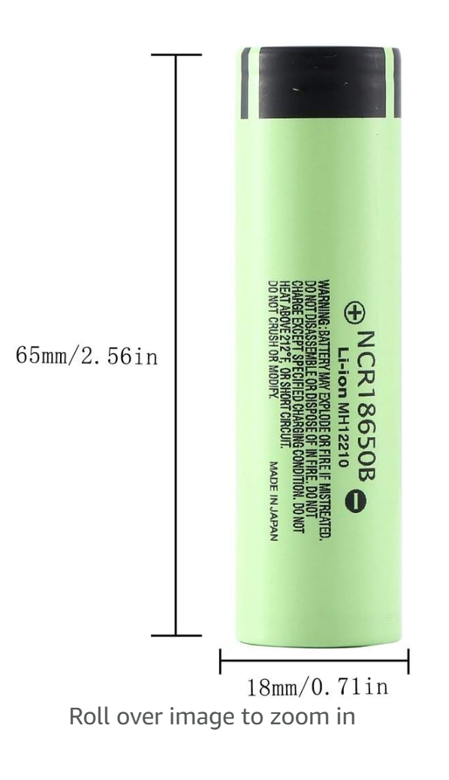

AFSONGOO 1-8-6-5-0 Flat Top Battery for 3000mah (Green) (Flat Top)
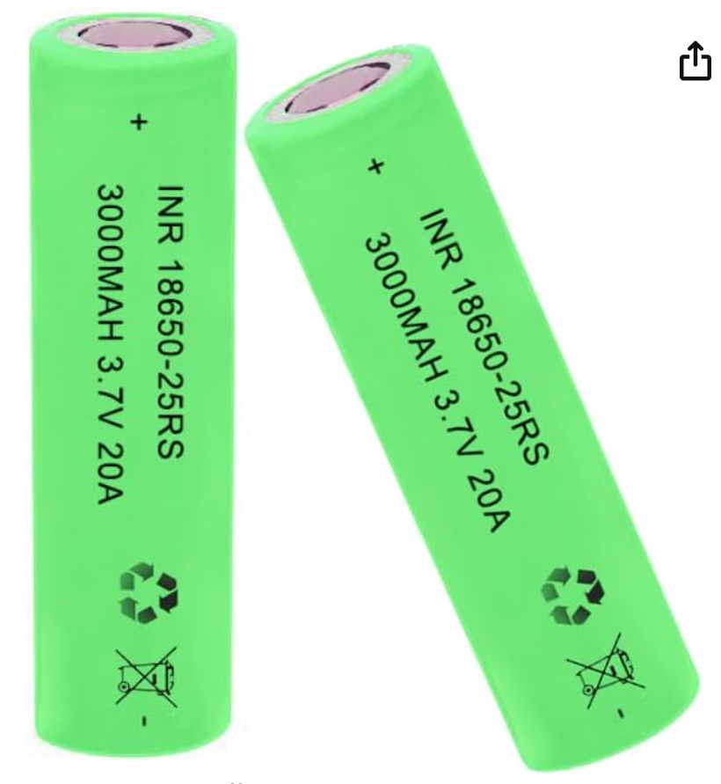

Smart battery charger Inlife S4

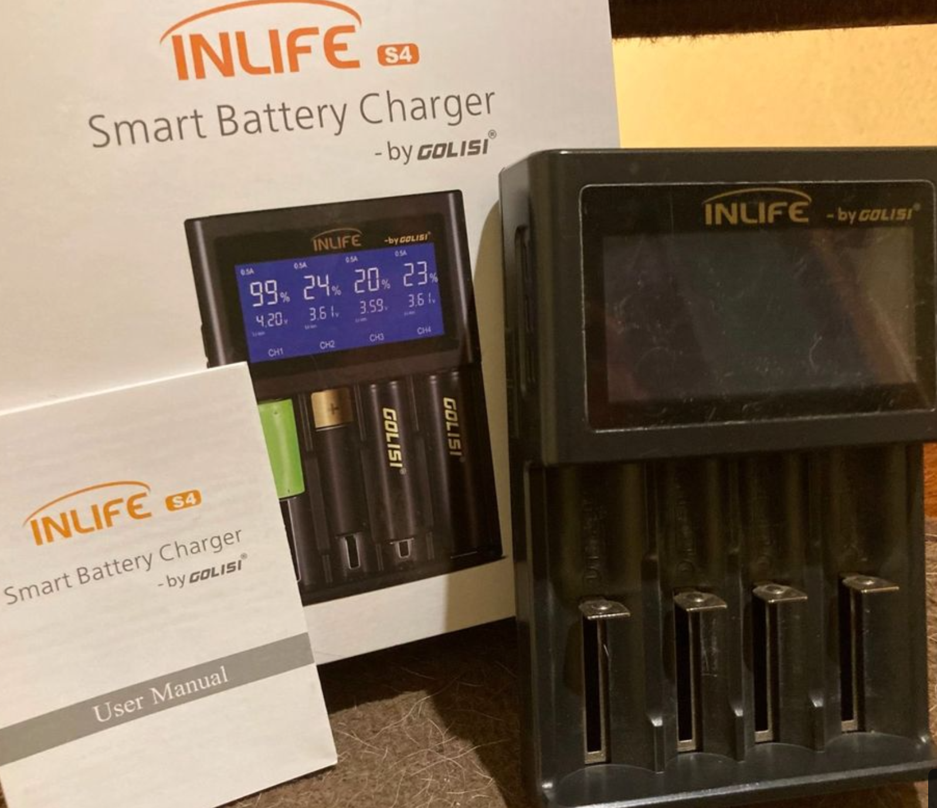

BESTEK 300W Power Inverter DC 12V to 110V AC Car Inverter with 4.2A Dual USB Car Adapter

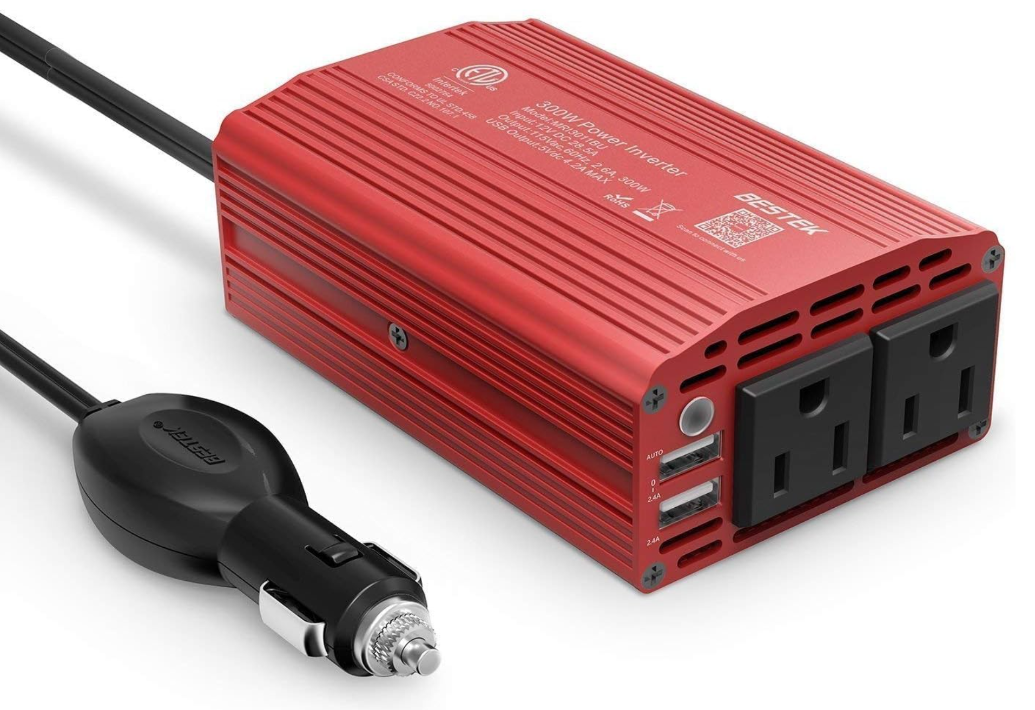

Mastercraft Digital Clamp Multimeter with 3.5-in LCD Display

Infrared Thermometer
(Not for Human) Non-Contact Digital Laser Temperature Gun Pyrometer with LCD Color Display
-58℉～1112℉(-50℃～600℃) Adjustable Emissivity for Cooking/BBQ/Freezer/Industry/Repair

Intertek Electric Fan FE-20 Personal Mini Fan 120VAC 60Hz 25W
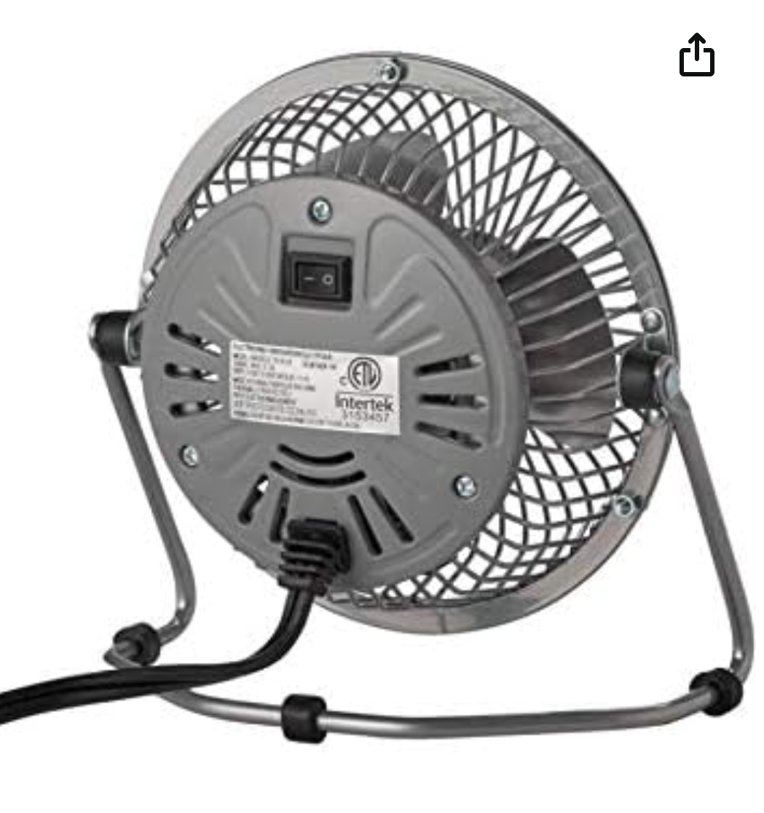

Wion 50049 Outdoor Wi-Fi Wireless Plug-In Switch; Smartphone and Table – Lighting Doctor
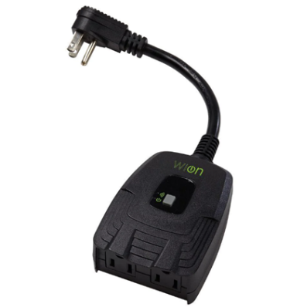

Appendix 4 Citation and Reference
- https://www.ceicdata.com/zh-hans/turkey/environmental-environmental-policy-taxes-and-transfers-oecd-member-annual/tr-industry-electricity-price-usd-per-kwh
- Vasudharini Sridharan, Mingjian Tuo and Xingpeng Li, "Wholesale Electricity Price Forecasting using Integrated Long-term Recurrent Convolutional Network Model",https://arxiv.org/abs/2112.13681.

