Using Plasma as a Power Supply Logbook
By Naga Kondepati
Outline:
- Research background information about current sources of energy, and then gather in-depth information about fusion energy
- Assess the quality of plasma from CME’s
- Make a thesis statement
- Assess the factors that will affect the plasma collector
- Create final good copy

Date | Expectation
March 1st, 2021 | All background research done
March 1st – 11th, 2021 | All research and information collected for the project
March 11th – 16th, 2021 | Finish all criteria and factors effecting plasma collector
March 15th- 18th, 2021 | Editing, changing or adding any last-minute stuff
March 19th, 2021 | The final project is due! No more editing

Background Research – February 20, 2021
Principles of Energy – Thermodynamics:
Consider thermodynamics to grasp a deeper understanding of energy
- Perpetual motion machines do not work because of the laws of thermodynamics
- 0th law – Heat flows from a warmer area to a colder area naturally
- 1st law – Energy is neither created or destroyed, you can’t get out more energy than you put in, the energy is only in a different form
- 2nd law – Entropy always increases overtime even in a vacuum, friction and heat can be radiated away, losing energy
- 3rd law – When something reaches absolute 0, (-273.15 C) its atoms will completely stop moving
- Entropy – The measure of randomness or disorder of how energy is spread out

Current Power Sources:
Earth’s Energy – Energy is neither created nor destroyed, it is just in different forms
- Fossil fuels – Coal, oil, natural gas – From the energy of the sun that plants captured millions of years ago, now in the form of carbon
- Our non-renewable sources are finite, lasting for about 50-100 years before they completely run out
- Renewable energy are infinite from an energy source that is otherwise wasted but it can’t power 100% of our energy needs
- Efficiency – It must be accessible year-round (such as year-round sun or continuous wind)
- Nuclear Energy – although sustainable in a way, and also efficient, it produces harmful radioactive waste that can lead to pollution and increased amounts of cancer
Comparing Current Resources February 25 – March 1st, 2021

Type of energy | Renewable Energy | Non-Renewables | Nuclear Energy | Plasma/Fusion Energy
Summary | Renewable energy includes solar, wind, and hydropower. These are sources that can be renewed, meaning that they won’t run out. They aren’t efficient enough to power all of the world currently. | Non-renewables include oil, coal, and gas. They contain the stored energy of prehistoric organisms. They only last for a certain period of time, and they take millions of years to replenish (form new fossils). | Nuclear energy involves splitting the nucleus of an atom to create energy. Although effective, it produces radioactive waste, which requires extremely careful measures to dispose. | Fusion energy uses nuclear fusion using plasma. The plasma reaches high enough temperatures to rip atoms apart, and fuse them into heavier elements. Such as hydrogen to helium. It is currently experimental, and not commercially available.
Pros | - It provides us with clean energy  - Healthier society (due to low pollution)  - Low maintenance  - Reliable sources  - Steady price | - It is a cheaper, and is more available  - Although leaks and spills do sometimes occur, they don’t produce harmful waste, such as radioactive waste  - We have an big supply currently  - They power the economy  - More reliable than renewables, since they don’t require constant sun or wind | - Nuclear energy caused less deaths than renewables or non-renewables  - The waste is stored safely instead of releasing it into the air, water, or land | - It is a carbon-free resource  - If confinement fails, fusion would stop, not violently explode or cause damage in any way  - If achieved, it will be the most practical and efficient energy source on Earth  - Sustainability  - No CO2
Cons | - Relies on weather (such as sunshine and wind)  - Efficiency is low  - Not available everywhere, so it requires a lot of transportation  - Start-up infrastructure is expensive | - Produces harmful methane and CO2 gases, along with many other greenhouse gases  - We currently have a big supply, but it won’t last longer than a century, based on current usage  - The gases it produces contribute to global warming and climate change  - Oil spills and other disasters are frequent and harmful to all eco-systems | - Nuclear energy and by-products could be used for nuclear weapons  - Nuclear waste such as plutonium is a very deadly and radioactive substance that loses its harmfulness over thousands of years  - Accidents are very dangerous, releasing large amounts of radioactivity  - Accidents make large areas unsafe and uninhabitable to living things | - It is still highly theoretical and experimental  - We will need hydrogen isotopes like deuterium and tritium  - Deuterium is found abundantly on Earth  - Tritium is incredibly rare and radioactive  - We could use helium-3 but it is also rare

Process of Fusion: March 1 – 10th, 2021
- Press two elements extremely close together
- Protons are positively charged, so they repel each other
- When the nuclei get close enough, strong nuclear force fuses them into heavier elements
- An isotope of hydrogen, deuterium was fused into helium
Current Issues:
- Deuterium is abundant, but tritium is so rare, that there is only 20 kgs of it, mostly in nuclear weapons
- Helium-3 is a substitute, which is also rare
- The magnets, confinement, materials, and the safety measures are very expensive, huge investments would be required
Problem:
- Non-renewables don’t last forever and they are slowly killing us with pollution and toxic substances
- Renewables aren’t enough to power all of the world 100% effectively all of the time, due to the sources they need
- Nuclear power poses a security threat, and also the radioactive waste is highly toxic unless stored safely
- Fusion power is a highly reliable source if worked out, with the exception of how difficult it is to create plasma on Earth

Question: How Do We Use Fusion Energy on Earth with Easily Available Plasma?

Collecting plasma and/or tritium from a reliable source would be the next best thing
- 1. Understand the properties of plasma, and specifically the plasma required for fusion energy
- 2. Find the most reliable sources of plasma on or near Earth
- 3. Construct a method of extracting and storing the plasma, along with a way to store our energy

What is fusion?
- Atoms don’t rest, they move faster with hotter temperatures
- Hydrogen atoms move very fast, overcoming the repulsion of the positive charges and fusing into helium
- During the fusion process, the mass is lost and energy is gained
- E=mc² – Equivalence of Mass and Energy
- Mass x speed of light squared = Energy
- Our sun is doing fusion by the hot temperatures that are caused by the enormous gravity that is holding it together
- Fusing deuterium and tritium is the most efficient fusion with the highest energy gain and the lowest possible temperatures (150 000 000 degrees C)

- What is plasma, and what are the required properties for plasma to be fused?
Plasma
- 99.9% of the Universe is made of plasma
- Plasma is a state of matter
- Continual heating of gas caused the atoms to be separated
- Then they ionize
- Ionization caused the negative electrons and positive ions to be freely roaming in a plasma
- Any gas can be made into one
- Plasma reacts to electrical and magnetic fields
- Light is generated when plasmas collide into a magnetic field, which causes auroras
Required Properties of Plasma to Achieve Fusion
- High temperatures
- Sufficient Plasma Density
- Sufficient Confinement
Capturing the Energy During Fusion
- 80% of energy is carried from the plasma through neutrons, which have no electric charge (neutral)
- The kinetic energy in the neutrons is absorbed by the walls of the fusion reactor into heat
- The heat will be used to make steam, which will be made into electricity through turbines and alternators

- What are the most reliable sources of plasma?
Current sources of plasma (extractable) –
- Lightning – Lightning only lasts a couple seconds at most, so extracting it would be challenging, but complicated
- Auroras or Solar Wind (CMEs)

Thesis:
If there is sufficient and usable plasma in CMEs, then we could extract and contain the plasma using magnetic fields, making the fusion process easier and more durable.
CMEs
- The sun is made of plasma, that is constantly fusing
- The plasma creates a magnetic field because plasma is electrically charged
- The plasma is moving, so the magnetic field isn’t always consistent
- Solar wind - trickle of the plasma in the sun
- Sun’s magnetic field releases large amounts of plasma into the solar system
- Earth’s atmosphere absorbs x-rays before they reach the ground
- The plasma is affected by the magnetic field of Earth, being diverted into the magnetic poles
- Northern lights – When the particles of plasma interact with oxygen and nitrogen in the atmosphere, producing lights
- CMEs occur every 5 days on average during calmer periods
Theory: The plasma being catapulted at Earth may contain hydrogen isotopes deuterium and tritium. The sun is a main sequence star that is composed of hydrogen and helium. Although samples of the sun have never been directly observed, we can infer that there would be at least trace amounts of tritium, which could be beneficial to us.

What Others Have Achieved So Far:
- 1930s – Scientists discovered nuclear fusion
- 1940s – Scientists researched how to create fusion on Earth, and what that energy could be used for
- 1950s – Scientists were convinced that fusion had no military applications
- 1960s – Scientists developed inertial confinement, which was using lasers to confine the plasma
- 1970s – Magnetic confinement was developed
- 1980s and 90s – Billions of dollars were spent on creating more advanced Tokamaks

The Operation of Tokamak by I.T.E.R.
- The donut shaped vacuum chamber is where the plasma takes place
- Magnetic coils steer and shaped the plasma, away from the vessel walls, in order to confine it
- Air and other impurities are removed to produce a vacuum
- Electrical currents ionize the plasma
- The ionized plasma collides, and while heat causes collisions, collisions heat it up more
- Heating methods cause fusion temperatures
- Once the atoms overcome natural repulsion (positive ≠ positive) the fuse
- Since their atomic mass combined together is more than the actual mass of the fused element, it produces energy in return
- The neutrons collide against the vessel walls, producing heat, which will then in return be used to heat water into steam

- Construct a way to extract and store that plasma. – March 11, 2021
ITER Magnetic Confinement – Use magnets to confine plasma
Plasma is made up of electrical charges, so magnetism will control it
Plasma is diverted to the poles due to Earth’s magnetic field
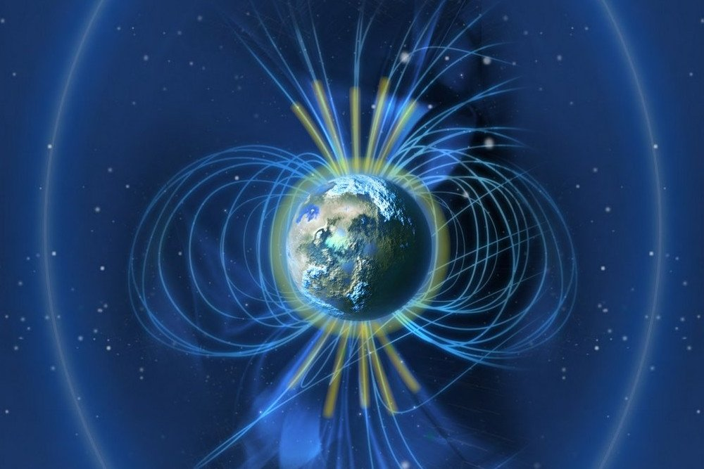
Picture Retrieved from ScienceABC

Criteria for collecting plasma –
- 100 GJ Magnetic Power – To be able to work for long without losing magnetism
- The plasma will be diverted to the magnets due to their strength
- The magnets must be reliable and durable, to survive the journey into the atmosphere, collect plasma using their magnetic field, and return back to the surface
- Once collected, the plasma needs to confined in a vacuum, which will be easy since the exosphere doesn’t contain much air
- The plasma collector will have to be a portable fusion reactor that will be capable of collecting plasma in the air
- Be able to concentrate the plasma enough for fusion to occur
Factors Influencing the Plasma Collector/Fusion Reactor –
- Atmospheric pressure
- Magnetosphere of the Earth
- Friction with air
- Cost
- Availability of plasma through CMEs

Email Written to Quirks and Quarks on CBC –

Hello Naga

Thank you for your message regarding your science fair project on harnessing plasma from the Earth's atmosphere. It is a very innovative idea.

You are right that the sun delivers a tremendous amount of energy to our atmosphere that we see as the northern lights, but that energy is spread out over a very large area. The challenge for you is how to gather that up and concentrate it into a smaller space so it is more dense and we can put it to work. As you know, concentrating plasmas into a smaller space has been a huge challenge for fusion reactors.

You will need a very large energy collector of some kind. that can reach up very high into the atmosphere to gather the energy and concentrate it somehow. I will leave that challenge up to you.

We have the same issue with other forms of energy such as solar and wind, which are again plentiful, but spread out across the surface of the Earth so we need huge solar farms that cover a lot of land or many giant windmills to produce enough electricity for a city.

I hope that helps, good luck with your project.

Sincerely,
Bob McDonald
Host, Quirks & Quarks
CBC Radio Canada

The Abilities of the Proposed Machine
- The machine must be able to collect plasma in the atmosphere near the poles
- The machine should be around the size of Tokamak by I.T.E.R. but also light enough to travel into the atmosphere
- The objective of the machine is to use magnetic coils, like Tokamak, to contain the plasma
- Plasma must be confined closely together to conduct fusion
- The machine should be able to collect plasma and serve as a part of a fusion reactor or a fusion reactor, to save the costs of transporting plasma

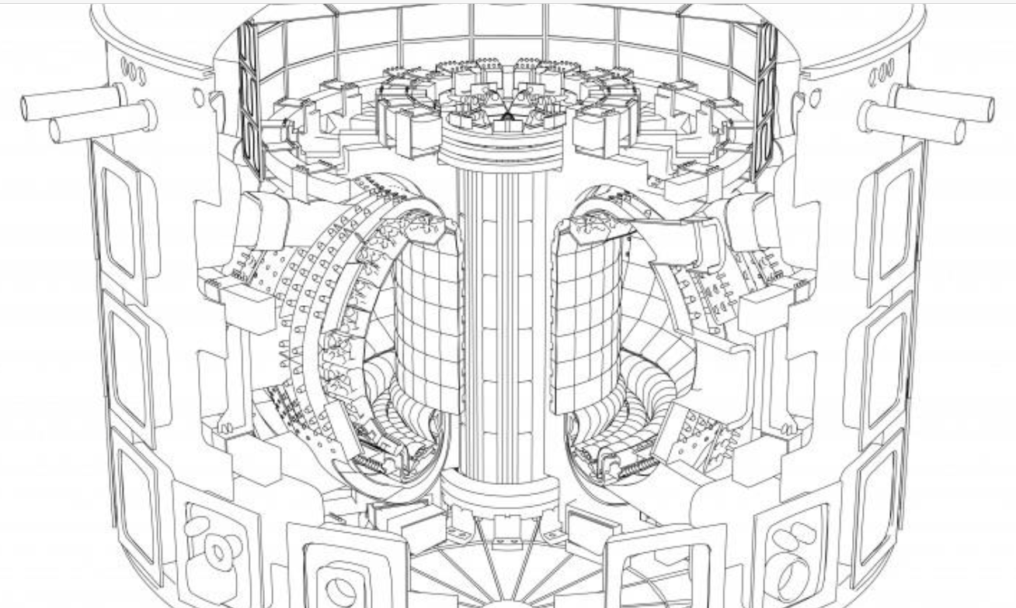

Magnets used to confine plasma

The blanket is what the neutrons collide with, producing heat
Vacuum vessel where the fusion process takes place

The diverter protects the surrounding walls from thermal and neutronic loads

Picture from Assembling the machine (iter.org)

Final Ideas for Plasma Collector: With a CME occurring every five days on average, we could harness all that energy and plasma. A plasma collector that is able to collect plasma and serve as a fusion reactor will be beneficial in the aspect that we can save transporting plasma between the collector and the reactor. It will need to be 100% automated, with enhanced machinery, since humans will receive their radiation dose limit within hours if they are exposed to the deadly ionizing radiation in the upper layers of the atmosphere.
Next Steps: My next steps will be to meet up with some mechanical engineers and astrophysicists to create a workable blueprint that can be built. Although it isn’t certain that this idea will work, it is a hugely worth trying idea. With a small collector, we could do tests and experiments, to see if the plasma from CMEs is compatible with our current fusion reactors. If the plasma is a good source of deuterium and tritium, then it will be an effective way of fusion. With all the background information collected on fusion, experimenting is the next step.

Why Is This Revolutionary: If these experiments were carried out and they are successful, then more companies will be interested in investing. With an easy plasma source, we could be able to make fusion our primary source of energy, one that is carbon free, and provides almost zero waste. Scientists would find this idea revolutionary, since we would be able to create energy for generations without worry.

References

A guide to the energy of the Earth - Joshua M. Sneideman. (2014, June 30). [Video]. YouTube. https://www.youtube.com/watch?v=fHztd6k5ZXY
Can 100% renewable energy power the world? - Federico Rosei and Renzo Rosei. (2017, December 7). [Video]. YouTube. https://www.youtube.com/watch?v=RnvCbquYeIM
Sources of Energy: A Comparison. (n.d.). World101 from the Council on Foreign Relations. https://world101.cfr.org/global-era-issues/climate-change/sources-energy-comparison
(2019, January 12). Post author: admin. Pros an Cons. https://prosancons.com/energy/pros-and-cons-of-renewable-energy/
Team, T. E. P. (2018, June 12). The Pros and Cons of Non Renewable Energy. The Earth Project. https://theearthproject.com/pros-and-cons-of-non-renewable-energy/#:%7E:text=%20The%20Pros%20of%20Non%20Renewable%20Energy%20,are%20less%20dependable%20than%20non%20renewables.%20More
kurzgesagt nuclear power - Bing video. (n.d.). Youtube. https://www.bing.com/videos/search?q=kurzgesagt+nuclear+power&&view=detail&mid=7ACD7EDAC3FC02DBFCCA7ACD7EDAC3FC02DBFCCA&&FORM=VRDGAR&ru=%2Fvideos%2Fsearch%3Fq%3Dkurzgesagt%2Bnuclear%2Bpower%26qs%3DMM%26form%3DQBVR%26sp%3D2%26pq%3Dkurzgesagtt%2Bnucla%26sk%3DMM1%26sc%3D3-17%26cvid%3D93B938428DEE4D2F881AF4B08E3DC659
3 Reasons Why Nuclear Energy Is Terrible! 2/3. (n.d.). Youtube. https://www.bing.com/videos/search?q=kurzgesagt+nuclear+power&&view=detail&mid=C4A79D21EC692C78AA9BC4A79D21EC692C78AA9B&&FORM=VRDGAR
Fusion Power Explained – Future or Failure. (2016, November 10). [Video]. YouTube. https://www.youtube.com/watch?v=mZsaaturR6E
Fusion Has Major Problems That No One Is Telling You About. (2020, November 28). [Video]. YouTube. https://www.youtube.com/watch?v=FrUWoywZRt8
TED-Ed. (2015, July 28). Solid, liquid, gas and … plasma? - Michael Murillo. YouTube. https://www.youtube.com/watch?v=tJplytSR-ww
Fusion. (n.d.). ITER. https://www.iter.org/sci/whatisfusion
Capturing the energy. (n.d.). ITER. https://www.iter.org/sci/makingitwork
Advantages of fusion. (n.d.). ITER. https://www.iter.org/sci/Fusion
Kurzgesagt – In a Nutshell. (2020, June 7). Could Solar Storms Destroy Civilization? Solar Flares & Coronal Mass Ejections. YouTube. https://www.youtube.com/watch?v=oHHSSJDJ4oo
What is a coronal mass ejection or CME? (n.d.). NASA. https://www.nasa.gov/content/goddard/what-is-a-coronal-mass-ejection/
Machine. (n.d.). ITER. https://www.iter.org/mach
Peshin, A. (2019, December 12). What Causes Earth’s Magnetic Field? Science ABC. https://www.scienceabc.com/nature/what-causes-earths-magnetic-field.html
TED-Ed. (2017, June 5). Why don’t perpetual motion machines ever work? - Netta Schramm. YouTube. https://www.youtube.com/watch?v=A-QgGXbDyR0
TED-Ed. (2017a, May 9). What is entropy? - Jeff Phillips. YouTube. https://www.youtube.com/watch?v=YM-uykVfq_E
What is Nuclear Fusion? - Science and Engineering. (n.d.). [Illustration]. Science-Engineering. https://www.bing.com/images/search?view=detailV2&ccid=NaX1xR0H&id=1A5AB487F148991BFE1A5A15AF17FA386EEBD050&thid=OIP.NaX1xR0HtLBl6Qock5uKKAHaE9&mediaurl=https%3A%2F%2Fwww.science-engineering.co.uk%2Fwp-content%2Fuploads%2F2020%2F11%2Fnuclear-fusion-energy-tokamak-e1606137159752.jpg&exph=802&expw=1198&q=nuclear+fusion&simid=608045739997925663&ck=1566EFA594D76AFC65B88246D48A7D15&selectedindex=47&form=IRPRST&ajaxhist=0&vt=0&sim=11
Tokamak. (n.d.). ITER. https://www.iter.org/mach/Tokamak
I.T.E.R. (n.d.). Tokamak [Illustration]. I.T.E.R. https://www.iter.org/construction/TokamakAssembly
Crockett, C. (2020, December 10). What are coronal mass ejections? EarthSky. https://earthsky.org/space/what-are-coronal-mass-ejections#:%7E:text=During%20its%20quieter%20periods,%20CMEs%20occur%20only%20about,the%20sun%E2%80%99s%20magnetic%20field%20plays%20a%20major%20role.
L. (2017, July 24). Brief History of Fusion Power. LPPFusion. https://lppfusion.com/technology/brief-history-of-fusion-power

