Windmills
By: Smyan Tripathi
Mr.Knoll
Grade 7
Westmount Charter School

The research part of my project:
My project has two parts: the research and the experiment. I have researched the following:
- The Horizontal Axis Wind Turbine (HAWT)............................................................Page 2
- The Vertical Axis Wind Turbine (VAWT).................................................................Page 2
- What are the mechanics of the HAWT?……………………………………………….Page 3
- What are the mechanics of the VAWT?..................................................................Page 3
- How does the winds kinetic energy spin a windmill?..............................................Page 4
- Does the HAWT or the VAWT work better?............................................................Page 4
- Why windmills instead of fossil fuels?.....................................................................Page 7

Experiment part of my project
- Hypothesis………………………………………………………………………………..Page 5
- Observation…………………………………………………………………………….. Page 6
- Observation/Conclusion………………………………………………………………...Page 7
- Sources/Citations………………………………………………………………………..Page 8
For this project, I used a fan, a turbine model, and a different number of blades for each test. I used the fan to act as the wind's kinetic energy. As soon as I started the fan, I also started a timer for exactly 10 seconds to see how many times the wind turbine’s blades spun. After testing one type of blade, I moved on to the next blade, gradually increasing the number of blades. Then I recorded my findings after each test.
The experiment was repeated 10 times for each blade amount to get an average of how many times the blades spin. After that, I observed what design had the most amount of spins. The design’s blades that spun the most will generate the most electricity and is the best model.

What are the two types of windmills?

The Horizontal Axis Wind Turbine (HAWT)
Horizontal-axis turbines are one of the most common types of windmills we see. They are very similar to propeller airplane engines. These 3 bladed giants are as tall as 20-story buildings, and their blades are around 100 feet long. The taller a turbine and longer the blades, the more energy a turbine can generate.

The HAWT can sometimes be found in wind farms. Wind farms are large clusters of wind farms that generate tons of electricity.

Vertical Axis Wind Turbine (VAWT)
Vertical-axis wind turbines are the type of turbines we can find in residential areas. They can serve as a source of renewable energy for the community. The blades on the turbine are placed vertically to the ground, so they are perpendicular to the direction of the wind. One of the advantages of the VAWT is that it can function at lower wind speeds.

How does the mechanics of the HAWT work?
The mechanics of a Horizontal Axis Wind Turbine sounds complicated to understand but in reality, they are simple. The 3 blades on a wind turbine work to collect the wind's kinetic energy. This energy spins the blades in a clockwise direction. When the blades spin, they move the gears inside the gearbox along with it.

The nacelle is what carries the gearbox and generator, it's also the part that connects the blades to the tower. This part is vital to the windmill as it provides a shell for most of the main components.

A rod connects from the gearbox to the blades of the windmill. Then the gearbox transfers the kinetic energy to the generator. The generator transfers this energy into electricity, then cables from the generator travel through the tower into the transformer carrying the electricity.

The transformer connects to the switchyard/grid. The switchyard/grid is the huge metal structures that carry electricity around the region. In conclusion, this is how the wind's kinetic energy can be turned into electricity and be carried around a specific region.

How do the mechanics of the VAWT work?
The Vertical Axis Wind Turbine was invented by an engineer named George Jeans Marie Darrieus in 1931. He designed this wind turbine to work from all directions. When the wind comes across the turbine, the blades spin along the central column. The central column spins the gearbox. The gearbox is connected to the generator. The generator turns the kinetic energy into electricity and transfers the electricity through cables onto the switchyard/grid.

How does the wind’s kinetic energy spin a windmill?
The science behind how the wind makes a windmill spin is similar to how wings on an airplane generate lift. Firstly, on every windmill, there is a wind vane at the top. This part sits on top of the nacelle. The wind vane shows which way the wind is travelling. This allows the nacelle to turn around to face the wind. The blades that are attached to the windmill also spin on their axis to generate maximum energy.

When wind blows on the turbine, the air pressure on one side of each of the blades decreases. This is because the air particles are moving much faster than the other side. Then, because of the low air pressure, the turbine spins in one direction. Depending on the wind speed the turbine spins at different speeds. A wind turbine can generate electricity from 11 kph to 90 kph, after 90 kph, wind turbines automatically stop due to safety issues.

Does the HAWT or VAWT work better?
The HAWT and the HAWT both have pros and cons, but the HAWT is proven to work better. This is because the HAWT catches more air and can generate more electricity than the VAWT. The VAWT is much more suitable for urban/residential areas where there are low wind speeds and the wind is turbulent.

The VAWT has many advantages over the HAWT, for example, the VAWT generator and gearbox are located near the bottom of the wind turbine. This provides easy access to maintenance issues. The HAWT on the other hand has to keep all of its equipment at the top of the tower.

Hypothesis:
Two Blades Hypothesis: I hypothesize that the 2 blades will generate more electricity in lower wind speeds because of the reduced drag and its lightweight. I predict that the 2 blades will generate the 2nd most energy.
Three Blades Hypothesis: I hypothesize that the 3 blades will generate the most energy. This is because the drag and efficiency will be equally balanced.
Four Blades Hypothesis: I hypothesize that the 4 blades will generate a bit more energy than the 5 blades. This is because the weight and drag will be too much compared to the force of rotation.
Five Blades Hypothesis: I hypothesize that the 5 blades will generate the least amount of energy. Though the blades will catch more wind, the drag and weight will stop the blades from moving much. I predict that the five blades will generate the least amount of energy.

Observations:

 | 2 Blades | 3 Blades | 4 Blades | 5 Blades
Test 1 | 10 | 14 | 9 | 13
Test 2 | 9 | 13 | 10 | 13
Test 3 | 9 | 12 | 11 | 12
Test 4 | 10 | 12 | 11 | 12
Test 5 | 9 | 13 | 11 | 12
Test 6 | 9 | 14 | 11 | 12
Test 7 | 9 | 13 | 11 | 12
Test 8 | 10 | 14 | 11 | 12
Test 9 | 9 | 14 | 12 | 12
Test 10 | 10 | 13 | 12 | 12
Average | 9.4 | 13.2 | 10.9 | 12.2

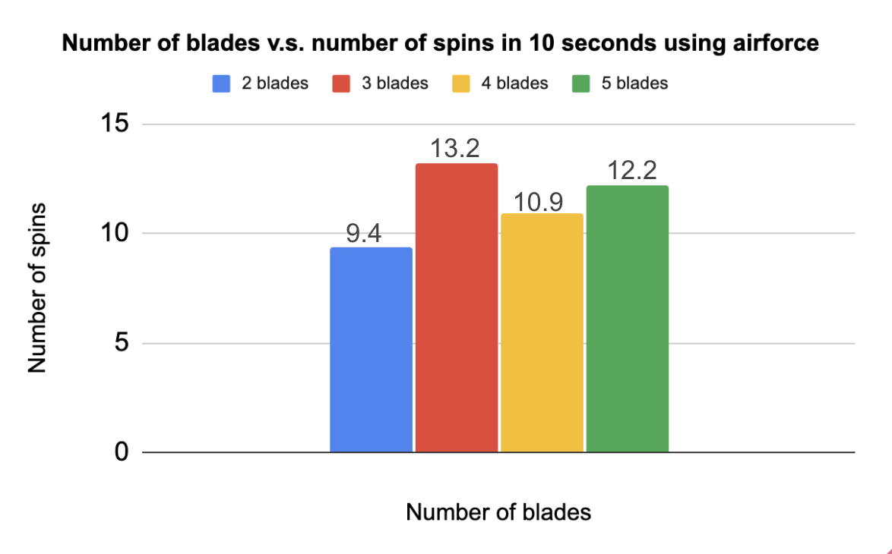

Observations/Conclusion:
My hypothesis was correct. After observing that the 3 blades spun the most, we can understand that 3-bladed wind turbines are the most efficient and can generate the most electricity. Another observation I made was that odd-numbered blades worked better than even-numbered blades. The 3 and 5 blades did much better than the 4 and 2 blades. So I researched this theory. Odd-numbered blades can work better than even-numbered blades for 1 main reason, balance. It is important for the rotor on a windmill to be balanced or else different components may have tension.
In conclusion, windmills with 3 blades work best, they are cost-effective and are the most efficient. To achieve energy production, we must take into account, the balance of a windmill, cost, and efficiency.

Why windmills instead of fossil fuels?
Wind turbines come with great advantages over non-renewable sources. Wind turbines come in a group called renewable sources along with solar, geothermal and hydropower. Renewable sources are sources that are constantly being replenished. For example, there is lots of wind for wind turbines and tons of sunlight for solar power. These sources don’t pollute our environment with carbon dioxide when used.

When we burn fossil fuels they produce tons of carbon dioxide that adds to our global warming crisis. This is bad for the environment and puts up many risks.

Another reason we use wind turbines is because it is cost-effective. Wind turbines are one of the lowest-priced energy sources today. Fossil fuels take a lot of money to mine and then burn. In conclusion, fossil fuels are not the way to go because of cost, pollution and danger.

Sources/Citations:
“Advantages and Challenges of Wind Energy.” Energy.Gov, www.energy.gov/eere/wind/advantages-and-challenges-wind-energy#:~:text=Wind%20power%20is%20a%20clean,fuel%20or%20polluting%20the%20air. Accessed 18 Jan. 2024.
Agarwal, Tarun. “Vertical Axis Wind Turbine : Block Diagram, Working & Its Applications.” ElProCus, 27 Dec. 2021, www.elprocus.com/vertical-axis-wind-turbine/#:~:text=In%20this%20turbine%2C%20the%20generator,electricity%20by%20using%20wind%20power.
Energy, Windcycle. “What Is a Vertical Axis Wind Turbine (VAWT)?” WindCycle, 24 Oct. 2022, windcycle.energy/what-is-a-vawt/.
“Modern Turbines: How They Work.” Modern Turbines: How They Work - Electricity & Alternative Energy - Alberta’s Energy Heritage, www.history.alberta.ca/energyheritage/energy/wind-power/modern-wind-power/modern-turbines-how-they-work.aspx. Accessed 18 Jan. 2024.
“U.S. Energy Information Administration - EIA - Independent Statistics and Analysis.” Types of Wind - U.S. Energy Information Administration (EIA), www.eia.gov/energyexplained/wind/types-of-wind-turbines.php. Accessed 18 Jan. 2024.
“How Does a Wind Turbine Work? | Sustainability - Acciona.” YouTube, YouTube, 23 Feb. 2016, www.youtube.com/watch?v=DILJJwsFl3w.
Li, Yan. “Straight-Bladed Vertical Axis Wind Turbines: History, Performance, and Applications.” IntechOpen, IntechOpen, 1 Mar. 2019, www.intechopen.com/chapters/65843.
Winslow, Andrew R., "Urban Wind Generation: Comparing Horizontal and Vertical Axis Wind Turbines at Clark University in Worcester, Massachusetts" (2017). International Development, Community and Environment (IDCE). 127. https://commons.clarku.edu/idce_masters_papers/127
“Vertical Axis Wind Turbine.” Vertical Axis Wind Turbine - an Overview | ScienceDirect Topics, www.sciencedirect.com/topics/engineering/vertical-axis-wind-turbine#. Accessed 18 Jan. 2024.

